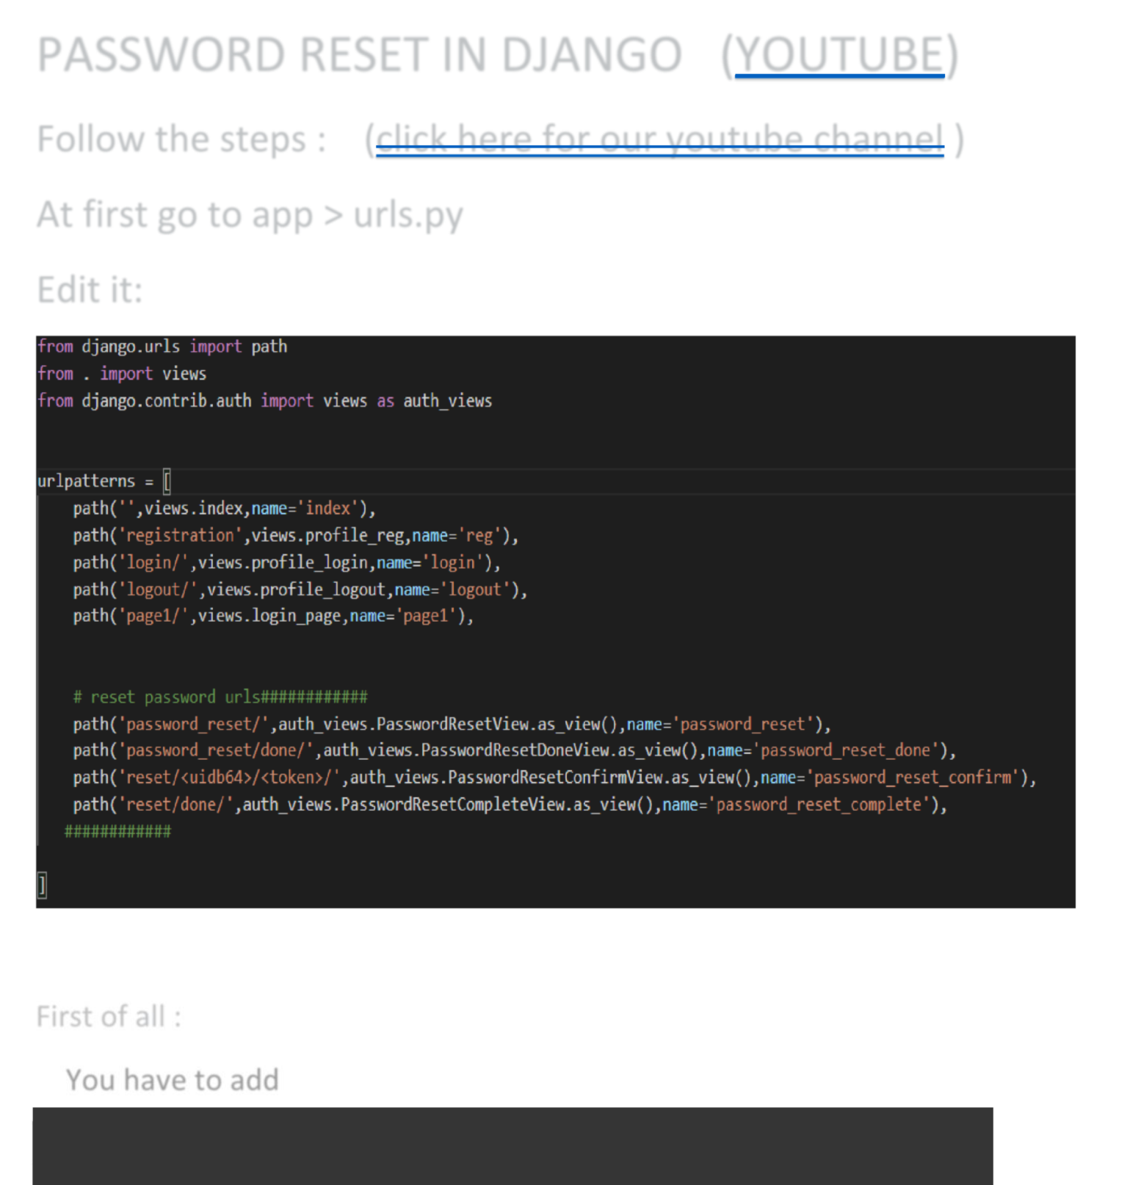

PASSWORD RESET IN DJANGO ([YOUTUBE](https://www.youtube.com/channel/UCJdXMYn7RaOv8QAsBj1b96Q)) Follow the steps : ([click here for our youtube channel](https://www.youtube.com/channel/UCJdXMYn7RaOv8QAsBj1b96Q) ) At first go to app > urls.py   
Edit it:

First of all :   
 You have to add

|  |
| --- |
| from django.contrib.auth import views as auth_views |

from django.contrib.auth import views as auth_views



THEN :

Then :

Add the urls patterns :

path('password_reset/',auth_views.PasswordResetView. as_view(),name='password_reset'),

path('password_reset/done/',auth_views.PasswordReset DoneView.as_view(),name='password_reset_done'),

path('reset/<uidb64>/<token>/',auth_views.PasswordRe setConfirmView.as_view(),name='password_reset_confir m'),

path('reset/done/',auth_views.PasswordResetCompleteV iew.as_view(),name='password_reset_complete'),

like:

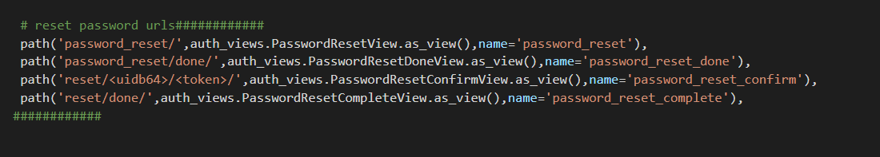

Then :

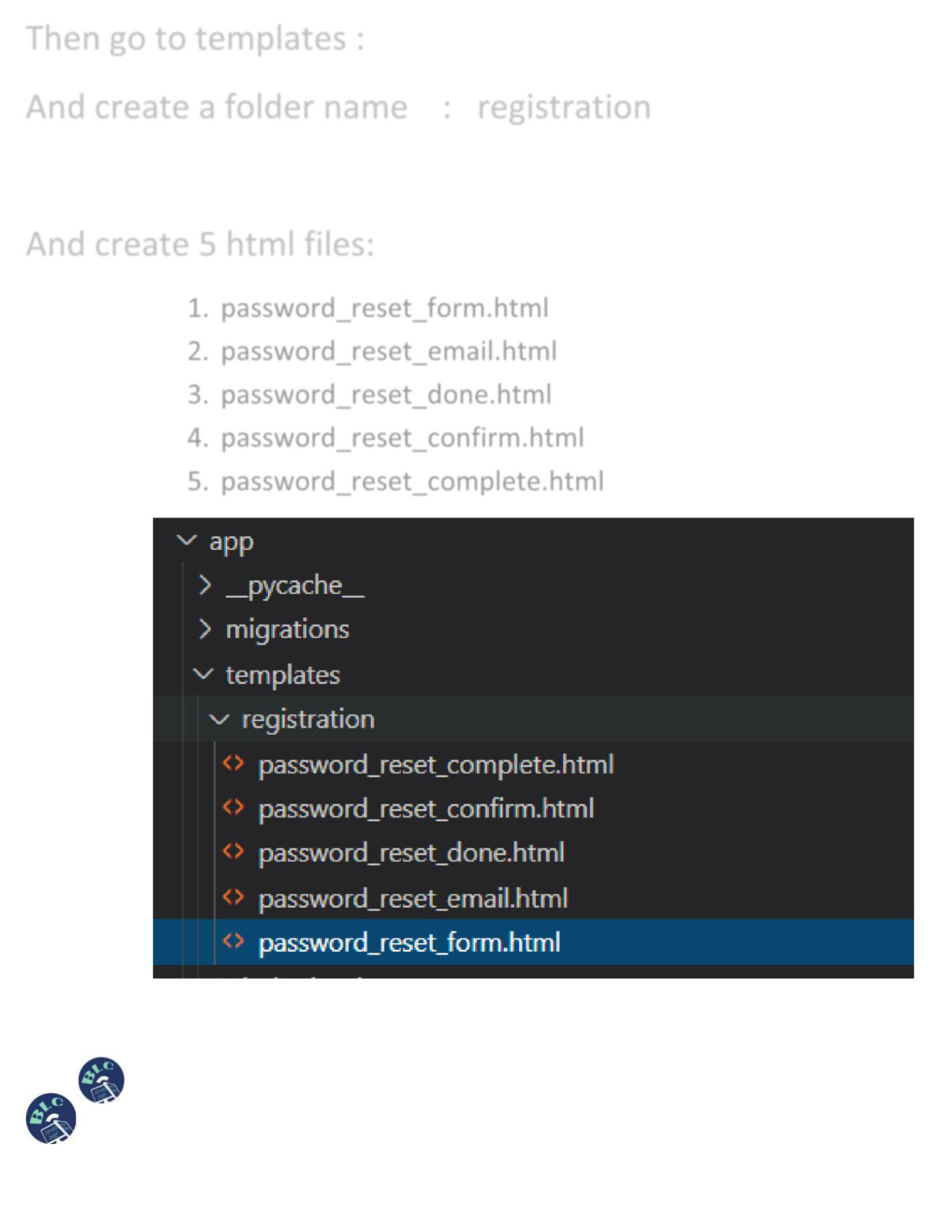

Then go to templates :

And create a folder name : registration

And create 5 html files:

1.password_reset_form.html   
2.password_reset_email.html   
3.password_reset_done.html   
4.password_reset_confirm.html   
5.password_reset_complete.html

Then :

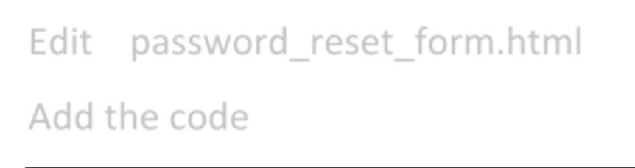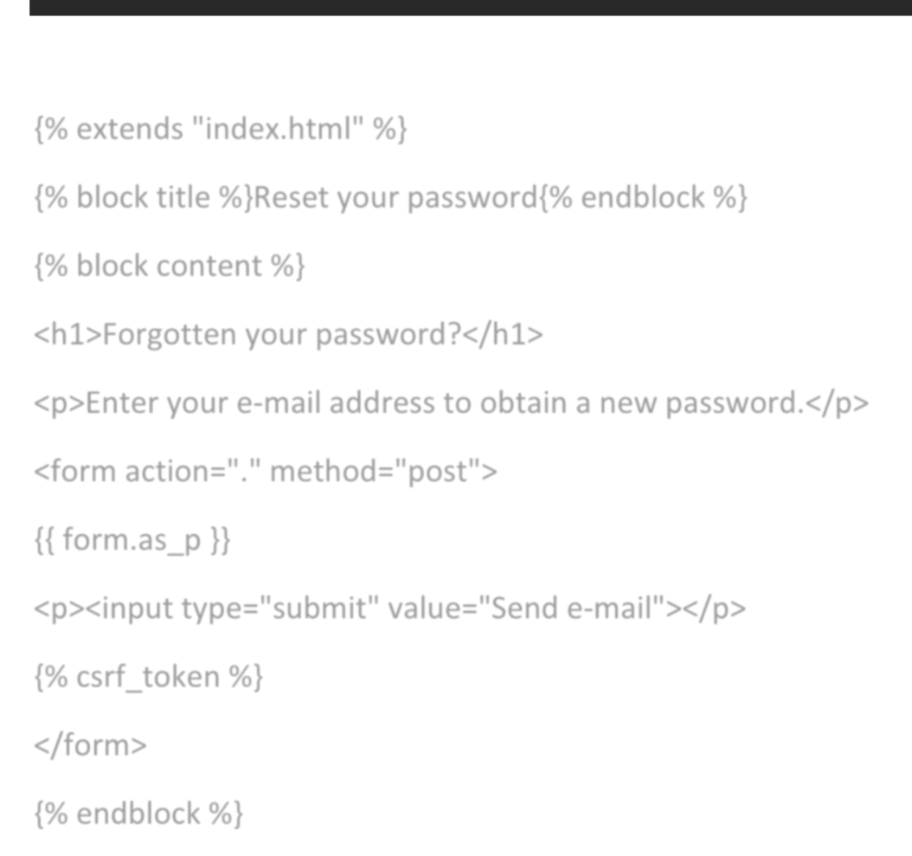

Edit password_reset_form.html

Add the code

|  |
| --- |
| {% extends "index.html" %} |

|  |
| --- |
| {% block title %}Reset your password{% endblock %} |

|  |
| --- |
| {% block content %} |

|  |
| --- |
| <h1>Forgotten your password?</h1> |

|  |
| --- |
| <p>Enter your e-mail address to obtain a new password.</p> |

|  |
| --- |
| <formaction="."method="post"> |

|  |
| --- |
| {{ form.as_p }} |

|  |
| --- |
| <p><inputtype="submit"value="Send e-mail"></p> |

|  |
| --- |
| {% csrf_token %} |

|  |
| --- |
| </form> |

{% endblock %}

{% extends "index.html" %}

{% block title %}Reset your password{% endblock %}

{% block content %}

<h1>Forgotten your password?</h1>

<p>Enter your e-mail address to obtain a new password.</p>

<form action="." method="post">

{{ form.as_p }}

<p><input type="submit" value="Send e-mail"></p>

{% csrf_token %}

</form>

{% endblock %}

|  |  |
| --- | --- |
|  |  |

Then :

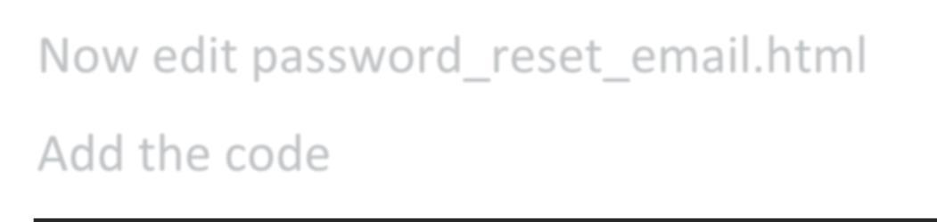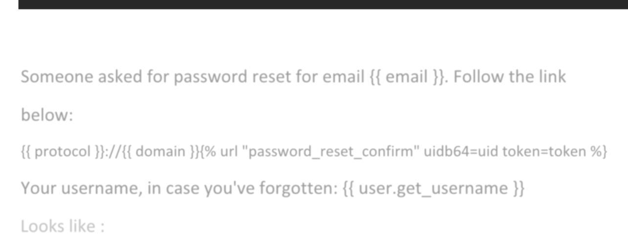

Now edit password_reset_email.html Add the code

|  |
| --- |
| Someone asked for password reset for email {{ email }}. Follow the link |

|  |
| --- |
| below: |

{{ protocol }}://{{ domain }}{% url "password_reset_confirm" uidb64=uid token=tok

|  |
| --- |
| en %} |

Your username, in case you've forgotten: {{ user.get_username }}

Someone asked for password reset for email {{ email }}. Follow the link below:   
{{ protocol }}://{{ domain }}{% url "password_reset_confirm" uidb64=uid token=token %} Your username, in case you've forgotten: {{ user.get_username }}   
Looks like :

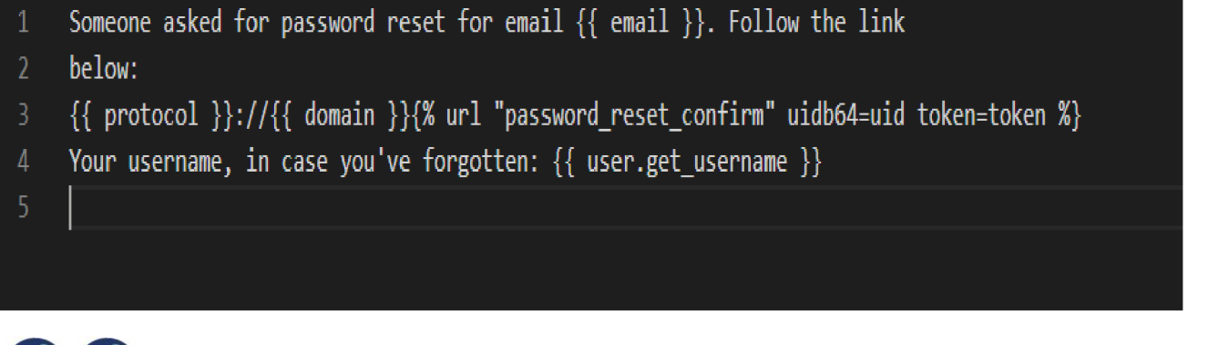





Then :

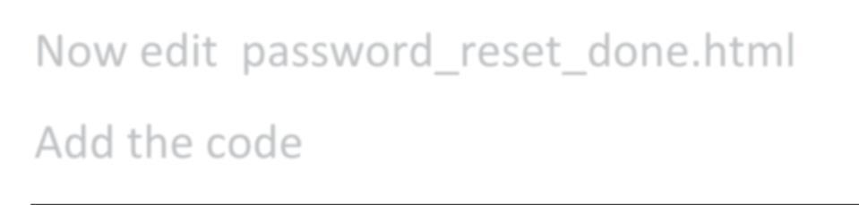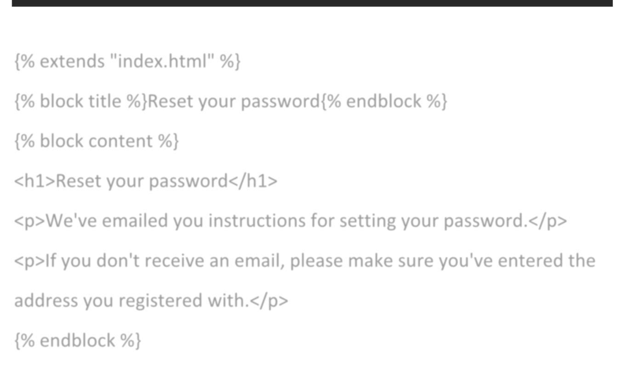

Now edit password_reset_done.html

Add the code

|  |
| --- |
| {% extends "index.html" %} |

|  |
| --- |
| {% block title %}Reset your password{% endblock %} |

|  |
| --- |
| {% block content %} |

|  |
| --- |
| <h1>Reset your password</h1> |

|  |
| --- |
| <p>We've emailed you instructions for setting your password.</p> |

|  |
| --- |
| <p>If you don't receive an email, please make sure you've entered the |

|  |
| --- |
| address you registered with.</p> |

{% endblock %}

{% extends "index.html" %}

{% block title %}Reset your password{% endblock %}

{% block content %}

<h1>Reset your password</h1>

<p>We've emailed you instructions for setting your password.</p>

<p>If you don't receive an email, please make sure you've entered the

address you registered with.</p>

{% endblock %}

|  |  |
| --- | --- |
|  |  |

Then :

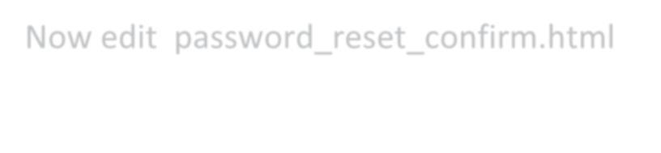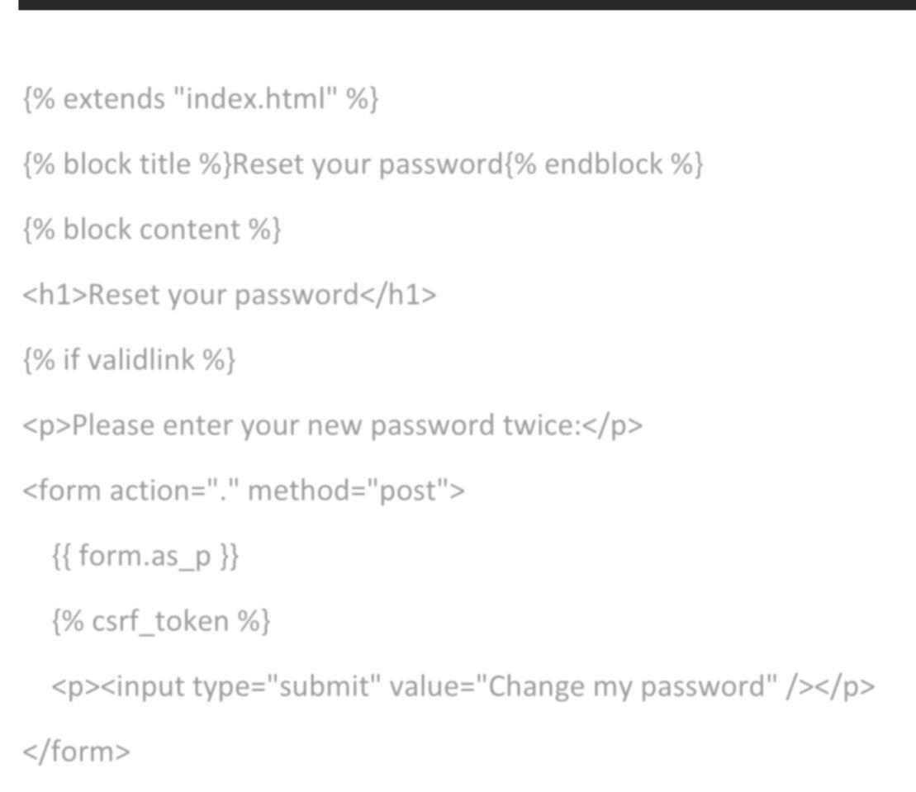

Now edit password_reset_confirm.html

{% extends "index.html" %}   
{% block title %}Reset your password{% endblock %}   
{% block content %}   
<h1>Reset your password</h1>   
{% if validlink %}   
<p>Please enter your new password twice:</p>   
<formaction="."method="post">  
 {{ form.as_p }}   
 {% csrf_token %}   
 <p><inputtype="submit"value="Change my password"/></p> </form>   
{% else %}   
<p>The password reset link was invalid, possibly because it has already been used. Please request a new password reset.</p> {% endif %}   
{% endblock %}

{% extends "index.html" %}

{% block title %}Reset your password{% endblock %}

{% block content %}

<h1>Reset your password</h1>

{% if validlink %}

<p>Please enter your new password twice:</p>

<form action="." method="post">

{{ form.as_p }}

{% csrf_token %}

<p><input type="submit" value="Change my password" /></p>

</form>

Then :

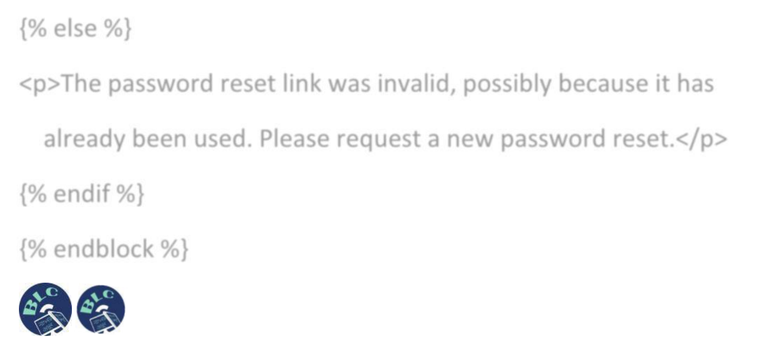

{% else %}   
<p>The password reset link was invalid, possibly because it has already been used. Please request a new password reset.</p> {% endif %}   
{% endblock %}



Then :

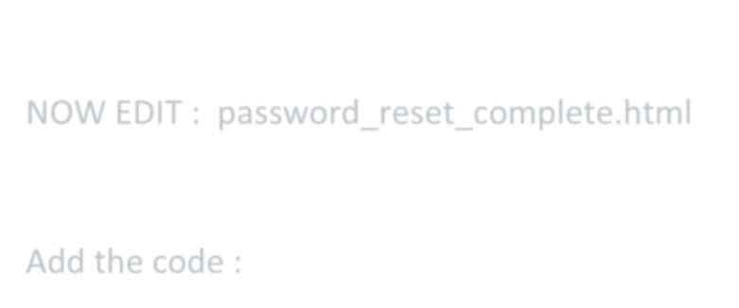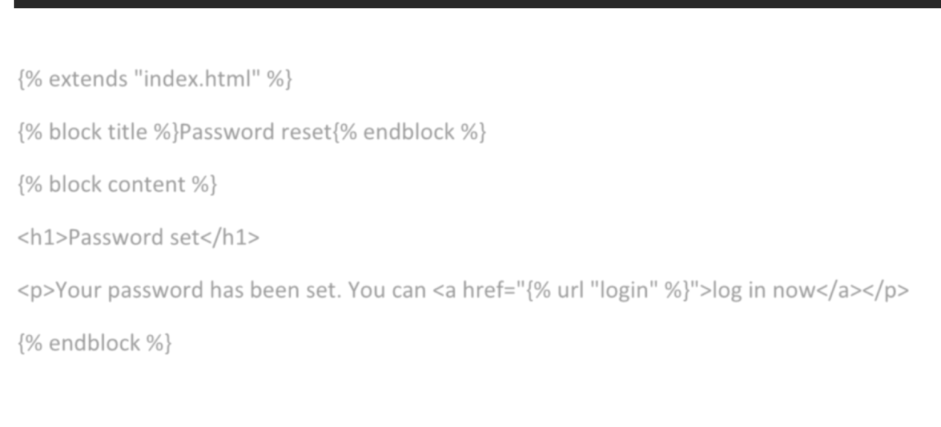

NOW EDIT : password_reset_complete.html

Add the code :

|  |
| --- |
| {% extends "index.html" %} |

|  |
| --- |
| {% block title %}Password reset{% endblock %} |

|  |
| --- |
| {% block content %} |

|  |
| --- |
| <h1>Password set</h1> |

<p>Your password has been set. You can <ahref="{% url "login"%}">log in now</a>

|  |
| --- |
| </p> |

|  |
| --- |
| {% endblock %} |

{% extends "index.html" %}   
{% block title %}Password reset{% endblock %}   
{% block content %}   
<h1>Password set</h1>   
<p>Your password has been set. You can <a href="{% url "login" %}">log in now</a></p> {% endblock %}

|  |  |
| --- | --- |
|  |  |

Then :

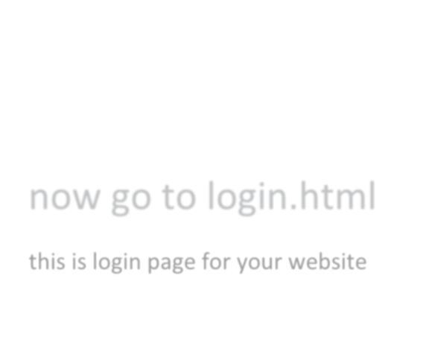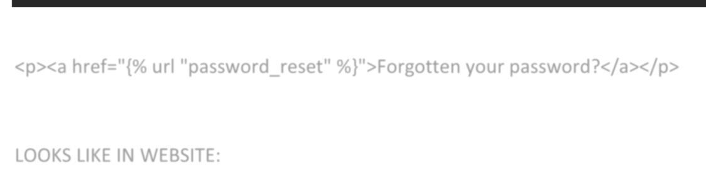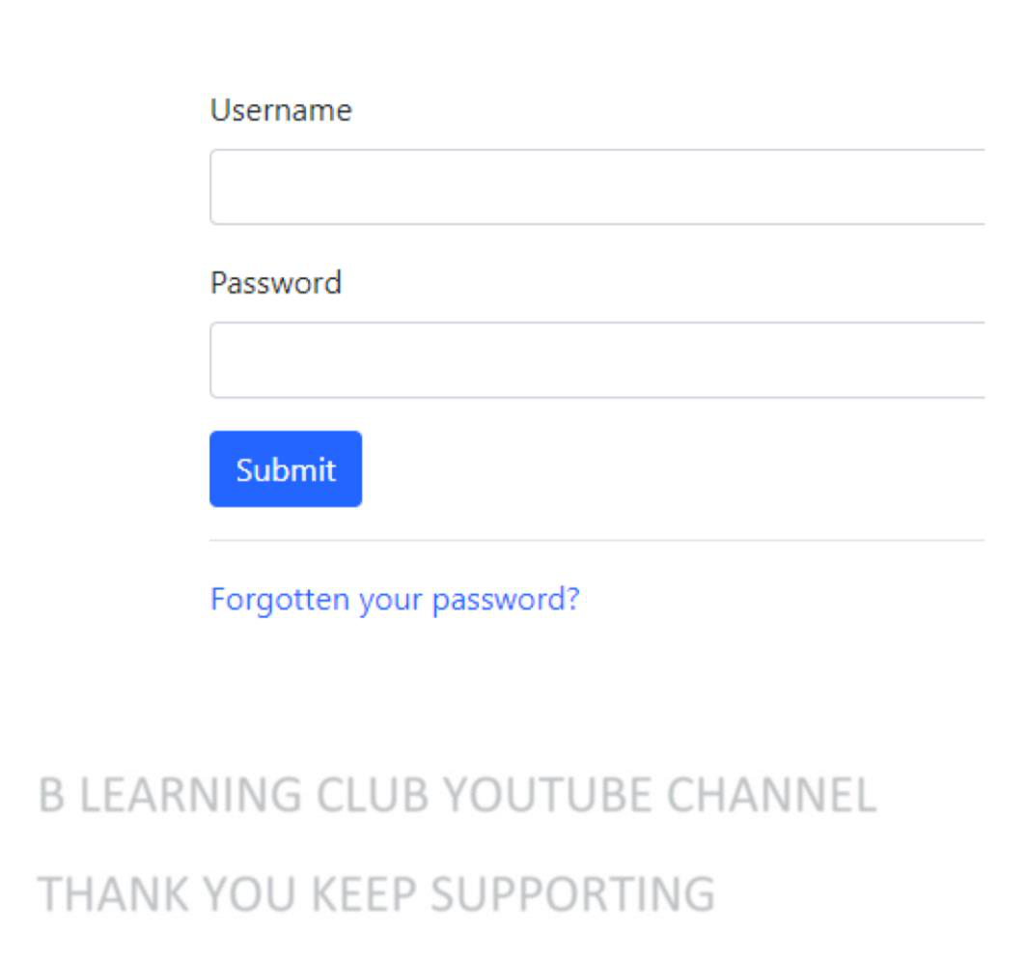

now go to login.html   
this is login page for your website

|  |
| --- |
| <p><ahref="{% url "password_reset"%}">Forgotten your password?</a></p> |

<p><a href="{% url "password_reset" %}">Forgotten your password?</a></p>

LOOKS LIKE IN WEBSITE:

B LEARNING CLUB YOUTUBE CHANNEL

THANK YOU KEEP SUPPORTING

Then :

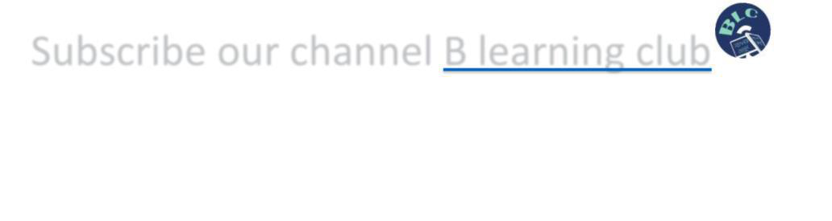

Subscribe our channel [B learning club](https://www.youtube.com/channel/UCJdXMYn7RaOv8QAsBj1b96Q)

Then :