Hotel

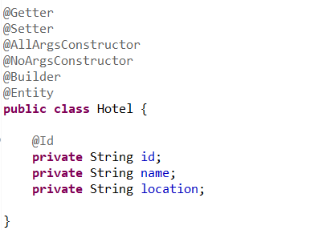

Controller

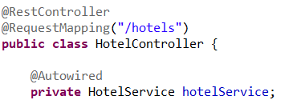

Repo

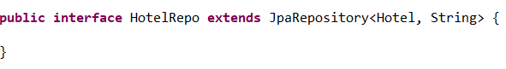

Create new hotel

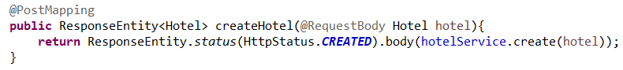

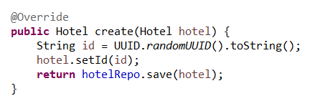

Get all hotels

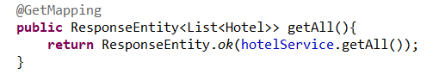

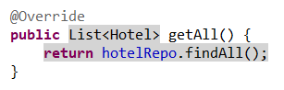

Get hotel by hotel id

