Rating

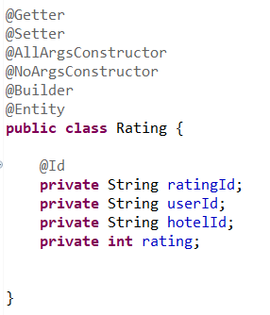

Controller

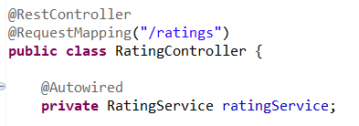

Repo

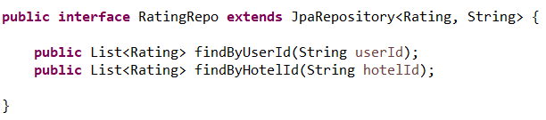

Create new rating

Controller

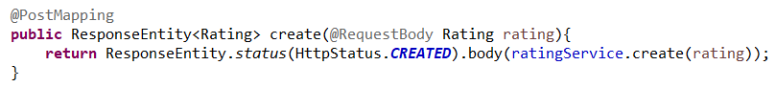

Service

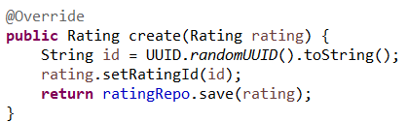

Get all ratings

Controller

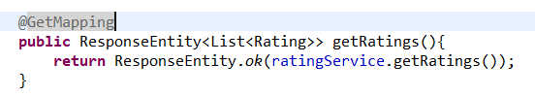

Service

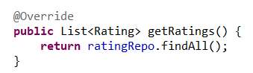

Get rating by user

Controller

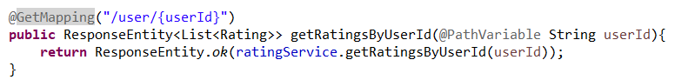

Service

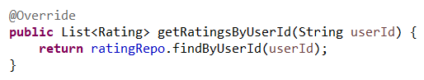

Get rating by hotel

Controller

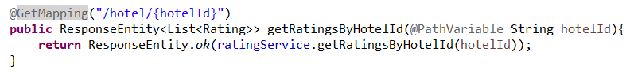

Service

