Order

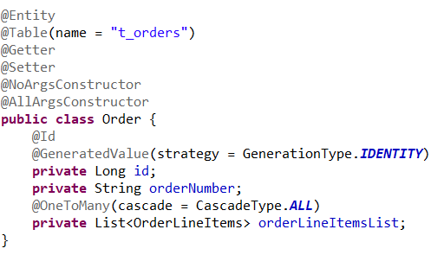

OrderLineItems – the items we have in our order

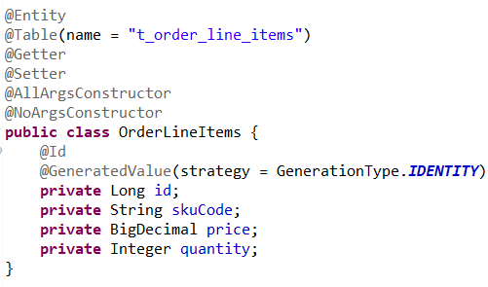

DTO

OrderRequest

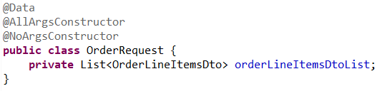

OrderLineItemsDto

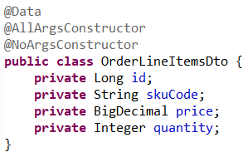

InventoryResponse

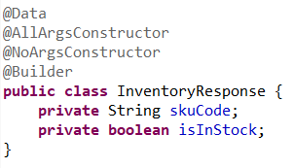

Controller

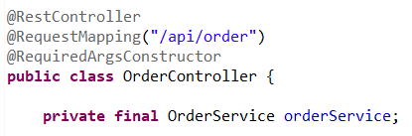

placeOrder

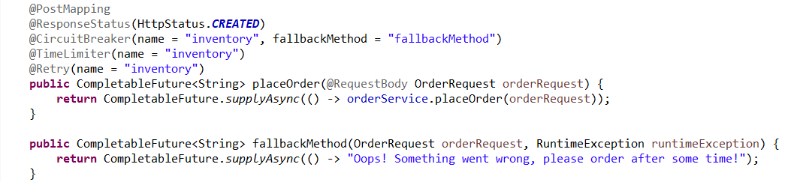

Service

Map from orderLineItems to orderLineItemsDto

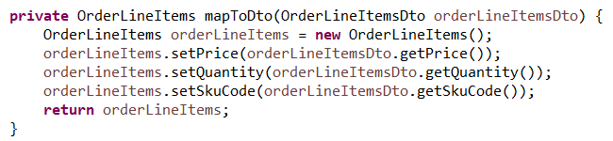

OrderService

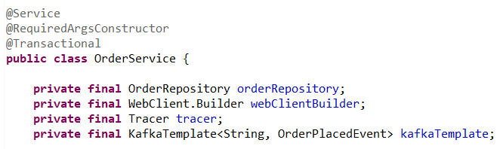

placeOrder

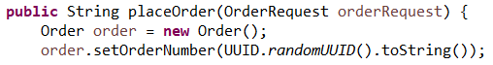

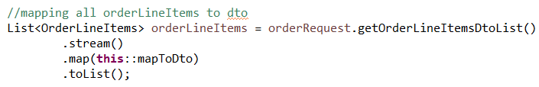



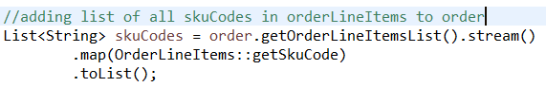



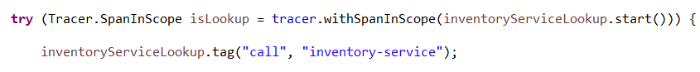

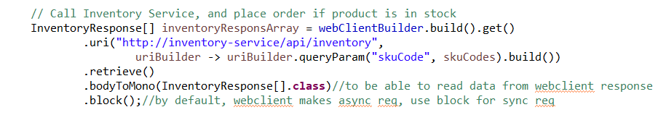



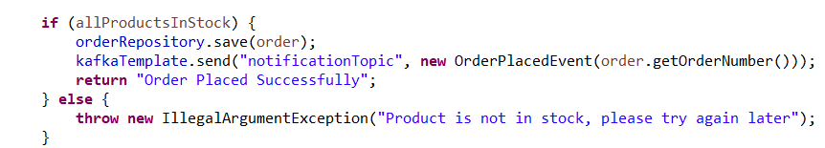

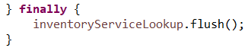

OrderPlacedEvent – for kafka event if order is placed

