­­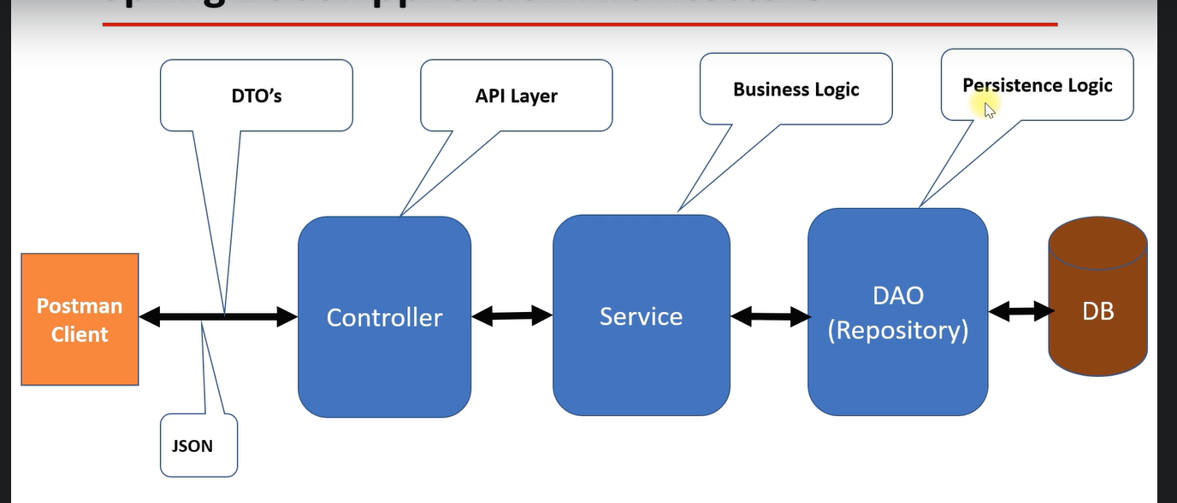

**Entitites –**

Post – id, description, content, title -> @OneToMany(mappedBy=”post”) Set <Comment> comments

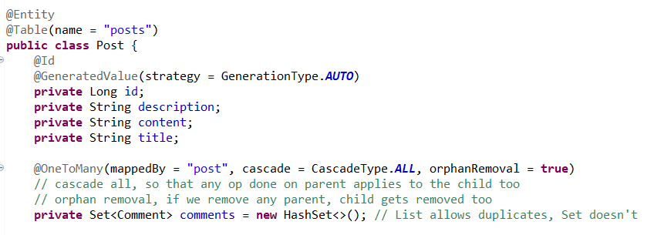

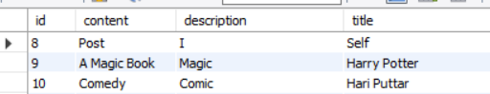

Comment – id, name, email, body -> @ManyToOne @JoinColumn(name="post_id", nullable=false) Post post

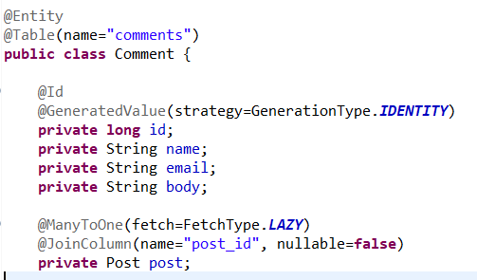

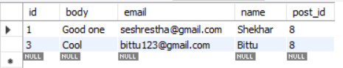

**DTOs –**

PostDTO :

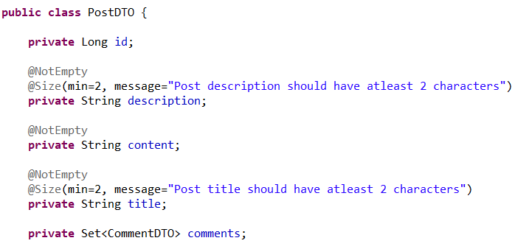

CommentDTO :

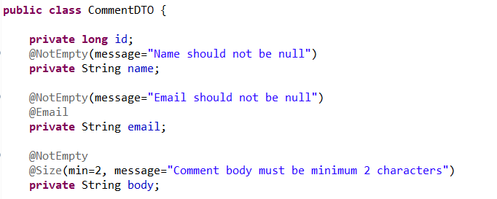

Service : Dto to obj and vice versa in both post and comment services

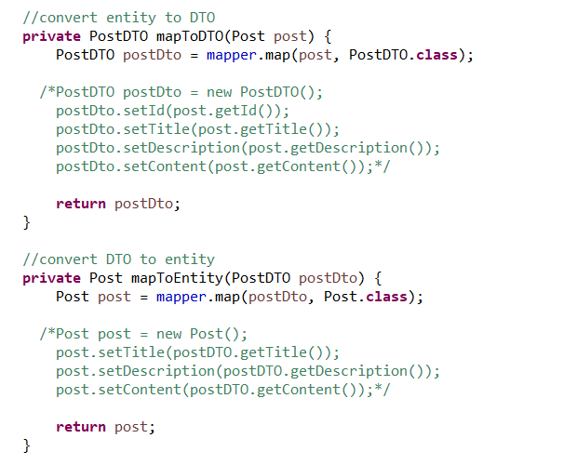

Main class : ModelMapper so that we can map objs

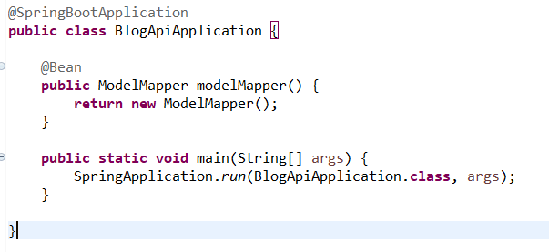

**Adding a new Post –**

Controller :

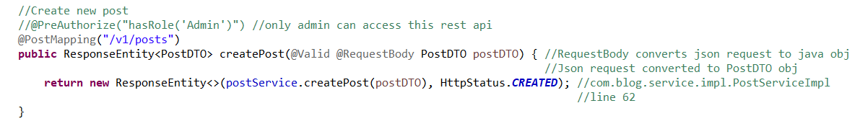

Service :



ServiceImpl :

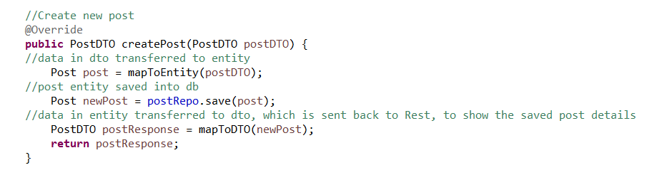

**Get post by id –**

Controller :

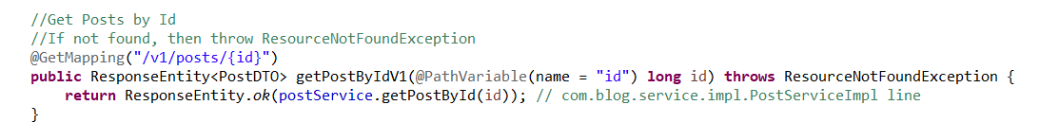

Service:



ServiceImpl :

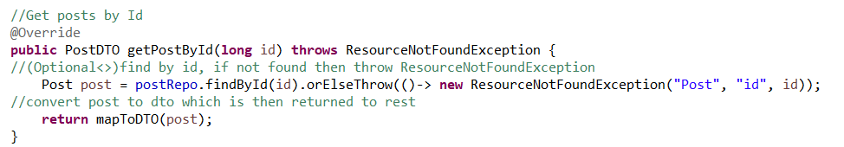

**Update post by id –**

Controller :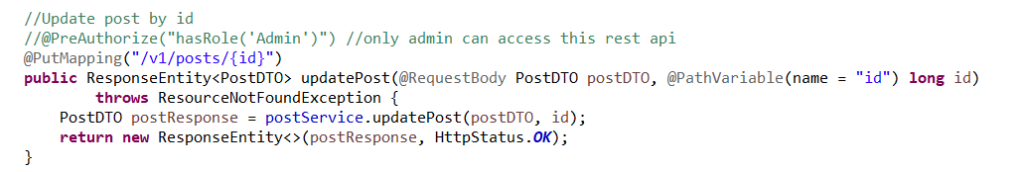

Service :



ServiceImpl :

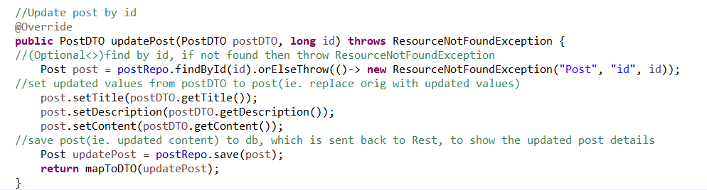

**Delete post by id –**

Controller :

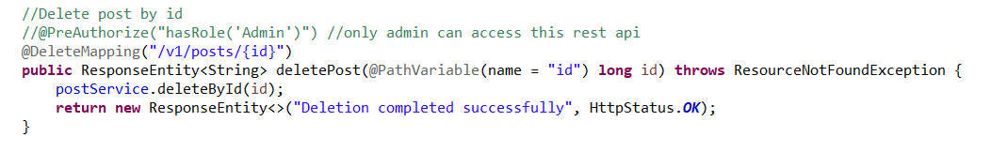

Service :



ServiceImpl :

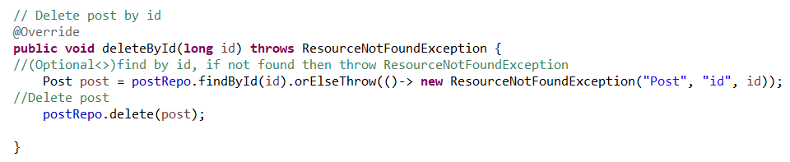

**Pagination –**

PostRepo extends JpaRepository

JpaRepository extends PagingAndSortingRepository



PagingAndSortingRepository

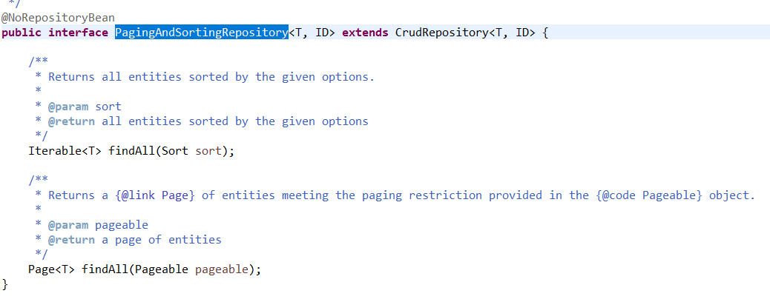

PageRequest :

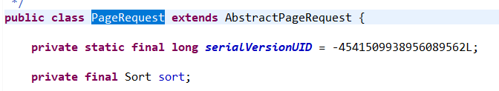

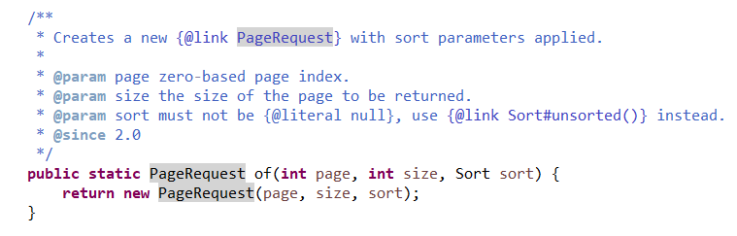

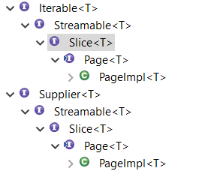

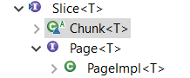

Slice:

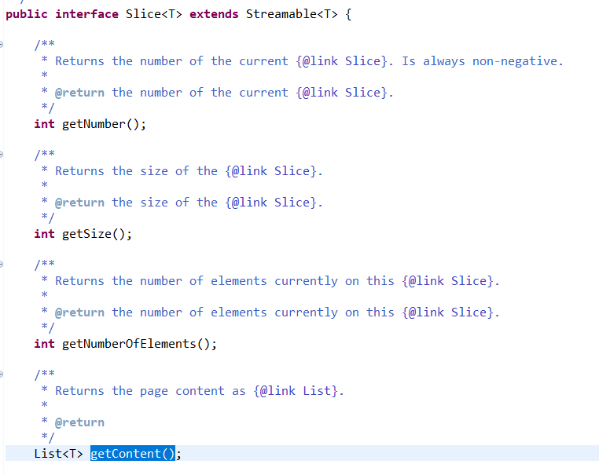

Chunk

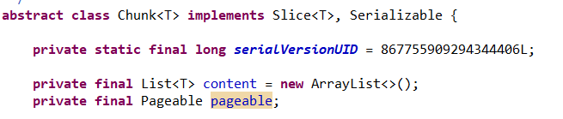

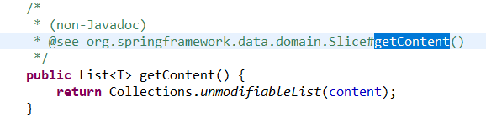

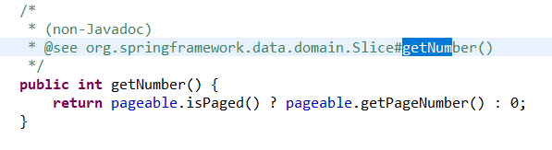

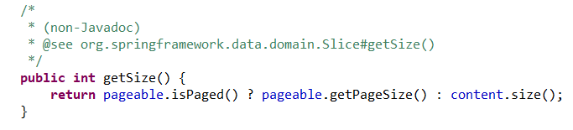

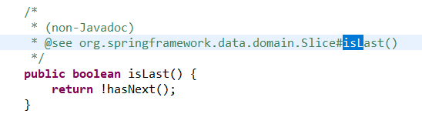

PageImpl:

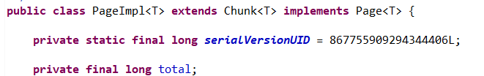

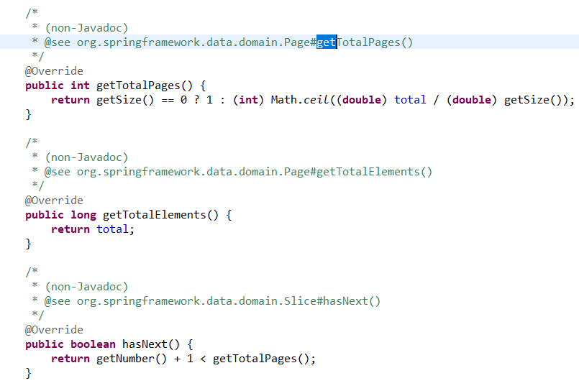

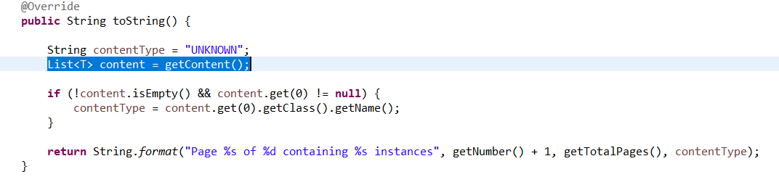

**Sorting –**

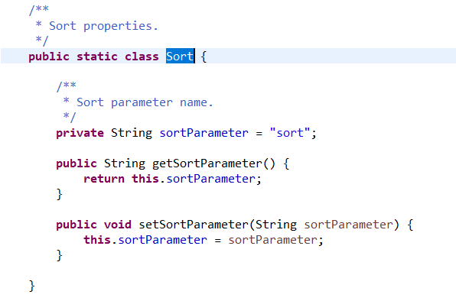

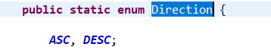

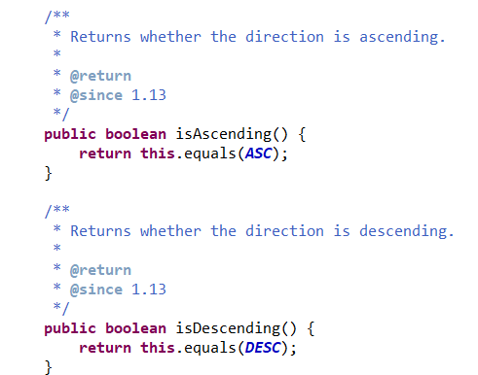

PostResponse:

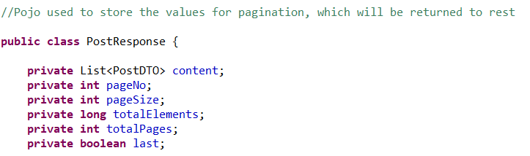

**Get all ids with pagination and sorting :**

Controller:

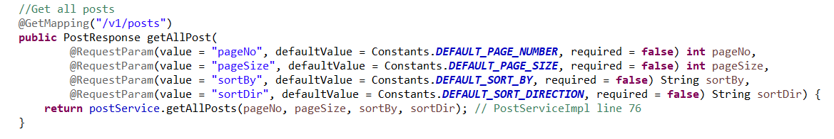

ServiceImpl :

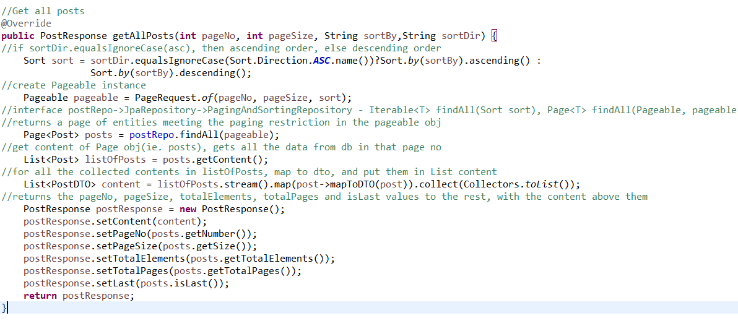

o/p

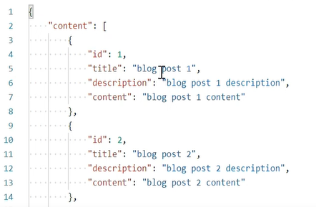

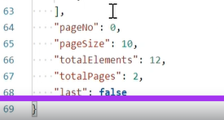

**Comment –**

Dto :

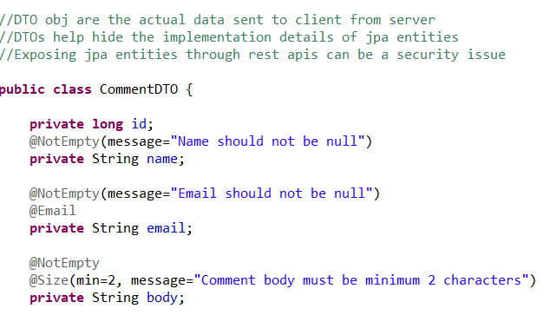

**Add new comment :**

Controller :

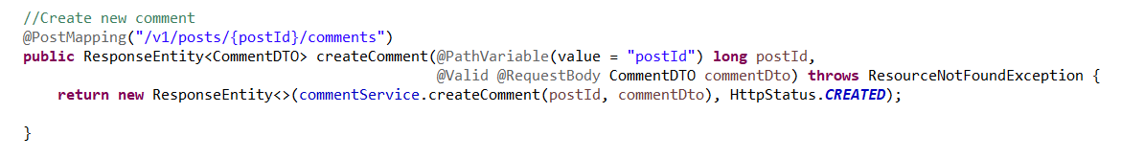

ServiceImpl :

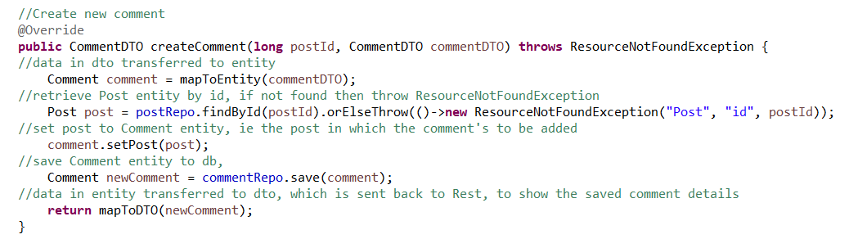

o/p

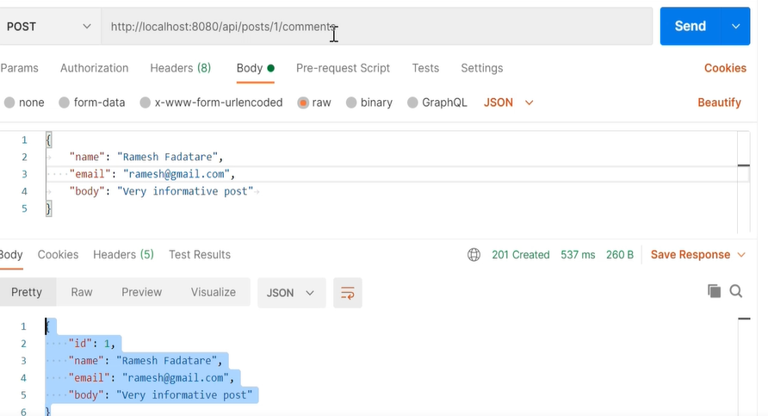

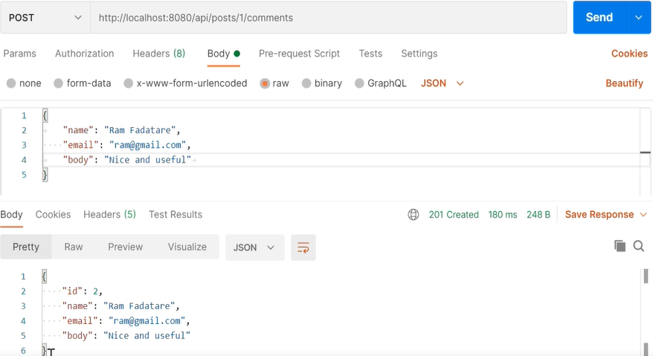

**Get all comments of a particular post id :**

Controller :

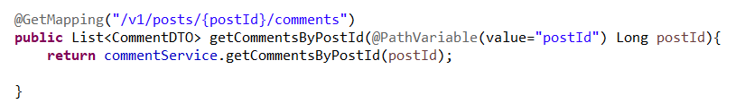

ServiceImpl :

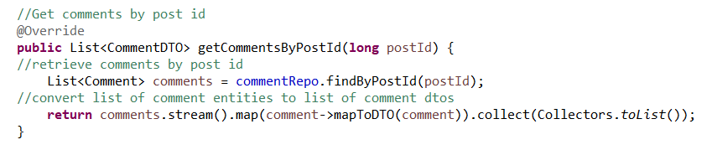

**Get comment by id :**

Controller :

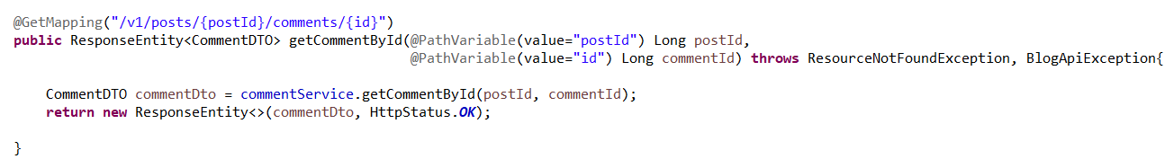

ServiceImpl :

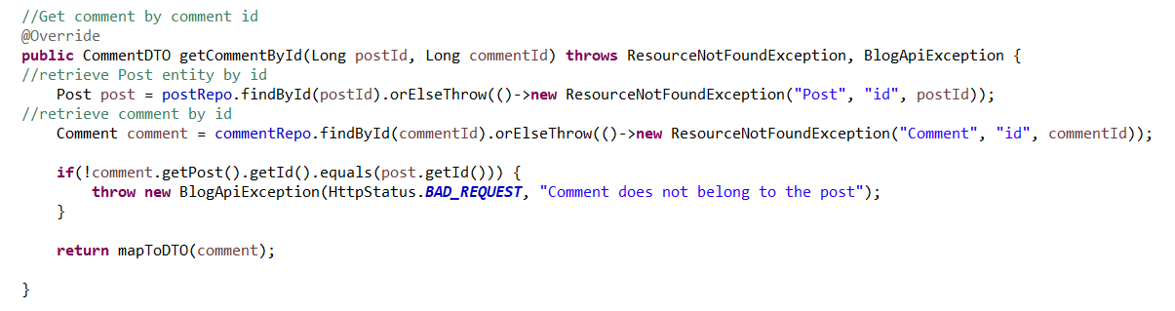

**Update comment :**

Controller :

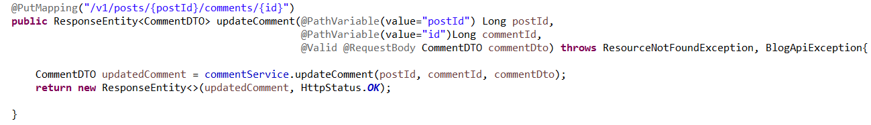

ServiceImpl :

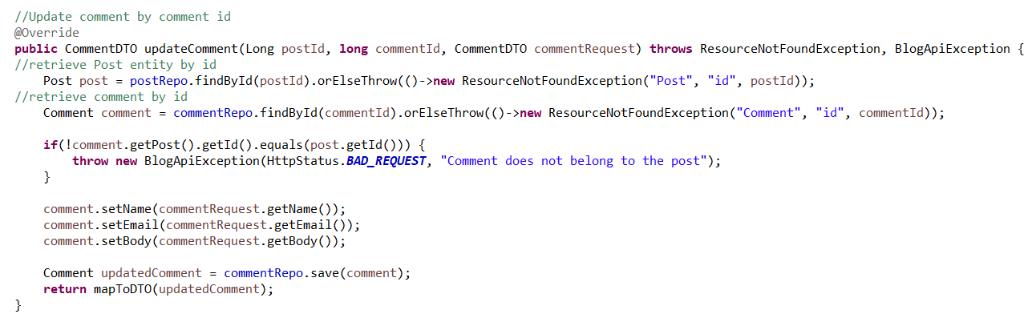

**Delete a comment:**

Controller :

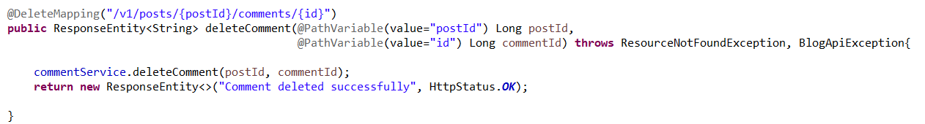

ServiceImpl :

