**Exception Handling :**

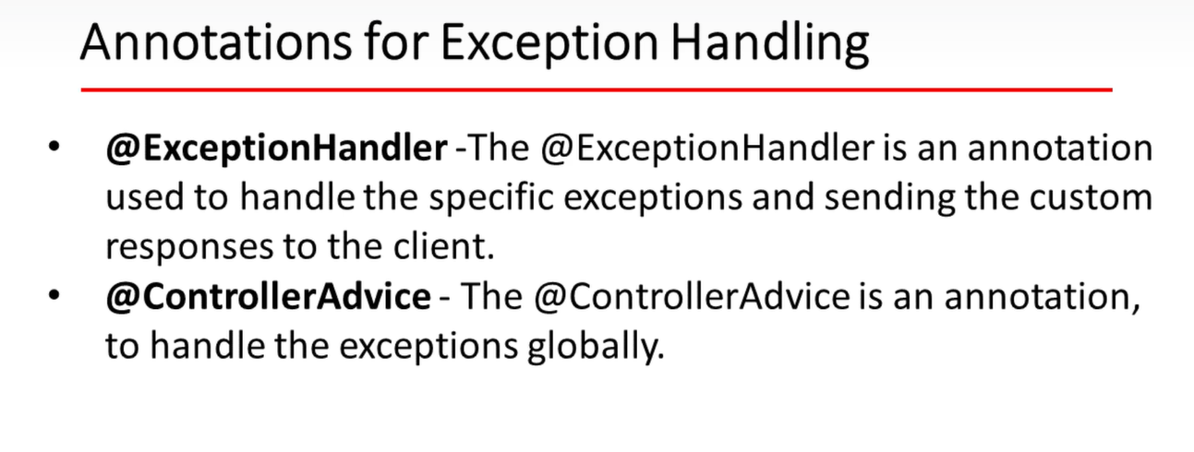

ResourceNotFoundException :

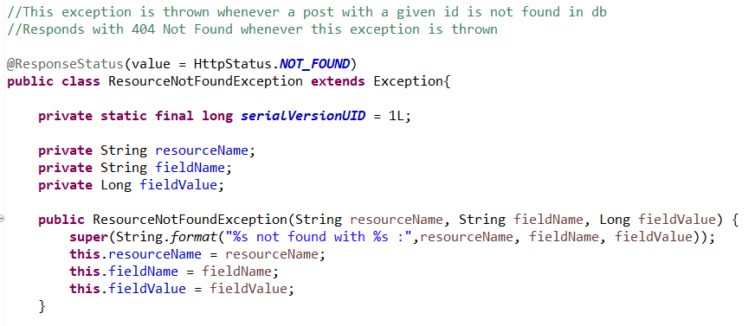

o/p when any resource not found

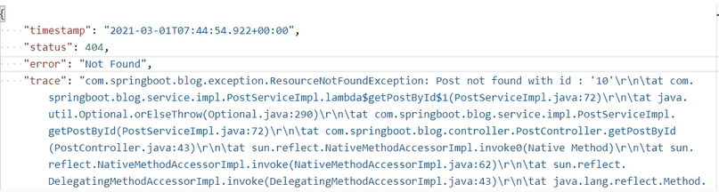

Need to remove unnecessary details like trace, and keep necessary details

ErrorDetails : No setters

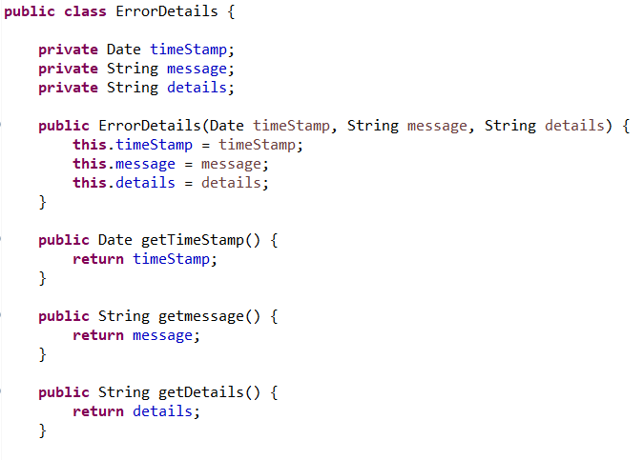

GlobalExceptionHandler :

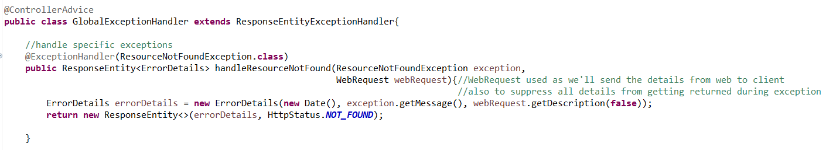

New o/p for ResourceNotFound

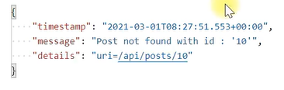

BlogApiException:

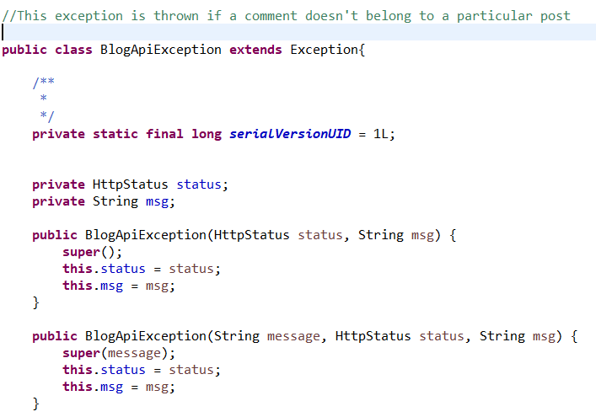

GlobalExceptionHandler :

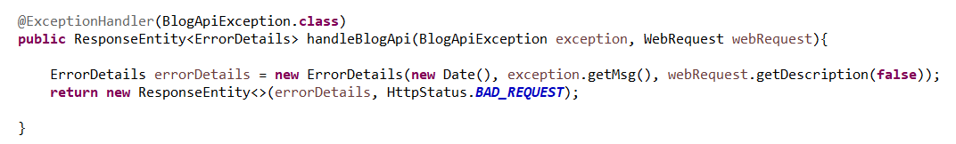

GlobalExceptionHandler : MethodArgumentTypeMismatchException

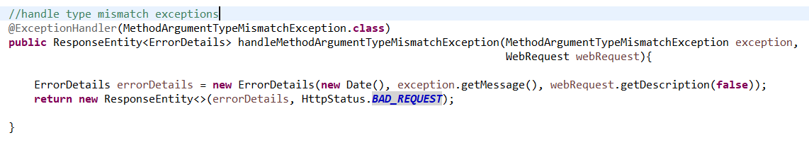

GlobalExceptionHandler : handle global exceptions

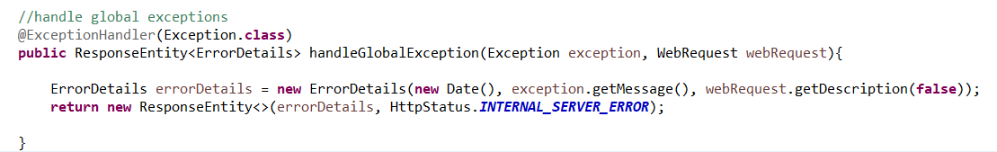

GlobalExceptionHandler : handle validation methods like @NotNull, @Min etc



