User :

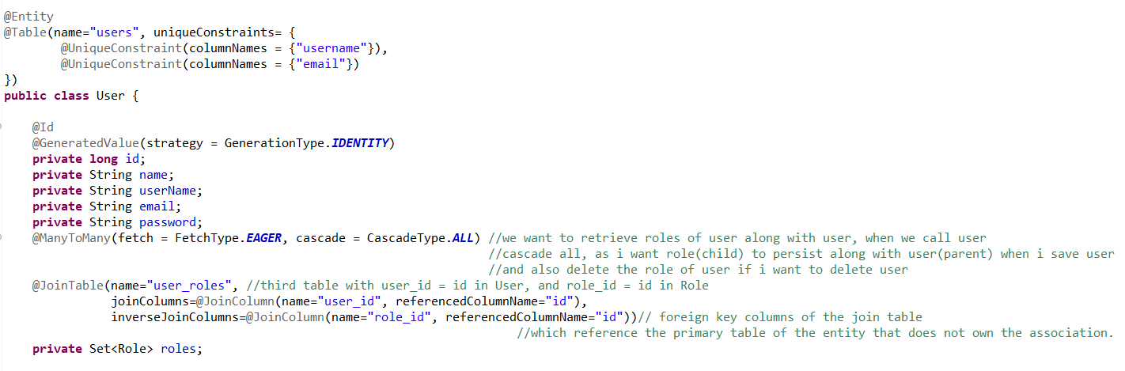

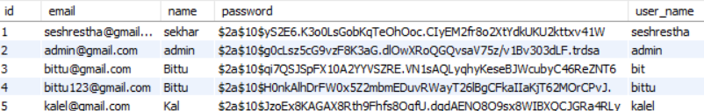

Role :

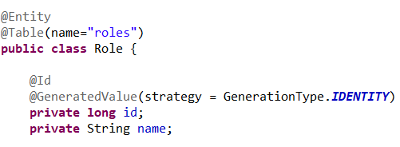

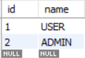

user_roles

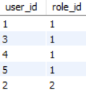

UserRepo :

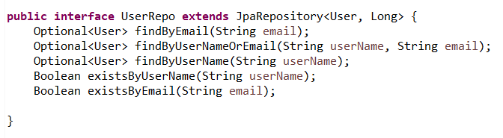

Role Repo :

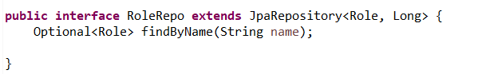

CustomUserDetailsService : to validate username password details

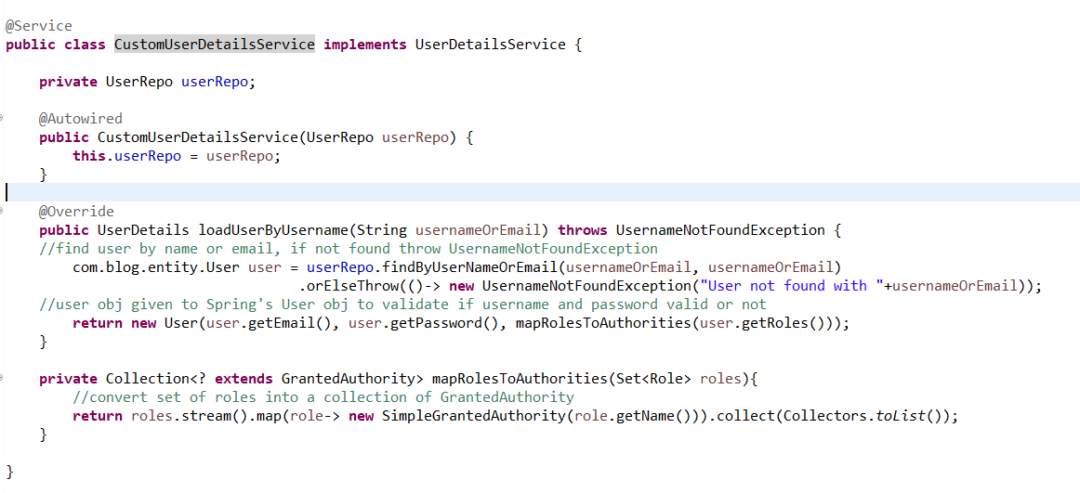

Roles converted into list of granted auth so that the roles can be passed to Spring’s User obj,

SecurityConfig :

