The Mass Effect: Tactics project began as a tabletop RPG for the Mass Effect universe.

My fiancé and I are both fans of the series and wanted a way to experience our own Mass Effect story together with friends. Having recently played Fantasy Flight’s *Edge of the Empire*, I was inspired by how they’d managed to create emergent narrative via their dice mechanic.

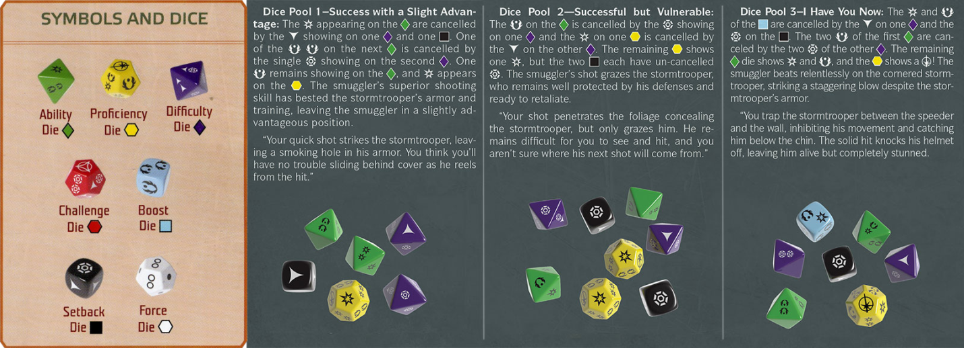

I knew this would supply a solid base for the non-combat actions so critical to the ME experience, but I was not satisfied with how it would handle the combat. Historically I tend to find traditional RPG combat unsatisfying for players. The narratives that can evolve out of them can be exciting and there are ways to spice things up for special encounters but so often it comes down to rolling dice until an opponents hit points reach zero. To better emulate the feel of combat in the Mass Effect Universe and give the players more autonomy, I wanted to take things in a different direction.

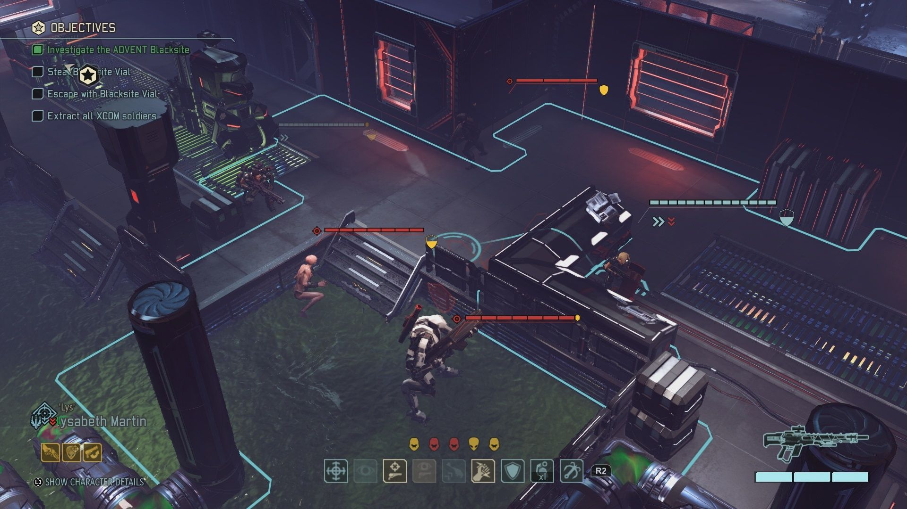

The Mass Effect series always had the elements for tactical, squad-based combat but they never fully committed to it. Something I can completely understand due to their target demographic. You could direct squad-mates to locations to attack/defend; enemies that were weak to particular damage types/abilities and a plethora of weapon types. This was something I wanted to explore in this new combat system. The concept of players fighting together as a squad trying to solve a spatial problem excited me. They would need to work together to suppress and flank the enemy. The biotic on the team could throw up barriers to defend the team and block enemy movement. The engineer could operate various devices in the environment to tip the scales in the players favor. All of this and more drew me to XCOM as inspiration. Being a tabletop game and knowing my audience I didn’t want it to be as complicated or punishing, but I definitely wanted to emulate an XCOM experience where each player fought as a member of the squad using their unique abilities to resolve the situation.

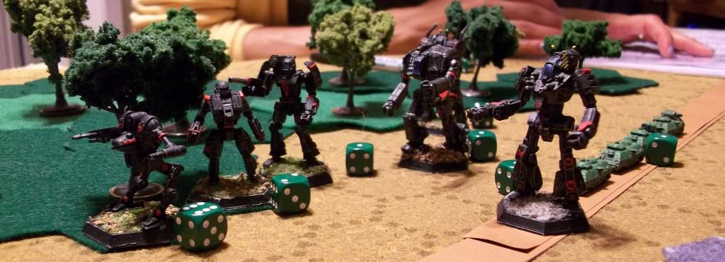

Knowing most non-combat systems would be handled by the narrative dice, I began by writing up a scratch spec (a design overview) for combat. As I wrote I always considered how this would be presented to the player on the tabletop. Initially I envisioned it as a miniature/board-game similar to Battletech or Warhammer 40,000 but the more I worked on it the more I felt like a digital tool would work better; not only for the player experience but for the game master also. If I created a digital tool to visualize and manage combat, I wouldn’t have to build physical boards / environments; I wouldn’t be limited by the space on my coffee table; environments could be fully realized and the more tedious parts of playing a tabletop game could be hidden under the hood; rolling dice, calculating angles and so on. By the time I finished the scratch spec I’d decided.

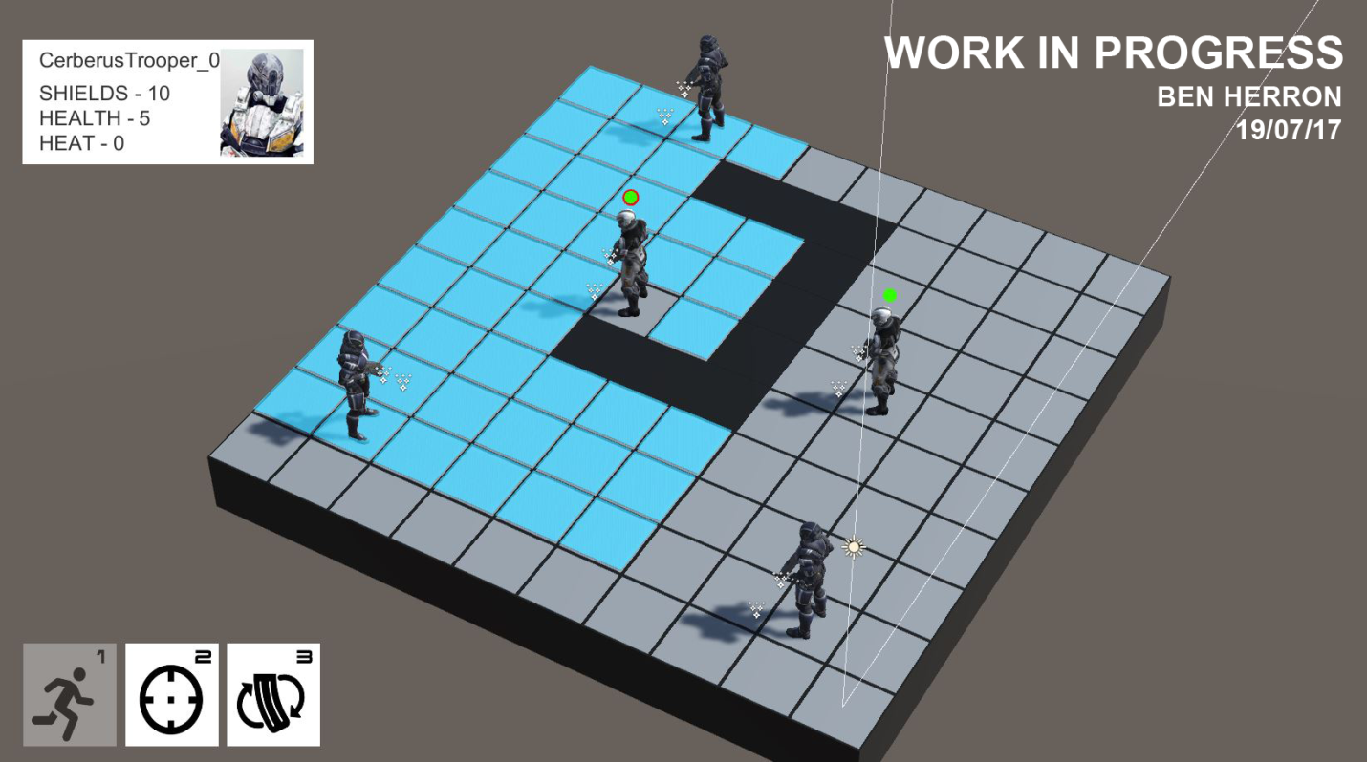

Upon completion I immediately jumped into Unity and began prototyping. The more I worked, the more I saw potential for this to grow beyond just a tool and into its own game. The above is where I find myself now. The basic combat loop is functional; there are two teams that take turns moving units across a grid and attacking one another; they can take damage and die; and when a team eliminates their opponent they are the victor.

The next goal is to implement more of the systems that will help shape it into a game, this way the true potential can be seen. I will be implementing the cover and suppression systems as well as some more critical player feedback elements.

Until next time.