Visoka škola strukovnih studija za informacione i komunikacione tehnologije

Dokumentacija

<http://jsklk.000webhostapp.com/>

Web programiranje 1

Student : David Sekulić

Broj indeksa : 68/18

Contents

1.Uvod 3

1.1 Korišćeni programski jezici 3

1.2 Opis funckionalnosti 3

1.3 Template 3

2.Organizacija 3

2.1 Organizaciona šema 3

2.2 Mapa sajta 4

2.3 Slike stranica i opisi funkcionalnosti 5

2.3.1 Index.html-Menu 5

2.3.2 Index.html-Toggle i Scroll to top 5

2.3.3 Index.html-Gallery 6

2.3.4 Index.html-Footer 6

2.3.5 Support.html-Support us (dinamički sadržaj) 6

2.3.6 Support.html-Buy (forma) 7

2.3.7 Contact.html-FAQ (filtriranje) 7

2.3.8 Contact.html-Message (forma) 7

2.3.9 Author.html (dinamički sadržaj) 8

3. Kodovi 8

3.1 HTML kodovi 8

3.1.1 index.html 8

3.1.2 suppot.html 13

3.1.3 contact.html 17

3.1.4 author.html 21

3.2 CSS kodovi 24

3.2.1 style.css 24

3.2.2 query.css 45

3.2.3 fotorama.css (preuzeto sa interneta) 66

3.3 JavaScript i jQuery (main.js) 71

# 1.Uvod

## 

## 1.1 Korišćeni programski jezici

Za izradu sajta su korišćeni slededi programski i markup jezici: HTML, CSS, XML, JavaScript i JQuery.

## 1.2 Opis funckionalnosti

Dinamčki ispisan navigation meni, drugi meni napravljen za manje rezolucije, više razlilčitih animacija, scroll to top (preuzet jQuery plugin).

Introduction: toggle efekti,hover efekti i interaktvina galerija (preuzet jQuery plugin).

Support us: Dinamicki ispis sadržaja (korišćenjem niza objekata i tajmera), validacija forme, ispis svih grešaka i njihovo obeležavanje i funkcija za interaktivnu validaciju i ispis cene.

Contact: filtriranje ,toggle efekti, validacije forme (blur).

Author: dinamički prikaz linkovane slike (thumbnail) u odnosu na selekciju realizovan niza.

## 1.3 Template

Nije korišćen.

# 2.Organizacija

## 2.1 Organizaciona šema

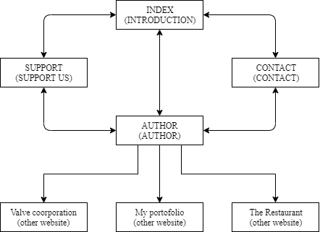

## 2.2 Mapa sajta

<?xml version="1.0" encoding="utf-8"?>

<urlset xmlns="http://www.sitemaps.org/schemas/sitemap/0.9">

<url>

<loc>http://jsklk.000webhostapp.com/</loc>

<lastmod>2019-12-02</lastmod>

<changefreq>monthly</changefreq>

<priority>0.4</priority>

</url>

<url>

<loc>http://jsklk.000webhostapp.com/author.html</loc>

<lastmod>2019-12-02</lastmod>

<changefreq>monthly</changefreq>

<priority>0.1</priority>

</url>

<url>

<loc>http://jsklk.000webhostapp.com/support.html</loc>

<lastmod>2019-12-02</lastmod>

<changefreq>monthly</changefreq>

<priority>0.3</priority>

</url>

<url>

<loc>http://jsklk.000webhostapp.com/contact.html</loc>

<lastmod>2019-12-02</lastmod>

<changefreq>monthly</changefreq>

<priority>0.2></priority>

</url>

</urlset>

## 2.3 Slike stranica i opisi funkcionalnosti

### 2.3.1 Index.html-Menu



Dinamčki ispisan navigation meni pomoću dva niza i dve for petlje ispisan u native javascriptu a pozvan hover metodom u jQuery-u. Linkovi u meniju su smooth scroll. Ispod njega se nalazi dugme realizovano pomoću css-a i jQuery-a (hover).

### 2.3.2 Index.html-Toggle i Scroll to top



Toggle efekat koji se izvršava click metodom i scroll to top jQuery plugin koji je preuzet sa interneta.

### 2.3.3 Index.html-Gallery

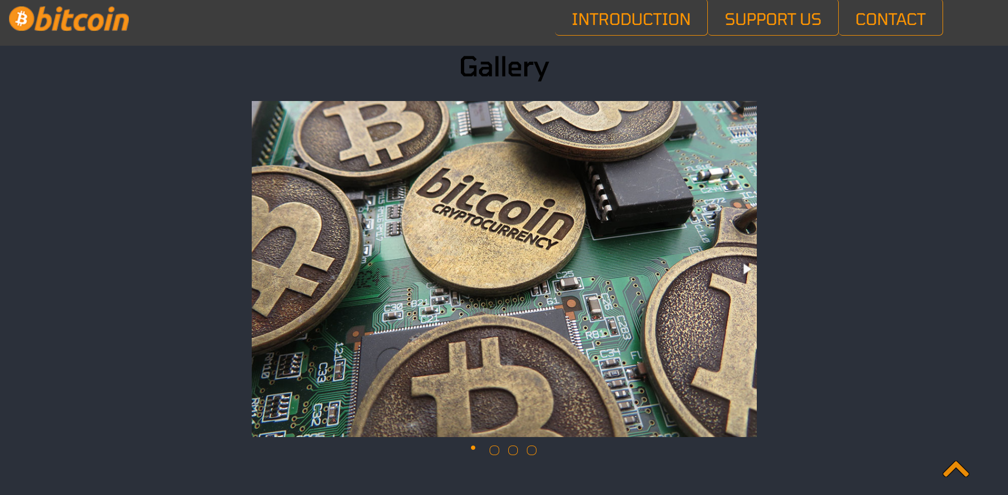

Galerija jQuery plugin preuzet sa interneta.

### 2.3.4 Index.html-Footer



Jquery hover efekat nad linkovima.

### 2.3.5 Support.html-Support us (dinamički sadržaj)

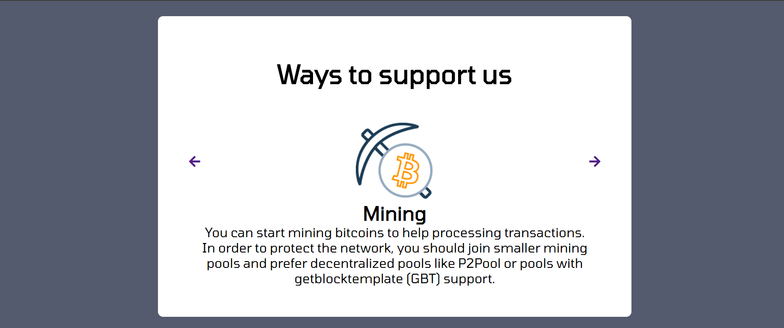

Sadržaj ovog diva se ispisuje dinamički u zavisnosti od izabrane pozicije koja se menja tajmerom na svakih 10 sekundi ili klikom na neku od strelica (u tom slucaju se tajmer resetuje na 10 sekundi). U kodu realizovano pomoću niza objekata.

### 2.3.6 Support.html-Buy (forma)

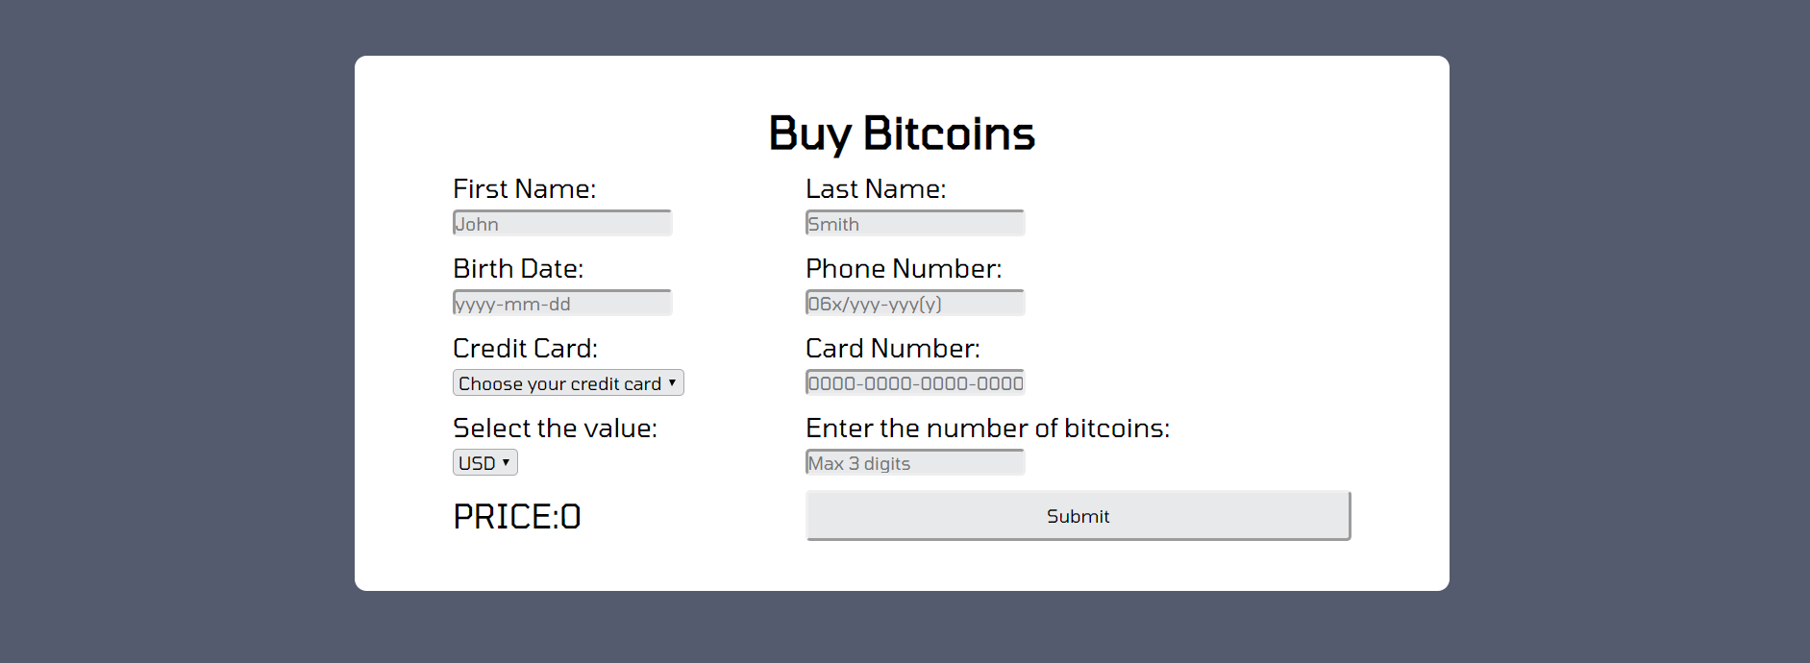

Cena (price) se ispisuje i proverava dinamicki u odnosu na selektovanu valutu i broj bitcoina. Dok se ostatak validacije vrši nakon clicka na dugme. Greške se ispisuju iz niza pomoću javascript-a.

### 2.3.7 Contact.html-FAQ (filtriranje)

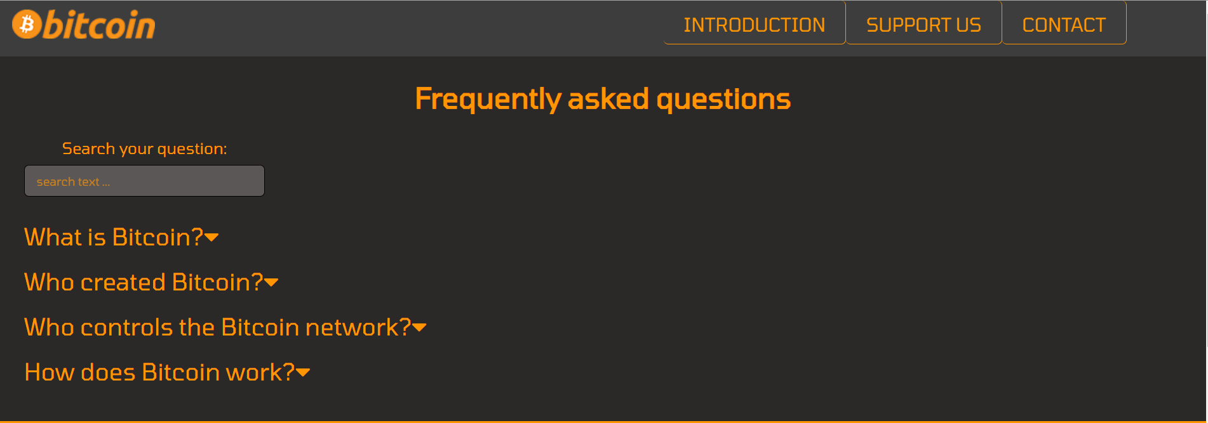

Toggle i hover efekat pomoću jQuery-a i css-a. Filtriranje pitanja, podvlači pitanje koje sadrži tekst ukucan u search bar-u.

### 2.3.8 Contact.html-Message (forma)

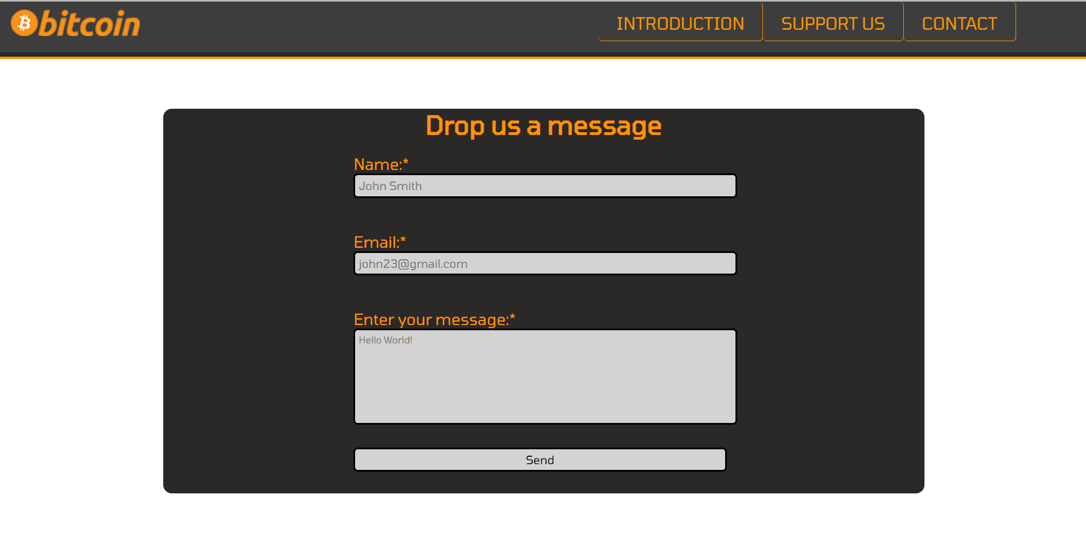

Validacija napisana u javascript-u i vrši se pomoću blur metode a greške se ispisuju pomoću css-a.

### 2.3.9 Author.html (dinamički sadržaj)

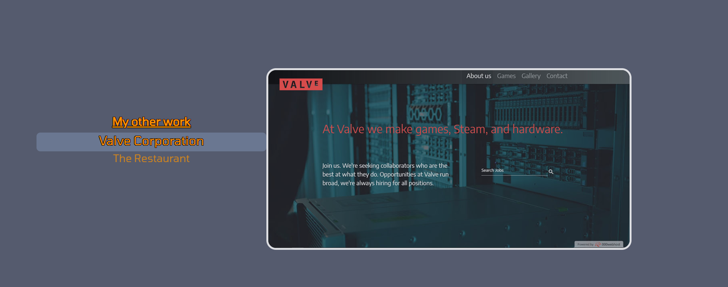

Slika se prikazuje dinamički u zavisnosti od toga koji je li tag selektovan. Napisano u javascriptu pomoću niza. Korišćen je i jQuery za hover animaciju.

# 3. Kodovi

## 3.1 HTML kodovi

### 3.1.1 index.html

<!DOCTYPE html>

<html lang="en">

<head>

    <title>The Bitcoin Website</title>

    <link rel="icon" href="assets/img/fav.ico">

    <script src="https://kit.fontawesome.com/71de788cbb.js" crossorigin="anonymous"></script>

    <link rel="stylesheet" type="text/css" href="assets/css/style-min.css">

    <link href="https://fonts.googleapis.com/css?family=Tomorrow&display=swap" rel="stylesheet">

    <link rel="canonical" href="http://jsklk.000webhostapp.com/">

    <meta charset="UTF-8">

    <meta name="viewport" content="width=device-width, initial-scale=1.0">

    <meta name="description" content="Bitcoin is an innovative payment network and a new kind of money. Find all you need to know and get started with Bitcoin." />

    <meta name="keywords" content="bitcoin, btc, bitcoin mining, bitcoin value"/>

    <meta name="author" content="David Sekulić"/>

</head>

<body>

    <div id="header">

        <div id="logo">

            <a href="index.html"><img src="assets/img/logo.png" alt="logo"></a>

        </div>

        <div id="menu">

        </div>

        <div class="cleaner"></div>

    </div>

    <div id="smallHeader">

        <i class="fas fa-bars"></i>

        <ul>

            <li><a href="index.html">INTRODUCTION</a></li>

            <li><a href="support.html">SUPPORT US</a></li>

            <li><a href="contact.html">CONTACT</a></li>

        </ul>

    </div>

    <div id="content">

        <div id="titl">

            <h1>Bitcoin is an innovative payment network and a new kind of money.</h1>

            <a class="button" id="dugme" href="support.html#Buy">BUY NOW</a>

        </div>

        <div id="started">

            <h2>Get started with Bitcoin</h2>

            <div class="textD">

                <p>Bitcoin uses peer-to-peer technology to operate with no central authority or banks; managing transactions and the issuing of bitcoins is carried out collectively by the network. Bitcoin is open-source; its design is public, nobody owns or controls Bitcoin and everyone can take part. Through many of its unique properties, Bitcoin allows exciting uses that could not be covered by any previous payment system.</p>

            </div>

            <div class="imgD">

                <figure>

                    <img src="assets/img/coin.jpg" alt="coin">

                    <figcaption class="funFact"><a href="#">Fun Fact <i class="fas fa-caret-down"></i></a><p>The first Bitcoin purchase was for pizza.</p></figcaption>

                </figure>

            </div>

            <div class="cleaner"></div>

        </div>

        <div class="how" id="drugi">

            <h2>How does Bitcoin work?</h2>

            <div class="imgD">

                <figure>

                    <img src="assets/img/user.png" alt="user">

                    <figcaption class="funFact"><a href="#">Fun Fact <i class="fas fa-caret-down"></i></a><p>The inventor of Bitcoin is still unknown.</p></figcaption>

                </figure>

            </div>

            <div class="textD">

                <h3>The basics for a new user</h3>

                <p>As a new user, you can get started with Bitcoin without understanding the technical details. Once you've installed a Bitcoin wallet on your computer or mobile phone, it will generate your first Bitcoin address and you can create more whenever you need one. You can disclose your addresses to your friends so that they can pay you or vice versa. In fact, this is pretty similar to how email works, except that Bitcoin addresses should be used only once.</p>

            </div>

            <div class="cleaner"></div>

        </div>

        <div class="how" id="seccond">

            <div class="textD">

                <h3>Processing - mining</h3>

                <p>Mining is a distributed consensus system that is used to confirm pending transactions by including them in the block chain. It enforces a chronological order in the block chain, protects the neutrality of the network, and allows different computers to agree on the state of the system. </p>

            </div>

            <div class="imgD">

                <figure>

                    <img src="assets/img/mining.jpg" alt="user">

                    <figcaption class="funFact"><a href="#">Fun Fact <i class="fas fa-caret-down"></i></a><p>There will only ever be 21 million bitcoins.</p></figcaption>

                </figure>

            </div>

            <div class="cleaner"></div>

        </div>

        <div id="gallery">

            <h2>Gallery</h2>

            <div class="fotorama">

                <img src="assets/img/gCoin.jpg" alt="dinar">

                <img src="assets/img/gSrb.jpg" alt="udruzenjeBitcoin">

                <img src="assets/img/gMicro.jpg" alt="coin mining">

                <img src="assets/img/gMining.jpg" alt="mining">

            </div>

        </div>

        <div id="goTop"></div>

    </div>

    <div id="footer">

        <ul>

            <li><a href="rss.xml">Rss <i class="fas fa-rss-square"></i></a></li>

            <li><a href="sitemap.xml">Sitemap <i class="fas fa-sitemap"></i></a></li>

            <li><a href="author.html">Author <i class="fas fa-crown"></i></a></li>

            <li><a href="documentation.pdf">Documentation <i class="fas fa-file-pdf"></i></a></li>

        </ul>

    </div>

    <script src="assets/js/jquery-3.4.1.min.js"></script>

    <script src="assets/js/main-min.js"></script>

</body>

</html>

### 3.1.2 suppot.html

<!DOCTYPE html>

<html lang="en">

<head>

    <title>The Bitcoin Website-Support</title>

    <link rel="icon" href="assets/img/fav.ico">

    <script src="https://kit.fontawesome.com/71de788cbb.js" crossorigin="anonymous"></script>

    <link rel="stylesheet" type="text/css" href="assets/css/style-min.css">

    <link href="https://fonts.googleapis.com/css?family=Tomorrow&display=swap" rel="stylesheet">

    <meta charset="UTF-8">

    <meta name="viewport" content="width=device-width, initial-scale=1.0">

    <meta name="description" content="Buy bitcoins and support us"/>

    <meta name="keywords" content="bitcoin, bitcoin price, btc, buy bitcoin, buy btc"/>

    <meta name="author" content="David Sekulić"/>

</head>

<body>

    <div id="header">

        <div id="logo">

            <a href="index.html"><img src="assets/img/logo.png" alt="logo"></a>

        </div>

        <div id="menu">

        </div>

        <div class="cleaner"></div>

    </div>

    <div id="smallHeader">

        <i class="fas fa-bars"></i>

        <ul>

            <li><a href="index.html">INTRODUCTION</a></li>

            <li><a href="support.html">SUPPORT US</a></li>

            <li><a href="contact.html">CONTACT</a></li>

        </ul>

    </div>

    <div id="sContent">

        <div id="bitSupport">

            <div id="arrows">

                <div id="bLeft" class="arrow"><a href=""><i class="fas fa-arrow-left"></i></a></div>

                <div id="bRight" class="arrow"><a href=""><i class="fas fa-arrow-right"></i></a></div>

            </div>

            <h1>Ways to support us</h1>

            <div id="bBlock">

            </div>

        </div>

        <div id="buy">

            <h2>Buy Bitcoins</h2>

            <form action="">

                <table>

                    <tr><td>First Name:<br><input id="firstName" type="text" name="firstName" placeholder="John"></td><td>Last Name:<br><input id="lastName" type="text" name="lastName" placeholder="Smith"></td></tr>

                    <tr><td>Birth Date:<br><input id="birth" type="text" name="birth" placeholder="yyyy-mm-dd"></td><td>Phone Number:<br><input id="phone" type="text" name="phone" placeholder="06x/yyy-yyy(y)"></td></tr>

                    <tr>

                        <td>

                            Credit Card:<br>

                            <select id="creditCard" name="creditType">

                                <option value="error">Choose your credit card</option>

                                <option value="Pp">Paypal</option>

                                <option value="Visa">Visa</option>

                                <option value="MC">Master Card</option>

                            </select>

                        </td>

                        <td>Card Number:<br><input id="credit" type="text" name="credit" placeholder="0000-0000-0000-0000"></td>

                    </tr>

                    <tr>

                        <td>

                            Select the value:

                            <select name="value" id="value">

                                <option value="USD">USD</option>

                                <option value="EUR">EUR</option>

                                <option value="GBP">GBP</option>

                                <option value="CNY">CNY</option>

                            </select>

                        </td>

                        <td>Enter the number of bitcoins:<input id="coins" type="text" name="coins" placeholder="Max 3 digits" maxlength="3"></td>

                    </tr>

                    <tr><td><p id="price">PRICE:0</p></td><td><input id="submit" type="button" name="button" value="Submit"></td></tr>

                </table>

            </form>

        </div>

        <div id="new">

        </div>

    </div>

    <div id="footer">

        <ul>

            <li><a href="rss.xml">Rss <i class="fas fa-rss-square"></i></a></li>

            <li><a href="sitemap.xml">Sitemap <i class="fas fa-sitemap"></i></a></li>

            <li><a href="author.html">Author <i class="fas fa-crown"></i></a></li>

            <li><a href="documentation.pdf">Documentation <i class="fas fa-file-pdf"></i></a></li>

        </ul>

    </div>

     <script src="assets/js/jquery-3.4.1.min.js"></script>

     <script src="assets/js/main-min.js"></script>

</body>

</html>

### 3.1.3 contact.html

<!DOCTYPE html>

<html lang="en">

<head>

    <title>The Bitcoin Website-Contact</title>

    <link rel="icon" href="assets/img/fav.ico">

    <script src="https://kit.fontawesome.com/71de788cbb.js" crossorigin="anonymous"></script>

    <link rel="stylesheet" type="text/css" href="assets/css/style-min.css">

    <link href="https://fonts.googleapis.com/css?family=Tomorrow&display=swap" rel="stylesheet">

    <meta charset="UTF-8">

    <meta name="viewport" content="width=device-width, initial-scale=1.0">

    <meta name="description" content="Contact us and read frequently asked questions"/>

    <meta name="keywords" content="what is bitcoin, bitcoin contact, message us"/>

    <meta name="author" content="David Sekulić"/>

</head>

<body>

    <div id="header">

        <div id="logo">

            <a href="index.html"><img src="assets/img/logo.png" alt="logo"></a>

        </div>

        <div id="menu">

        </div>

        <div class="cleaner"></div>

    </div>

    <div id="smallHeader">

        <i class="fas fa-bars"></i>

        <ul>

            <li><a href="index.html">INTRODUCTION</a></li>

            <li><a href="support.html">SUPPORT US</a></li>

            <li><a href="contact.html">CONTACT</a></li>

        </ul>

    </div>

    <div id="mContent">

        <div id="faq">

            <h2>Frequently asked questions</h2>

            <div id="searchDiv">

                <p>Search your question: </p> <input id="search" type="search" placeholder="search text ...">

            </div>

            <div class="question">

                <a href="">What is Bitcoin?<i class="fas fa-caret-down"></i></a>

                <p>Bitcoin is a consensus network that enables a new payment system and a completely digital money. It is the first decentralized peer-to-peer payment network that is powered by its users with no central authority or middlemen. From a user perspective, Bitcoin is pretty much like cash for the Internet. Bitcoin can also be seen as the most prominent triple entry bookkeeping system in existence.</p>

            </div>

            <div class="question">

                <a href="">Who created Bitcoin?<i class="fas fa-caret-down"></i></a>

                <p>Bitcoin is the first implementation of a concept called "cryptocurrency", which was first described in 1998 by Wei Dai on the cypherpunks mailing list, suggesting the idea of a new form of money that uses cryptography to control its creation and transactions, rather than a central authority. The first Bitcoin specification and proof of concept was published in 2009 in a cryptography mailing list by Satoshi Nakamoto. Satoshi left the project in late 2010 without revealing much about himself. The community has since grown exponentially with many developers working on Bitcoin.</p>

            </div>

            <div class="question">

                <a href="">Who controls the Bitcoin network?<i class="fas fa-caret-down"></i></a>

                <p>Nobody owns the Bitcoin network much like no one owns the technology behind email. Bitcoin is controlled by all Bitcoin users around the world. While developers are improving the software, they can't force a change in the Bitcoin protocol because all users are free to choose what software and version they use. In order to stay compatible with each other, all users need to use software complying with the same rules. Bitcoin can only work correctly with a complete consensus among all users. Therefore, all users and developers have a strong incentive to protect this consensus.</p>

            </div>

            <div class="question">

                <a href="">How does Bitcoin work?<i class="fas fa-caret-down"></i></a>

                <p>From a user perspective, Bitcoin is nothing more than a mobile app or computer program that provides a personal Bitcoin wallet and allows a user to send and receive bitcoins with them. This is how Bitcoin works for most users.</p>

            </div>

        </div>

        <div id="message">

            <form>

                <h2>Drop us a message</h2>

                <p>Name:*</p><input id="name" type="text" name="name" placeholder="John Smith"><span id="nameError" class="error">Wrong name - Correct Format Example: John Smith</span>

                <p>Email:*</p><input id="email" type="email" name="email" placeholder="john23@gmail.com"><span id="emailError" class="error">Wrong email - Correct Format Example: john23@gmail.com</span>

                <p>Enter your message:*</p><textarea id="mess" rows="10" cols="51" placeholder="Hello World!"></textarea></span><span id="messageError1" class="error">Message needs to be betweeen 15 and 160 characters!</span>

                <input type="button" name="send" id="send" value="Send">

            </form>

        </div>

    </div>

    <div id="footer">

        <ul>

            <li><a href="rss.xml">Rss <i class="fas fa-rss-square"></i></a></li>

            <li><a href="sitemap.xml">Sitemap <i class="fas fa-sitemap"></i></a></li>

            <li><a href="author.html">Author <i class="fas fa-crown"></i></a></li>

            <li><a href="documentation.pdf">Documentation <i class="fas fa-file-pdf"></i></a></li>

        </ul>

    </div>

     <script src="assets/js/jquery-3.4.1.min.js"></script>

     <script src="assets/js/main-min.js"></script>

</body>

</html>

### 3.1.4 author.html

<!DOCTYPE html>

<html lang="en">

<head>

    <title>The Bitcoin Website-Author</title>

    <link rel="icon" href="assets/img/fav.ico">

    <script src="https://kit.fontawesome.com/71de788cbb.js" crossorigin="anonymous"></script>

    <link rel="stylesheet" type="text/css" href="assets/css/style-min.css">

    <link href="https://fonts.googleapis.com/css?family=Tomorrow&display=swap" rel="stylesheet">

    <meta charset="UTF-8">

    <meta name="viewport" content="width=device-width, initial-scale=1.0">

    <meta name="description" content="Everything about the author David Sekulić"/>

    <meta name="keywords" content="david, sekulić, david sekulić, portofollio"/>

    <meta name="author" content="David Sekulić"/>

</head>

<body>

    <div id="header">

        <div id="logo">

            <a href="index.html"><img src="assets/img/logo.png" alt="logo"></a>

        </div>

        <div id="menu">

        </div>

        <div class="cleaner"></div>

    </div>

    <div id="smallHeader">

        <i class="fas fa-bars"></i>

        <ul>

            <li><a href="index.html">INTRODUCTION</a></li>

            <li><a href="support.html">SUPPORT US</a></li>

            <li><a href="contact.html">CONTACT</a></li>

        </ul>

    </div>

    <div id="content">

        <div id="aHead">

            <h1>This website is created by David Sekulić.</h1>

        </div>

        <div id="aContent">

            <div id="aLeft">

                <h2>My portofollio</h2>

                <a href="http://davidskola.dx.am"><img src="assets/img/porto.jpg" alt="protofollio"></a>

            </div>

            <div id="aFlex">

                <div id="aList">

                    <h2>My other work</h2>

                    <ul class="list">

                        <li class="selected">Valve Corporation</li>

                        <li>The Restaurant</li>

                    </ul>

                </div>

                <div id="aShow">

                    <p id="workShow"><a href="https://valve1.000webhostapp.com"><img src="assets/img/valve.jpg" alt="valve"></a></p>

                </div>

            </div>

        </div>

    </div>

    <div id="footer">

        <ul>

            <li><a href="rss.xml">Rss <i class="fas fa-rss-square"></i></a></li>

            <li><a href="sitemap.xml">Sitemap <i class="fas fa-sitemap"></i></a></li>

            <li><a href="#">Author <i class="fas fa-crown"></i></a></li>

            <li><a href="documentation.pdf">Documentation <i class="fas fa-file-pdf"></i></a></li>

        </ul>

    </div>

    <script src="assets/js/jquery-3.4.1.min.js"></script>

    <script src="assets/js/main-min.js"></script>

</body>

</html>

## 3.2 CSS kodovi

### 3.2.1 style.css

* {

    margin: 0px;

    padding: 0px;

    font-family: 'Tomorrow', sans-serif;

}

html {

    scroll-behavior: smooth;

    height: 100%;

}

body {

    min-height: 100%;

    min-width: 100%;

    background-color:white;

    position: relative;

    padding-bottom: 110px;

}

#header {

    background-color: #3d3d3d;

    position: fixed;

    z-index: 999;

    top: 0px;

    width: 100%;

    height: 70px;

}

#smallHeader {

    display: none;

    position: fixed;

    z-index: 999;

    top: 50px;

    right: 50px;

    width: 100px;

    height: 50px;

    text-align: center;

}

#smallHeader i{

    font-size:47px;

}

#smallHeader ul{

    display:none;

    list-style:none;

    background-color:black;

    border-radius:15px;

    padding:5px;

}

#smallHeader ul li a{

    text-decoration:none;

    color:#FF9500;

    font-size:12px;

}

#logo{

    width:130px;

    margin-top:10px;

    margin-left:15px;

    float:left;

}

#menu {

    float: right;

    margin-right: 100px;

}

#menu ul{

    list-style-type:none;

}

#menu ul ul{

    display:none;

}

#menu2 > li {

    float: left;

    padding: 15px 25px 10px 25px;

    background-color:  #3d3d3d;

    border-radius: 6px;

    border-bottom:1px solid  #FF9500;

    border-right: 1px solid  #FF9500;

}

#menu ul li a {

    font-size: 24px;

    text-decoration: none;

    color: #FF9500;

}

#content {

    width: 100%;

    padding-top: 70px;

    min-height: 100%-180px;

}

#titl{

    width:100%;

    height:680px;

    background-image:url("../img/bg.jpg");

}

#titl h1{

    font-size:40px;

    color:#FF9500;

    text-align:center;

    padding-top:13%;

    padding-bottom:60px;

    width:70%;

    margin-left:15%;

    text-shadow: -1px -1px 0 #000, 1px -1px 0 #000, -1px 1px 0 #000, 1px 1px 0 #000;

}

#started {

    padding: 90px;

    width: 100%-90px;

    height: 450px;

    border-top: 2px solid black;

    background:white;

}

#started h2{

    font-size:40px;

}

.textD {

    margin-top: 50px;

    text-align: left;

    font-size:22px;

    width: 40%;

    float: left;

}

.imgD {

    width: 50%;

    float: left;

    padding-left: 50px;

    padding-right: 50px;

    text-align: center;

}

.imgD figcaption{

    padding-top:6px;

    color: #FF9500;

}

.imgD a{

    font-size:22px;

    text-decoration:none;

    color:black;

}

.imgD p{

    display:none;

    font-size:18px;

    color:black;

}

.imgD img{

    border:2px solid black;

    border-radius:30px;

}

.how {

    width: 100%-180px;

    padding: 90px;

    height: 520px;

    background-color: white;

}

.how h2 {

    color:black;

    font-size: 40px;

    margin-left:25%;

}

.how .textD{

    color:black;

    padding-left:70px;

    border-left:1px solid black;

}

.how .imgD{

    width:30%;

    padding-left:170px;

    padding-top:50px;

}

#seccond{

    background: rgb(255,255,255);

    background: linear-gradient(180deg, rgba(255,255,255,1) 0%, rgba(43,48,58,0.7150210425967262) 50%, rgba(43,48,58,1) 100%);

}

#drugi .imgD img{

    border:none;

}

#drugi figcaption{

    margin-right:60px;

}

.textD h3{

    padding-bottom:40px;

    text-decoration:underline;

}

#seccond .imgD {

    padding-top: 0px;

}

#seccond .textD{

    border:none;

}

#gallery {

    padding:60px;

    padding-left:25%;

    padding-right: 25%;

    background-color:#2B303A;

    font-size:35px;

    width:50%;

    text-align:center;

}

#gallery h2{

    font-size:40px;

    padding-bottom:30px;

}

#footer {

    box-sizing:border-box;

    height: 110px;

    padding: 20px;

    background-color:black;

    font-size: 20px;

    width: 100%;

    position: absolute;

    bottom: 0;

}

#footer ul{

    padding-top:20px;

    text-align:center;

}

#footer ul li a{

    display:inline;

    color:#FF9500;

}

#footer ul li {

    display:inline;

    padding-left:30px;

}

#footer ul li a i{

     font-size:35px;

}

.button {

    font-size: 35px;

    border: 2px solid black;

    width: 70%;

    text-align: center;

    margin-left: 44%;

    text-decoration: none;

    color: black;

}

/*author css*/

#aHead {

    width: 100%;

    padding-top: 30px;

    height: 55px;

    background-color: #555B6E;

}

#aHead h1 {

    text-align: center;

    font-size:35px;

    color:#FF9500;

    text-shadow: -1px -1px 0 #000, 1px -1px 0 #000, -1px 1px 0 #000, 1px 1px 0 #000;

}

#aContent {

    padding-top: 60px;

    padding-bottom:80px;

    background-color: #555B6E;

    min-height: 500px;

}

#aLeft {

    width: 40%;

    margin-left:30%;

    margin-right:30%;

    text-align: center;

    padding-bottom:20px;

}

#aLeft h2{

    text-align:center;

    color:#FF9500;

    text-shadow: -1px -1px 0 #000, 1px -1px 0 #000, -1px 1px 0 #000, 1px 1px 0 #000;

}

#aLeft img{

    margin-top:15px;

    width:100%;

    border:4px solid white;

    border-radius:10px;

    opacity:0.8;

}

#aFlex{

    margin-top:120px;

    display: flex;

    padding-left:5%;

    padding-right:5%;

}

#aList{

    margin-top:7%;

    width:35%;

    text-align:center;

}

#aList h2{

    padding-bottom:10px;

    text-decoration:underline;

    color:#FF9500;

    text-shadow: -1px -1px 0 #000, 1px -1px 0 #000, -1px 1px 0 #000, 1px 1px 0 #000;

}

#aList ul{

    list-style-type: none;

}

#aList ul li{

   padding-bottom:7px;

   color:#FF9500;

   opacity:0.7;

   font-size:20px;

}

#aShow{

    width:55%;

}

#aShow img{

    width:100%;

    border:4px solid white;

    border-radius:20px;

    opacity :0.8;

}

.selected {

    opacity:1 !important;

    font-size:26px !important;

    text-shadow: -1px -1px 0 #000, 1px -1px 0 #000, -1px 1px 0 #000, 1px 1px 0 #000;

    background-color:rgba(170, 210, 255, 0.24);

    border-radius:8px;

}

/*CONTACT*/

#mContent {

    background-color: white;

    padding-top: 70px;

    width: 100%;

    min-height: 100%-180px;

}

#message {

    height: 560px;

    width: 70%;

    text-align: center;

    font-size: 30px;

    padding-left: 15%;

    padding-right: 15%;

    padding-top:50px;

    padding-bottom:60px;

    border-top:3px solid #FF9500;

    color:#FF9500;

}

#message form{

    padding-left:25%;

    padding-right:25%;

    padding-bottom:30px;

    width:50%;

    margin-top:20px;

    text-align:left;

    font-size:22px;

    border-radius:12px;

    background-color:#2B2828;

}

#message input {

    width:98%;

    font-size:16px;

    background-color: lightgrey;

    border:2px solid black;

    border-radius:6px;

    padding:1%;

}

#message form h2{

    font-size:36px;

    text-align: center;

}

#message form p{

    padding-top:20px;

}

#message textarea{

    resize: none;

    width:98%;

    height:120px;

    border-radius:6px;

    border: 2px solid black;

    padding:1%;

    background-color: lightgrey;

}

#faq {

    width: 100%;

    background-color: #2B2828;

    color: #FF9500;

    padding-top:30px;

    padding-bottom:35px;

}

#faq p{

    font-size:20px;

    display:none;

    padding-top:10px;

    padding-bottom:10px;

    width:90%;

}

#faq h2{

    text-align:center;

    font-size:36px;

    padding-bottom:30px;

}

.question{

    padding:10px;

    padding-left:30px;

    width:100%-30px;

}

.question a{

    text-decoration: none;

    color: #FF9500;

    font-size:30px;

}

#searchDiv{

    width:20%;

    height:40px;

    padding-left:30px;

    text-align: center;

    padding-bottom:55px;

}

#searchDiv p{

    display: inline;

}

#search{

    margin-top:10px;

    width: 100%;

    height:100%;

    border-radius:6px;

    border:1px solid black;

    background-color: #5c5757;

    color:#FF9500;

    font-size:15px;

    padding-left:15px;

}

input[id="search"]::placeholder   {

    color:#FF9500;

    opacity:0.7;

}

/*support*/

#sContent {

    width: 60%;

    background-color: #555B6E;

    font-size: 25px;

    padding: 100px 20% 30px 20%;

}

#bitSupport{

    box-sizing:border-box;

    height:580px;

    width: 100%;

    background-color: white;

    text-align: center;

    border: none;

    border-radius: 10px;

    padding: 40px;

    margin-bottom:50px;

    background-color:#FFFFFF;

}

#bBlock{

    margin-top: 25px;

    padding: 40px;

    opacity:1;

}

#arrows{

    width:100%;

    height:40px;

    position:relative;

    top:45%;

}

.arrow{

    position: absolute;

}

#bLeft{

    right:95%;

}

#bRight{

    left:95%;

}

#buy{

    box-sizing:border-box;

    width: 100%;

    background-color: white;

    text-align: left;

    border: none;

    border-radius: 10px;

    padding: 40px;

    background-color:#FFFFFF;

    margin-bottom:40px;

}

#buy h2{

    text-align: center;

}

#buy form table input,select{

    font-size:15px;

    border-radius:4px;

    background-color: #e8e9eb;

}

#buy form table{

    font-size:22px;

}

#buy form table td{

    padding-top:10px;

    padding-left:40px;

    padding-right:40px ;

}

#buy p{

    font-size:28px;

}

#submit{

    width:100%;

    padding:10px;

}

#new{

    box-sizing:border-box;

    display:none;

    width:100%;

    background-color:white;

    text-align: left;

    font-size: 20px;

    color:red;

    font-weight:bold;

    border: none;

    border-radius :10px;

    padding: 40px;

    margin-top: 20px;

}

#new ul{

    list-style: none;

}

.error {

    color:#b83b3b;

    font-weight: bold;

    font-size:16px;

    width:100%;

    visibility:hidden;

    padding-left:5px;

}

.showError {

    visibility:visible;

}

.inputError {

    border: 2px solid red;

    background-color: #ffadad;

}

.hover {

    font-size:30px;

    text-decoration-color: #ffce8a;

}

.hover2 {

    color: #ffce8a !important;

}

.hover3{

    color: #ffce8a !important;

    text-decoration:underline !important;

}

.hover i {

    color: #ffce8a;

}

#goTop {

    color: #FF9500;

    text-shadow: -1px -1px 0 #000, 1px -1px 0 #000, -1px 1px 0 #000, 1px 1px 0 #000;

}

.cleaner {

    clear: both;

}

### 3.2.2 query.css

@media screen and (max-width: 1200px) {

    /*INDEX*/

    #menu ul li a {

        font-size: 20px;

    }

    #titl h1 {

        font-size: 32px;

    }

    .button{

        font-size:30px;

    }

    #started h2 {

        font-size: 32px;

    }

    .textD {

        font-size: 19px;

    }

    .imgD{

        width: 50%;

        padding-left:60px;

        padding-top:20px;

        padding-right:0px;

    }

    #drugi .imgD{

        padding-left: 50px;

        padding-right: 60px;

    }

    .imgD img{

       width:100%;

    }

    .imgD a {

        font-size: 19px;

    }

    .how h2 {

        font-size: 32px;

    }

    #gallery h2{

        font-size:32px;

    }

    #footer{

        font-size:18px;

    }

    #footer ul li a i{

        font-size:22    px;

    }

    /*SUPPORT*/

    #bitSupport h1{

        font-size:36px;

    }

    #bitSupport h2{

        font-size:28px;

    }

    #bitSupport p{

        font-size:20px;

    }

    #bitSupport{

        height:530px;

    }

    #buy h2{

        font-size:36px;

    }

    #buy form table{

        font-size:17px;

    }

    #buy p{

        font-size:22px;

    }

    #new{

        font-size:16px;

    }

    /*CONTACT*/

    #faq h2{

        font-size:30px;

    }

    #faq p{

        font-size:18px;

    }

    .question a{

        font-size:25px;

    }

    #message form h2{

        font-size:30px;

    }

    #message form p{

        font-size:20px;

    }

    .error{

        font-size:13px;

    }

    /*AUTOR*/

    #aHead h1{

        font-size:32px;

    }

    #aLeft h2{

        font-size:22px;

    }

    #aList h2{

        font-size:22px;

    }

}

@media screen and (max-width: 992px) {

    #menu ul li a {

        font-size: 17px;

    }

    #logo img {

        width: 100%;

    }

    #titl h1 {

        font-size: 28px;

    }

    #titl {

        height: 480px;

    }

    .button {

        margin-left: 35%;

    }

    #started h2 {

        font-size: 28px;

    }

    .how h2 {

        font-size: 28px;

    }

    .textD {

        font-size: 18px;

        display: block;

        width: 100%;

        padding-bottom: 30px;

    }

    .imgD {

        width: 50%;

        padding-left: 0px;

        padding-top: 10px;

        padding-right: 0px;

    }

    #drugi .imgD {

        padding-left: 0px;

        padding-right: 60px;

        width: 30%;

        float: left;

    }

    #drugi h2 {

        margin-left: 19%;

    }

    #drugi .textD {

        float: left;

        width: 55%;

        padding-left: 15px;

    }

    #seccond{

        padding-left:0px;

    }

    /*SUPPORT*/

    #bitSupport h1{

        font-size:30px;

    }

    #bitSupport h2{

        font-size:24px;

    }

    #bitSupport p{

        font-size:17px;

    }

    #bitSupport{

        height:470px;

        padding-top:0px;

    }

    #buy h2{

        font-size:30px;

    }

    #buy form table{

        font-size:14px;

    }

    #buy p{

        font-size:20px;

    }

    #buy form table td{

        padding-top:10px;

        padding-left:0px;

        padding-right:10px ;

    }

    #new{

        font-size:13px;

    }

    /*CONTACT*/

    #faq h2{

        font-size:26px;

    }

    #faq p{

        font-size:15px;

    }

    .question a{

        font-size:21px;

    }

    #message form h2{

        font-size:26px;

    }

    #message form p{

        font-size:18px;

    }

    .error{

        font-size:14px;

    }

    /*AUTOR*/

    #aHead h1{

        font-size:26px;

    }

    #aLeft h2{

        font-size:20px;

    }

    #aList h2{

        font-size:20px;

    }

    #aList ul li {

        font-size:18px !important;

    }

}

@media screen and (max-width: 768px) {

    #smallHeader{

        display:block;

        right:10px;

    }

    #smallHeader i{

        font-size:38px;

    }

    #header{

        display:none !important;

    }

    #content{

        padding-top:0px;

    }

    #titl h1 {

        font-size: 25px;

    }

    #started h2 {

        font-size: 25px;

    }

    #drugi h2{

        font-size:25px;

    }

    .how {

        padding:30px;

        height:460px;

    }

    .textD {

        font-size: 15px;

        padding-left:0px !important;

    }

    .imgD {

        width: 50%;

        padding-left: 0px;

        padding-top: 20px;

        padding-right: 0px;

    }

    .funFact a{

        font-size:10px;

    }

    .funFact p{

        font-size:14px;

    }

    #drugi .imgD {

        padding-left: 0px;

        padding-right: 0px;

    }

    #drugi .textD{

        border:none;

        width:65%;

    }

    .imgD img {

        width: 100%;

    }

    .imgD a {

        font-size: 20px;

    }

    .how h2 {

        font-size: 35px;

    }

    #seccond{

        padding-left: 25px;

    }

    #gallery h2 {

        font-size: 28px;

    }

    #footer {

        font-size: 15px;

    }

    #footer ul li a i{

        font-size:17px;

    }

     /*SUPPORT*/

     #bitSupport h1{

        font-size:25px;

    }

    #bitSupport h2{

        font-size:19px;

    }

    #bitSupport p{

        font-size:12px;

    }

    #bBlock{

        margin-top:0px;

    }

    #bitSupport{

        height:430px;

        padding-top:0px;

    }

    #buy h2{

        font-size:25px;

    }

    #buy{

        padding-left:60px;

        padding-right:20px;

    }

    #buy form table{

        font-size:14px;

    }

    #buy p{

        font-size:15px;

        padding-right:80px;

    }

    #price{

        margin-top:50px;

        display: inline-block;

        width:100%;

    }

    #buy form table td{

        padding-right:10px;

        display: inline-block;

    }

    #submit {

        width:250px;

    }

    #new{

        font-size:12px;

    }

    #new ul li{

        width:100%;

        padding-right:80px;

    }

    #price{

        margin-top: 0px;

    }

    /*CONTACT*/

    #faq h2{

        font-size:22px;

    }

    #faq p{

        font-size:11px;

    }

    #faq input {

        font-size:13px;

    }

    .question a{

        font-size:18px;

    }

    #message form h2{

        font-size:22px;

    }

    #message form p{

        font-size:14px;

    }

    .error{

        font-size:11px;

    }

     /*AUTOR*/

     #aHead h1{

        font-size:24px;

        margin-top:40px;

    }

    #aLeft{

        width:60%;

        margin-right:20%;

        margin-left:20%;

    }

    #aLeft h2{

        font-size:19px;

    }

    #aList h2{

        font-size:19px;

    }

    #aList ul li {

        font-size:16px !important;

    }

}

@media screen and (max-width: 576px) {

     #smallHeader i{

        font-size:32px;

    }

    #smallHeader{

        top:10px;

        right:0px;

    }

    #titl h1{

        font-size:22px;

    }

    #titl{

        height:350px;

    }

    #started h2 {

        font-size: 20px;

    }

    #started {

        padding:30px;

    }

    .how {

        padding: 0px;

        height: 460px;

    }

    #seccond{

        padding-left: 0px;

    }

    #seccond .textD {

        margin-left: 15px !important;

        width:95%;

    }

    .textD {

        font-size: 12px;

        padding-left: 0px !important;

    }

    .imgD {

        width: 50%;

        padding-left: 0px;

        padding-top: 20px;

        padding-right: 0px;

    }

    .funFact a{

        font-size: 14px !important;

    }

    .funFact p {

        font-size: 12px;

    }

    #drugi h2{

        font-size:20px;

    }

    .how h2 {

        font-size: 20px;

    }

    #gallery h2 {

        font-size: 20px;

    }

    #footer {

        font-size: 12px;

        padding-left: 0px;

        padding-top: 0px;

    }

    #footer ul li{

        display:block;

    }

    #footer ul li a i {

        font-size: 15px;

    }

     /*CONTACT*/

     #faq h2{

        font-size:18px;

    }

    #faq p{

        font-size:11px;

    }

    #faq input {

        font-size:10px;

    }

    .question a{

        font-size:14px;

    }

    #message{

        width:90%;

        padding-left:5%;

        padding-right:5%;

    }

    #message form input{

        font-size:11px;

    }

    #message form h2{

        font-size:18px;

    }

    #message form p{

        font-size:14px;

    }

    .error{

        font-size:11px;

    }

    /*SUPPORT*/

     #bitSupport h1{

        font-size:20px;

    }

    #bitSupport h2{

        font-size:16px;

    }

    #bitSupport p{

        font-size:12px;

    }

    #bBlock{

        margin-top:0px;

        padding:0px;

        padding-top:20px;

    }

    #bBlock img{

        width:70%;

    }

    #bitSupport{

        height:430px;

        padding-top:0px;

    }

    #buy h2{

        font-size:16px;

    }

    #buy{

        padding-left:0px;

        padding-right:0px;

    }

    #buy form table{

        font-size:14px;

    }

    #buy p{

        font-size:15px;

        padding-right:80px;

    }

    #submit {

        width:180px;

    }

    #new{

        font-size:12px;

    }

    #new ul li{

        width:100%;

        padding-right:80px;

    }

    #price{

        margin-top: 0px;

    }

    /*AUTOR*/

    #aHead h1{

        font-size:15px;

        margin-top:40px;

    }

    #aLeft h2{

        font-size:13px;

    }

    #aList h2{

        font-size:13px;

    }

    #aList ul li {

        font-size:11px !important;

    }

    #aList{

        margin-top:5%;

    }

}

### 3.2.3 fotorama.css (preuzeto sa interneta)

/*!

* Fotorama 4.6.4 | http://fotorama.io/license/

*/

.fotorama__arr:focus:after,.fotorama__fullscreen-icon:focus:after,.fotorama__html,.fotorama__img,.fotorama__nav__frame:focus .fotorama__dot:after,.fotorama__nav__frame:focus .fotorama__thumb:after,.fotorama__stage__frame,.fotorama__stage__shaft,.fotorama__video iframe{position:absolute;width:100%;height:100%;top:0;right:0;left:0;bottom:0}.fotorama--fullscreen,.fotorama__img{max-width:99999px!important;max-height:99999px!important;min-width:0!important;min-height:0!important;border-radius:0!important;box-shadow:none!important;padding:0!important}.fotorama__wrap .fotorama__grab{cursor:move;cursor:-webkit-grab;cursor:-o-grab;cursor:-ms-grab;cursor:grab}.fotorama__grabbing *{cursor:move;cursor:-webkit-grabbing;cursor:-o-grabbing;cursor:-ms-grabbing;cursor:grabbing}.fotorama__spinner{position:absolute!important;top:50%!important;left:50%!important}.fotorama__wrap--css3 .fotorama__arr,.fotorama__wrap--css3 .fotorama__fullscreen-icon,.fotorama__wrap--css3 .fotorama__nav__shaft,.fotorama__wrap--css3 .fotorama__stage__shaft,.fotorama__wrap--css3 .fotorama__thumb-border,.fotorama__wrap--css3 .fotorama__video-close,.fotorama__wrap--css3 .fotorama__video-play{-webkit-transform:translate3d(0,0,0);transform:translate3d(0,0,0)}.fotorama__caption,.fotorama__nav:after,.fotorama__nav:before,.fotorama__stage:after,.fotorama__stage:before,.fotorama__wrap--css3 .fotorama__html,.fotorama__wrap--css3 .fotorama__nav,.fotorama__wrap--css3 .fotorama__spinner,.fotorama__wrap--css3 .fotorama__stage,.fotorama__wrap--css3 .fotorama__stage .fotorama__img,.fotorama__wrap--css3 .fotorama__stage__frame{-webkit-transform:translateZ(0);transform:translateZ(0)}.fotorama__arr:focus,.fotorama__fullscreen-icon:focus,.fotorama__nav__frame{outline:0}.fotorama__arr:focus:after,.fotorama__fullscreen-icon:focus:after,.fotorama__nav__frame:focus .fotorama__dot:after,.fotorama__nav__frame:focus .fotorama__thumb:after{content:'';border-radius:inherit;background-color:rgba(0,175,234,.5)}.fotorama__wrap--video .fotorama__stage,.fotorama__wrap--video .fotorama__stage__frame--video,.fotorama__wrap--video .fotorama__stage__frame--video .fotorama__html,.fotorama__wrap--video .fotorama__stage__frame--video .fotorama__img,.fotorama__wrap--video .fotorama__stage__shaft{-webkit-transform:none!important;transform:none!important}.fotorama__wrap--css3 .fotorama__nav__shaft,.fotorama__wrap--css3 .fotorama__stage__shaft,.fotorama__wrap--css3 .fotorama__thumb-border{transition-property:-webkit-transform,width;transition-property:transform,width;transition-timing-function:cubic-bezier(0.1,0,.25,1);transition-duration:0ms}.fotorama__arr,.fotorama__fullscreen-icon,.fotorama__no-select,.fotorama__video-close,.fotorama__video-play,.fotorama__wrap{-webkit-user-select:none;-moz-user-select:none;-ms-user-select:none;user-select:none}.fotorama__select{-webkit-user-select:text;-moz-user-select:text;-ms-user-select:text;user-select:text}.fotorama__nav,.fotorama__nav__frame{margin:auto;padding:0}.fotorama__caption__wrap,.fotorama__nav__frame,.fotorama__nav__shaft{-moz-box-orient:vertical;display:inline-block;vertical-align:middle;*display:inline;*zoom:1}.fotorama__nav__frame,.fotorama__thumb-border{box-sizing:content-box}.fotorama__caption__wrap{box-sizing:border-box}.fotorama--hidden,.fotorama__load{position:absolute;left:-99999px;top:-99999px;z-index:-1}.fotorama__arr,.fotorama__fullscreen-icon,.fotorama__nav,.fotorama__nav__frame,.fotorama__nav__shaft,.fotorama__stage__frame,.fotorama__stage__shaft,.fotorama__video-close,.fotorama__video-play{-webkit-tap-highlight-color:transparent}.fotorama__arr,.fotorama__fullscreen-icon,.fotorama__video-close,.fotorama__video-play{background:url(fotorama.png) no-repeat}@media (-webkit-min-device-pixel-ratio:1.5),(min-resolution:2dppx){.fotorama__arr,.fotorama__fullscreen-icon,.fotorama__video-close,.fotorama__video-play{background:url(fotorama@2x.png) 0 0/96px 160px no-repeat}}.fotorama__thumb{background-color:#7f7f7f;background-color:rgba(127,127,127,.2)}@media print{.fotorama__arr,.fotorama__fullscreen-icon,.fotorama__thumb-border,.fotorama__video-close,.fotorama__video-play{background:none!important}}.fotorama{min-width:1px;overflow:hidden}.fotorama:not(.fotorama--unobtrusive)>*:not(:first-child){display:none}.fullscreen{width:100%!important;height:100%!important;max-width:100%!important;max-height:100%!important;margin:0!important;padding:0!important;overflow:hidden!important;background:#000}.fotorama--fullscreen{position:absolute!important;top:0!important;left:0!important;right:0!important;bottom:0!important;float:none!important;z-index:2147483647!important;background:#000;width:100%!important;height:100%!important;margin:0!important}.fotorama--fullscreen .fotorama__nav,.fotorama--fullscreen .fotorama__stage{background:#000}.fotorama__wrap{-webkit-text-size-adjust:100%;position:relative;direction:ltr;z-index:0}.fotorama__wrap--rtl .fotorama__stage__frame{direction:rtl}.fotorama__nav,.fotorama__stage{overflow:hidden;position:relative;max-width:100%}.fotorama__wrap--pan-y{-ms-touch-action:pan-y}.fotorama__wrap .fotorama__pointer{cursor:pointer}.fotorama__wrap--slide .fotorama__stage__frame{opacity:1!important}.fotorama__stage__frame{overflow:hidden}.fotorama__stage__frame.fotorama__active{z-index:8}.fotorama__wrap--fade .fotorama__stage__frame{display:none}.fotorama__wrap--fade .fotorama__fade-front,.fotorama__wrap--fade .fotorama__fade-rear,.fotorama__wrap--fade .fotorama__stage__frame.fotorama__active{display:block;left:0;top:0}.fotorama__wrap--fade .fotorama__fade-front{z-index:8}.fotorama__wrap--fade .fotorama__fade-rear{z-index:7}.fotorama__wrap--fade .fotorama__fade-rear.fotorama__active{z-index:9}.fotorama__wrap--fade .fotorama__stage .fotorama__shadow{display:none}.fotorama__img{-ms-filter:"alpha(Opacity=0)";filter:alpha(opacity=0);opacity:0;border:none!important}.fotorama__error .fotorama__img,.fotorama__loaded .fotorama__img{-ms-filter:"alpha(Opacity=100)";filter:alpha(opacity=100);opacity:1}.fotorama--fullscreen .fotorama__loaded--full .fotorama__img,.fotorama__img--full{display:none}.fotorama--fullscreen .fotorama__loaded--full .fotorama__img--full{display:block}.fotorama__wrap--only-active .fotorama__nav,.fotorama__wrap--only-active .fotorama__stage{max-width:99999px!important}.fotorama__wrap--only-active .fotorama__stage__frame{visibility:hidden}.fotorama__wrap--only-active .fotorama__stage__frame.fotorama__active{visibility:visible}.fotorama__nav{font-size:0;line-height:0;text-align:center;display:none;white-space:nowrap;z-index:5}.fotorama__nav__shaft{position:relative;left:0;top:0;text-align:left}.fotorama__nav__frame{position:relative;cursor:pointer}.fotorama__nav--dots{display:block}.fotorama__nav--dots .fotorama__nav__frame{width:18px;height:30px}.fotorama__nav--dots .fotorama__nav__frame--thumb,.fotorama__nav--dots .fotorama__thumb-border{display:none}.fotorama__nav--thumbs{display:block}.fotorama__nav--thumbs .fotorama__nav__frame{padding-left:0!important}.fotorama__nav--thumbs .fotorama__nav__frame:last-child{padding-right:0!important}.fotorama__nav--thumbs .fotorama__nav__frame--dot{display:none}.fotorama__dot{display:block;width:4px;height:4px;position:relative;top:12px;left:6px;border-radius:6px;border:1px solid #7f7f7f}.fotorama__nav__frame:focus .fotorama__dot:after{padding:1px;top:-1px;left:-1px}.fotorama__nav__frame.fotorama__active .fotorama__dot{width:0;height:0;border-width:3px}.fotorama__nav__frame.fotorama__active .fotorama__dot:after{padding:3px;top:-3px;left:-3px}.fotorama__thumb{overflow:hidden;position:relative;width:100%;height:100%}.fotorama__nav__frame:focus .fotorama__thumb{z-index:2}.fotorama__thumb-border{position:absolute;z-index:9;top:0;left:0;border-style:solid;border-color:#00afea;background-image:linear-gradient(to bottom right,rgba(255,255,255,.25),rgba(64,64,64,.1))}.fotorama__caption{position:absolute;z-index:12;bottom:0;left:0;right:0;font-family:'Helvetica Neue',Arial,sans-serif;font-size:14px;line-height:1.5;color:#000}.fotorama__caption a{text-decoration:none;color:#000;border-bottom:1px solid;border-color:rgba(0,0,0,.5)}.fotorama__caption a:hover{color:#333;border-color:rgba(51,51,51,.5)}.fotorama__wrap--rtl .fotorama__caption{left:auto;right:0}.fotorama__wrap--no-captions .fotorama__caption,.fotorama__wrap--video .fotorama__caption{display:none}.fotorama__caption__wrap{background-color:#fff;background-color:rgba(255,255,255,.9);padding:5px 10px}@-webkit-keyframes spinner{0%{-webkit-transform:rotate(0);transform:rotate(0)}100%{-webkit-transform:rotate(360deg);transform:rotate(360deg)}}@keyframes spinner{0%{-webkit-transform:rotate(0);transform:rotate(0)}100%{-webkit-transform:rotate(360deg);transform:rotate(360deg)}}.fotorama__wrap--css3 .fotorama__spinner{-webkit-animation:spinner 24s infinite linear;animation:spinner 24s infinite linear}.fotorama__wrap--css3 .fotorama__html,.fotorama__wrap--css3 .fotorama__stage .fotorama__img{transition-property:opacity;transition-timing-function:linear;transition-duration:.3s}.fotorama__wrap--video .fotorama__stage__frame--video .fotorama__html,.fotorama__wrap--video .fotorama__stage__frame--video .fotorama__img{-ms-filter:"alpha(Opacity=0)";filter:alpha(opacity=0);opacity:0}.fotorama__select{cursor:auto}.fotorama__video{top:32px;right:0;bottom:0;left:0;position:absolute;z-index:10}@-moz-document url-prefix(){.fotorama__active{box-shadow:0 0 0 transparent}}.fotorama__arr,.fotorama__fullscreen-icon,.fotorama__video-close,.fotorama__video-play{position:absolute;z-index:11;cursor:pointer}.fotorama__arr{position:absolute;width:32px;height:32px;top:50%;margin-top:-16px}.fotorama__arr--prev{left:2px;background-position:0 0}.fotorama__arr--next{right:2px;background-position:-32px 0}.fotorama__arr--disabled{pointer-events:none;cursor:default;*display:none;opacity:.1}.fotorama__fullscreen-icon{width:32px;height:32px;top:2px;right:2px;background-position:0 -32px;z-index:20}.fotorama__arr:focus,.fotorama__fullscreen-icon:focus{border-radius:50%}.fotorama--fullscreen .fotorama__fullscreen-icon{background-position:-32px -32px}.fotorama__video-play{width:96px;height:96px;left:50%;top:50%;margin-left:-48px;margin-top:-48px;background-position:0 -64px;opacity:0}.fotorama__wrap--css2 .fotorama__video-play,.fotorama__wrap--video .fotorama__stage .fotorama__video-play{display:none}.fotorama__error .fotorama__video-play,.fotorama__loaded .fotorama__video-play,.fotorama__nav__frame .fotorama__video-play{opacity:1;display:block}.fotorama__nav__frame .fotorama__video-play{width:32px;height:32px;margin-left:-16px;margin-top:-16px;background-position:-64px -32px}.fotorama__video-close{width:32px;height:32px;top:0;right:0;background-position:-64px 0;z-index:20;opacity:0}.fotorama__wrap--css2 .fotorama__video-close{display:none}.fotorama__wrap--css3 .fotorama__video-close{-webkit-transform:translate3d(32px,-32px,0);transform:translate3d(32px,-32px,0)}.fotorama__wrap--video .fotorama__video-close{display:block;opacity:1}.fotorama__wrap--css3.fotorama__wrap--video .fotorama__video-close{-webkit-transform:translate3d(0,0,0);transform:translate3d(0,0,0)}.fotorama__wrap--no-controls.fotorama__wrap--toggle-arrows .fotorama__arr,.fotorama__wrap--no-controls.fotorama__wrap--toggle-arrows .fotorama__fullscreen-icon{opacity:0}.fotorama__wrap--no-controls.fotorama__wrap--toggle-arrows .fotorama__arr:focus,.fotorama__wrap--no-controls.fotorama__wrap--toggle-arrows .fotorama__fullscreen-icon:focus{opacity:1}.fotorama__wrap--video .fotorama__arr,.fotorama__wrap--video .fotorama__fullscreen-icon{opacity:0!important}.fotorama__wrap--css2.fotorama__wrap--no-controls.fotorama__wrap--toggle-arrows .fotorama__arr,.fotorama__wrap--css2.fotorama__wrap--no-controls.fotorama__wrap--toggle-arrows .fotorama__fullscreen-icon{display:none}.fotorama__wrap--css2.fotorama__wrap--no-controls.fotorama__wrap--toggle-arrows .fotorama__arr:focus,.fotorama__wrap--css2.fotorama__wrap--no-controls.fotorama__wrap--toggle-arrows .fotorama__fullscreen-icon:focus{display:block}.fotorama__wrap--css2.fotorama__wrap--video .fotorama__arr,.fotorama__wrap--css2.fotorama__wrap--video .fotorama__fullscreen-icon{display:none!important}.fotorama__wrap--css3.fotorama__wrap--no-controls.fotorama__wrap--slide.fotorama__wrap--toggle-arrows .fotorama__fullscreen-icon:not(:focus){-webkit-transform:translate3d(32px,-32px,0);transform:translate3d(32px,-32px,0)}.fotorama__wrap--css3.fotorama__wrap--no-controls.fotorama__wrap--slide.fotorama__wrap--toggle-arrows .fotorama__arr--prev:not(:focus){-webkit-transform:translate3d(-48px,0,0);transform:translate3d(-48px,0,0)}.fotorama__wrap--css3.fotorama__wrap--no-controls.fotorama__wrap--slide.fotorama__wrap--toggle-arrows .fotorama__arr--next:not(:focus){-webkit-transform:translate3d(48px,0,0);transform:translate3d(48px,0,0)}.fotorama__wrap--css3.fotorama__wrap--video .fotorama__fullscreen-icon{-webkit-transform:translate3d(32px,-32px,0)!important;transform:translate3d(32px,-32px,0)!important}.fotorama__wrap--css3.fotorama__wrap--video .fotorama__arr--prev{-webkit-transform:translate3d(-48px,0,0)!important;transform:translate3d(-48px,0,0)!important}.fotorama__wrap--css3.fotorama__wrap--video .fotorama__arr--next{-webkit-transform:translate3d(48px,0,0)!important;transform:translate3d(48px,0,0)!important}.fotorama__wrap--css3 .fotorama__arr:not(:focus),.fotorama__wrap--css3 .fotorama__fullscreen-icon:not(:focus),.fotorama__wrap--css3 .fotorama__video-close:not(:focus),.fotorama__wrap--css3 .fotorama__video-play:not(:focus){transition-property:-webkit-transform,opacity;transition-property:transform,opacity;transition-duration:.3s}.fotorama__nav:after,.fotorama__nav:before,.fotorama__stage:after,.fotorama__stage:before{content:"";display:block;position:absolute;text-decoration:none;top:0;bottom:0;width:10px;height:auto;z-index:10;pointer-events:none;background-repeat:no-repeat;background-size:1px 100%,5px 100%}.fotorama__nav:before,.fotorama__stage:before{background-image:linear-gradient(transparent,rgba(0,0,0,.2) 25%,rgba(0,0,0,.3) 75%,transparent),radial-gradient(farthest-side at 0 50%,rgba(0,0,0,.4),transparent);background-position:0 0,0 0;left:-10px}.fotorama__nav.fotorama__shadows--left:before,.fotorama__stage.fotorama__shadows--left:before{left:0}.fotorama__nav:after,.fotorama__stage:after{background-image:linear-gradient(transparent,rgba(0,0,0,.2) 25%,rgba(0,0,0,.3) 75%,transparent),radial-gradient(farthest-side at 100% 50%,rgba(0,0,0,.4),transparent);background-position:100% 0,100% 0;right:-10px}.fotorama__nav.fotorama__shadows--right:after,.fotorama__stage.fotorama__shadows--right:after{right:0}.fotorama--fullscreen .fotorama__nav:after,.fotorama--fullscreen .fotorama__nav:before,.fotorama--fullscreen .fotorama__stage:after,.fotorama--fullscreen .fotorama__stage:before,.fotorama__wrap--fade .fotorama__stage:after,.fotorama__wrap--fade .fotorama__stage:before,.fotorama__wrap--no-shadows .fotorama__nav:after,.fotorama__wrap--no-shadows .fotorama__nav:before,.fotorama__wrap--no-shadows .fotorama__stage:after,.fotorama__wrap--no-shadows .fotorama__stage:before{display:none}

## 3.3 JavaScript i jQuery (main.js)

window.onload = function () {

    menuCreate();

    //menu animacija

    $("li").hover(function () {

        $(this).find("ul").stop(true, true).slideDown(300);

        $(this).children().stop(true, true).addClass("hover2");

    },

        function () {

            $(this).find("ul").stop(true, true).slideUp(150);

            $(this).children().stop(true, true).removeClass("hover2");

        });

    //footer

    //mali menu

    $("#smallHeader").click(function () {

        $(this).find("ul").stop(true, true).toggle(300);

    });

    let fileName = location.pathname.split("/").slice(-1);

    if ((fileName == "index.html") || (fileName == "")) {

        //BUY ME DUGME

        $("#dugme").hover(function () {

            $(this).stop(true, true).css({ color: "#FF9500" });

        },

            function () {

                $(this).stop(true, true).css({ color: "black" });

            });

        $(".funFact").click(function (e) {

            e.preventDefault();

            $(this).find("p").stop(true, true).toggle(300);

        });

        $(".funFact").hover(function () {

            $(this).find("a").stop(true, true).addClass("hover2");

        },

            function () {

                $(this).find("a").stop(true, true).removeClass("hover2");

            });

        //fotorama i go to top preuzeti plugini

        fotoramaVersion = "4.6.4", function…..

    }

    else if (fileName == "support.html") {

        $(".arrow a").hover(function () {

            $(this).stop(true, true).addClass("hover");

        },

            function () {

                $(this).stop(true, true).removeClass("hover");

            });

        //ways to support us

        let position=0;

        let timer=setInterval(function(){

            position++;

            ChangeBlock();

        }, 10000);

        ChangeBlock();

        document.getElementById("bLeft").addEventListener("click", function (e){

            e.preventDefault();

            position-=1;

            ChangeBlock();

        });

        document.getElementById("bRight").addEventListener("click", function (e){

            e.preventDefault();

            position+=1;

            ChangeBlock();

        });

        function ChangeBlock()

        {

            clearInterval(timer);

            timer=setInterval(function(){

                position++;

                ChangeBlock();

            }, 10000);

            let supportBlok=document.getElementById("bBlock");

            let blokovi=[

                {

                    slika:{

                        src:"assets/img/bBlock1.png",

                        alt:"heart"

                    },

                    naslov:"Using bitcoin",

                    text: "Using Bitcoin is the first thing you can do to support Bitcoin. There are probably many cases where it can make your life easier. You can accept payments and make purchases with Bitcoin."

                },

                {

                    slika:{

                        src:"assets/img/bBlock2.png",

                        alt:"mine"

                    },

                    naslov:"Mining",

                    text: "You can start mining bitcoins to help processing transactions. In order to protect the network, you should join smaller mining pools and prefer decentralized pools like P2Pool or pools with getblocktemplate (GBT) support."

                },

                {

                    slika:{

                        src:"assets/img/bBlock3.png",

                        alt:"screen"

                    },

                    naslov:"Development",

                    text: "Bitcoin is free software. If you are a developer, you can use your superpowers to do good and improve Bitcoin. Or you can build amazing new services or software that use Bitcoin."

                }

            ];

            if(position<0)

                position=blokovi.length-1;

            else if(position>blokovi.length-1)

                position=0;

            supportBlok.innerHTML= `<img src=${blokovi[position].slika.src} alt=${blokovi[position].slika.alt}>

            <h2>${blokovi[position].naslov}</h2>

            <p>${blokovi[position].text}</p>`;

        }

        //osatlo

        document.getElementById("submit").addEventListener("click", test);

        document.getElementById("coins").addEventListener("blur", price);

        document.getElementById("value").addEventListener("change", price);

        let greskaS = [];

        let podaciS = [];

        function test() {

            let submit = true;

            let firstName, reName, lastName, birth, reBirth, phone, rePhone, creditCard, cardNumber, reCardNumber, value, coinsNumber, reCoins;

            firstName = document.querySelector("#firstName").value.trim();

            lastName = document.querySelector("#lastName").value.trim();

            birth = document.querySelector("#birth").value.trim();

            phone = document.querySelector("#phone").value.trim();

            creditCard = document.querySelector("#creditCard").value;

            cardNumber = document.querySelector("#credit").value.trim();

            value = document.querySelector("#value").value;

            coinsNumber = document.querySelector("#coins").value.trim();

            reName = /^[A-Z][a-z]{2,14}(\s[A-Z][a-z]{2,14})*$/;

            reBirth = /^(19[\d]{2}|20[01][\d])\-(0[1-9]|1[012])\-(0[1-9]|[12][\d]|3[01])$/;

            rePhone = /^06[01234569]\/[\d]{3}\-[\d]{3,4}$/;

            reCardNumber = /^\d{4}(\-\d{4}){3}$/;

            reCoins = /^[1-9]{1,3}$/;

            if (!reName.test(firstName)) {

                greskaS.push("Wrong first name - Corret format example: John");

                document.querySelector("#firstName").classList.add("inputError");

                submit = false;

            }

            else

                document.querySelector("#firstName").classList.remove("inputError");

            if (!reName.test(lastName)) {

                greskaS.push("Wrong last name - Corret format example: Smith");

                document.querySelector("#lastName").classList.add("inputError");

                submit = false;

            }

            else

                document.querySelector("#lastName").classList.remove("inputError");

            if (!reBirth.test(birth)) {

                greskaS.push("Wrong birth date - Corret format: yyyy-mm-dd");

                document.querySelector("#birth").classList.add("inputError");

                submit = false;

            }

            else

                document.querySelector("#birth").classList.remove("inputError");

            if (!rePhone.test(phone)) {

                greskaS.push("Wrong phone number - Corret format: 06x-yyy-yyy(y)");

                document.querySelector("#phone").classList.add("inputError");

                submit = false;

            }

            else

                document.querySelector("#phone").classList.remove("inputError");

            if (!reCardNumber.test(cardNumber)) {

                greskaS.push("Wrong card number - Corret format: 0000-0000-0000-0000");

                document.querySelector("#credit").classList.add("inputError");

                submit = false;

            }

            else

                document.querySelector("#credit").classList.remove("inputError");

            if (!reCoins.test(coinsNumber)) {

                greskaS.push("Please enter valid number of coins");

                submit = false;

                document.querySelector("#coins").classList.add("inputError");

            }

            else

                document.querySelector("#coins").classList.remove("inputError");

            if (creditCard == "error") {

                greskaS.push("Please choose your credit card!");

                submit = false;

                document.querySelector("#creditCard").classList.add("inputError");

            }

            else

                document.querySelector("#creditCard").classList.remove("inputError");

            if (!submit) {

                let list = "<ul>";

                for (let i = 0; i < greskaS.length; i++)

                    list += "<li>" + greskaS[i] + "</li>";

                list += "</ul>";

                document.getElementById("new").innerHTML = "";

                document.getElementById("new").innerHTML = list;

                document.getElementById("new").style.display="block";

                greskaS = [];

                podaci=[];

            }

            else {

                podaciS.push(firstName);

                podaciS.push(lastName);

                podaciS.push(birth);

                podaciS.push(phone);

                podaciS.push(cardNumber);

                podaciS.push(coinsNumber);

                podaciS.push(creditCard);

                console.log(podaciS);

                document.getElementById("new").innerHTML = "";

                greskaS = [];

                alert("Kupovina uspesno obavljena.");

                podaciS=[];

                document.getElementById("new").style.display="none";

            }

        }

        function price() {

            let creditType = document.getElementById("value").value;

            let price = 0;

            switch (creditType) {

                case "USD": price = 7554;

                    break;

                case "EUR": price = 6906;;

                    break;

                case "GBP": price = 6187;

                    break;

                case "CNY": price = 53879;

                    break;

            }

            let number = document.getElementById("coins").value;

            if (isNaN(number) || !number)

                document.getElementById("price").innerText = "PRICE: 0"

            else

                document.getElementById("price").innerText = "PRICE:" + (number * price);

        }

    }

    else if (fileName == "contact.html") {

        //FAQ search

        let searchBar=document.getElementById("search");

        let questions=document.querySelectorAll(".question a");

        searchBar.addEventListener("keyup",search);

        function search(){

            let searchValue=searchBar.value.toLowerCase();

            for (let question of questions) {

                    if(question.text.toLowerCase().indexOf(searchValue)>-1){

                        question.classList.add("hover3");

                    }

                    else

                    question.classList.remove("hover3");

                }

            for (let question of questions) {

                if(searchValue.length<=0)

                    question.classList.remove("hover3");

            }

        }

        //FAQ

        $(".question").click(function (e) {

            e.preventDefault();

            $(this).find("p").stop(true, true).toggle(300);

        });

        $(".question a").hover(function () {

            $(this).stop(true, true).addClass("hover2");

        },

            function () {

                $(this).stop(true, true).removeClass("hover2");

            });

        document.getElementById("send").addEventListener("click", test);

        document.getElementById("name").addEventListener("blur", testName);

        document.getElementById("email").addEventListener("blur", testEmail);

        document.getElementById("mess").addEventListener("blur", testMess);

        let send = true;

        let podaciM=[];

        function test() {

            send = true;

            testName();

            testEmail();

            testMess();

            if (send) {

                podaciM.push( document.querySelector("#name").value.trim());

                podaciM.push( document.querySelector("#email").value.trim());

                podaciM.push( document.querySelector("#mess").value.trim());

                console.log(podaciM);

                alert("Message was sent");

                podaciM=[];

            }

        }

        function testName() {

            let name = document.querySelector("#name").value.trim();

            let reName = /^[A-Z][a-z]{1,14}(\s[A-Z][a-z]{1,19})+$/;

            if (!reName.test(name)) {

                document.getElementById("nameError").classList.add("showError");

                send = false;

            }

            else

                document.getElementById("nameError").classList.remove("showError");

        }

        function testEmail() {

            let email = document.querySelector("#email").value.trim();

            let reEmail = /^[a-z][a-z\d\_\.\-]+\@[a-z\d]+(\.[a-z]{2,4}){1,3}$/;

            if (!reEmail.test(email)) {

                document.getElementById("emailError").classList.add("showError");

                send = false;

            }

            else

                document.getElementById("emailError").classList.remove("showError");

        }

        function testMess() {

            let message=document.querySelector("#mess").value.trim();

            if (message.length > 160||message.length < 16) {

                document.getElementById("messageError1").classList.add("showError");

                send = false;

            }

            else

                document.getElementById("messageError1").classList.remove("showError");

        }

    }

    else if (fileName == "author.html") {

        //AUTHOR

        $("#aLeft img").hover(function () {

            $(this).stop(true, true).css({ "opacity": "1","border":"4px solid #4a4aff"});

        },

            function () {

                $(this).stop(true, true).css({ "opacity": "0.8","border":"4px solid white"});

            });

        $("#aShow").hover(function () {

            $(this).find("img").stop(true, true).css({  "opacity": "1","border":"4px solid #4a4aff" });

        },

            function () {

                $(this).find("img").stop(true, true).css({  "opacity": "0.8","border":"4px solid white" });

            });

        $(".list li").hover(function () {

            $(this).stop(true, true).css({ "font-size": "26px", "cursor": "pointer" }).addClass("hover2");

        },

            function () {

                $(this).stop(true, true).css({ "font-size": "22px", "cursor": "pointer" }).removeClass("hover2");

            });

        let listItems = document.querySelectorAll(".list li");

        let prev = 0;

        let selected = 0;

        let workNiz = [];

        workNiz[1] = '<a href="https://sekula99.github.io"><img src="assets/img/rest.jpg" alt="restaurant"></a>';

        workNiz[0] = '<a href="https://valve1.000webhostapp.com"><img src="assets/img/valve.jpg" alt="valve"></a>';

        for (let i = 0; i < listItems.length; i++) {

            listItems[i].addEventListener("click", function () { show(i) });

        }

        function show(i) {

            selected = i;

            if (selected != prev) {

                listItems[selected].classList.add("selected");

                listItems[prev].classList.remove("selected");

                prev = selected;

            }

            let show = document.querySelector("#workShow");

            show.innerHTML = workNiz[i];

        }

    }

}

//menu

function menuCreate() {

    let menu = [["index.html", "INTRODUCTION"], ["support.html", "SUPPORT US"], ["contact.html", "CONTACT"]];

    let dropMenu = [[["index.html#started", "Get Started"], ["index.html#drugi", "How It Works"], ["index.html#gallery", "Gallery"]], [["support.html#", "Support"],["support.html#buy", "Buy Bitcoin"]], [["contact.html#message", "Message"], ["#", "FAQ"]]];

    let value = '<ul id="menu2">';

    let outerMenu = document.getElementById("menu");

    let innerMenu = document.getElementById("menu");

    for (let i = 0; i < menu.length; i++) {

        value += "<li><a href='" + menu[i][0] + "'>" + menu[i][1] + "</a>";

        value += "<ul>";

        for (let j = 0; j < dropMenu[i].length; j++) {

            value += "<li><a href='" + dropMenu[i][j][0] + "'>" + dropMenu[i][j][1] + "</a></li>";

        }

        value += "</li></ul>"

    }

    value += "</ul>"

    outerMenu.innerHTML = value;

}