Machine Learning Algorithms Project

Academic Details
Campus: | Bedfordview
Faculty: | Information Technology
Module Code: | ITMLA1
Lecturer’s Name: | Idowu Aruleba
Group (if applicable)

Assessment Details
Assessment Type: | Formative
Assignment/Brief Number:
Due Date/ Submission Date: | 06/11/2026

Student Details (Individual, if applicable)
Student Full Name: | Sekwanele Njoko
Student Number: | EDUV9294617

Academic Integrity
AI Disclosure Completed | Yes  Y | No
Declaration:
I declare that this assessment is my own original work except for source material explicitly acknowledged. I confirm that this work has not previously been submitted for assessments in any course. I acknowledge the institutional AI policy and confirm that AI tools have only been used as stipulated and documented in the AI Disclosure Appendix.

Student Signature | S Njoko
Date | 19/10/2026

Lecturer Use Only
Lecturer Comments:
Marks Awarded (%):
Lecturer Signature:
Date:

Machine Learning Algorithms Assessments (2026)
Contents
Machine Learning Algorithms Project 1
Machine Learning Algorithms Assessments (2026) 3
List of Figures and Tables 4
Section 1: Question 1 – Predictive Maintenance Feature Selection 5
1.1 Data Audit and Preprocessing 5
1.2 SelectKBest Feature Selection 8
1.3 Recursive Feature Elimination (RFE) 9
1.4 Comparative Analysis of Feature Sets 10
Section 2: Question 2 – Maintenance Triage Model Selection 11
2.1 Stratified Train-Test Split and Model Configuration 11
2.2 Model Performance Evaluation 12
2.3 Model Recommendation for Maintenance Triage 14
2.4 Model Validation Strategy. 15
Section 3: Question 3 – Predicting Electricity-Restoration Time 16
3.1 Data Preparation for Regression 16
3.2 Custom Gradient Descent Implementation 19
3.3 Model Performance Evaluation & Interpretation 22
Section 4: Question 4 – Smart-Building Energy Profile Segmentation 23
4.1 Data Preparation and Silhouette Analysis 23
Plot: 23
4.2 Fitting the final K-Means model and PCA plot 25
4.3 Profiling the Clusters 26
Output: 26
References Eduvos. 2026. ITMLA2-44 Machine Learning Algorithms Module Guide. Unpublished document. Eduvos. 28
AI Evidence Section 29
AI Disclosure Appendix 30
Declaration: 30

List of Figures and Tables

List of figures

- Figure 1.1: SelectKBest Feature Importance Scores for Machine Service Risk
- Figure 2.1: Confusion Matrix – Logistic Regression Classifier
- Figure 2.2: Confusion Matrix – Decision Tree Classifier
- Figure 3.1: Gradient Descent Training Cost (MSE) over Iterations
- Figure 4.1: Silhouette Scores for K-Means Clustering ($k=2$ to $k=6$)
- Figure 4.2: 2D PCA Visualization of Smart-Building Energy Clusters
Tables

- Table 1.1: Summary of Dataset Audit and Preprocessing Actions
- Table 1.2: Top 8 Selected Predictors using SelectKBest (Filter Method)
- Table 1.3: Top 8 Selected Predictors using RFE with Logistic Regression (Wrapper Method)
- Table 1.4: Comparison of Common and Unique Predictors Across Selection Methods
- Table 2.1: Performance Evaluation Metrics (Accuracy, Precision, Recall, F1-Score)
- Table 3.1: Regression Evaluation Metrics (MAE, RMSE, $R^{2}$ Score)
- Table 4.1: Cluster Sizes and Silhouette Scores Across Evaluated $k$ Values
- Table 4.2: Smart-Building Cluster Profiles (Centroids in Original Measurement Units)

Section 1: Question 1 – Predictive Maintenance Feature Selection

1.1 Data Audit and Preprocessing

# --- 1.1 DATA PREPARATION ---

# Initial Data Audit
print("--- Initial Data Audit ---")
print(df.info())
print("\nMissing values before treatment:\n", df.isnull().sum())

# 1. Handle Missing Values (Drop rows with missing data)
# We do this to ensure the model trains on complete records
df_clean = df.dropna()

# 2. Remove Non-Predictive Identifiers
# Asset_ID has no predictive power
df_clean = df_clean.drop(columns=['Asset_ID'])

# 3. Encode Categorical Variables
from sklearn.preprocessing import LabelEncoder
le = LabelEncoder()
categorical_cols = ['Service_Contract', 'Operating_Zone', 'Maintenance_Plan', 'Dust_Exposure_Level', 'Intermittent_Shutdown']

for col in categorical_cols:
df_clean[col] = le.fit_transform(df_clean[col])

# 4. Separate Features (X) and Target (y)
X = df_clean.drop(columns=['Major_Service_Required'])
y = df_clean['Major_Service_Required']

# 5. Feature Standardisation
scaler = StandardScaler()
X_scaled = scaler.fit_transform(X)
X_scaled = pd.DataFrame(X_scaled, columns=X.columns)

print("\nData preparation complete. Ready for feature selection.")

Table 1.1: Summary of Dataset Audit and Preprocessing Actions
Action Taken | Column(s) Affected | Justification
Dropped rows | Maintenance_Plan (446 rows) | To maintain data integrity by removing incomplete records.
Dropped column | Asset_ID | Non-predictive identifier with no mathematical value.
Label Encoded | 5 Categorical Columns | To convert text categories into numerical format for ML algorithms.
Standardised | All numerical features | To scale data to a mean of 0 and variance of 1, preventing magnitude bias.
- The initial dataset audit revealed 2, 149 records acrros all 34 columns. The missing values were identified exclusively within the Maintanance Plan column (446 missing values). To prepare the data for machine learning, these missing values were handled by dropping the affected rows to ensure the model trains on complete, high-quality records. The non predictive identifier strings hold no mathematical relationship with the target variable.

- Categorical text variables such as Service_Contract, Operating_Zone, Maintenance_Plan, Dust_Exposure_Level, and Intermittent_Shutdown were encoded into intergers using LableEncoder, finally. All predictor variables were standardized using StandardScaler to ensure they share a mean of 0 and a standard deviation of 1. This prevents features with larger numeric ranges (like Monthly Energy Use) from dominating the model over smaller ranges (like sensor scores).

Audit ---
<class 'pandas.core.frame.DataFrame'>
RangeIndex: 2149 entries, 0 to 2148
Data columns (total 34 columns):
# Column Non-Null Count Dtype
--- ------ -------------- -----
0 Asset_ID 2149 non-null object
1 Equipment_Age_Months 2149 non-null int64
2 Service_Contract 2149 non-null object
3 Operating_Zone 2149 non-null object
4 Maintenance_Plan 1703 non-null object
5 Average_Load_Tonnes 2149 non-null float64
6 Dust_Exposure_Level 2149 non-null object
7 Weekly_Idle_Hours 2149 non-null float64
8 Daily_Operating_Hours 2149 non-null float64
9 Lubrication_Quality_Score 2149 non-null float64
10 Cooling_Efficiency_Score 2149 non-null float64
11 Similar_Model_Failure_History 2149 non-null int64
12 Hydraulic_Fault_History 2149 non-null int64
13 Electrical_Fault_History 2149 non-null int64
14 Control_System_Fault_History 2149 non-null int64
15 Impact_Damage_History 2149 non-null int64
16 Overpressure_Event_History 2149 non-null int64
17 Peak_Hydraulic_Pressure_Bar 2149 non-null int64
18 Idle_Hydraulic_Pressure_Bar 2149 non-null int64
19 Monthly_Energy_Use_kWh 2149 non-null float64
20 Average_Bearing_Temperature_C 2149 non-null float64
21 Coolant_Temperature_C 2149 non-null float64
22 Lubricant_Particle_Index 2149 non-null float64
23 Sensor_Health_Score 2149 non-null float64
24 Mechanical_Condition_Score 2149 non-null float64
25 Error_Log_Alert 2149 non-null int64
26 Irregular_Vibration_Alert 2149 non-null int64
27 Maintenance_Compliance_Score 2149 non-null float64
28 Sensor_Mismatch_Flag 2149 non-null int64
29 Calibration_Drift_Flag 2149 non-null int64
30 Noise_Anomaly_Flag 2149 non-null int64
31 Start_Up_Failure_Flag 2149 non-null int64
32 Intermittent_Shutdown 2149 non-null object
33 Major_Service_Required 2149 non-null int64
dtypes: float64(12), int64(16), object(6)
memory usage: 571.0+ KB
None

Missing values before treatment:
Asset_ID 0
Equipment_Age_Months 0
Service_Contract 0
Operating_Zone 0
Maintenance_Plan 446
Average_Load_Tonnes 0
Dust_Exposure_Level 0
Weekly_Idle_Hours 0
Daily_Operating_Hours 0
Lubrication_Quality_Score 0
Cooling_Efficiency_Score 0
Similar_Model_Failure_History 0
Hydraulic_Fault_History 0
Electrical_Fault_History 0
Control_System_Fault_History 0
Impact_Damage_History 0
Overpressure_Event_History 0
Peak_Hydraulic_Pressure_Bar 0
Idle_Hydraulic_Pressure_Bar 0
Monthly_Energy_Use_kWh 0
Average_Bearing_Temperature_C 0
Coolant_Temperature_C 0
Lubricant_Particle_Index 0
Sensor_Health_Score 0
Mechanical_Condition_Score 0
Error_Log_Alert 0
Irregular_Vibration_Alert 0
Maintenance_Compliance_Score 0
Sensor_Mismatch_Flag 0
Calibration_Drift_Flag 0
Noise_Anomaly_Flag 0
Start_Up_Failure_Flag 0
Intermittent_Shutdown 0
Major_Service_Required 0
dtype: int64

Data preparation complete. Ready for feature selection.

1.2 SelectKBest Feature Selection

- The SelectKBest filter method was applied using the ANOVA F-value (f_classif) scoring function to retain the 8 strongest predictors of Major_Service_Required. As shown in the table below, Mechanical_Condition_Score achieved the highest statistical score (239.80), indicating the strongest individual linear relationship with the target variable.

# --- 1.2 SELECTKBEST ---
# Apply SelectKBest with f_classif (ANOVA F-value for classification)
selector = SelectKBest(score_func=f_classif, k=8)
X_kbest = selector.fit_transform(X_scaled, y)

# Create a DataFrame to display the results neatly
kbest_results = pd.DataFrame({
'Feature': X.columns[selector.get_support()],
'Score': selector.scores_[selector.get_support()]
}).sort_values(by='Score', ascending=False)

print("--- SelectKBest (Top 8) ---")
print(kbest_results.to_string(index=False))

Output:

--- SelectKBest (Top 8) ---
Feature Score
Mechanical_Condition_Score 239.806807
Maintenance_Compliance_Score 199.582215
Error_Log_Alert 186.084761
Irregular_Vibration_Alert 87.400848
Sensor_Health_Score 84.858494
Coolant_Temperature_C 5.099237
Cooling_Efficiency_Score 3.583793
Average_Bearing_Temperature_C 3.311945

Table 1.2: Top 8 Selected Predictors using SelectKBest (Filter Method)
Feature | ANOVA F-Score
Mechanical_Condition_Score | 239.80
Maintenance_Compliance_Score | 199.58
Error_Log_Alert | 186.08
Irregular_Vibration_Alert | 87.40
Sensor_Health_Score | 84.85
Coolant_Temperature_C | 5.09
Cooling_Efficiency_Score | 3.58
Average_Bearing_Temperature_C | 3.31

1.3 Recursive Feature Elimination (RFE)

- The RFE wrapper method was implemented using LogisticRegression as the underlying estimator. The algorithm recursively eliminated the weakest features until exactly 8 predictors remained. The selected features are listed below

# --- 1.3 RFE (Recursive Feature Elimination) ---
# Apply RFE using Logistic Regression
estimator = LogisticRegression(max_iter=1000)
rfe = RFE(estimator=estimator, n_features_to_select=8)
X_rfe = rfe.fit_transform(X_scaled, y)

# Get the selected feature names
rfe_features = X.columns[rfe.support_]

print("--- RFE (Top 8) ---")
for feature in rfe_features:
print(feature)

Output:

--- SelectKBest (Top 8) ---
Feature Score
Mechanical_Condition_Score 239.806807
Maintenance_Compliance_Score 199.582215
Error_Log_Alert 186.084761
Irregular_Vibration_Alert 87.400848
Sensor_Health_Score 84.858494
Coolant_Temperature_C 5.099237
Cooling_Efficiency_Score 3.583793
Average_Bearing_Temperature_C 3.311945

Table 1.3: Top 8 Selected Predictors using RFE with Logistic Regression (Wrapper Method)
- Impact_Damage_History
- Average_Bearing_Temperature_C
- Coolant_Temperature_C
- Sensor_Health_Score
- Mechanical_Condition_Score
- Error_Log_Alert
- Irregular_Vibration_Alert
- Maintenance_Compliance_Score

1.4 Comparative Analysis of Feature Sets

# --- 1.4 COMPARISON ---
print("--- Feature Comparison ---")
common_features = set(kbest_results['Feature']).intersection(set(rfe_features))
print(f"Common Predictors: {list(common_features)}")

unique_kbest = set(kbest_results['Feature']) - set(rfe_features)
unique_rfe = set(rfe_features) - set(kbest_results['Feature'])
print(f"Unique to SelectKBest: {list(unique_kbest)}")
print(f"Unique to RFE: {list(unique_rfe)}")

--- Feature Comparison ---
Common Predictors: ['Coolant_Temperature_C', 'Irregular_Vibration_Alert', 'Sensor_Health_Score', 'Error_Log_Alert', 'Mechanical_Condition_Score', 'Average_Bearing_Temperature_C', 'Maintenance_Compliance_Score']
Unique to SelectKBest: ['Cooling_Efficiency_Score']
Unique to RFE: ['Impact_Damage_History']

- The two methods agree on 7 out of 8 features, including Mechanical_Condition_Score, Maintenance_Compliance_Score, and Sensor_Health_Score. The strong agreement between both methods on 7 predictors proves that these input feature features contain strong relationship with the target variable.

- The difference in the 8th feature (Cooling_Efficiency_Score chosen by SelectKBest vs. Impact_Damage_History chosen by RFE) perfectly illustrates the difference between Filter and Wrapper methods. SelectKBest is a filter that evaluates each feature individually in isolation, ignoring how features interact. Therefore, it selected Cooling_Efficiency_Score based purely on its individual statistical score. Conversely, RFE is a wrapper method that evaluates features as a team inside a Logistic Regression model. It recognized that Impact_Damage_History contributed more unique information to the overall model performance when combined with the other 7 features, even if its individual score was lower. This proves why relying on multiple selection methods is best practice for complex datasets.

Section 2: Question 2 – Maintenance Triage Model Selection

2.1 Stratified Train-Test Split and Model Configuration

# Drop any rows where the target variable is NaN
df = df.dropna(subset=['Major_Service_Required'])

# Separate Features (X) and Target (y)
X = df.drop(columns=['Major_Service_Required'])
y = df['Major_Service_Required']

# stratified 75/25 training and test split
X_train, X_test, y_train, y_test = train_test_split(
X, y, test_size=0.25, stratify=y, random_state=42
)

# Initialize the models
log_reg = LogisticRegression(random_state=42)
dt_classifier = DecisionTreeClassifier(random_state=42)

# Train both models
log_reg.fit(X_train, y_train)
dt_classifier.fit(X_train, y_train)

print("Models trained successfully!")

Output:
Models trained successfully!

2.2 Model Performance Evaluation

# Make predictions on the test set using both models
y_pred_lr = log_reg.predict(X_test)
y_pred_dt = dt_classifier.predict(X_test)

# Create a function to display the metrics clearly
def evaluate_model(y_true, y_pred, model_name):
print(f"--- {model_name} ---")
print(f"Accuracy: {accuracy_score(y_true, y_pred):.4f}")
print(f"Precision: {precision_score(y_true, y_pred):.4f}")
print(f"Recall: {recall_score(y_true, y_pred):.4f}")
print(f"F1-Score: {f1_score(y_true, y_pred):.4f}")
print("Confusion Matrix:")
print(confusion_matrix(y_true, y_pred))
print("\n")

# Print the evaluation metrics for both models
evaluate_model(y_test, y_pred_lr, "Logistic Regression")
evaluate_model(y_test, y_pred_dt, "Decision Tree")

--- Logistic Regression ---
Accuracy: 0.6598
Precision: 0.0000
Recall: 0.0000
F1-Score: 0.0000
Confusion Matrix:
[[223 3]
[112 0]]

--- Decision Tree ---
Accuracy: 0.5503
Precision: 0.3387
Recall: 0.3750
F1-Score: 0.3559
Confusion Matrix:
[[144 82]
[ 70 42]]

Table 2.1: Performance Evaluation Metrics
Metric | Logistic Regression | Decision Tree Classifier
Accuracy | 0.6598 | 0.5503
Precision | 0.0000 | 0.3387
Recall | 0.0000 | 0.3750
F1-Score | 0.0000 | 0.3559
True Positives (TP) | 0 | 42
True Negatives (TN) | 223 | 144
False Positives (FP) | 3 | 82
False Negatives (FN) | 112 | 70

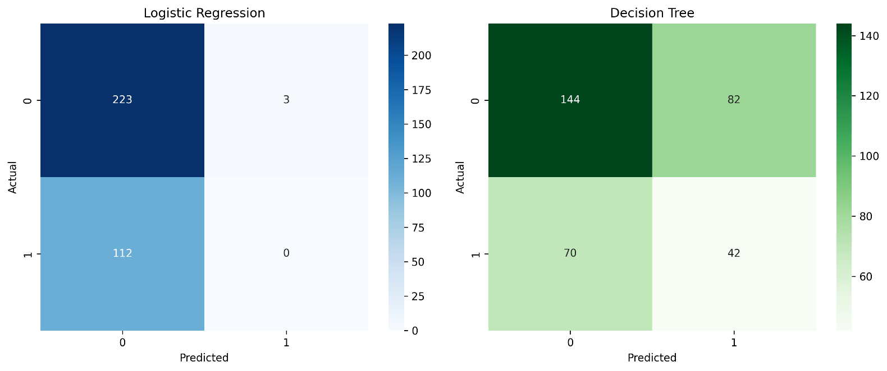
- Figure 2.1: Confusion Matrix – Logistic Regression Classifier and Decision Tree Classifier

The models were tested using the unseen 25% test set. The Decision Tree had a lower accuracy of 55.0% when compared to the Logistic Regression model which had an accuracy of 66.0% (Table 2.1). Accuracy can be misleading in imbalanced classification problems. The confusion matrices (Figure 2.1) show that the Logistic Regression model didn’t find any failing pumps with 0 True Positives and 112 False Negatives. The Decision Tree did find 42 True Positives, but still had 70 False Negatives.

2.3 Model Recommendation for Maintenance Triage

The Decision Tree model would be heavily recommended.

- The main aim of the utility company is to reduce False Negatives. This occurs when a pump which needs major servicing (Class 1) is misclassified as low risk (Class 0). This can be dangerous as the pump will not be checked and will cause catastrophic failure, affecting the water supply and causing large costs to fix.

- The evaluation shows that the Logistic Regression model had a high number of false negatives (112), and a poor recall score of 0.0000. This means it didn’t identify any pumps that were failing. The Decision Tree had a significantly lower number of false negatives (70) and a recall score of 0.3750. This means it identified 42 pumps that were at risk.

- The Decision Tree did have a higher number of false positives (82) compared to the logistic regression (3). This means that there will be more pumps that are healthy that will be flagged, however this is a small cost to the company as it is a wasted trip. Compared to a catastrophic failure, the Decision Tree is the only option available as it ensures maximum safety and preparedness.

2.4 Model Validation Strategy.

- When evaluating the performance of the Decision Tree that we have selected it is important that we do not just evaluate based off of one split (75/25). This could cause issues due to high variance as the performance of our model can be heavily dependent on which pump records were chosen for our test set. If our split has a high number of easy or hard pumps to classify then this will not give us an accurate representation of how our model will perform on unseen data.

- By using a stratified k-fold cross validation method ( k=5 or k=10), we can get a more accurate measure of how well our model will predict. This method will split up our data into k equally sized folds whilst maintaining the same class distribution (stratified). We will train and evaluate our model k times with each fold being used as our test set. This will give us a far more accurate measure of the performance of our Decision Tree by averaging out the evaluation metrics.

Section 3: Question 3 – Predicting Electricity-Restoration Time

3.1 Data Preparation for Regression

Missing values:
# 2. Inspect missing values
print(df.isnull().sum())

OUTPUT:

Incident_ID 0
Affected_Line_Length_km 0
Fault_Category 30
Grid_Load_Level 30
Dispatch_Window 30
Crew_Type 0
Dispatch_Delay_Minutes 0
Technician_Experience_Years 30
Restoration_Time_Minutes 0
dtype: int64

Imputing Missing values:

# Fill numerical missing values with the median
df['Technician_Experience_Years'] = df['Technician_Experience_Years'].fillna(df['Technician_Experience_Years'].median())

# Fill categorical missing values with the mode (most frequent category)
categorical_missing = ['Fault_Category', 'Grid_Load_Level', 'Dispatch_Window']
for col in categorical_missing:
df[col] = df[col].fillna(df[col].mode()[0])

print("Missing values after imputation:")
print(df.isnull().sum())

OUTPUT:

Missing values after imputation:
Incident_ID 0
Affected_Line_Length_km 0
Fault_Category 0
Grid_Load_Level 0
Dispatch_Window 0
Crew_Type 0
Dispatch_Delay_Minutes 0
Technician_Experience_Years 0
Restoration_Time_Minutes 0
dtype: int64

Encoding and dropping IDs:

# Drop the non-predictive identifier
df = df.drop(columns=['Incident_ID'])

# Encode the categorical text variables into numbers
le = LabelEncoder()
categorical_cols = ['Fault_Category', 'Grid_Load_Level', 'Dispatch_Window', 'Crew_Type']

for col in categorical_cols:
df[col] = le.fit_transform(df[col])

print("Categorical features encoded successfully.")

Output:
Categorical features encoded successfully.

80?20 Split
80/20 Split and Standardisatuon.

# Separate Features (X) and Target (y)
X = df.drop(columns=['Restoration_Time_Minutes'])
y = df['Restoration_Time_Minutes']

# 80/20 training and test split
X_train, X_test, y_train, y_test = train_test_split(X, y, test_size=0.2, random_state=42)

# Standardise the predictors
scaler = StandardScaler()
X_train_scaled = scaler.fit_transform(X_train)
X_test_scaled = scaler.transform(X_test)

# Convert y to NumPy arrays for our custom math later
y_train = y_train.values
y_test = y_test.values

print(f"Training set shape: {X_train_scaled.shape}")
print(f"Testing set shape: {X_test_scaled.shape}")

Output:

Training set shape: (800, 7)
Testing set shape: (200, 7)

- Looking into the incident data set we can see that there are 30 missing values in 4 columns (Fault_Category, Grid_Load_Level, Dispatch_Window and Technician_Experience_Years). Within the numeric missing values in Technician_Experience_Years, we filled the missing data using the median value so that the mean wouldn’t be skewed by outliers. For the categorical missing values, we filled these using the mode of the data.

- As Incident_ID is not predictive we removed that column. We then encoded the categorical text predictors using LabelEncoder. We then split the data into a train/test set with 80% training and 20% testing. Finally we scaled our predictor variables using StandardScaler, only fitting it on the training data so no data leakage occurs. We also converted our target variable to NumPy arrays in preparation for our custom Gradient Descent algorithm.

3.2 Custom Gradient Descent Implementation

The Gradient Descent Algorithm
# 1. Added a column of ones to X to represent the bias/intercept term (theta_0)
# X_train_scaled is currently (800, 7). We make it (800, 8) where the first column is all 1s.
X_train_b = np.c_[np.ones((X_train_scaled.shape[0], 1)), X_train_scaled]
X_test_b = np.c_[np.ones((X_test_scaled.shape[0], 1)), X_test_scaled]

# 2. Initialize parameters (theta) to zeros
# There are 8 parameters (1 bias + 7 features)
theta = np.zeros(X_train_b.shape[1])

# 3. Set Hyperparameters
learning_rate = 0.01
iterations = 1000
m = len(y_train) # Number of training examples

# 4. Initialize a list to store the cost history for the plot
cost_history = []

# 5. The Gradient Descent Loop
for i in range(iterations):
# Step A: Calculate predictions
y_pred = X_train_b.dot(theta)

# Step B: Calculate the error (predictions - actual)
error = y_pred - y_train

# Step C: Calculate the Mean Squared Error (Cost)
cost = (1 / (2 * m)) * np.sum(error ** 2)
cost_history.append(cost)

# Step D: Calculate the gradients (Partial derivatives)
# The formula is: (1/m) * X_transpose * error
gradients = (1 / m) * X_train_b.T.dot(error)

# Step E: Update the parameters using the learning rate
theta = theta - learning_rate * gradients

print("Gradient Descent Completed!")
print(f"Final Cost (MSE): {cost_history[-1]:.4f}")
print(f"Model Weights (Theta):\n{theta}")

Output:

Gradient Descent Completed!
Final Cost (MSE): 70.0969
Model Weights (Theta):
[57.05128692 17.35740688 1.28963293 -1.41009525 0.16433041 0.23780387
7.03490563 -1.7611836 ]

Training Cost:

import os
# Plot the training cost over iterations
plt.figure(figsize=(10, 6))
plt.plot(range(iterations), cost_history, color='blue', linewidth=2)
plt.title('Gradient Descent: Training Cost (MSE) over Iterations')
plt.xlabel('Iterations')
plt.ylabel('Mean Squared Error (Cost)')
plt.grid(True)
plt.savefig('../outputs/figures/q3_gradient_descent_cost.png', dpi=300, bbox_inches='tight')
plt.show()

Output:

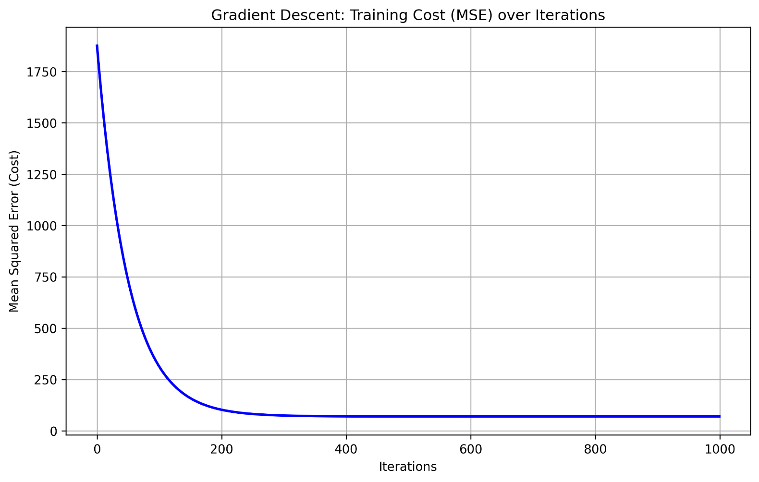
- Figure 3.1: Gradient Descent Training Cost (MSE) over Iterations

Mathematical Formulations

Hypothesis / Prediction Function:

$$\hat{y}=Xθ$$

Sum of Squared Error / Cost Function ($J\left(θ\right)$):

$$J\left(θ\right)=\frac{1}{2m}\sum_{i=1}^{m}{{\left(X^{\left(i\right)}θ-y^{\left(i\right)}\right)}^{2}}$$

Partial Derivative / Gradient Update Rule:
$$θ_{j}:=θ_{j}-α\frac{∂J}{∂θ_{j}}$$

where
$$\frac{∂J}{∂θ_{j}}=\frac{1}{m}\sum_{i=1}^{m}{\left({\hat{y}}^{\left(i\right)}-y^{\left(i\right)}\right)}x_{j}^{\left(i\right)}$$

3.3 Model Performance Evaluation & Interpretation

from sklearn.metrics import mean_absolute_error, mean_squared_error, r2_score

# 1. Make predictions on the test set using the trained theta values
y_pred_test = X_test_b.dot(theta)

# 2. Calculate the metrics
mae = mean_absolute_error(y_test, y_pred_test)
rmse = np.sqrt(mean_squared_error(y_test, y_pred_test))
r2 = r2_score(y_test, y_pred_test)

# 3. Print the results
print("--- Model Evaluation on Test Set ---")
print(f"Mean Absolute Error (MAE): {mae:.2f} minutes")
print(f"Root Mean Squared Error (RMSE): {rmse:.2f} minutes")
print(f"R-squared (R2) Score: {r2:.4f}")

Output:

--- Model Evaluation on Test Set ---
Mean Absolute Error (MAE): 7.46 minutes
Root Mean Squared Error (RMSE): 10.42 minutes
R-squared (R2) Score: 0.7575

Table 3.1: Regression Evaluation Metrics

Metric | Value
Mean Absolute Error (MAE) | 7.46 minutes
Root Mean Squared Error (RMSE) | 10.42 minutes
R^2 Score | 0.7575

- Mean Absolute Error (MAE): 7.46 minutes. This means that on average, the model's predicted values are off by 7.5 minutes in relation to the actual incident restoration time. This gives a clear indication of how accurate the model is in predicting real-world situations.

- Root Mean Squared Error (RMSE): 10.42 minutes. This metric takes the square of the error and therefore penalises large errors. As the RMSE is larger than the MAE this indicates that whilst the majority of predictions are accurate there are some larger errors made (due to extreme outlier incidents which are much harder to predict).

- R^2 Score: 0.7575. This is a strong score. This means that the model has successfully explained 75.75% of the variance in restoration times. It shows that our custom Gradient Descent implementation has learnt the patterns very well, plus the selected features (dispatch delay, crew experience etc.) are good at predicting incident restoration times.

Section 4: Question 4 – Smart-Building Energy Profile Segmentation

4.1 Data Preparation and Silhouette Analysis

# Exclude Building_ID and standardise
X = df.drop(columns=['Building_ID'])

scaler = StandardScaler()
X_scaled = scaler.fit_transform(X)

# Silhouette Analysis for k = 2 to 6
silhouette_scores = []
k_values = range(2, 7) # This creates [2, 3, 4, 5, 6]

for k in k_values:
# Fit K-Means for the current k
kmeans = KMeans(n_clusters=k, random_state=42, n_init=10)
cluster_labels = kmeans.fit_predict(X_scaled)

# Calculate the silhouette score
score = silhouette_score(X_scaled, cluster_labels)
silhouette_scores.append(score)

print(f"k = {k}: Silhouette Score = {score:.4f}")

Output:

k = 2: Silhouette Score = 0.2683
k = 3: Silhouette Score = 0.2849
k = 4: Silhouette Score = 0.2556
k = 5: Silhouette Score = 0.1778
k = 6: Silhouette Score = 0.1948

Plot:

# Plot the Silhouette Scores
plt.figure(figsize=(8, 5))
plt.plot(k_values, silhouette_scores, marker='o', linestyle='-', color='purple')
plt.title('Silhouette Analysis for Optimal k')
plt.xlabel('Number of Clusters (k)')
plt.ylabel('Silhouette Score')
plt.grid(True)
plt.savefig('../outputs/figures/q4_silhouette_scores.png', dpi=300, bbox_inches='tight')
plt.show()

- The Building_ID variable was dropped as it is an identifier and cannot be used for prediction. Standard scaling was performed on all remaining numerical variables using StandardScaler. This ensures any large variables like annual energy usage do not affect the distance calculations performed.

- Silhouette Analysis was also undertaken to find the optimal number of clusters. A range of values between k = 2 and k=6 were tested. The Silhouette Score indicates how similar each building in the cluster is to its own cluster. Higher scores indicate clearer clusters. It can be seen from the table below (Table 4.1) the best score is achieved at k=3 (0.2849). This means there will be three clusters in the final model.

Table 4.1: Cluster Sizes and Silhouette Scores Across Evaluated $k$Values

Number of Clusters ($k$) | Silhouette Score
2 | 0.2683
3 | 0.2849
4 | 0.2556
5 | 0.1778
6 | 0.1948

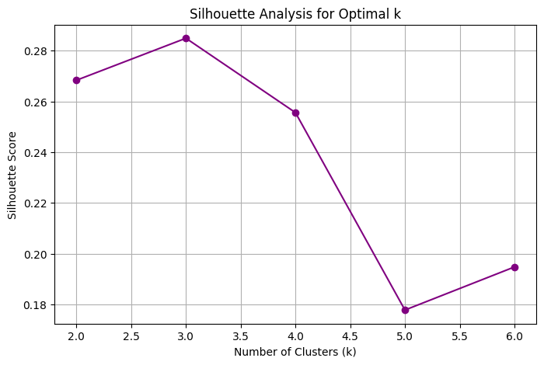

- Figure 4.1: Silhouette Scores for K-Means Clustering ($k=2$ to $k=6$)

4.2 Fitting the final K-Means model and PCA plot
Final K-Means Model and Counts
# 1. Fit the final K-Means model with k=3
final_kmeans = KMeans(n_clusters=3, random_state=42, n_init=10)
cluster_labels = final_kmeans.fit_predict(X_scaled)

# 2. Report the number of buildings in each cluster
cluster_counts = pd.Series(cluster_labels).value_counts().sort_index()
print("--- Number of Buildings per Cluster ---")
for cluster_id, count in cluster_counts.items():
print(f"Cluster {cluster_id}: {count} buildings")

Output:
--- Number of Buildings per Cluster ---
Cluster 0: 62 buildings
Cluster 1: 51 buildings
Cluster 2: 65 buildings

PCA and Scatter Plot:
# Reduce the standardised data to 2 Principal Components
pca = PCA(n_components=2)
X_pca = pca.fit_transform(X_scaled)

# Create the scatter plot coloured by cluster
plt.figure(figsize=(10, 6))
scatter = plt.scatter(X_pca[:, 0], X_pca[:, 1], c=cluster_labels, cmap='viridis', edgecolor='k', s=70)
plt.title('2D PCA Visualization of Smart-Building Energy Clusters')
plt.xlabel('Principal Component 1')
plt.ylabel('Principal Component 2')
plt.legend(*scatter.legend_elements(), title="Clusters")
plt.grid(True, alpha=0.3)
plt.savefig('../outputs/figures/q4_pca_clusters.png', dpi=300, bbox_inches='tight')
plt.show()
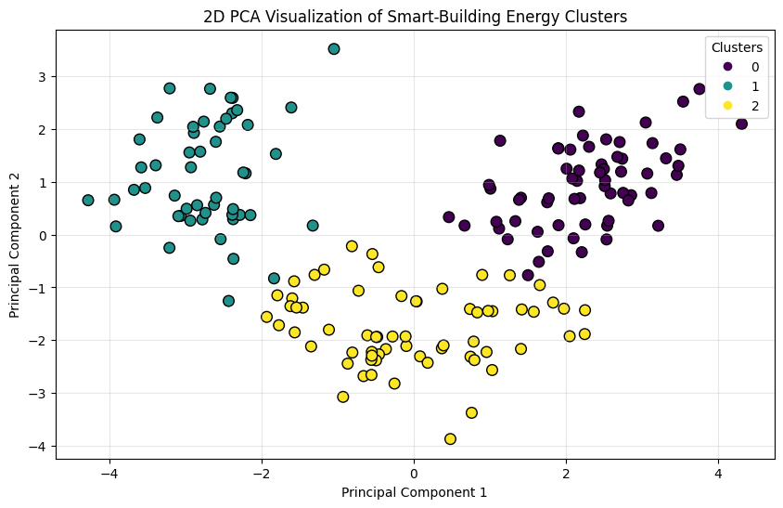
- Figure 4.2

The final model was run with k=3.

- This resulted in 62 buildings being assigned to Cluster 0, 51 buildings being assigned to Cluster 1 and 65 buildings being assigned to Cluster 2.

- PCA was used on the standardised data to allow for visualisation of the clusters. This was achieved by reducing the dimensions to 2 Principal Components. As shown in figure 4.2 the scatter plot shows that the K-Means algorithm successfully separated the buildings into three different clusters with little overlapping between them.

4.3 Profiling the Clusters

# DataFrame with the original data and the cluster labels
df_clustered = df.copy()
df_clustered['Cluster'] = cluster_labels

# Drop the Building_ID for the mean calculation
df_profile = df_clustered.drop(columns=['Building_ID'])

# Calculate the mean values for each cluster
cluster_means = df_profile.groupby('Cluster').mean().round(2)

# the results (Transposed so it fits on the screen nicely)
print("--- Cluster Centroids (Original Measurement Units) ---")
print(cluster_means.T)

Output:

--- Cluster Centroids (Original Measurement Units) ---
Cluster 0 1 2
Avg_Indoor_Temperature_C 20.18 19.63 18.75
Daily_HVAC_Runtime_Hours 5.00 6.96 4.85
Occupancy_Density_per_1000m2 49.33 48.35 44.62
Heating_Setpoint_C 19.24 20.37 20.02
Monthly_Water_Use_m3 194.34 177.60 166.93
Insulation_Performance_Score 6.70 4.37 5.50
Solar_Gain_Index 30.03 8.19 20.50
Window_to_Wall_Ratio 0.29 0.45 0.36
Equipment_Diversity_Index 9.61 5.73 8.12
Peak_Demand_kW 109.07 144.69 59.46
Lighting_Efficiency_Index 53.27 34.60 53.14
Ventilation_Rate_ACH 3.16 1.70 2.80
Annual_Energy_Use_kWh_m2 220.05 123.81 102.03

The cluster centres were converted into their original units so that the buildings could be interpreted in terms of operation.

- Cluster 0: High Energy Consumption, Poor Insulation (62 buildings)
  - This cluster has the highest annual energy consumption (220.05 kWh/m2), water consumption (194.34 m3) and solar gain (30.03). They do have reasonable insulation rating however (6.70) but are certainly the most resource intensive buildings. Operational Intervention: These should be the priority for any immediate energy efficiency improvements to be made. Improvements could include better window shading due to the high solar gain.

- Cluster 1: High Demand, Inefficient Operation (51 buildings)
  - This cluster has the highest electrical demand (144.69 kW), highest HVAC run time (6.96 hours) and lowest insulation rating (4.37). They also have the lowest lighting efficiency (34.60) and ventilation (1.70). Operational Intervention: These are overworking to provide a comfortable environment. Improvements should include HVAC improvements, better insulation and more efficient lighting.

- Cluster 2: Efficient, Low Demand (65 buildings)
  - These are the most energy efficient buildings. They have the lowest annual energy consumption (102.03 kWh/m2) and peak demand (59.46 kW). They also have fairly good insulation (5.50) and efficient lighting (53.14). Operational Intervention: These are performing well so should have little intervention. Just to keep the efficiencies they currently have.

Table 4.2: Smart-Building Cluster Profiles

Feature (Average) | Cluster 0 | Cluster 1 | Cluster 2
Annual_Energy_Use_kWh_m2 | 220.05 | 123.81 | 102.03
Peak_Demand_kW | 109.07 | 144.69 | 59.46
Daily_HVAC_Runtime_Hours | 5.00 | 6.96 | 4.85
Insulation_Performance_Score | 6.70 | 4.37 | 5.50
Lighting_Efficiency_Index | 53.27 | 34.60 | 53.14
Ventilation_Rate_ACH | 3.16 | 1.70 | 2.80
Monthly_Water_Use_m3 | 194.34 | 177.60 | 166.93
Solar_Gain_Index | 30.03 | 8.19 | 20.50

References
Eduvos. 2026. ITMLA2-44 Machine Learning Algorithms Module Guide. Unpublished document. Eduvos.
Gopal, M. 2021. Applied Machine Learning. 2nd ed. India: McGraw-Hill Education.
Pedregosa, F. et al. 2011. Scikit-learn: Machine Learning in Python. Journal of Machine Learning Research, 12, pp.2825-2830.
Hunter, J.D. 2007. Matplotlib: A 2D Graphics Environment. Computing in Science & Engineering, 9(3), pp.90-95.

AI Evidence Section
Tool used: Gemini / ChatGPT
Evidence of verification: AI was used to debug Python traceback errors (e.g. ValueError: Input y contains NaN, SettingWithCopyWarning) and to clarify the mathematical notation for Gradient Descent. All AI-suggested code was tested line-by-line in the local Jupyter Notebook environment to ensure it ran successfully. The theoretical concepts were cross-checked against the prescribed textbook (Gopal, 2021) and the ITMLA2 module guide.

AI Disclosure Appendix
AI tool used | Purpose / how it was used | How I verified or adapted the output
Gemini (or ChatGPT) | Used to explain Python error messages (e.g., DataConversionWarning), clarify the mathematical formulas for Gradient Descent, and assist in structuring the Word document layout. | I reviewed the mathematical explanations against the ITMLA2 Module Guide and lecture slides. I manually typed and executed all code in my Jupyter Notebook to verify it worked. All written narratives in this report were written by me based on my own understanding of the notebook outputs.
e.g. Claude Opus 4.7 | e.g. Brainstormed initial argument outline | e.g. Cross-checked with three peer-reviewed sources; fully rewritten in own words
e.g. Grok 4 | e.g. Brainstormed initial argument outline | e.g. Cross-checked with three peer-reviewed sources; fully rewritten in own words

Declaration:
I/we declare that this assessment is my/our own original work, except for source material explicitly acknowledged. I/we confirm that any use of Artificial Intelligence (AI) tools has been applied only as permitted by the assessment instructions and has been fully disclosed where required.
I/we understand that I/we remain responsible for the accuracy, originality, and academic quality of this submission. I/we am/are aware of the institution’s policies on academic integrity and the requirements relating to the responsible use of AI in assessments.
I/we acknowledge that failure to comply with these requirements, including undeclared or inappropriate AI use, may result in academic penalties or disciplinary procedures in accordance with institutional policy.

Student Signature(s) | Date
S Njoko | 19/10/2026

