ST10445866 - Botshelo Koketso Sekwena

IIE MSA MONASH RUIMSIG

PROG6112

Assignment

Table of Contents

Online Links: 2

GitHub Repository Link: 2

YouTube Unlisted Video Link: 2

Project Description: 3

Section A: Series Management Java Project 3

Description: 3

Class Summaries: 3

Function Description: 3

Unit Test Summaries: 4

(Farrel, 2023) 5

Section A: Retail inventory Java Project 6

Description: 6

Class Summaries: 6

Function Description: 7

Unit Test Summary – InventoryTests 7

Unit Test Summary – ProductTests 8

Bibliography 10

# Online Links:

## GitHub Repository Link:

<https://github.com/SekwenaBotshelo/PROG6112_Assessment1_ST10445866.git>

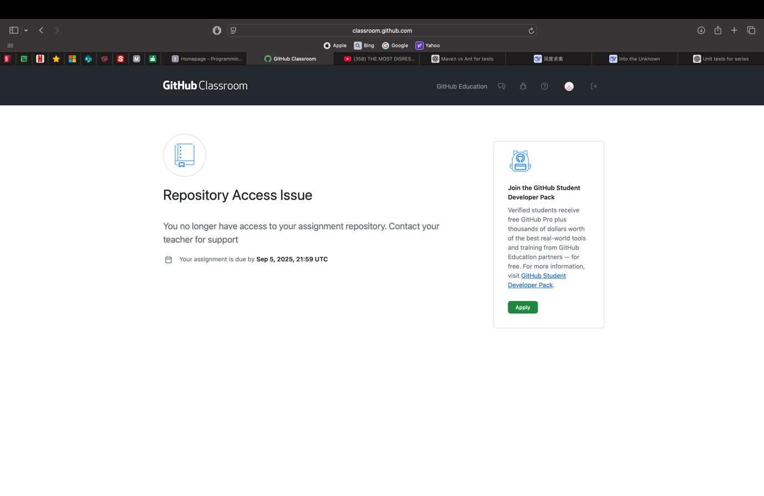

PLEASE NOTE THAT I COULD NOT ACCESS THE GITHUB REPOSITORY THAT YOU PROVIDED.

SO I HAVE CREATED A GITHUB REPOSITORY WHERE YOU CAN ACCESS THE PROJECT FILES FOR YOUR OWN VIEWING.

## YouTube Unlisted Video Link:

<https://youtu.be/la3VMAuGrKc>

# Project Description:

## Section A: Series Management Java Project

### Description:

This is a Java application that is used to manage a list of television shows. Users can verify age limitations while searching, updating, and deleting series records. The system uses ArrayList<SeriesModel> to store series’ in memory.

### Class Summaries:

* Series
  + This class represents a comprehensive TV show that includes the title, rating, age limit, genre, and year of release.
* SeriesModel
  + A series' ID, name, age restriction, and episode count are displayed simply (used for storing in the program).
* Prog6112PracticalAssignment
  + Console menus, CRUD operations, and SeriesModel object management are handled by the main application class.

### Function Description:

* Capture New Series
  + Provides ID, name, age restriction (verified between 2 and 18), and episode prompts.
  + Creates an ArrayList<SeriesModel> to hold the new series.
* Search for a Series
  + Searching by Series ID or Series Name is possible.
  + If a series is discovered, series information are displayed.
* Revise the Age Limitation
  + Identifies a series.
  + Verifies newly entered ages (2–18).
  + The series record is updated.
* Delete a Series
  + This action eliminates a series from the list based on its ID.
* Print Report
  + Produces a structured report that includes all of the stored series.
  + If there are no series, a notice is displayed.
* Validation
  + The age range must be between 2 and 18.
  + Invalid entries are prevented using numerical validation.

### Unit Test Summaries:

|  |  |  |
| --- | --- | --- |
| Test Method | Purpose | Expected Outcome |
| TestSearchSeries() | Look up current series by ID. | Returns matching SeriesModel |
| TestSearchSeries_SeriesNotFound() | Look up non-existent series | Returns null |
| TestUpdateSeries() | Update the age limit for a legitimate series ID. | Returns true and updates value |
| TestDeleteSeries() | Remove current series by ID. | Returns true and removes series |
| TestDeleteSeries_SeriesNotFound() | Try to remove any non-existent series. | Returns false |
| TestSeriesAgeRestriction_AgeValid() | Verify the age restriction (between 2 and 18). | Returns true |
| TestSeriesAgeRestriction_AgeInValid() | Verify the age restriction outside of the range. | Returns false |

## (Farrel, 2023)

## Section A: Retail inventory Java Project

### Description:

This is a Java console application called RetailInventoryAppST10445866 that is used to manage a store's inventory of groceries and electronics. Products can be added, sold, inventory reports can be generated, and transactions can be tracked.

### Class Summaries:

* Product
  + Base class for generic goods
* Electronics
  + Product subclass with a months-long warranty
* Grocery
  + Product subclass with an expiration date
* Inventory
  + Oversees a number of sales, transactions, and items.
* InputHelper
  + Manages user input (string, date, double, and integer).
* RetailInventoryAppST10445866
  + The console interface is provided by the main class.
* InventoryTests
  + Unit tests for methods in the Inventory class
* ProductTests
  + Unit tests for the classes of groceries, electronics, and products

### Function Description:

* Add Products:
  + Ensures that the inventory is complete by adding groceries or electronics.
* Sell Products:
  + Keeps track of transactions, advises when stock is low or unavailable, and updates stock.
* Reports:
  + Produces transaction and inventory reports that include stock alerts.
* Search:
  + Look up products by name and get information related to a given category.

### Unit Test Summary – InventoryTests

|  |  |  |
| --- | --- | --- |
| Test Method | Purpose | Expected Outcome |
| testAddProduct | Add product to inventory | Product added successfully |
| testAddProductInventoryFull | Attempt to add product beyond inventory capacity | Product not added (null returned) |
| testSellProduct | Sell available stock | Stock decreases accordingly |
| testGetProductByName | Retrieve product by name | Returns correct product or null |
| testTransactionHistory | Check stock and transaction after sales | Stock updated and transactions recorded |

### Unit Test Summary – ProductTests

|  |  |  |
| --- | --- | --- |
| Test Method | Purpose | Expected Outcome |
| testproductGetter | Verify Product getters | Correct values returned |
| testProductSell | Sell Product | Stock decreases or remains if insufficient |
| testElectronicsWarranty | Verify Electronics Warranty | Correct Warranty returned |
| testElectronicsReport | Verify Electronics report string | Report contains product info |
| testGroceryExpiryDate | Verify Grocery expiry date | Correct date returned |
| testGroceryReport | Verify Grocery report string | Report contains product info |

(Farrel, 2023) (Krysik, 2024) (ADMIN, 2025) (ChatGPT, 2025)

# Bibliography

Farrel, J. (2023). *Java Programming.* Boston: Cengage.

Krysik, A. (2024, December 9). *How to Build an Inventory Management System: Key Steps and Tips*. Retrieved from STRATO FLOW: https://stratoflow.com/how-to-build-inventory-management-system/

ADMIN. (2025, August 30). *How to Create Inventory Management System in Java NetBeans*. Retrieved from Inventory System Solutions: https://inventorysystemsolutions.com/how-to-create-inventory-management-system-in-java-netbeans/

ChatGPT. (2025). *ChatGPT*. Retrieved from ChatGPT: https://chatgpt.com