SeraEdit: Scoped and Validated Language-Guided MusicXML Editing
Yuan Gao
Zhejiang Conservatory of Music, No. 1 Zheyin Road, Zhuantang Street, Xihu District, Hangzhou, Zhejiang Province, China 310024
Corresponding author: selanceg@gmail.com
ORCID: 0009-0005-0394-3623

Abstract
SeraEdit represents language-guided MusicXML edits as source-bound, scoped ScorePatch transactions with deterministic validation, rollback and user review. Its contribution is reusable editing and evaluation software, not a new music model or guaranteed accuracy improvement. Local processing supports offline use; optional remote models receive score context. The packaged desktop and automated notation-host integration target Windows; the Python reviewer path is documented separately. On 120 development tasks, a DeepSeek demonstration completed 360 runs. Strict editing success was 72/110 for Full Rewrite, 65/110 for Patch Only and 63/110 for Sera Full. Sera Full had no measured non-target changes among 73 output scores but erroneously refused 34 executable tasks. A constructed-error study rejected 180/180 invalid patches after a documented detector fix, while round-trip limitations rejected 3/20 valid controls. The software makes this protection/completion tradeoff inspectable and reproducible; the results do not establish higher overall editing success or held-out generalization.
Keywords: MusicXML; symbolic music; score editing; structured patches; validation; research software

1. Motivation and significance
MusicXML exchanges common Western music notation among applications [1]. Natural-language interfaces could simplify transposition, dynamics or articulation edits. Full-document model rewriting, however, exposes unrelated elements to change. A well-formed response can alter an unselected staff, break a tie, change measure duration, or drift from the reviewed source.
Existing symbolic-music toolkits provide rich programmatic analysis and generation facilities [2,3], while recent work investigates music reasoning and generation with large language models [4,5]. SeraEdit addresses a narrower systems problem: how to make a language-guided edit inspectable, source-bound, minimal, and rejectable before it is returned to a professional notation environment. The core research object is therefore not a generated score but a transaction over a canonical score representation.
The software supports research into constrained generation, deterministic evaluation of editing agents, error taxonomies, repair policies, and human-in-the-loop notation workflows. Stable task fixtures and three separately implemented experimental conditions allow investigators to compare full-document rewriting, unprotected structured patches, and a fully validated transaction without changing the source score or metric code. Executed tests already define acceptance in code-editing research: SWE-bench evaluates repository issue resolution [8], Can It Edit? evaluates instruction-following code changes [9], and CodeEditorBench covers multiple editing scenarios [6]. In music, Not that Groove studies instruction-driven drum-groove editing with a textual symbolic representation and annotated tests [10]. SeraEdit does not introduce language-guided symbolic editing or test-based evaluation. Its narrower contribution is their integration with pitched, multi-staff MusicXML: stable event addressing, source fingerprints, explicit protected scopes, and a reversible transaction checked against notation and export invariants. MuseScore Studio provides the notation-host context through its plugin mechanism [11]. Citation metadata follows software-citation principles [7]. These are contextual comparisons, not measured performance comparisons against those external systems; different representations and task contracts prevent a direct ranking from the present experiment.
The software contributes (1) a reusable ScorePatch contract for version-bound, scoped MusicXML changes; (2) an executable validation, preview and rollback workflow that makes acceptance independent of model confidence; and (3) licensed development tasks, separate comparison conditions and saved-output recomputation tools. The live comparison and fault-injection study demonstrate this infrastructure's research use, including failures and rejection costs. They are bounded demonstrations rather than claims of a superior model, universal correctness or improved musical quality.

2. Software description

2.1. Software architecture
Figure 1 summarizes the local pipeline. A MusicXML snapshot is imported into one canonical ScoreDocument. Editable events receive stable identifiers, while a canonical SHA-256 fingerprint identifies the exact source state. The renderer, preview, patch executor, MIDI conversion, and exporter consume this same document; the research pipeline does not maintain a hidden second score for playback or export.
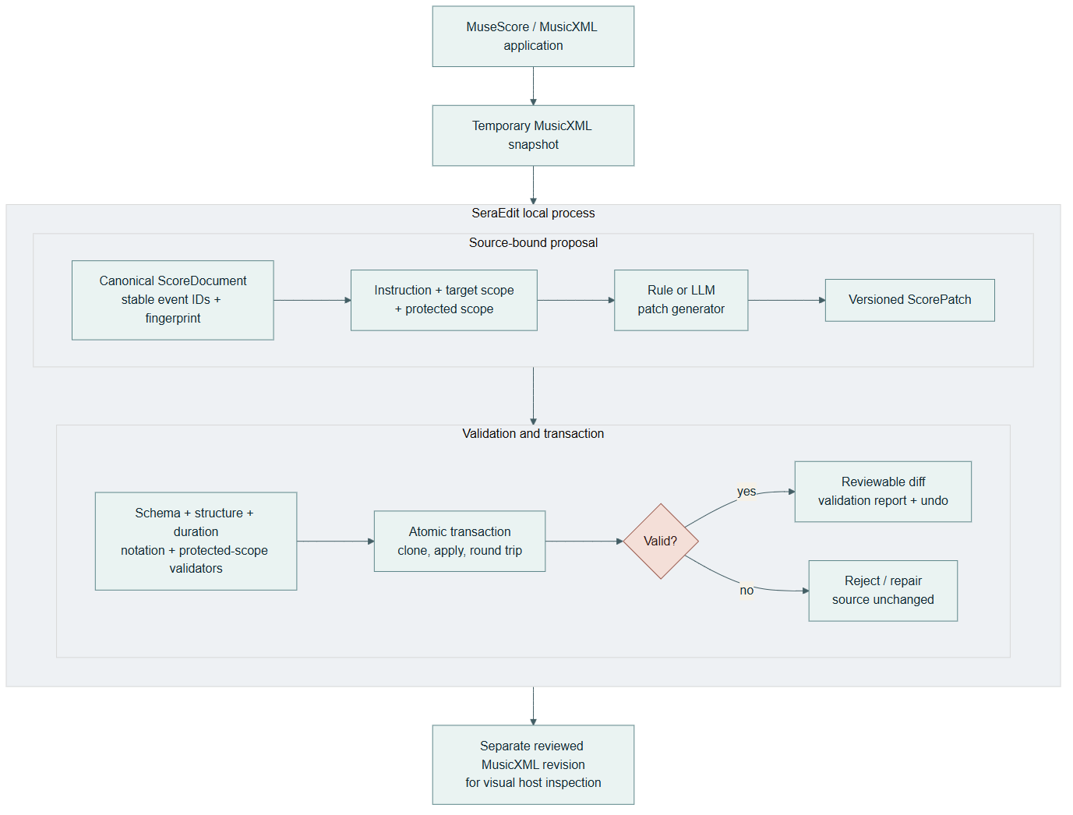
Figure 1. The notation host remains the visual source. SeraEdit produces a separate reviewed MusicXML revision or rejects the transaction while retaining the source.

2.2. Software functionalities
A ScoreScope deterministically selects measures, parts, staves, voices, event IDs, and optional time ranges. Each patch declares a target scope, a protected scope, and explicit exclusions. Its operations use a versioned JSON schema and describe selectors, arguments, preconditions, and expected change counts. Implemented research operations include pitch and duration changes, event insertion/deletion, dynamics, articulations, ties, slurs, signature changes, voice moves, motif duplication, chord replacement, and transactional batches. The product interface enables only operations whose host round-trip contract is established; unknown operations fail as unsupported rather than becoming silent no-ops.
The validation terminology is fixed to eight checks: source binding, schema, structure and addressing, measure duration, notation relations, declared semantic conditions, protected scope, and MusicXML round-trip fidelity. Source binding and pre-apply checks precede cloning and operation application; post-apply checks precede commit. Only implemented properties are checked: a valid transaction is not proof that unrestricted musical intent was satisfied. Section 3.2 measures specific faults. The result includes errors, a human-readable diff, fingerprints and snapshots for undo/redo. Deterministic repair normalizes formatting or enums. Bounded model repair receives errors and immutable scopes; it cannot bypass the transaction.
Provider adapters share a response contract recording model, latency, token use, estimated cost, request ID, finish reason, raw output, parsed output, and normalized errors. API keys are external to source and experiment artifacts. The desktop agent can respond locally first and refine a high-level plan asynchronously with an optional LLM, so provider latency does not block access to local safe candidates. Neither response is auto-applied.
The three condition names are used consistently throughout: Full Rewrite (full_rewrite, formerly Full-Score Rewrite) accepts complete MusicXML without the patch validation/repair pipeline; Patch Only (patch_only, formerly ScorePatch Only) parses and basically applies a patch; Sera Full (sera_full, formerly Sera Full Pipeline) adds the eight checks, bounded repair/refusal, atomic execution and undo. Immutable run IDs, hashes, saved responses and deterministic metric recomputation support auditing. Section 3.1 defines the comparison and scoring denominators.

2.3. Platform and local-processing boundary
The packaged Electron desktop, automatic host discovery and stored-credential UI currently target Windows. Source-level Python reviewer commands do not require the desktop or MuseScore. POSIX installation and API commands are provided in the guide; this revision was tested on Windows, so it does not claim independently verified macOS/Linux desktop or bridge support. Non-Windows users can use the source-level reviewer path and manually open exported MusicXML in their notation application; that is not the automated bridge. Optional providers use environment variables off Windows. Local-first means local score state, files and deterministic execution; remote-model mode transmits instruction and score context to the chosen provider.

3. Illustrative examples
The local-rule demonstration uses: “Transpose measure 1 of staff 1 up by a major second while preserving rhythm.” SeraEdit binds the candidate to the imported fingerprint and resolves only pitched events in measure 1, staff 1. Preview applies the transposition to a clone. Duration equality is checked with rational values, protected content is compared event-by-event, and the exported MusicXML must parse, import, export, and parse again. A valid preview reports the exact changed event count; a stale fingerprint, missing event, duration change, or protected-scope difference rejects and rolls back the whole patch.
The optional MuseScore bridge sends selection context and a user-selected saved score to Sera Desktop. On MuseScore 4.5.2, native files use CLI conversion because QML export is unavailable; MusicXML files are read directly. Users must save first: unsaved in-memory changes are excluded. Review and apply creates a separate revision opened in MuseScore, preserving the original. A captured local-rule demonstration verified this complete path and four pitch changes (Figures 2 and 4; BRIDGE_VISUAL_ACCEPTANCE.json). Final visual review and saving remain user actions. Sera undo creates another revision; single-step host undo is not implemented.
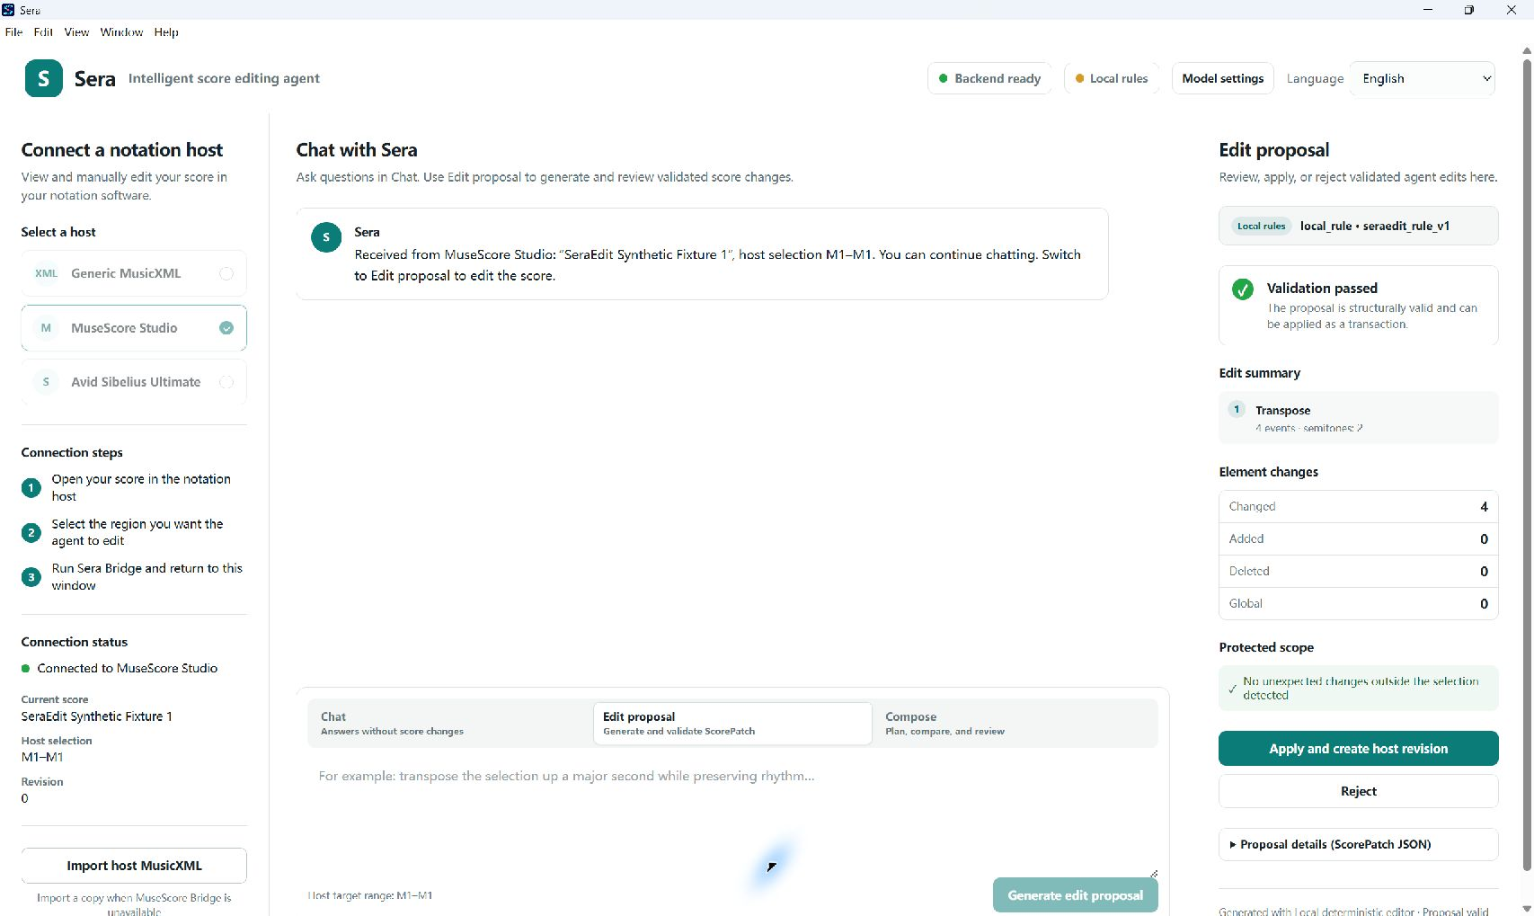
Figure 2. Actual Electron development shell after MuseScore plugin handoff of a saved synthetic score. Local rules propose four pitch changes with validation, protection and apply/reject controls. This demonstrates the workflow, not live-model accuracy.
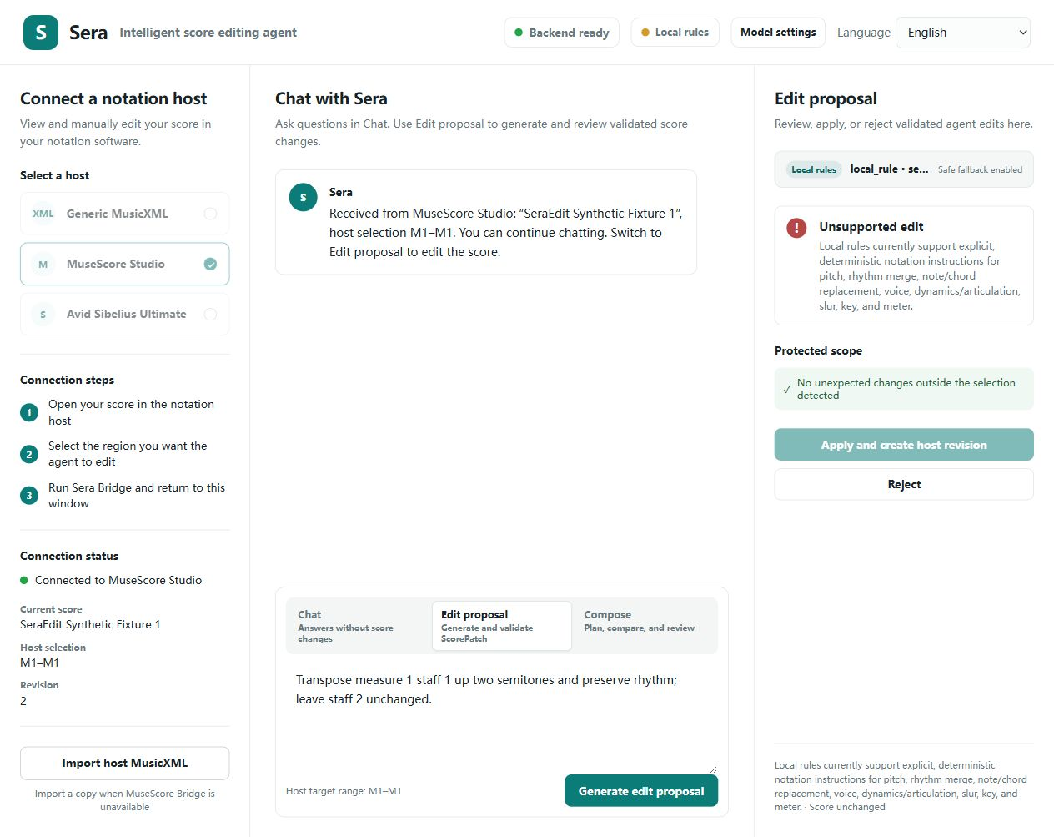
Figure 3. Source-browser UI after manual MusicXML import: an unsupported local-rule instruction. Apply is disabled and the score is unchanged. This is an observed wording limitation, not a simulated error. Additional applied/undo states and reproduction steps accompany the revision.
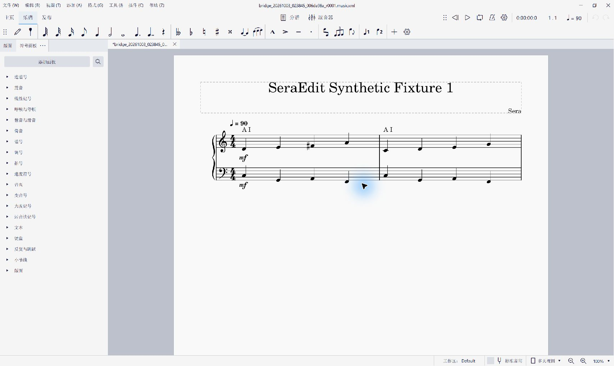
Figure 4. MuseScore 4.5.2 displaying revision 1 opened by the plugin. Measure 1, staff 1 changes C–D–E–G to D–E–F♯–A; other notes remain unchanged.
For offline verification, the repository contains 20 short CC0 synthetic scores and 120 tasks spanning transposition, rhythm, harmony/key, voice/texture, dynamics, insertion/deletion, ties/slurs, meter, compound edits, and expected refusal. Tasks carry target/protected scope and deterministic expected constraints. The fixture provider returns known outputs to exercise all runner and metric paths without network access or token cost.
For review, scripts/run_reviewer_demo.py runs six representative tasks through the actual local product entry point and writes a compact evidence report plus five host-openable MusicXML revisions (the sixth task is an expected refusal). It requires neither an API key nor a network connection. The included Windows CI workflow repeats the Python regression suite, benchmark validation, this reviewer demo, package audit, frontend tests, and production build on each push or pull request.
Automatic benchmark validation accepted 120/120 task definitions. The retained human inspection completed 120/120 current primary decisions and a stratified 30/30 repeat check with zero stale records; all current decisions were compliant after the correction cycle. The append-only export retains 194 records, including superseded revision findings. Both passes used the same pseudonymous reviewer, so these data verify task instructions, scopes, Gold outputs, and host-visible notation but do not measure inter-rater reliability.
Software verification was repeated on 2 October 2026 on Windows 11 (build 10.0.26200) with Python 3.12.5 and a newly installed dependency environment. The clean revision checkout passed all 438 collected Python tests. The new softwarex_revision_verification_120_v2 fixture completed 360 task-condition cases with zero execution errors. Independent recomputation matched all 360 saved metric rows, and all 13 integrity checks passed, including input, dependency, provider-output and human-review file hashes. The original fixture is retained as historical evidence: the revision audit identified stale benchmark/dependency hashes and six metric rows inconsistent with the released task definitions. The corrected snapshot has a separate identifier and does not amend the original deposited artifact. These are software verification results, not evidence that a language model achieves perfect edits; the experiment manifest explicitly sets formal_results_allowed to false.
We additionally replayed every benchmark instruction through the interactive product entry point without supplying its Gold patch to generation. Across English and Chinese instructions and three deterministic repetitions, 720/720 runs completed generation or the expected refusal, transaction preview, atomic commit, protected-scope checking, deterministic constraints, and MusicXML export/re-import. All 660 executable runs produced valid MusicXML; 60 conflict runs refused safely; no unsafe execution occurred. Patch and result fingerprints were identical in all 240 repeated task-language groups. After correcting a Chinese preserve pitch/tenuto ambiguity exposed by cross-language comparison, all 120 task groups also produced semantically equivalent patches and identical final score fingerprints across English and Chinese. The rule generator was therefore adjusted using feedback from these same benchmark instructions. These runs are regression evidence on a development benchmark, not a held-out generalization evaluation; withholding Gold patches during generation does not change that distinction. The 720 executions represent 120 tasks with language variants and repetitions, not 720 independent tasks. The compact publication snapshot retains all run metrics and hashes for all 1,380 raw and host evidence files, plus 220 host-openable outputs for complete task review. This establishes deterministic product-path acceptance, not remote-LLM accuracy or human musical quality.
We separately tested localization when the notation host supplied a wider selection than the measure named in the instruction. The robustness runner added one adjacent measure to each eligible explicit-measure request. It passed 240/240 bilingual runs; expansion was applicable in 174 runs, and all 174 retained the intended task result, protected content, and valid MusicXML. The remaining 66 runs were not widened because the instruction did not name a specific measure, the source lacked an adjacent measure, or the operation was global. This regression set directly tests host-selection versus semantic-target resolution and remains deterministic product evidence, not model accuracy.

3.1. Real-provider demonstration
On 2 October 2026, we ran all three conditions once on each of the 120 development tasks using the DeepSeek API alias deepseek-flash. The API does not identify an immutable model snapshot. The frozen producer was commit e3a34e1, with temperature zero, thinking disabled, an 8,192-token output limit, no cache or transport retries, and at most two model repairs for Sera Full. The answer-blind protocol provides instruction, source and user scopes, excluding Gold patches, expected-status labels, scoring constraints and unsupported reasons. Both patch conditions receive identical initial messages and schemas, but generate separate responses. Only Sera Full receives repair, so this is a system comparison, not an equal-call-budget comparison.
Two retained six-task pilots preceded the core run. The first revealed ambiguous public documentation of typed patch assertions; we clarified that documentation identically for both patch conditions before freezing the core run. Pilot tasks overlap the core benchmark. Neither this development benchmark nor the pilot-informed protocol establishes held-out generalization. No metric or producer implementation was changed after observing the core results.
Strict editing success requires the frozen task constraints, valid MusicXML, complete non-target preservation, an actual score output and no refusal. The 110 executable tasks and 10 expected-refusal tasks have separate denominators. Leakage counts scores with any measured non-target change among produced editing scores; withheld outputs cannot establish successful editing.
Condition | Strict editing success | Produced scores | Scores with leakage | Correct refusal | Erroneous editing refusal
Full Rewrite | 72/110 (65.5%) | 105 | 17/105 | 10/10 | 5/110
Patch Only | 65/110 (59.1%) | 92 | 18/92 | 10/10 | 10/110
Sera Full | 63/110 (57.3%) | 73 | 0/73 | 10/10 | 34/110
These results do not demonstrate higher overall editing success for structured patches. Sera Full constrained measured leakage while reducing output coverage. An exploratory paired bootstrap over the 20 source-score clusters (5,000 resamples) gave a Sera Full minus Full Rewrite strict-success difference of -8.18 percentage points, with a 95% interval of [-21.10, 5.50]. This small development-set comparison does not establish superiority or population-wide equivalence. Scoring follows operational benchmark constraints: for example, the insertion task requires deletion and insertion even if an in-place pitch change might satisfy a musician's reading of “replace the final note.” We retain this limitation without changing scoring post hoc.
All 360 initial generations and 43 repair responses were returned without provider failures or token-limit termination. Independent offline recomputation reproduced all 360 metric rows and passed 14 integrity checks. Replay of the same initial Sera Full responses with model repair disabled yielded 62/120 correct outcomes (strict edits plus correct refusals), compared with 73/120 after repair: 11 improvements and no regressions. However, 25 repaired editing tasks ended in erroneous refusal. Median recorded latency was 9.93, 2.05 and 2.27 seconds for Full Rewrite, Patch Only and Sera Full, respectively. Estimated main-run cost was USD 1.03 using configured peak/cache-miss rates; this is not a billing receipt. Raw outputs, repair requests, per-task metrics, costs and exploratory analyses accompany the revision evidence.

3.2. Constructed-error detection
We tested nine labeled mutation families on each of the 20 synthetic sources, plus one canonical-valid dynamic-edit control per source: 180 invalid cases and 20 controls. The families cover malformed schema, stale fingerprint, missing event, duration, orphan tie/slur, protected-scope change, pitch-preservation violation and incorrect declared dynamics. The study exposed an ignored dynamic_equals postcondition; after implementing its event/value check, targeted detection improved from 0/20 to 20/20 on those same cases. All 180 invalid patches were rejected after the fix. Pre-fix outputs are retained, and this same-case result is regression evidence.
Three of 20 canonical-valid controls were also rejected because grace-note dynamics changed during MusicXML export/re-import. This 15% end-to-end rejection rate measures an export/representation limitation, not isolated validator false positives. All 200 caller inputs remained unchanged and all 183 rejected transactions retained their original fingerprints. Constructed mutations do not estimate real-model error prevalence or prove detection of arbitrary semantic errors. The final implementation passed 445 Python tests, extending the earlier 438-test reproducibility checkpoint.
Evidence layer | Scale | Verified result | Claim boundary
Benchmark definition | 120 tasks / 20 scores | 120/120 valid | Schema, Gold application, constraints, round trip
Automated regression | 445 Python tests | All passed | Final live-protocol revision checkout; earlier archive checkpoint had 438
Real-provider comparison | 360 runs / 120 tasks | Strict edits: 72, 65, 63 of 110; 14 integrity checks | One API alias and development benchmark; protection/coverage tradeoff
Constructed-error detection | 180 mutations + 20 controls | 180 invalid rejected; 3 controls rejected | Regression after a detector fix; round-trip limitation retained
Reviewer demo | 6 representative tasks | 6/6 passed; five host files | Offline product-path reproducibility
Product replay | 720 bilingual runs | 720/720; 660 host exports | Deterministic local generator, not remote-LLM accuracy
Wider host selection | 240 bilingual runs | 240/240; 174 widened, 66 not widened | Semantic target remains narrower than authorization
Human task review | 120 primary + 30 repeat | Complete; zero stale | Same reviewer; no inter-rater or aesthetic claim

4. Impact
SeraEdit makes failure observable and reusable as research data. A rejected request is classified by stage—for example malformed patch, invalid selector, duration mismatch, broken relation, protected-scope violation, incomplete execution, over-editing, conflict, unsupported operation, or provider timeout—instead of being reduced to an application error. Raw outputs and post-hoc deterministic metrics support studies of which safeguards contribute to validity, task completion, non-target preservation, minimality, repair, and refusal behavior.
Researchers can reuse the front end, provider adapters, transaction engine and reporting pipeline with additional licensed fixtures. Mock runs support continuous integration and teaching; API-backed runs remain separate. The interface exposes these contracts to notation users.
The main empirical implication is that constrained acceptance and task completion can diverge. The preserved failures support separate investigation of proposal quality, repair, score representability and operational scoring. Improving completion while retaining protection requires new evaluation; neither current results nor the architecture alone guarantee that improvement. These components can support later agent research, but this paper does not establish long-horizon composition or learned musical intelligence.
The architecture also supports future interaction studies, with musical acceptance remaining a human judgment.
Current evidence supports reliability engineering, human-checked benchmark semantics, and reproducible experiment execution, not universal musical correctness or aesthetic improvement. The fixtures are small and synthetic, and the repeated check was performed by the same reviewer rather than an independent panel. The canonical importer is strongest for common short MusicXML passages and does not establish universal handling of tuplets, grace relations, complex cross-voice notation, or every notation application. MuseScore has an exercised bridge; Sibelius interoperability is not yet verified. Live-provider quality, latency, and cost can change with model versions and networks. Structural orchestration and unrestricted composition remain outside the host-safe contract. The real-provider demonstration shows reduced measured leakage at the cost of more refusals, not improved overall editing success. Results depend on the task scorer, small synthetic development set and optional repair budget. Deterministic validators check implemented properties, not unrestricted musical intent or aesthetic quality.

5. Conclusions
SeraEdit packages language-guided MusicXML editing as a source-bound, scoped, validated, and reversible transaction. Its principal contribution is an executable reliability boundary: the model proposes, while canonical score state, deterministic validators, protected-scope comparison, MusicXML round trips, and user review decide whether a revision exists. Future releases will prioritize held-out comparisons across models, cross-host testing, richer exact notation relations, and independent blinded musician evaluation rather than weakening transaction safeguards.

Code metadata
The following links identify the unchanged original public release. The new revision code and evidence are local candidates; final archival links must be supplied before submission. The original deposit does not contain the new live-model results.
Nr. | Code metadata description | Metadata
C1 | Current code version | 1.0.0
C2 | Permanent link to code/repository used for this code version | https://github.com/Selancee/Sera/releases/tag/v1.0.0
C3 | Permanent link to reproducible capsule | https://doi.org/10.5281/zenodo.22128976
C4 | Legal code license | MIT; benchmark data CC0-1.0
C5 | Code versioning system used | Git
C6 | Software code languages, tools and services used | Python, TypeScript/JavaScript, React, FastAPI, Electron, QML, PowerShell, MusicXML
C7 | Compilation requirements, operating environments and dependencies | Python >=3.10; Node.js/npm for interface development; verified Windows 11 build 10.0.26200, Python 3.12.5, Node.js 24.16.0, npm 11.13.0; Windows desktop package; POSIX source instructions with no independent platform validation; tested constraints and npm lock files
C8 | Developer documentation/manual | docs/softwarex/API_REFERENCE.md, INSTALLATION.md, USER_MANUAL.md, REVIEWER_GUIDE.md, and generated OpenAPI /docs
C9 | Support email for questions | selanceg@gmail.com

Software metadata
Nr. | Software metadata description | Metadata
S1 | Current executable software version | 1.0.0
S2 | Permanent link to executable | https://github.com/Selancee/Sera/releases/download/v1.0.0/Sera-1.0.0-x64.exe
S3 | Permanent link to reproducible capsule | https://doi.org/10.5281/zenodo.22128976
S4 | Legal software license | MIT
S5 | Computing platforms/operating systems | Windows 10/11 x64; source-level core also uses Python >=3.10
S6 | Installation requirements and dependencies | See docs/softwarex/INSTALLATION.md
S7 | User manual | docs/softwarex/USER_MANUAL.md
S8 | Support email | selanceg@gmail.com

Author contributions
Yuan Gao: Conceptualization, Methodology, Software, Validation, Investigation, Data curation, Writing – original draft, Writing – review & editing, Visualization.

Funding
This research did not receive any specific grant from funding agencies in the public, commercial, or not-for-profit sectors.

Declaration of competing interest
The author declares that there are no known competing financial interests or personal relationships that could have appeared to influence the work reported in this paper.

Data and code availability
Source code, synthetic benchmark data, test fixtures, evaluation configuration, and the non-formal verification run are available from the tagged public repository in C2 and the immutable Zenodo software deposit in C3 at https://doi.org/10.5281/zenodo.22128976. No API key is distributed. The separate revision evidence includes softwarex_revision_verification_120_v2, softwarex_deepseek_core_20261002_v1, both retained DeepSeek pilots and softwarex_validator_detection_200_v1. These local candidates include saved outputs and offline recomputation commands; publication of the revised archive is pending.

Declaration of generative AI and AI-assisted technologies in the manuscript preparation process
During preparation of this work, the author used OpenAI Codex to assist with source code implementation, testing, documentation structuring, and language editing. The author reviewed and edited all generated material and takes full responsibility for the content of the publication. No AI system is listed as an author.

References
[1] M. Good (Ed.), MusicXML 4.0, W3C Music Notation Community Group Final Report, 2021.
[2] M. S. Cuthbert, C. Ariza, music21: A toolkit for computer-aided musicology and symbolic music data, ISMIR, 2010, 637–642.
[3] C. Raffel, D. P. W. Ellis, Intuitive analysis, creation and manipulation of MIDI data with pretty_midi, ISMIR Late-Breaking/Demo, 2014.
[4] R. Yuan et al., ChatMusician: Understanding and generating music intrinsically with LLM, Findings of ACL, 2024.
[5] Z. Zhou et al., Can LLMs “reason” in music? An evaluation of LLMs' capability of music understanding and generation, ISMIR, 2024.
[6] J. Guo et al., CodeEditorBench: Evaluating code editing capability of large language models, arXiv:2404.03543, 2024.
[7] A. M. Smith, D. S. Katz, K. E. Niemeyer, FORCE11 Software Citation Working Group, Software citation principles, PeerJ Computer Science 2 (2016) e86. https://doi.org/10.7717/peerj-cs.86.
[8] C. E. Jimenez, J. Yang, A. Wettig, S. Yao, K. Pei, O. Press, K. Narasimhan, SWE-bench: Can Language Models Resolve Real-World GitHub Issues?, ICLR, 2024; preprint 2023. https://arxiv.org/abs/2310.06770.
[9] F. Cassano et al., Can It Edit? Evaluating the Ability of Large Language Models to Follow Code Editing Instructions, arXiv:2312.12450, 2023, revised 2024. https://arxiv.org/abs/2312.12450.
[10] L. Zhang, Not that Groove: Zero-Shot Symbolic Music Editing, arXiv:2505.08203v1, 2025. https://arxiv.org/abs/2505.08203v1.
[11] MuseScore, MuseScore Studio Handbook: Plugins, https://handbook.musescore.org/customization/plugins (accessed 3 October 2026).

