SeraEdit: Reliable Language-Guided MusicXML Editing through Structured Score Patches
[AUTHOR GIVEN NAME] [AUTHOR FAMILY NAME] [AFFILIATION, POSTAL ADDRESS, COUNTRY] Corresponding author: [SUPPORT EMAIL] ORCID: [ORCID]

Abstract
SeraEdit is local-first research software for reliable language-guided editing of symbolic scores. Rather than asking a language model to rewrite an entire MusicXML document, it represents a request as a versioned ScorePatch bound to stable event identifiers, target and protected scopes, and a source fingerprint. Layered validators check schema, score structure, duration, notation relations, protected content, and MusicXML round-trip fidelity inside an atomic transaction. A desktop interface and MuseScore bridge expose proposals, diffs, rejection reasons, and undo without silently overwriting the host score. The release includes 20 synthetic scores, 120 editing tasks, three evaluation conditions, resumable experiment tooling, and offline fixtures for reproducible software verification.
Keywords: MusicXML; symbolic music; score editing; structured patches; validation; research software

1. Motivation and significance
MusicXML is a widely used interchange representation for common Western music notation, allowing scores to move among notation, analysis, engraving, and archival systems [1]. Natural-language interfaces could reduce the mechanical cost of local edits such as transposition, dynamics, articulation, or voice assignment. However, the obvious implementation—send a complete MusicXML document to a generative model and accept a complete rewrite—mixes the intended change with thousands of unrelated elements. A syntactically well-formed response can still alter an unselected staff, break a tie, change measure duration, or drift from the source that the user reviewed.
Existing symbolic-music toolkits provide rich programmatic analysis and generation facilities [2,3], while recent work investigates music reasoning and generation with large language models [4,5]. SeraEdit addresses a narrower systems problem: how to make a language-guided edit inspectable, source-bound, minimal, and rejectable before it is returned to a professional notation environment. The core research object is therefore not a generated score but a transaction over a canonical score representation.
The software supports research into constrained generation, deterministic evaluation of editing agents, error taxonomies, repair policies, and human-in-the-loop notation workflows. Stable task fixtures and three separately implemented experimental conditions allow investigators to compare full-document rewriting, unprotected structured patches, and a fully validated transaction without changing the source score or metric code. This separation is analogous to structured editing evaluations in programming-language research [6], but the invariants include exact musical time, voices, and notation relations. Citation and archival metadata follow established software-citation principles [7].

2. Software description

2.1. Software architecture
Figure 1 summarizes the local pipeline. A MusicXML snapshot is imported into one canonical ScoreDocument. Editable events receive stable identifiers, while a canonical SHA-256 fingerprint identifies the exact source state. The renderer, preview, patch executor, MIDI conversion, and exporter consume this same document; the research pipeline does not maintain a hidden second score for playback or export.
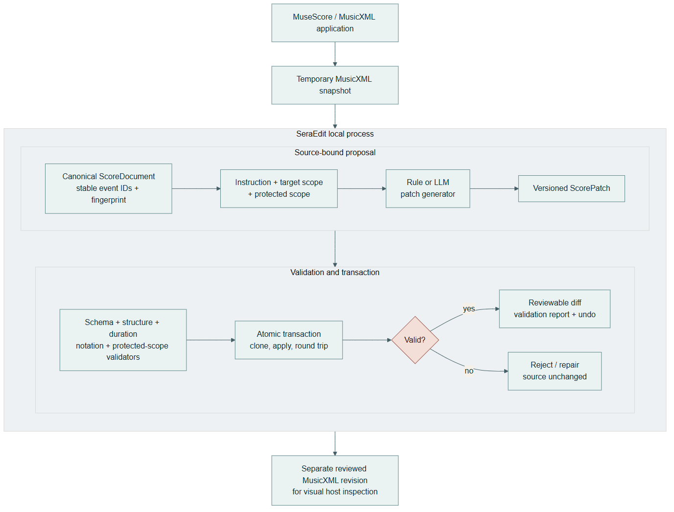
Figure 1. The notation host remains the visual source. SeraEdit produces a separate reviewed MusicXML revision or rejects the transaction while retaining the source.

2.2. Software functionalities
A ScoreScope deterministically selects measures, parts, staves, voices, event IDs, and optional time ranges. Each patch declares a target scope, a protected scope, and explicit exclusions. Its operations use a versioned JSON schema and describe selectors, arguments, preconditions, and expected change counts. Implemented research operations include pitch and duration changes, event insertion/deletion, dynamics, articulations, ties, slurs, signature changes, voice moves, motif duplication, chord replacement, and transactional batches. The product interface enables only operations whose host round-trip contract is established; unknown operations fail as unsupported rather than becoming silent no-ops.
Applying a patch is a transaction: validate the source fingerprint and schema; resolve selectors and preconditions; clone the score; apply operations; validate structure, exact measure duration, notation relations, semantic constraints, and protected scope; export/re-import MusicXML; then commit or roll back. The result includes machine-readable errors, a human-readable diff, fingerprints, and before/after snapshots for undo/redo. Deterministic repair is limited to transparent formatting or enum normalization. An optional model repair is bounded by a configurable attempt count and receives the validation errors and immutable scopes; it cannot bypass the transaction.
Provider adapters share a response contract recording model, latency, token use, estimated cost, request ID, finish reason, raw output, parsed output, and normalized errors. API keys are external to source and experiment artifacts. The desktop agent can respond locally first and refine a high-level plan asynchronously with an optional LLM, so provider latency does not block access to local safe candidates. Neither response is auto-applied.
The evaluation subsystem implements three conditions. full_rewrite accepts a complete MusicXML response without protected-scope repair. patch_only parses and basically applies a structured patch without the full safety pipeline. sera_full enables source fingerprints, scopes, layered validation, bounded repair/refusal, atomic apply, undo, and round-trip checks. Runs have immutable IDs, configuration and prompt hashes, retry and cost limits, caching, resumability, raw outputs, normalized outputs, and deterministic metric recomputation.

3. Illustrative examples
Consider the instruction: “Transpose measures 1–2 of staff 1 up two semitones and preserve rhythm; leave staff 2 unchanged.” SeraEdit binds the candidate to the imported fingerprint and resolves only pitched events in measures 1–2, staff 1. Preview applies the transposition to a clone. Duration equality is checked with rational values, staff 2 is compared event-by-event as protected content, and the exported MusicXML must parse, import, export, and parse again. A valid preview reports the exact changed event count; a stale fingerprint, missing event, duration change, or difference on staff 2 rejects and rolls back the whole patch.
The same workflow is available through the desktop interface or an optional MuseScore Studio 4 bridge. The bridge exports a temporary snapshot and selection context to the local Sera process. After proposal review, the bridge opens a separate reviewed revision in MuseScore. This is deliberately not described as in-place control of MuseScore's internal document: the original open score is not overwritten, and final visual review and saving remain user actions.
For offline verification, the repository contains 20 short CC0 synthetic scores and 120 tasks spanning transposition, rhythm, harmony/key, voice/texture, dynamics, insertion/deletion, ties/slurs, meter, compound edits, and expected refusal. Tasks carry target/protected scope and deterministic expected constraints. The fixture provider returns known outputs to exercise all runner and metric paths without network access or token cost.
On Windows 11 (build 10.0.26200), Python 3.12.5, Node.js 24.16.0, and npm 11.13.0, the 2026-08-27 verification produced the following results. Automatic benchmark validation accepted 120/120 task definitions. Human inspection then completed 120/120 current primary decisions and a stratified 30/30 repeat check with zero stale records; all current decisions were compliant after the correction cycle. The append-only export retains 194 records, including superseded revision findings. Both passes used the same pseudonymous reviewer, so these data verify task instructions, scopes, Gold outputs, and host-visible notation but do not measure inter-rater reliability. The Python suite collected and passed 404 tests. Vitest passed 120 tests in 72 files, the Vite production build transformed 216 modules, and staged backend, compatibility launcher, and Electron desktop runtime smoke checks passed. The fresh softwarex_verification_120_v1 fixture run completed all 360 expected task-condition cases with zero execution errors. Its verifier confirmed matching configuration, benchmark, prompt, dependency and metric evidence. These are software verification results, not evidence that a language model achieves perfect edits; the experiment manifest explicitly sets formal_results_allowed to false.
We additionally replayed every benchmark instruction through the interactive product entry point without supplying its Gold patch to generation. Across English and Chinese instructions and three independent repetitions, 720/720 runs completed generation or the expected refusal, transaction preview, atomic commit, protected-scope checking, deterministic constraints, and MusicXML export/re-import. All 660 executable runs produced valid MusicXML; 60 conflict runs refused safely; no unsafe execution occurred. Patch and result fingerprints were identical in all 240 repeated task-language groups. After correcting a Chinese preserve pitch/tenuto ambiguity exposed by cross-language comparison, all 120 task groups also produced semantically equivalent patches and identical final score fingerprints across English and Chinese. The compact publication snapshot retains all run metrics and hashes for all 1,380 raw and host evidence files, plus 220 host-openable outputs for complete task review. This establishes deterministic product-path acceptance, not remote-LLM accuracy or human musical quality.
We separately tested localization when the notation host supplied a wider selection than the measure named in the instruction. The robustness runner added one adjacent measure to each eligible explicit-measure request. It passed 240/240 bilingual runs; expansion was applicable in 174 runs, and all 174 retained the intended task result, protected content, and valid MusicXML. The remaining 66 tasks were not widened because the instruction did not name a specific measure, the source lacked an adjacent measure, or the operation was global. This regression set directly tests host-selection versus semantic-target resolution and remains deterministic product evidence, not model accuracy.

4. Impact
SeraEdit makes failure observable and reusable as research data. A rejected request is classified by stage—for example malformed patch, invalid selector, duration mismatch, broken relation, protected-scope violation, incomplete execution, over-editing, conflict, unsupported operation, or provider timeout—instead of being reduced to an application error. Raw outputs and post-hoc deterministic metrics support studies of which safeguards contribute to validity, task completion, non-target preservation, minimality, repair, and refusal behavior.
The software also lowers the cost of building controlled symbolic-editing experiments. Researchers can add public-domain fixtures and task constraints without creating a new front end, provider wrapper, transaction engine, or reporting pipeline. The mock path supports continuous integration, classrooms, and reproducibility checks, while API-backed runs remain clearly separated. A local desktop and MusicXML bridge make the same research contracts inspectable by composers and notation users rather than only by programmers.
Potential reuse extends beyond music: source fingerprinting, explicit editable/protected regions, typed operations, deterministic validators, and atomic rollback are applicable to language-guided editing of other structured scientific documents. Within music, the architecture provides a foundation for more rigorous human studies of interaction and musical quality without treating a model's output as ground truth.
Current evidence supports reliability engineering, human-checked benchmark semantics, and reproducible experiment execution, not universal musical correctness or aesthetic improvement. The fixtures are small and synthetic, and the repeated check was performed by the same reviewer rather than an independent panel. The canonical importer is strongest for common short MusicXML passages and does not establish universal handling of tuplets, grace relations, complex cross-voice notation, or every notation application. MuseScore has an exercised bridge; Sibelius interoperability is not yet verified. Live-provider quality, latency, and cost can change with model versions and networks. Structural orchestration and unrestricted composition remain outside the host-safe contract.

5. Conclusions
SeraEdit packages language-guided MusicXML editing as a source-bound, scoped, validated, and reversible transaction. Its principal contribution is an executable reliability boundary: the model proposes, while canonical score state, deterministic validators, protected-scope comparison, MusicXML round trips, and user review decide whether a revision exists. The open-source release candidate includes a desktop demonstration, host bridge, benchmark, three evaluation conditions, automated metrics, tests, and reproducibility tooling. Future releases will prioritize formal model comparisons, cross-host testing, richer exact notation relations, and independent blinded musician evaluation rather than weakening transaction safeguards.

Code metadata
Nr. | Code metadata description | Metadata
C1 | Current code version | 1.0.0-dev.14
C2 | Permanent link to code/repository used for this code version | https://github.com/Selancee/Sera (must be made public and tagged before submission)
C3 | Permanent link to reproducible capsule | [ZENODO OR CODE OCEAN DOI/URL]
C4 | Legal code license | MIT; benchmark data CC0-1.0
C5 | Code versioning system used | Git
C6 | Software code languages, tools and services used | Python, TypeScript/JavaScript, React, FastAPI, Electron, QML, PowerShell, MusicXML
C7 | Compilation requirements, operating environments and dependencies | Python >=3.10; Node.js/npm for development; Windows 10/11 desktop; dependencies in requirements.txt and npm lock files
C8 | Developer documentation/manual | docs/softwarex/API_REFERENCE.md, INSTALLATION.md, USER_MANUAL.md, and generated OpenAPI /docs
C9 | Support email for questions | [SUPPORT EMAIL]

Software metadata
Nr. | Software metadata description | Metadata
S1 | Current executable software version | 1.0.0-dev.14
S2 | Permanent link to executable | [RELEASE ASSET URL]
S3 | Permanent link to reproducible capsule | [ZENODO OR CODE OCEAN DOI/URL]
S4 | Legal software license | MIT
S5 | Computing platforms/operating systems | Windows 10/11 x64; source-level core also uses Python >=3.10
S6 | Installation requirements and dependencies | See docs/softwarex/INSTALLATION.md
S7 | User manual | docs/softwarex/USER_MANUAL.md
S8 | Support email | [SUPPORT EMAIL]

Author contributions
[AUTHOR NAME]: Conceptualization, Methodology, Software, Validation, Investigation, Data curation, Writing – original draft, Writing – review & editing, Visualization. Edit the roles to reflect actual contributions before submission.

Funding
[FUNDING STATEMENT OR: This research did not receive any specific grant from funding agencies in the public, commercial, or not-for-profit sectors.]

Declaration of competing interest
[THE AUTHORS DECLARE NO KNOWN COMPETING INTERESTS, OR INSERT THE REQUIRED DISCLOSURE.]

Data and code availability
Source code, synthetic benchmark data, test fixtures, evaluation configuration, and the non-formal verification run will be available from the tagged public repository and permanent archive listed in C2-C3. No API key is distributed.

References
[1] M. Good (Ed.), MusicXML 4.0, W3C Music Notation Community Group Final Report, 2021. [2] M. S. Cuthbert, C. Ariza, music21: A toolkit for computer-aided musicology and symbolic music data, ISMIR, 2010, 637–642. [3] C. Raffel, D. P. W. Ellis, Intuitive analysis, creation and manipulation of MIDI data with pretty_midi, ISMIR Late-Breaking/Demo, 2014. [4] R. Yuan et al., ChatMusician: Understanding and generating music intrinsically with LLM, Findings of ACL, 2024. [5] Z. Zhou et al., Can LLMs “reason” in music? An evaluation of LLMs' capability of music understanding and generation, ISMIR, 2024. [6] J. Guo et al., CodeEditorBench: Evaluating code editing capability of large language models, arXiv:2404.03543, 2024. [7] A. M. Smith, D. S. Katz, K. E. Niemeyer, FORCE11 Software Citation Working Group, Software citation principles, PeerJ Computer Science 2 (2016) e86. https://doi.org/10.7717/peerj-cs.86.

