**Reg No.: EG/2020/3894**

**Name : Didulani P.K.S**

**Date : 01/06/2024**

**Implement the FCFS scheduling algorithm.**

#include<iostream>

using namespace std;

#include<vector>

#include<map>

int main(){

    // get the number of processes

    int number_of_processes;

    cout<< "Enter the number of processes: ";

    cin >> number_of_processes;

    cout <<endl;

    // map to store the arrival time and burst time of each process. Here key is arrival time and value is burst time

    map<int, int> process;

    // Get the arrival time and burst time of each process in a single line

    cout << "Enter the arrival time and burst time of process separated by space: "<<endl;

    for (int i = 0; i < number_of_processes; i++) {

        int arrival_time, burst_time;

        cin >> arrival_time >> burst_time;

        process[arrival_time] = burst_time;

    }

// array to store the completion time of each process

    vector<int> completion_time(number_of_processes);

    // get the completion time of each process

    int temp=0;

    int index =0;

    for(const auto& i: process){

        if(i.first == 0){

            temp=  i.second;

        }else{

            temp = i.second + temp;

        }

        completion_time[index] = temp;

        index++;

    }

    // array to store the turnaround time of each process

    vector<int> turnaround_time(number_of_processes);

    // get the turnaround time of each process

    int temp1=0;

    for (auto i: process){

        turnaround_time[temp1] = completion_time[temp1] - i.first;

        temp1++;

    }

    // array to store the waiting time of each process

    vector<int> waiting_time(number_of_processes);

    // get the waiting time of each process

    int temp2=0;

    for (auto i: process){

        waiting_time[temp2] = turnaround_time[temp2] - i.second;

        temp2++;

    }

    // print the average waiting times

    int sum =0;

    for(int i=0; i<number_of_processes; i++){

        sum = sum + waiting_time[i];

    }

    double average_waiting_time = sum/number_of_processes;

    cout << "\n\nAverage waiting time: " << average_waiting_time <<endl;

}

**Output of the FCFS algorithm,**

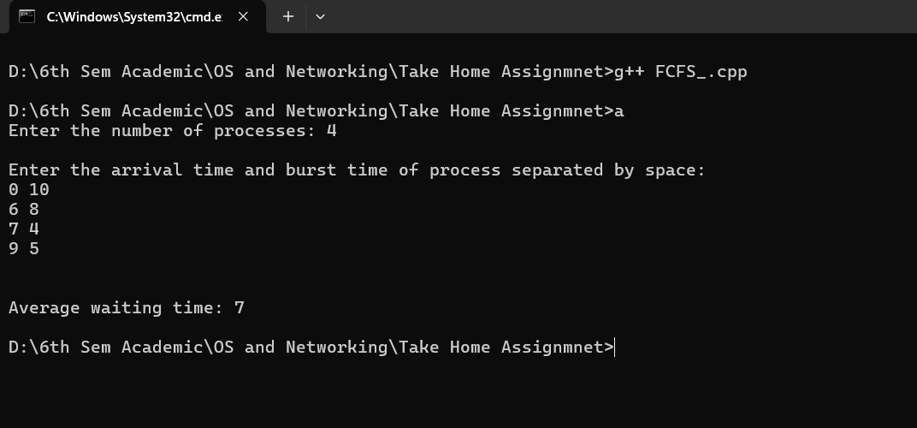

**Implement the SJF scheduling algorithm.**

#include <iostream>

#include <algorithm>

#include <cstring>

using namespace std;

int main() {

    // Define a structure to represent each process

    typedef struct process {

        int arrival_time, burst_time, completion_time, turnaround_time, waiting_time, btt;

        string pro_id; // Process ID

    } Schedule;

    // Comparison function to sort processes by arrival time

    auto compare = [](Schedule a, Schedule b) {

        return a.arrival_time < b.arrival_time;

    };

    // Comparison function to sort processes by burst time

    auto compare2 = [](Schedule a, Schedule b) {

        return a.burst_time < b.burst_time;

    };

    Schedule pro[10]; // Array to store processes

    int n, i, j, pcom; // n: number of processes, pcom: processes completed

//i & j = iterative variables

    cout << "Enter the number of Processes: ";

    cin >> n;

    cout << "Enter the arrival time and burst time of process separated by space: \n";

    // Input process details

    for (i = 0; i < n; i++) {

        cin >> pro[i].arrival_time;

        cin >> pro[i].burst_time;

        pro[i].btt = pro[i].burst_time;

    }

 // Sort processes by their arrival time

    sort(pro, pro + n, compare);

    i = 0;

    pcom = 0;

    // Loop until all processes are completed

    while (pcom < n) {

        // Find the processes that have arrived by the current time

        for (j = 0; j < n; j++) {

            if (pro[j].arrival_time > i)

                break;

        }

        // Sort the arrived processes by burst time

        sort(pro, pro + j, compare2);

        // If there are processes that have arrived

        if (j > 0) {

            // Find the first process that is not yet completed

            for (j = 0; j < n; j++) {

                if (pro[j].burst_time != 0)

                    break;

            }

            // If the next process's arrival time is in the future, skip time to its arrival

            if (pro[j].arrival_time > i) {

                i = pro[j].arrival_time;

            }

            // Update the completion time of the current process

            pro[j].completion_time = i + 1;

            // Decrement the remaining burst time of the current process

            pro[j].burst_time--;

        }

        i++; // Increment current time

        pcom = 0; // Reset completed process count

        // Count the number of processes that are completed

        for (j = 0; j < n; j++) {

            if (pro[j].burst_time == 0)

                pcom++;

        }

    }

double sum = 0;

    double avg_wait_time;

    // Calculate turnaround time and waiting time for each process

    for (i = 0; i < n; i++) {

        pro[i].turnaround_time = pro[i].completion_time - pro[i].arrival_time;

        pro[i].waiting_time = pro[i].turnaround_time - pro[i].btt;

        sum += pro[i].waiting_time; // Add waiting time to sum

    }

    // Calculate average waiting time

    avg_wait_time = sum / n;

    cout << "\nAverage waiting time: " << avg_wait_time << endl;

    return 0;

}

**Output of the SJF algorithm**

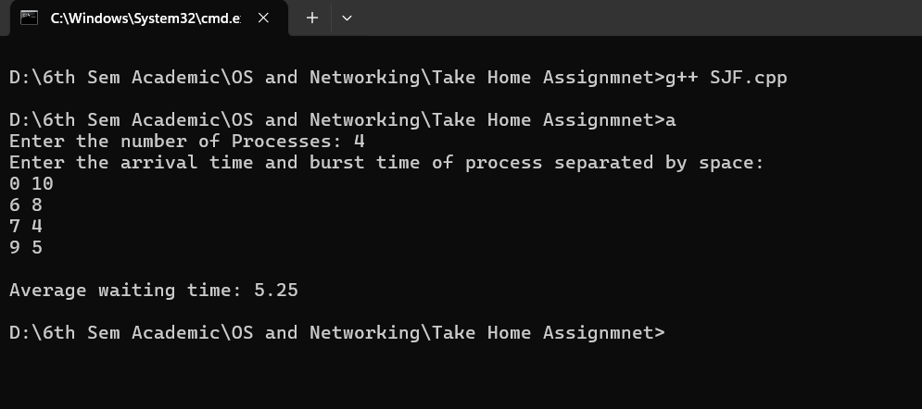

**Implement the RR scheduling algorithm.**

#include <iostream>

#include <vector>

using namespace std;

int main() {

    int i, n, time, remain, temps = 0, time_quantum;

    // wt=Total waiting time, tat=Total turnaround time

    int wt = 0, tat = 0;

    // get number of processes

    cout << "Enter the total number of processes: ";

    cin >> n;

    // Initialize the remaining processes counter

    remain = n;

    // Define vector arrays for arrival time, burst time, and remaining time for each process

    vector<int> at(n);

    vector<int> bt(n);

    vector<int> rt(n);

    // get the arrival time and burst time of each process

    cout << "Enter the arrival time and burst time of processes separated by space:" << endl;

    for (i = 0; i < n; i++) {

        cin >> at[i] >> bt[i];

        rt[i] = bt[i]; // Initialize remaining time with burst time

    }

    // Get the time quantum

    cout << "Enter the value of time QUANTUM: ";

    cin >> time_quantum;

 // Start the scheduling algorithm

    for (time = 0, i = 0; remain != 0;) {

        // If remaining time for the current process is less than or equal to time quantum and greater than 0

        if (rt[i] <= time_quantum && rt[i] > 0) {

            // Update time with the remaining time for the current process

            time += rt[i];

            // Set remaining time for the current process to 0

            rt[i] = 0;

            // Set flag to indicate that the process has finished executing

            temps = 1;

        } else if (rt[i] > 0) {

            // If remaining time for the current process is greater than 0, decrement remaining time by time quantum

            rt[i] -= time_quantum;

            // Update time with the time quantum

            time += time_quantum;

        }

        // If the current process has finished executing

        if (rt[i] == 0 && temps == 1) {

            // Decrement the remaining processes counter

            remain--;

            // turnaround time for the current process

            int turnaround_time = time - at[i];

            // waiting time for the current process

            int waiting_time = turnaround_time - bt[i];

            // Update total waiting time

            wt += waiting_time;

            // Reset flag indicating that the process has finished executing

            temps = 0;

        }

        // Determine the next process to execute based on arrival time and time quantum

        if (i == n - 1) {

            i = 0; // Wrap around to the beginning of the process queue if reached the end

        }

        // check if the arrival time is less than or equal to the current time

        else if (at[i + 1] <= time) {

            i++; // Move to the next process if so

        }

        else {

            i = 0; // otherwise reset to the beginning of the process queue

        }

    }

// Output average waiting time

    cout << "\n\nAverage waiting time: " << (double)wt / n << endl;

    return 0;

}

**Output of the RR algorithm,**

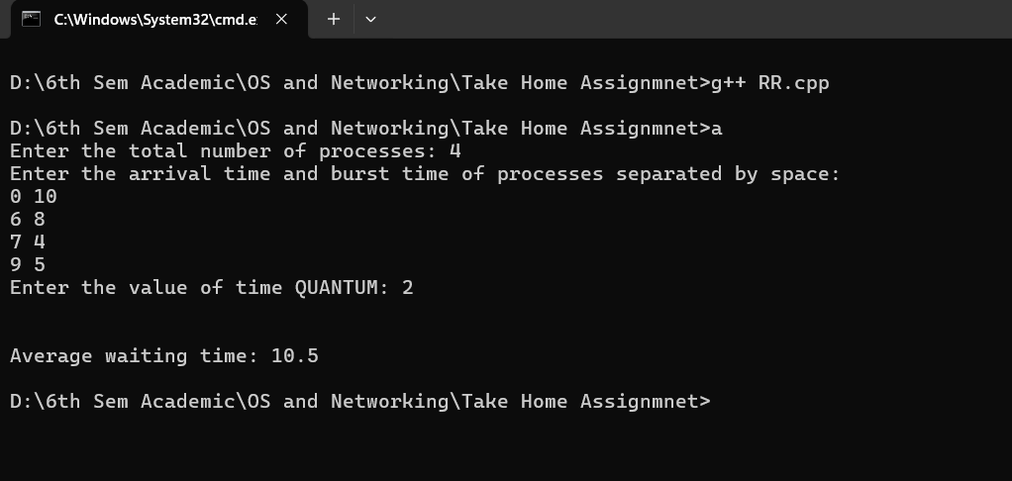

**Analysis comparing the performance of the algorithms based on average waiting time.**