**MODULE 1**

**Lesson 1**

Java is OOP language.

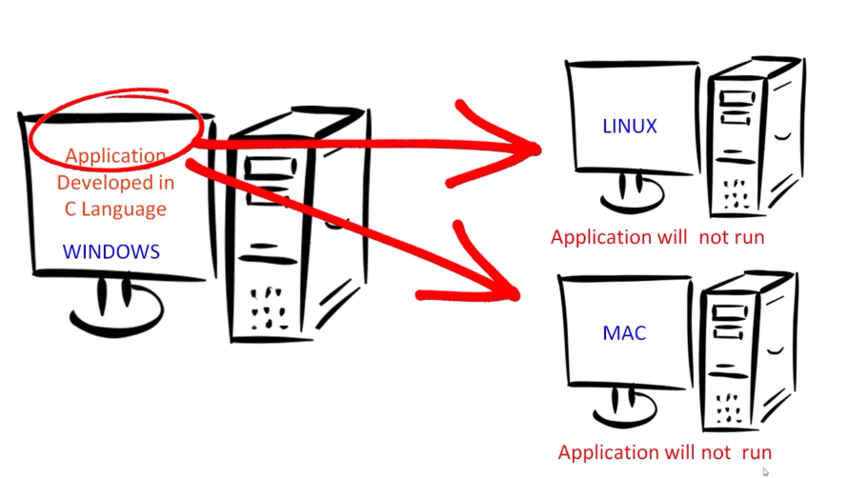Java is a language that is not tied to ant particular hardware or operating system.

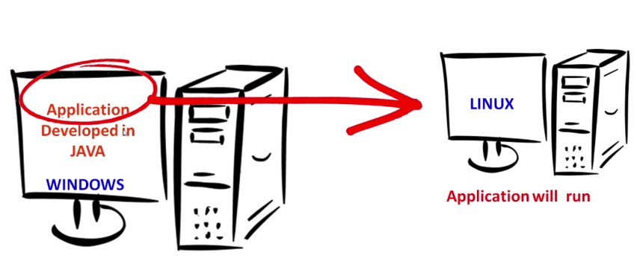Java is not like that. Here C is platform dependent language

**Lesson -2**

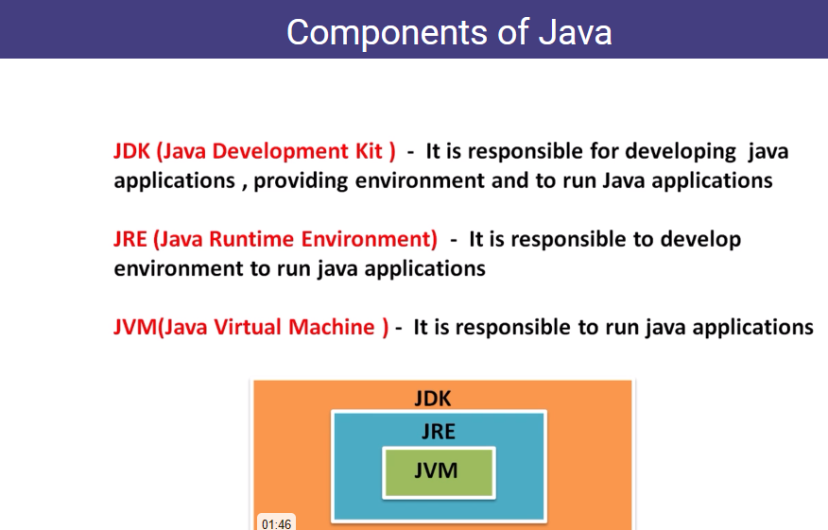

* Once the JRE install we can use JVM . It automatically installed.

When we installed JDK then all are available.

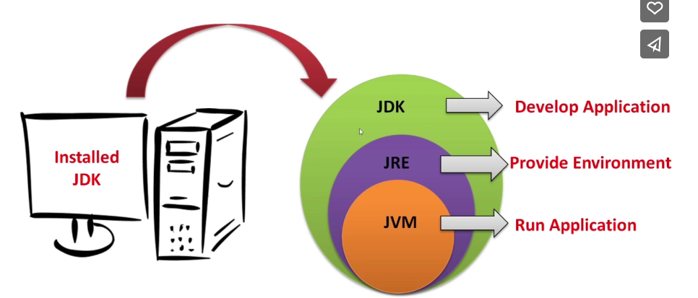

* To run Java application for all window, mac and linux operation system we need JVM.

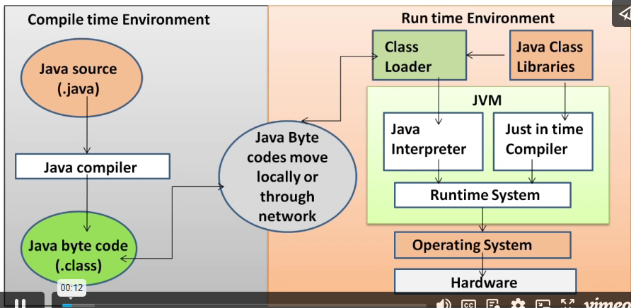**Lesson -3 – Why java platform independence**

1. Class Loader- check the bytes coming from machine 1
2. Java Interpreter- to generate intermediate code.
3. Just in Time Compiler - Generate native code

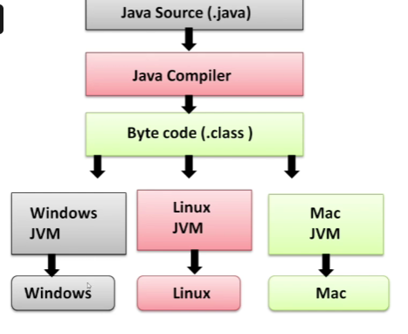Java compiler convert source code to byte code(Class).

Them each OS have it’s JVM.

**Lesson 4 : Platform Dependent and Independent language**

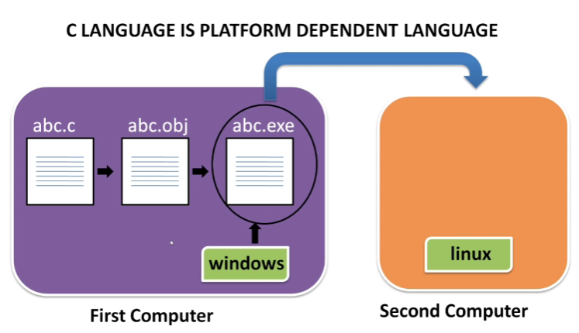

Here the abc.c is not run in the second computer.

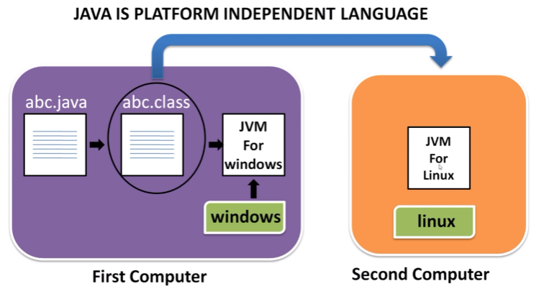

**MODULE 2**

**Lesson 1**

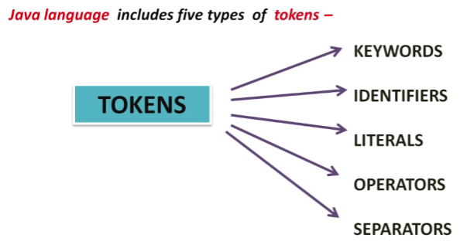Jave Tokens – Smallest individual units in a program are known as token.

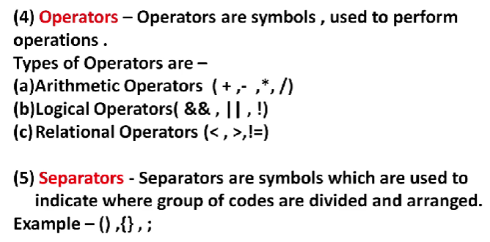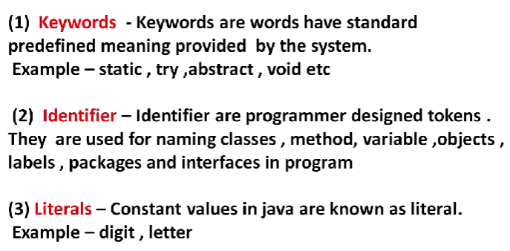

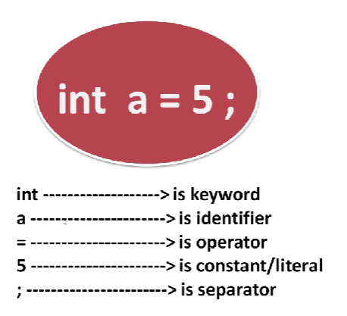

There are two data types.

* Primitive
* 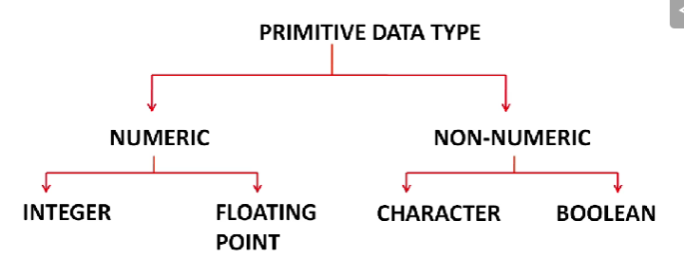Non primitive

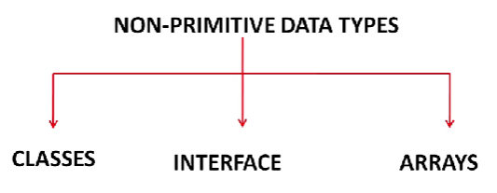

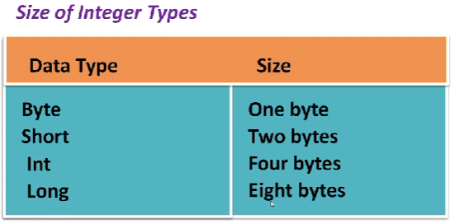Integer can be categorize into,

* Byte
* Short
* Int
* Long

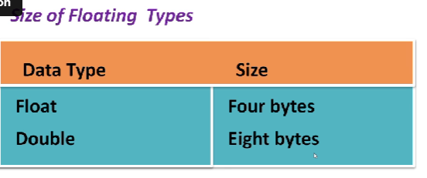Floating date type

* Float
* Double

**Lesson 2 : Features of Java**

* Platform Independent
* Object-Oriented
* Distributed
* Multithreaded
* Secure and Portable

**Module 3**

Basic programming steps

1. Sequence - Not have to take decision
2. Selection – Take a decision
3. One-way Selection
4. Two-way Selection
5. Multiple Selection
6. Loop – Set a condition and ittarete

Scanner is pre define class in java. It is inside the util.Scanner