**GROUP 2**

Gaffar Alhassan

Augustine Selase Adotri

Jonathan Asmah

Daniel Aba Frederick

Olakojo Olalekan Opeyemi

**CITY BIKE TRIP DATA ANALYSIS**

In the analysis, we examined number of trips completed by the bikers within a given period of time with Power BI.

The project is a comprehensive analysis of 5794 bikers. The total trip duration for all the bikers is 792937968 minutes. The purpose of the analysis is to determine the top 10 bikers and their trip duration.

Data Collection and Preparation

The data for the analysis was collected from a reputable source Citibikenyc, and processed to ensure accuracy. The data include these variables:

1. BikeId
2. Trip duration
3. Start Time
4. Stop Time
5. Usertype

The Total number of Bikers was calculated by counting distinctively the number of bikeid’s.

The Total trip duration was also calculated by summing all the trips taken by the bikers.

A trend analysis was also conducted to know and understand the overall trip by the bikers. This was done by creating a pie chart of the total trip duration by bikeid. The chart helped to know the bikers who had taken the most trips.

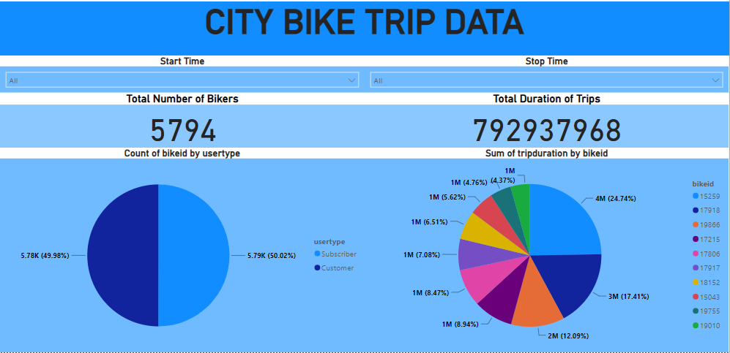

**TOP 10 BIKERS BY TRIP DURATION**

An analysis was carried out to identifier the top 10 bikers by total trip duration. The total trip duration was calculated by summing the trip duration for each biker. The top 10 bikers were then ranked in descending order in a clockwise manner.

**CONDITIONAL FORMATTING**

Conditional formatting was applied to the charts to highlight the difference in their rankings. 10 colours were picked to represent each bikeid. This helped to quickly identify the bikeid of each biker.

**CONCLUSION**

The analysis provided a comprehensive view of the trip durations of the 5794 bikers over time and also helped to identify the top 10 bikers with the highest trip durations.