

Enterprise Resource Planning

ERP

Selçuk Çalışkan-14030411041

Bedia AYDINLI -1403041137

Zeynep ALTUNKAYNAK-15030411030

Hatice Özgenur GÖŞELİ – 15030411014

Barış ÖZER- 15030411021

Muhammed Topgül-15030411040

**[Assoc. Prof. Dr. KEZİBAN SEÇKİN CODAL](https://neu.edu.tr/akademik/fakulteler/iktisadi-ve-idari-bilimler-fakultesi/akademik-kadro/doc-dr-tunc-durmus-medeni/?lang=tr)**

TABLE OF CONTENT

INTRODUCTION 3

Departments 4

The Difference Between MIS And ERP Software 5

ERP Basic Principles 6

The main functions of ERP-systems 6

Who uses ERP systems 7

Business Value of ERP 7

Positive and Negative Properties of ERP Systems 8

HISTORY OF ERP 10

Today: A New ERP Serving Model 12

Software as a Service (SaaS) 12

Future of ERP 13

What Types of Companies Use ERP Programs? 13

Top ERP Software Comparison List 15

WHY is ERP Necessary? …………………………………………………………… 15

Benefits of ERP to Businesses ……………………………………………………. 15

Function of ERP Systems …………………………………………………………… 16

-ERP system Picture

-Use of which Platforms ERP Graph

Explain ERP with an Example Think of a script about ERP? ……………………… 20-21

-Three different images related to the sample

Factors in the successful progress of ERP ……………………………………….... 21

The Best ERP Solutions …………………………………………..…………… 22-29

# Microsoft Dynamics 365 …………………………………………..…………… 2-24 Sage100cloud …………………………………………..………………………. 24-26

# Deltek ………………… …………………………………………..…………… .27 Deltek Vision …………………………………………..………………………. 28

Epicor ………………… …………………………………………..……………28-29 Epicor ERP Features ………………………………………..……………………29

ERP Failure ………………………………………………………………… 30-31-32

-Reasons of ERP fails images

The Main Reasons for the Negative Results of ERP Projects …………………. 32-33

General ERP Issues ………………………………………………………………... 34

-Statistical images related to the problems encountered in ERP

**ERP APPLICATION REVIEW with BILNEX** ……………. 34-35-36-37-38-39-40-41-42-43

# INTRODUCTION

Enterprise resource planning (ERP) provider of accounting , purchasing , project management , compliance with risk management and legislation, further supply chain operations refers to a type of software used to manage daily business activities like. A complete ERP product set also includes Enterprise Performance Management software that helps plan, budget, estimate and report an organization's financial results .

ERP systems combine many business processes and provide data flow between these business processes. ERP systems collect the organization's common transaction data from multiple sources, eliminating data duplication and ensuring data accuracy with a single source of accuracy.

ERP systems are critical today in the management of thousands of businesses of all sizes from every industry. ERP is indispensable for these companies, just like electrical energy.

Even when you search the word "ERP" on the Internet, we can find different definitions. This makes ERP a subjective phenomenon for business and an important phenomenon for business but all ERP systems have a common database. In other words, employees in different departments benefit from the common database for their needs.

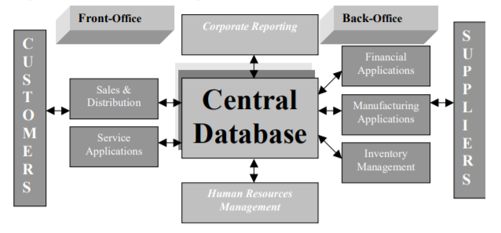

Figure 1

## 

## Departments

These departments are generally as follows;

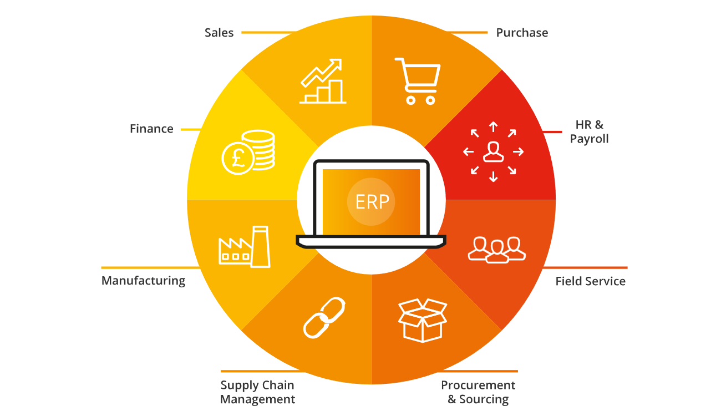

**\* Production:**

- Material listing operations

- Capacity analysis

- Work Order management

- Quality control

- Cost management

- Production operations

- Production flows

**\* Supply chain management:**

- Inventory management

- Order entry

- Buy

- Product configuration

- Supplier charts

**\* Financial Management:**

- General ledger

- Cash management

- Cash outlets

- Cash receipts

- Fixed assets

**\* Project management:**

- Cost calculation

- Listing operations

- Time and expenditure analysis

- Activity management

**\* Human Resources Management:**

- Human Resources

- Payroll

- Employee working time and continuity

**\* Customer relations management:**

- Sales & Marketing

- Commissions

- Services

- Customer contracts

- Helpline support

**\* Personal and public user interfaces for customers, suppliers and employees**

# The Difference Between MIS And ERP Software

MIS and ERP are widely used in sales, marketing, finance, logistics and other industries to track business data and make weighted operational and management decisions. The difference between them is that MIS is the designation of systems that control any kind of information, and ERP is a specific type of information. That is, the first is a particular and / or element of the second.

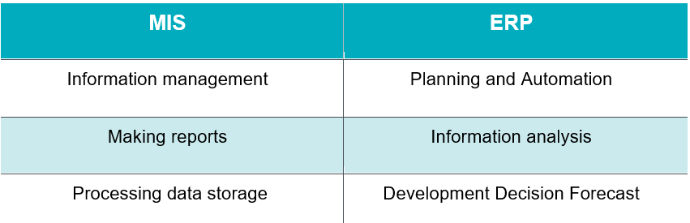

The main differences between MIS and ERP; As stated at the very beginning, an enterprise resource planning (ERP) system is a special case and / or element of a management information system (MIS). The main difference between the two:

1. **MIS** is mainly reporting. Such software collects, stores and processes information from various sources.
2. **ERP** is responsible for the automation of business processes and accounting related to the management of company resources. In addition, ERP monitors the current state of the business, analyzes it and helps to make forecasts for future activities and development.

Or, roughly speaking, **MIS** is information in the general sense, and ERP is information about resources. By analogy with how there are cars, and there are sports cars.

## ERP Basic Principles

ERP systems are generally designed to use a single, defined data structure (schema) on a common database. This helps to normalize the information used throughout the organization and to make it based on general definitions and user experiences. These basic structures are then interconnected with the business processes brought by the workflows in the business departments (eg finance, human resources, engineering, marketing, operations), providing links between the systems and the people who use them. In short, ERP is used to integrate people, processes and technologies in a modern company.

For example: Consider a company that produces cars by purchasing parts and components from multiple suppliers. Requesting and purchasing these goods can also use an ERP system to ensure that each component throughout the entire process, from purchase to payment, uses properly formatted and clean data linked to integrated corporate workflows, business processes, reports and analytics. When ERP is properly deployed to this automotive manufacturing company, for example the "front brake pads" component; part name, size, material, source, lot number, supplier part number, serial number, cost and technical information, as well as other descriptive and data oriented elements. Since the data is the lifeblood of every modern company, ERP.

ERP ensures that these data fields and qualities are included in the general records of the company with the correct account, so that all costs are properly monitored and represented. If the front brake pads are called "front brakes" in one software system (or perhaps in a series of spreadsheets), "brake pads" in another, and "front pads" elsewhere, the automotive manufacturing company changes the amount of years spent on the front brake pads, or more it will be difficult to figure out if he has to bargain for the good price.

Centralized data collection for broad distribution is one of the basic ERP principles. Instead of using multiple databases with a bottomless inventory of spreadsheets that are not interconnected, ERP systems checks the complexity to ensure that all users, from the CEO to debt accounts officers, create, store and use the same data derived from common processes. Thanks to a secure and centralized repository, everyone in the organization can be sure that the data is accurate, current and complete. Data integrity is ensured for every task performed throughout the organization, from using error-prone spreadsheets to quarterly balance sheets to outstanding claims reports.

## The main functions of ERP-systems

1. **Accounting**. Data collection and management of accounts receivable and payable, tax payments, payroll and time tracking. To track the status and manage accounting, ERP-systems use special tools that are usually created for a specific jurisdiction.
2. **Production**. A common centralized interface for managing production processes: procurements, budgeting, forecasting and planning. This makes it easier to work with suppliers and customers.
3. **Business analytics**. Collection, storage and analysis of data that are generated during the work of the enterprise for making more effective management decisions.
4. **Communication**. A common database accelerates workflows and enhances employee discipline.

**ERP application area**

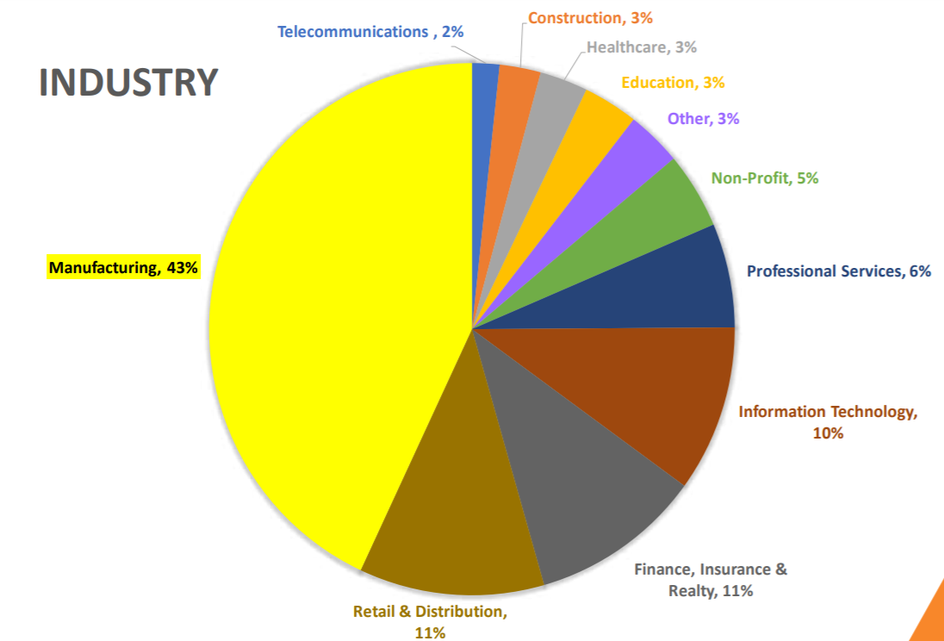

## Who uses ERP systems

[Panorama studies have shown](https://www.panorama-consulting.com/wp-content/uploads/2016/07/2016-ERP-Report-2.pdf), that 80% of enterprises are either in the process of implementation or are already using [ERP systems](https://merehead.com/blog/build-erp-system-scratch/). This is mainly a business in the field of retail, logistics, production, distribution, finance, real estate and information technology. Recently, ERP solutions based on distribution registers have been popular: block chain, Tangle, Hash graph.

## Business Value of ERP

The impact of ERP in today's business world cannot be ignored. As corporate data and processes are collected in ERP systems, businesses can achieve significant savings by harmonizing individual departments and improving workflows .

Some examples of specific business benefits:

* Improved business insights : derived from real-time information generated by reports
* Lower operating costs : Regular business processes and the ideal application is provided
* Increased collaboration : Provided by users sharing data in contracts , requests and purchase orders
* Productivity increase : Achieved through a common user experience in many business functions and well-defined business processes
* Consistent infrastructure : From the back office to the front office, all business activities give the same look and feel
* Higher user adoption rates : achieved through a common user experience and design
* Reduced risk : Improved data integrity and financial controls are provided through
* Lower management and operational costs : Provided with properly formed and integrated systems

# 

# Positive and Negative Properties of ERP Systems

In order to show what ERP offers to a business, information will be given about the modules in it. Although ERP modules; Although it is classified into many sub-modules such as sales, purchasing, accounting, production, engineering management, project management, warehouse management, human resources, customer relationship management, quality management, document management system, maintenance management, business models (Netsis, 2008). The following information is given only on the most commonly used stock management and production, purchasing, sales-distribution and material requirement planning modules (Özkan, 2008):

* Inventory management and production module: It covers the processes related to the inventory, from the entrance of the materials purchased for the enterprise to the sale of the products to the customer. The company may have warehouses for different purposes (main warehouse, scrap warehouse, escrow warehouse, red warehouse, etc.) and hierarchies between warehouses. Location, bunk / eye, etc. in each warehouse. may have different features on the basis of qualifications. All these definitions can be made by the system provided with ERP with the desired flexibility.
* Purchasing module: It covers the process of determining the requests coming to the business from the departments or material requirement planning, including automation, reporting to the vendor, tracking and receiving. These transactions are performed automatically and suppliers can be alerted immediately when the amount of inventory falls below a certain amount with the specified parameters. Thanks to this system, which will be described as an advanced stage of the JIT system, production continues uninterruptedly.
* Sales-distribution module: It covers the process from receiving the customer's finished product orders to delivery after production. Sales and distribution; the structure of the information system, the business areas of companies, their geographical spread, product types, etc. they may change according to the criteria. For example, one company created a distribution channel for retail, unlike the others, while the other can only wholesale. Systems provided with ERP show the user the flexibility of this definition.
* Material Requirements Planning Module: Uses complex, interrelated information from all other modules and reaches results based on material, quantity and date in general. Thus, the general material requirement of the enterprise can be revealed.

As it is seen, integrating all the functions of the enterprise mentioned in the previous section and mentioned in the definition of ERP is realized by working together of various modules as described above. The main ones are to create an institutional resource to meet the company's consistent information needs, to reach up-to-date and reliable data on the first try, and to integrate business systems under one roof as much as possible. Other reasons that direct businesses to ERP software are as follows (Davenport, 2000):

* Automation of works in the background,
* Integrating customer order information and financial information for better coordination between business processes, increasing the service quality level by standardizing the production process and human resources, increasing individual and organizational efficiency,
* Coordination between the units away from each other geographically,
* Providing terminology unity between different units of the institution,
* To have consistent application logic, consistent information and interface that facilitates understanding and working in the information technology infrastructure,
* The existence of a single system that makes it easier to manage the information technology infrastructure,
* The need for easy access to data in order to improve strategic business decisions,
* Expectation of decrease in operating costs,
* Expectation to increase customer contribution in the processes and
* The need for integration between business functions

It can be listed as.

* After listing the reasons needed for ERP software, it is necessary to mention the positive and negative features of these software. As with any technological development, ERP systems have positive and negative features. According to Microsoft, having a full ERP solution has many important advantages over piecemeal applications. These are listed below (Microsoft, 2008):
* Scalability: ERP solutions, has expanded in parallel with the organization's ability to grow. This system is due to the parametric and flexibility.
* Functionality: ERP solutions makes it possible to access different functions when needed at reasonable cost. A feature not needed today will be activated and used later.
* Support and services: It is extremely important in ERP solutions and support services. Support and service operations of an integrated ERP environment can be carried out much more simply and effectively.
* Security: industrial espionage, especially domestic institutions and a number of features that protect against operational risks is available in the ERP system.

ERP systems contain many negative factors in addition to the positive aspects above. These are also mentioned below:

* Success depends on labor qualifications and experience. This includes training on how the system can work properly. Many businesses are making cuts in their training budgets to cut costs. In small private enterprises, ERP systems are generally used by people who do not have enough knowledge about the subject.
* Companies can hire a new manager who does not have sufficient training on the ERP system used. The hired employee may not achieve integrity between the business subject and the existing ERP system.
* The possibility of customizing an ERP system according to the current company is limited. Customization in some systems can change the structure of the ERP system, but most systems usually do not allow it.
* Recommended by the ERP system, a re-engineering process in the industry standard, it may lead to the loss of the company's competitive advantage.
* Building an ERP system can be very expensive. It has been observed that it starts from 500,000 USD for small companies and can reach up to 15 million USD for large companies (Bayraktar, Efe, 2008).
* ERP systems are often custom workflow and work area of the system have to be adapted. This is the main source of various losses of companies.
* The use of the system is not easy.
* A department or user who is inefficient or unable to use the system may also adversely affect other departments or users.
* It may cause problems such as uncertainty in the business borders, accounting transactions, reliability and employee morale.
* Due to the difficulty of sharing sensitive internal information between departments, the efficiency of the software may decrease.
* Adaptation problems caused by various old systems frequently occur in departments.

# HISTORY OF ERP

DRP

CB.

ERP 2

ERP

MRP 2

MRP

I.M

CIM

1960s 1970s 1980s 1990s 2000s 2010s

Figure 2

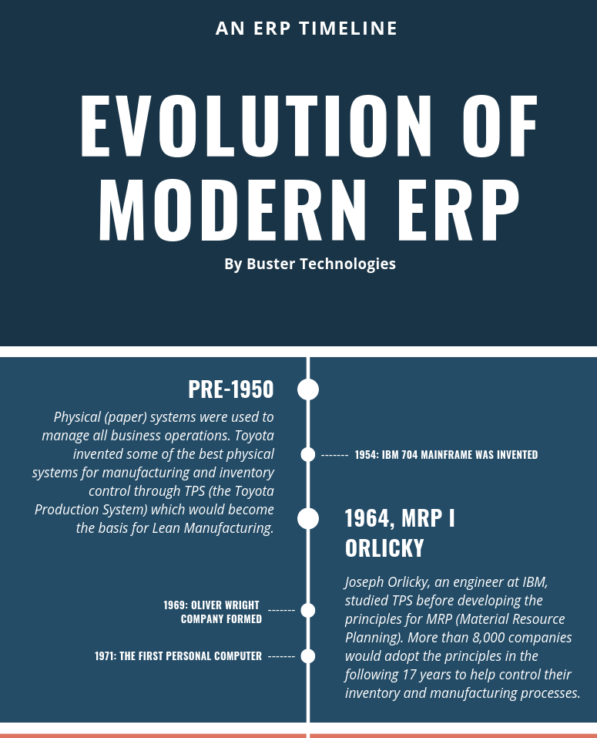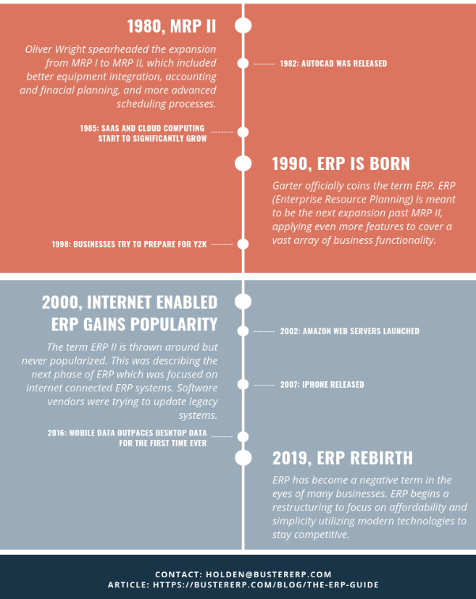

The definition of Enterprise Resource Planning, which was born with the integration of MRP, MRP II, CRP and DRP in the early 1990s, can be defined as the implementation of standard software modules developed for basic business processes, often with customizations expressed for competitive differences.Enterprise Resource Planning is a system that combines all departments of a business under a single computer system. With this common information system, all necessary data is made available to the employees in a single database. Due to its integrated ERP structure, it provides functionality by gathering all data in a single database and enables different departments with different needs to work in harmony with each other and to share better information between them. According to the definition of APICS (American Production and Inventory Control Society), Enterprise Resource Planning Systems include the purchase, fulfillment, delivery, and accounts and reports of customer orders for effective planning and control of all necessary resources. provides a method.Today, when we look at the internet or written sources, we see that there is information pollution on Erp's history. This is due to the different interpretation and different names of the stages in the process of the emergence of ERP rather than wrong information. Especially between 1960 and 1980, for example, MRP and MRP2. But from a broad perspective, this painting will lead us to the truth.(Figure 2.)

**Inventory Management & Control (the 1960s)**

Inventory management and control buys materials and gives dopes and retailers the product. So, inventory management does this;

-What are the inventory requirements?

-Determines the purpose.

-Tells the inventory stock etc.

**Material Requirement Planning (MRP)(the 1970s)**

MRP was first found in 1964. The first Toyota company used. It was used in the early

1970s. Allows planning, scheduling and inventory control for more efficient production.

**Manufacturing Requirements Planning (MRP II) (the 1980s)**

Unlike MRP 1, MRP2 has machine capacity scheduling, demand forecasting, quality assurance , general accounting

**Enterprise Resource Planning (ERP) (the 1990s) ( From the Company to the Cloud)**

It has a single database. It aims to improve the performance of the business process.

1990s to the beginning of the twenty-first century, ERP was put into use at an increasing pace. At the same time, the cost of using an ERP system began to rise. The hardware needed to run the software was usually large machines in a company-owned facility, in the server room. Both hardware and software licenses required capital investments, which lost their value for 5 to 10 years. In addition, organizations often wanted to customize ERP systems to suit their needs. This incurred additional costs for software consultants and training

Meanwhile, ERP technology has continued its evolution by adopting the Internet, with new features and functions such as embedded analytics. Over time, more and more organizations have discovered that internal ERP systems cannot keep up with modern security demands or emerging technologies such as smartphones.

**Web Functionalities with Internet (ERP II) (the 2000s)**

ERP was associated with other applications.(CRM). Access to information made easy. Technological progress was associated with ERP and SOA.

**Cloud-based ERP (the 2010s)**

Android, iOS, and browser applications are developed for delivering ERP software in the SaaS model.

# Today: A New ERP Serving Model

### Software as a Service (SaaS)

Cloud, especially software as a service (SaaS), has become a priority model for ERP. When ERP software is offered as a service in the cloud, it operates on the remote server network instead of the server room in the company. Instead of making expensive upgrades every 5 to 10 years with the on-premises system, the cloud provider patches, manages and updates the software several times a year. Cloud can reduce both operating costs (OpEx) and investment expenses (CapEx), as it eliminates the need for companies to purchase software and hardware or hire additional IT employees. These resources can be used instead to invest in new business opportunities, and the organization always uses the latest ERP software. Employees can focus on higher value-added tasks such as innovation and growth instead of IT management .

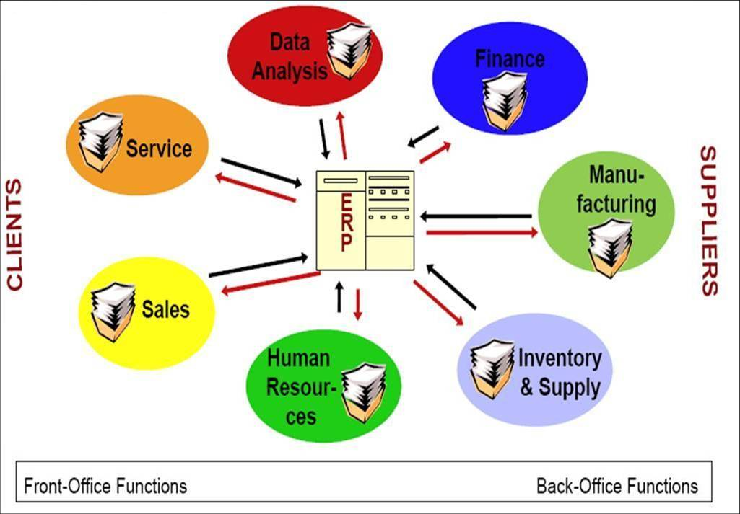

# Future of ERP

ERP has always progressed and aligned with technological progress. Artificial intelligence, machine learning, block chain, big data will be seen in Erp applications in the future.

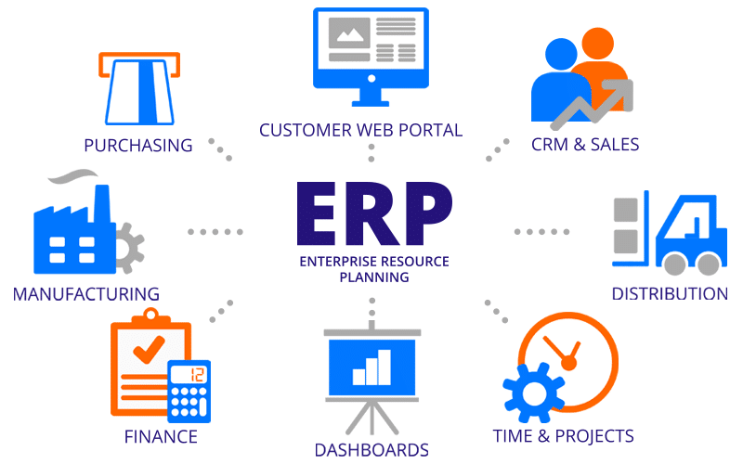

# What Types of Companies Use ERP Programs?

Many large companies and small companies used ERP system. Some of these are those;

* **Big-Box Retailers**

Most big-box retail stores use ERP systems to communicate information between individual retail locations, distribution centers, corporate headquarters and suppliers. Because big-box retailers maintain millions of items in inventory spread across multiple areas, an ERP system is the only feasible way to manage all of the data. ERP systems collect individual sales data from each of the retailer’s locations and send that data to the home office for sales and accounting purposes. It also sends data to the distribution center for inventory stocking purposes; in some instances, it sends data to the supplier for purchasing purposes. Many of the big-box retailers use collaborative planning, forecasting and replenishment (CPFR) demand planning techniques with their suppliers. The use of an ERP system makes this method of demand planning more acceptable to suppliers because it gives suppliers direct access to certain key pieces of customer information.

* **Manufacturers**

Many manufacturing companies rely on ERP systems to communicate data between departments such as production, shop floor planning, purchasing and accounting. ERP systems are the outgrowth of material requirements planning (MRP) systems. An MRP system calculates the necessary inventory and component requirements for production, and it keeps the production priorities up-to-date. MRP systems, however, cannot communicate with other systems (such as AP/AR and purchasing) within an organization. MRP grew into MRP II, which recognized the need to add supplier communication into the loop. MRP II later transformed into ERP. ERP systems give manufacturing companies a more effective communication tool between internal departments and external suppliers. Many manufacturing companies that use just in time (JIT) inventory management allow external suppliers to integrate with their ERP systems. This integration allows suppliers to make proactive inventory decisions based on real-time data.Pharmaceutical.

* **3PL Providers**

Many third-party logistics providers (3PLs) use ERP systems to manage internal business requirements and external client requirements. 3PL companies’ act as specialists in various areas of the supply chain industry. Some 3PL providers specialize in warehousing and logistics, while others specialize in returns management and process improvement. While most 3PL companies utilize some form of warehouse, transportation or distribution management system, these systems typically integrate with an internal ERP system or a customer’s ERP system. These often systems integrate with both internal and external ERP systems simultaneously. Because of the wide variety of tasks performed by 3PL companies, having an ERP system that’s easily configurable is essential.

* **Distribution**

ERP software represents a bold new vision for distribution and how distribution companies operate. If you look at Manufacturing and Distribution business processes from a macro-level, they seem undeniably similar. The order to cash process, identification of potential customers and management of the supply chain are very much alike. However, when you start to peel back the layers, order quantity and order volume is where they differ. Small manufacturers typically deal with small orders; small distributors deal with large orders and generally have a greater volume of orders to manage. Distributors place bulk orders with the manufacturer and then sell far smaller quantities to either retail stores or end-user customers. Distributors handle the logistics and marketing requirements that manufacturers don’t want to or aren’t able to handle in house. Since the two verticals work in different areas of the supply chain, their technology must conform to different needs. Distribution ERP tools are typically built with (or combined with) business intelligence and Customer Relationship Management (CRM) capabilities that provide valuable insight into customers’ buying habits. Distributors technically need more tools as they provide end-to-end solutions. Features such as fleet management, inventory management, marketing and shipping are all necessary for a successful distributor to run their business, but are not necessarily important to a manufacturer.

* **Technology, Hospitality ,Construction, Aerospace and Defense etc.**

Apart from these, it is used in almost every field, but these are the most basic uses.

# Top ERP Software Comparison List

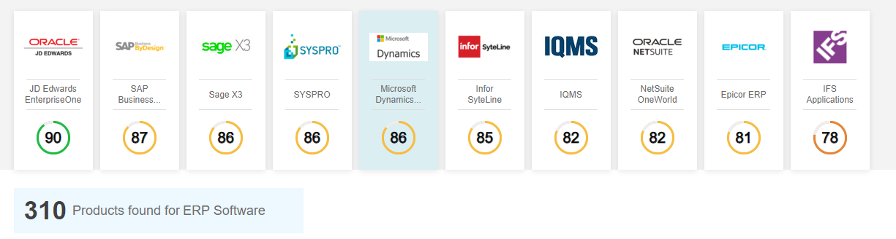

**WHY IS ERP NECESSARY?**

There is a need for ERP programs due to the necessity of a system which enables to follow and manage all processes within the enterprise. With ERP programs, business processes can be monitored from a single environment, the necessary data become regular and observable, and business productivity is increased.

**THREE SIGN THAT YOU NEED ERP;**

1. **Essential ingredients prevent you from growing**

You may be managing with essential components, but if your existing software limits you to market expansion or reaching a global scale, it may be time to move to a system without these limits.

1. **You are dealing with independent systems**

As technology changes, you will find that your independent systems do not work well with each other. You may find that your new accounting software is not compatible with your old HR system, you are tired of wasting time and resources to combine solutions.

1. **You cannot meet customer expectations**

If your system cannot handle the mobile and staffing of your customers, it is time to invest in a system that meets everyone's needs. If you can't afford to invest in meeting your customers' expectations and don't provide your staff with the tools they need to succeed, you lose them to one of the competitors.

**Benefits of ERP to Businesses**

As businesses grow, they become multi-site, enter international markets and even own factories in different countries. In this way, enterprises that are in intense competition aim to provide competitive advantage to their competitors by taking advantage of opportunities, protecting their strengths, improving their weaknesses and seeing potential hazards. Strategies are at the tactical and operational level, and implementation tools are plans for the use of business resources. The ERP system is a software system that enables efficient use of these resources in line with the strategies of the enterprise.

Even the smallest information gains value with the ERP system, and the enterprise gains a flexible structure with all its functions. This alleviates the volume and number of personnel and reduces costs while efficient, efficient production. The benefits of ERP systems can be listed as follows:

* It contributes to the reduction of inventory costs and holding costs through effective inventory management and control.
* Provides real-time profit-loss and cost analysis.
* Provides quick response to changing production conditions and increases competitiveness.
* Abilir Can simulate possible outcomes by creating sample scenarios (Simulation).
* Improves customer service levels and increases customer satisfaction.
* It eliminates language, geography and time limits by creating a central coordination in the activities in various functions, units, enterprises and countries that implement ERP system. Thus, a manager can easily monitor the various activities of the factory in another country.
* With the ERP system, the customer can call a single unit and place an order on the internet and then follow the development of the order. Since the system is standardized, the information is the same throughout the organization.

The following units in the enterprise are brought together with ERP.

**1. More Money Saving**

Although many vendors have offered flexible pricing in recent years, ERP packages are still a major investment. For many, high costs alone can make the program seem unlikely to save your organization money. However, after passing this bias, it is easy to see that ERP systems provide an excellent return on investment.

First, ERP now combines most of the systems that might be fragmented in your organization. Accounts to be paid from product development, your staff will have access to all the tools necessary for their work from a single central system.

By combining systems, you help your employees use their time more efficiently. With ERP, users do not need to hunt down a piece of information on multiple systems. It is very easy to get information with its central database. Moreover, your organization saves with ERP by eliminating the need for users to get training on many systems. This not only reduces the amount of money spent on training, but also reduces the logistics effort involved. Instead of setting up a few training sessions with several different vendors, you only need to communicate with one.

**2. Improved Collaboration**

The features of ERP applications may vary slightly depending on the program you use, but generally all systems somehow improve collaboration. As mentioned earlier, the central database is an integral part of what makes ERP unique. With this database, you provide your company with a single source of truth for its operation. This reduces errors by working with incorrect data, further reducing costs.

What's more, a central database reduces any hesitation or downtime during projects, as all team members can access the company-wide data they need. In addition, there is no need to combine information between various systems or resources. Since data is compiled, stored, shared, and accessed through a single system, no worries about how accurate, complete, or secure data files are.

Perhaps it is not easy to say if your team enters the same customer information over several different systems over and over. Without an ERP, you invite human error to your processes when it can be easily avoided.

**3. Better Analysis**

A central information database also makes it easy for you to analyze and report. Since an ERP records and stores all data entries, it makes it an excellent business intelligence tool. As long as your reseller provides powerful functionality, ERP software makes it easier and faster for your team to generate various reports. The research and compilation reports, which last for days without an ERP, take only a few minutes.

Most ERP systems provide a customizable dashboard so administrators can see reports when they first log into the system. These reports can include everything from income and expense tables to specific KPIs that provide insight into specific functions. The ability to quickly access these reports enables you and your team to make faster decisions.

You no longer need your IT staff to generate the reports you need. Finally, reports usually come with access levels and ensure that only authorized staff can see valuable company data.

**4. Improved Efficiency**

With traditional methods, boring jobs are completely inevitable. Tasks like generating reports, tracking inventory levels, tracking timelines and processing orders take the hours of employees. In addition to taking time out, these processes reduce employee morale and lead to human error. Even the best staff makes a mistake after entering the same data line countless times in different formats.

If you choose the right solution, an ERP system can automate your most boring tasks. Eliminates redundancy jobs such as database, multiple data entry in ERP software and enables the system to perform advanced calculations in minutes. This increases your team members' time to work more smartly, increasing their return on investment on labor. Therefore, ERP increases the productivity, efficiency and profitability of your organization.

**5. Happier Customers**

Nowadays, ERP programs now include CRM services within their customer relations. Because the biggest and most important responsibility for companies in today's world is customers.

Thanks to CRM, requests and requests from customers can be responded more quickly. It can be determined in which area or department the problems from the customers are predominant. This provides a very good method for the necessary corrections and improvements. Thanks to ERP, customer problems can be accessed more quickly, and solutions can be provided very quickly from all departments.

The more companies can achieve customer management and satisfaction in order and in an advanced way, the more opportunities that company can develop and increase its customer capacity. ERP programs can provide this situation. All these departments and managers can use ERP systems over different platforms and therefore ERP is a desirable requirement. The following shows how much ERP is used on which platforms.

**6. Simplified Compliance and Risk Management**

As companies grow and do business in different countries, it can be difficult to follow all the different regulations that apply to your business. Even local companies need to worry about various environmental, information security and human resources regulations.

Fortunately, many ERP systems have been built with these regulations in mind to help you maintain compliance at every stage. In addition, ERP software provides built-in inspection tools to help document things like chemical use and tax provisions. This makes it incredibly easy to formulate reports and send them to the relevant board of directors.

In addition, ERP systems often provide tools to manage risk. The improved reliability and accuracy of this solution improves overall financial management due to fewer errors in accounting. Forecasting tools also enable users to predict events when it comes to demand, labor and budget. With this information, you can create safer budgets, programs and product development plans.

**7. Improved Inventory Tracking**

The biggest challenge for growing companies is to track and monitor expanding inventory levels. ERP systems use barcoding, RFID tags and serial numbers to keep tabs on your inventory during the supply chain. These tools help you keep track of stock levels in different warehouses, which goods are being transported and which goods are on the shelves. Increased warehouse visibility greatly optimizes picking, packaging and shipping, preventing all predictive tasks from occurring.

Inventory tracking supports reporting as tracking technologies provide more accurate numbers. Users can configure custom KPIs to see which products move fastest, show more demand, and which transportation costs increase. With great precision from ERP, warehouse managers can take real-time data in their inventory to make more accurate business decisions.

**8. Improved Production Planning and Resource Management**

Besides managing your inventory, ERP systems also manage production. ERP provides information on all production operations, including the workshop area. This allows users to optimize production schedules, equipment and craftsmanship to maximize capacity.

In addition, it manages your ERP Bill of Materials (BOM) and fixed assets. With this software, users can easily create and edit BOMs as well as keeping track of all previous changes. Fixed asset management enables users to plan equipment maintenance to reduce unexpected downtimes, improve your profitability and supply chain relationships.

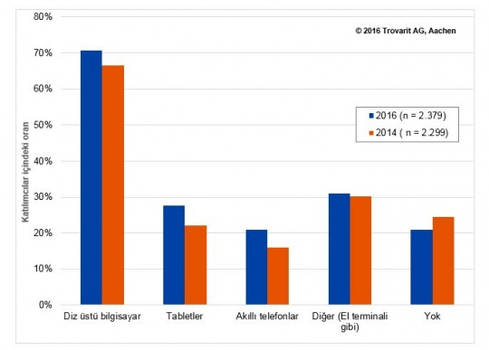

**Think about a script about Erp?** Let us explain what ERP is in general with an example.

ekran görüntüsü, bilgisayar, ıslatıcı içeren bir resim

Çok yüksek güvenilirlikle oluşturulmuş açıklama

As we have seen in the image, we have a company founded in Kayseri and the capital is dollars. However, the company started its business life without using ERP programs in its establishment and after a while the problems experienced in the distribution, not responding to customers quickly, demands, can not meet instantly and reports can not see the shortcomings of the lack of things as we see in the second picture starts to go wrong and the company's value begins to go wrong. Maybe the company sinks.

ekran görüntüsü, bilgisayar içeren bir resim

Çok yüksek güvenilirlikle oluşturulmuş açıklama

However, when we look at the 3rd picture, if this company had taken an ERP program after considering the needs of all its departments and thinking that it would come for itself at the time of its establishment, all these problems would not have occurred. The company would be able to maintain regular relations with its customers. The distribution would do where ever needed. Plan production according to needs. The managers would have instant access to the reports and be able to solve the deficiencies they saw here as needed. In this way, the value of the company would be increased and management and communication between the departments would be ensured efficiently.

oyuncak, ıslatıcı, saat içeren bir resim

Çok yüksek güvenilirlikle oluşturulmuş açıklama

Factors in the successful progress of ERP applications:

* Participation and support of senior management.
* Restructuring business processes.
* Improving project management.
* Accuracy of data.
* Good training on the system.
* Employee participation and support.
* Software-Hardware compatibility.

**THE BEST ERP SOLUTIONS**

**Microsoft**

Microsoft provides ERP programs to businesses of different sizes with different products: Microsoft AX, GP, SL, NAV, CRM, RMS. Microsoft Dynamics AX, the company's most widely used ERP software, is a good opportunity for businesses that support sectoral and operational business processes as well as detailed, basic enterprise resource planning (ERP) tasks for finance and human resources.

# **Microsoft Dynamics 365:**

Microsoft Dynamics 365 is an integrated customer relationship management (CRM) system based on a flexible Cloud Entreprise Resource Planning System (ERP). Microsoft Dynamics AX and Microsoft Dynamics CRM versions are included on the website.

Dynamics 365 allows companies to take informed decisions on the basis of observations and suggestions based on results. Through automating and managing manual tasks with intelligent workflows, businesses can function more effectively.

The CRM features of the software allow customers with the help of LinkedIn Sales Navigator to unify their relationship data, to train salespeople with onboarding and analytical diehboards and to customize their experience.

Dynamics 365 is also new in terms of ERP technology, integrating businesses' artificial intelligence (AI), machine learning and mixed reality technologies (a combination of reality and the virtual world). The solution is available:

* Predictive advertising instructions.
* Protection against automatic theft.
* Digital sales staff.
* Visualization of the items.
* Guides to holography.
* Remote support for mixed-reality.

For iOS and Android, a mobile app is available.

# **Features:**

The following modules are part of Microsoft Dynamics 365:

Sales – Microsoft Dynamics CRM's Selling Module provides all of the main features. Businesses can give priority to the right customers, automate the sales process, personalize customer experience and build meaningful relationships. An insight and predictive guidance on a customer dashboard are available. Companies may also enhance the shopping experience with virtual reality showing items.

Marketing-The marketing section focuses on the future and raises the number of professional executives. Multi-canal campaigns Through linking sales and marketing teams and knowing consumer dynamics through web and social data, businesses can identify and cultivate leads.

The Customer Service Module provides consumers with many platforms and tools to achieve meaningful interactions. Smart automated agents deliver personalized service experiences at no extra labor costs.

Trade – The Trade module optimizes store operations, merchandising, consumer enforcement and stock use.

Finance and Operations – All features of the Microsoft Dynamics AX Finance and Operations module allow enterprises to access a centralized finance dashboard using real-time business intelligence and embedded analysis. Employees can simplify and streamline financial, manufacturing, supply chain and asset management processes using role-based workspaces.

Project Service automation – A consistent and personalized service configuration model is used by the project service automation framework to assist businesses in preparing and executing projects successfully. It predicts resource demands, income and offers resources for collaboration.

Field Service – Unit Field Service optimizes job capital. Using mixed-reality, automation, and remote aid devices, service technicians may become more effective in solving problems in the field.

Human resources-The HR element aids organizations in recruiting top talent, maximizing employee engagement and strengthening HR management. This provides apps for new hires on-board, simplifies HR procedures and allows self-service for employees.

**Target Market:**

Microsoft Dynamics 365 covers multinational corporations, non-profit organisations, and governments. Several examples of its clients are as follows:

* Adobe
* Beyond Bank Australia
* Boys & Girls Clubs of America
* Hewlett Packard
* Hickory Farms
* Infosys
* Macy's
* Michael Hill
* Renault Sport
* Seattle Seahawks

**Implementation/Integration:**

Microsoft collaborates with experts from third parties who are providing specialist assistance in the development, deployment and optimisation of Dynamics 365 applications.

The app can be built through the cloud or on site. The Microsoft platform (Power BI, PowerApps and Flow) as well as Office 365 and LinkedIn can integrate solutions. Businesses should incorporate this solution.

**Customer Service & Support:**

Microsoft provides users self-help tools, such as documentation archive, group forums and forums centers, in which users can ask peers and experts questions.

The Customer Engagement Program offers customer service by telephone and internet.

Lifecycle services, which offer operational support through a dedicated project manager and the IT Administrator, can be purchased from Centralized Operations or Dynamic 365 Plans firms.

**Pricing:**

The prices of each module are as follows:

* **Sales** – $65 per user, per month (Professional) or $95 per user, per month (Enterprise)
* **Marketing** – 10,000 contacts for $1,500 per month (stand-alone) or $750 per month (if company also uses other Dynamics 365 apps)
* **Customer Service** – $50 per user, per month (Professional) or $95 per user, per month (Enterprise)
* **Commerce**– $180 per user, per month
* **Relationship Sales** – $130 per user, per month (10 user minimum)
* **Sales Insights** – $50 per user, per month
* **Customer Insights** – $1,500 per tenant, per month for up to 100,000 profiles
* **Customer Service Insights** – $75 per user, per month for up to 100,000 cases
* **Project Service Automation** – $95 per user, month
* **Field Service** – $95 per user, per month or $65 per user, per month (remote assist)
* **Human Resources** – $120 per user, per month
* **Finance** -$180 per user, per month
* **Business Central** – $70 per user, per month (Essentials) or $100 per user, per month (Premium)
* **Layout** – $95 per user, per month

**Sage**

Sage is an ERP software generally preferred by small and medium sized companies. Help them make strong business decisions. There are three different types of Sage’s ERP software; X3 for large businesses, 100 for small and medium-sized manufacturers, and 300 for small and medium-sized enterprises with multiple locations. Most used Sage ERP X3, complex processes, production, inventory, storage, purchase, finance, customer relations and electronics manage fields such as documents.

**Sage100cloud:**

Sage100cloud is specifically targeted at SMEs, dealers and distributors who are expected to simplify processes and link employees and gain business insights when they need them. Sage100cloud is a Sage100c / Sage 100ERP formerly.

Sage 100cloud is perfect for businesses which have outgrown their current accounting or manual processes to compile, store, maintain and analyze information across a organization.

Sage 100cloud offers the tools needed by organizations to handle goods, orders, clients, finance and transactions as a suscription-based platform. It provides insights into the need for businesses to cut costs, maintain compliance, deliver value to customers, and manage growth effectively.

Sage 100cloud provides a wide range of modules to satisfy its customers' multiple needs. Customizable software covers core programming and finance modules, business intelligence, client relations, eBusiness, personnel and payroll, manufacturing and distribution.

A company can combine modules to create a business-optimized ERP system by adding modules further as it expands.

Sage 100cloud builds on its predecessor, Sage 100c, with the same features and functionality. It's either an on-site desktop solution or a Cloud based platform like Amazon Web Services. It is available.

Sage 100cloud offers also a modern user interface with a specific desktop and screen configuration feature. The new interface was also developed with mobile technologies to allow users to experience more modern Sage 100 on various devices (i.e. desktops, laptops, tablets, mobile telephones).

**Features:**

Sage 100cloud features include:

Accounting and Financing: Increase efficiency, competitiveness and flexible personalization with streamlined visual procedural flows. Sage 100cloud provides key financial and accounting modules that simplify daily work. This package provides customizable options, easy to use design and an intuitive interface that blends workflow enhancement and performance increase.

Business knowledge and reporting: Enhancing the visibility of quicker and more informed decision taking in the organization. Enterprises gain instant visibility in the enterprise, improve their profitability and enhance business intelligence reporting that offers an integrated knowledge management solution.

Sales and client management: Sage 100cloud enables businesses to monitor sales funnel and enhance consumer satisfaction and to create loyalty to clients. Sales representatives can provide complete and up-to-date information to answer any customer's question, including access to individual stock quantities, item and quantity pricing and much more.

Sales and supplier management: from order to delivery, companies should streamline the whole cycle of purchases. Distributor procurement management maintains detailed, reliable records of any transaction, including amount, costs, who places the order and special instructions for the shipping.

Inventory management and warehousing: This function helps users to monitor inventories of warehouses that can reduce the expense of carryover and rapidly fulfill orders. Distributor real-time inventory management software allows businesses to reliably monitor their stock and improve customer service.

Fabrication: Companies will increase the productivity of their operations from planning to completion and delivery times. Sage 100cloud provides reliable, comprehensive monitoring and reporting at every point.

**Implementation/Integration:**

With Sage 100cloud, Sage provides many deployment options. An enterprise can start in the cloud immediately, retain its own on-site deployment or take a hybrid approach. An enterprise will in all cases have the same advanced functions and functionality as all other customers in Sage 100cloud. The integrations of Sage100cloud include Salesforce, Magento and Office 365.

**Customer Service & Support:**

Sage provides assistance for telephone and talk from 9.00 a.m. Around eight p.m. Excluding holidays, ET Monday through Friday. Active Sage Business Care support package provides consumers with more resources and personalized access to those support items.

Sage provides a broad range of expertise, a self-help website with up-to-date information, ideas and more, and an online community (Sage City) 24/7 where you can ask questions, exchange ideas and address problems with other Sage customers, staff and product experts. Sage also provides an online selfhelp website. University of Sage provides intensive instruction and on-demand learning topics for teachers.

**Pricing:**

Pricing Sage 100cloud can not be found on the website of Sage. The price depends on the kit and add-ons selected by the client. Increasing the overall cost would increase, but raising the cost per user.

Nevertheless, three pricing packages (not including implementation) are available on a third-party site:

Essentials package: $50 per user, per month, billed monthly:

* 1-5 users: $50/user/month
* 6-10 users: $47.50/user/month
* 11-25 users: $45.00/user/month
* Over 25 users: $40/user/month

Advanced package: $61.11 per user, per month, billed monthly:

* 1-5 users: $61.11/user/month
* 6-10 users: $58.06/user/month
* 11-25 users: $55.00/user/month
* Over 25 users: $48.89/user/month

Complete package: $66.67 per user, per month, billed monthly:

* 1-5 users: $66.67/user/month
* 6-10 users:$63.3/user/month
* 11-25 users: $60.00/user/month
* Over 25 users: $53.33/user/month

**Odoo**

Odoo is software for business administration including CRM, e-commerce, billing, payroll, manufacturing, storage, project management, and inventory management. The Community edition is the open source edition of LGPLv3, combined with the proprietary features and services offered by the Enterprise version. The source code for the application and core ERP modules is being developed by Odoo S.A., based in Belgium.

Odoo S.A (formerly OpenERP S.A) has been releasing software as an open source since its inception. After the release of V9.0, the company has migrated to an open core model which, in addition to the open source version, offers subscription-based proprietary enterprise software and cloud-hosted software as a service. The non-profit Odoo Community Association was founded in 2013 to promote the widespread use of Odoo and the collective creation of Odoo apps.

The extensible architecture of Odoo enables a large number of freelancers and organizations to create Odoo Apps or Modules and to put them on the market for sale or for free download. The key components of Odoo are the platform, roughly 30 core applications (also called official modules), and over 20000 group modules.

Odoo was used as an important part of the university courses. A research on educational learning proposed that Odoo (then known as OpenERP) would offer an acceptable alternative to proprietary teaching supplement systems.

Odoo has won many honors, including Trends Gazelle, Deloitte Technology Fast 50 Award and the InfoWorld BOSSIE Award 2013, before it changed its name. It has won consecutive BOSSIE Awards in 2014, 2015, and 2016, since changing its name to Odoo.

**Netsuite**

Netsuite's ERP software was created to meet the needs of a multi-branch company. NetSuite’s ERP software allows instant analysis and allows data from branch companies to be displayed at the same time. Netsuite enables you to access all of your data anytime and anywhere thanks to cloud system backup, while also generating database costs. Netsuite ERP provides proven financial management and ERP that integrates easily with your broader sales and service processes.

NetSuite Inc. was an American cloud computing company founded in 1998 with headquarters in Redwood Shores, California offering corporate accounting, operations, and customer relationship management software and services. The applications and services are designed for small, medium, and large businesses with ERP, CRM, PSA, and e-commerce modules.

In November 2016 Oracle Corporation purchased NetSuite for around US$9.3 billion. Executive Vice President Evan Goldberg oversees the newly created Oracle Netsuite business unit as Oracle's Cloud ERP for small to mid-sized companies.

NetSuite was created in 1998 by Evan Goldberg who provided web-hosted accounting software under the original name NetLedger. The business was filled with both Oracle CEO Larry Ellison's startup capital as well as a number of key workers previously working at Oracle. Chairman and CTO of the group, and other executives, have switched from Oracle to NetSuite. During one time Oracle approved the NetSuite software, but called The Oracle Small Business Solution, the project was short-lived and the system was discontinued. NetSuite is commonly regarded as the first cloud computing software service, with the launch of the service in 1999 pre-dating that of Salesforce.com by around one month. Goldberg was the President and Chief Technical Officer until the purchase of Oracle.

Following its initial public offering (IPO) of 6.2 million shares on the New York Stock Exchange in December 2007 NetSuite became a publicly traded company.

**Deltek**

With more than 22,000 customers worldwide, Deltek provides enterprise management software for project-focused organizations. Since its founding in 1983, Deltek has been delivering software developed for project-focused organizations in the government contracting, government agency, aerospace and defense, architecture and engineering, professional services, manufacturing, marketing and PR agencies and nonprofit industries. Deltek Costpoint, Deltek Vantagepiont, Deltek Vision, Deltek PPM Solutions, Deltek Talen Management, Deltek CRM, Deltek Ajera, Deltek PIM, Deltek Maconomy, Deltek Acumen, Deltek PM Compass, Deltek Cobra, Deltek Open Plan, Deltek + ConceptShare, Deltek + AVITRU, and WorkBook from Deltek encompass front- and back-office functionality for project-focused organizations. These products provide solutions in the areas of accounting, billing, resource planning, budgeting and control, business intelligence, customer relationship management (CRM) and proposal automation, employee time and expense, human resources management, procurement and materials management, project portfolio management, risk management, and earned value management. The company is headquartered in Herndon, Virginia (USA).

**-Deltek Vision**

Deltek Vision is an ERP software that manages the complete project lifecycle, enabling the automation of business information communication between different business departments.

Being a modular system, the software is split into 5 functions; CRM, resource planning, performance management, connectivity solutions for Microsoft software and navigation tools. Vision Navigator is a management portal for project managers which provides the ability to capture data, manage projects remotely, share status and delivers project control for project managers and project visibility for the rest of the team. All Deltek Vision ERP software is customisable and is available in multi-language and multi currency. All databases integrate with Microsoft and run alongside SQL and Microsoft servers, including Microsoft SharePoint internal functionality.

Companies who actively use the Deltek Vision ERP software include New Jersey construction management company Hill International, Californian consulting engineer Engeo Inc. and global biodiversity education provider UNEP-WCMC.

**Epicor**

Epicor has been delivering software solutions to business for more than 25 years. Epicor ERP is a global enterprise resource planning (ERP) solution offering end-to-end, industry-specific ERP functionality for the manufacturing, distribution, retail, and services industries.

ERP image

Epicor ERP uses a modular approach with a true service-oriented architecture (SOA), offering flexibility and adaptability to specific needs. Buyers can purchase only the modules they need and make a fully customized and integrated ERP system, and they can complement the system with a full range of services from Epicor. Several deployment options are available: onsite installation, hosted, and cloud based.

The company’s Epicor ERP version 10 added a completely multitenant software-as-a-service (SaaS) deployment option to existing on-premise and hosted deployment options. It also included integration, social, and mobile frameworks. Epicor 10 also began offering a high degree of customization, allowing users to easily tailor screens, reports, fields, and tables to their specifications.

Epicor ERP offers industry-specific functionality for the following industry verticals:

Distribution—automotive aftermarket; service market; consumer goods; electrical; fastener; fluid power; heating, ventilation, and air conditioning (HVAC); wholesaler; industrial; janitorial; lumber and building materials; medical supply; packaging; paper; petroleum; pharmaceuservices supply chain imagetical (chemical and allied); plumbing wholesaler; tile

Manufacturing—automotive aftermarket manufacturers; discrete manufacturing software; aerospace and defense; automotive; construction and engineering; electronics and high tech; energy; fabricated metals; furniture and fixtures; industrial machinery; rubber and plastics; process manufacturing software; food and beverage; packaging; pharmaceutical; mills and metals; printing; medical devices

Retail—automotive aftermarket; distributor and jobbers; service market; discount store; farm/home; general merchandizing; hardware and home center; lawn/garden; lumber and building materials; paint and decorating; pharmacy; specialty hard goods; sporting goods

Services—government and education; non-profit organizations; financial services; banking; credit unions; title and escrow; hospitality; food service; hotels, casinos, and resorts; sports and entertainment management; professional services; architecture; engineering; construction; audit and accountancy; management consulting; marketing; advertising; communications; research and development; software and computer services

**-Epicor ERP Features**

Epicor ERP 10.1 has enhanced functionality in key areas of manufacturing and the supply chain including inventory and material management, purchasing, shipping and receiving, quality assurance, project management and job scheduling, sales and CRM, and quoting and order management. It also has expanded global and compliance capabilities.

ERP software module capabiltiies imageBecause of the modularity of the Epicor ERP system, modules can be put together to create a unique solution for the user company. This can range from simple arrangements for companies with less complex needs (e.g., a basic accounting system including core modules such as CRM and HCM features), to complex systems with additional modules for sales and marketing, planning and scheduling, project management, and the supply chain.

Epicor ERP includes 14 functionality modules:

Customer Relationship Management

Sales Management

Human Capital Management

Service Management

Product Data Management

Planning and Scheduling

**ERP FAILURE**

60% of all ERP (Enterprise Resource Planning) software solutions fail to achieve the desired results. Whether it be a failure in ERP implementation or integration with the company’s processes, it is a scary number that represents a worst-case scenario for anyone shopping for an ERP system.

The reasons for incorrect application of ERP software not working successfully in the company:

* Personnel do not want the system to succeed.

- Job loss

-Fear of failure

-Decreasing social importance

* Expectations of the personnel regarding the new system.

-Unrealistic expectations

-Aircraft Carrier syndrome

* Personnel do not understand the basic requirements of the system.
* Failure to ensure data accuracy.

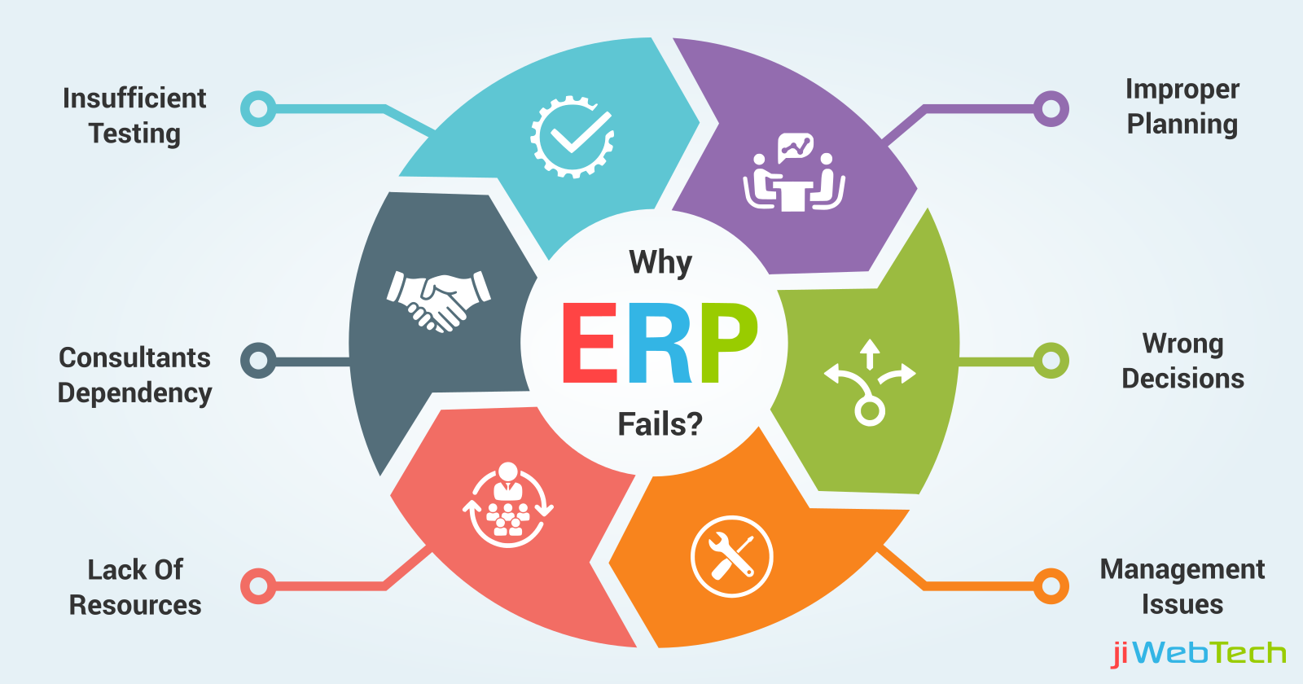

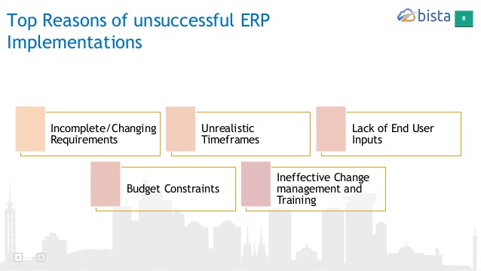

Take some companies that fail to implement ERP.

**Hershey**

Hershey, a chocolate and beverage company, experienced logistics problems with its failure in SAP R / 3 software and the company lost 35% of its market value.

In 1999, one of the most mentioned ERP failures occurred in Hershey. A user error was made on the firm's platform, which included SAP ERP, CRM and supply chain software, and the company failed to deliver the $ 100 million Hershey Kisses that season and lost 8% of its value.

**Nike**

In 2000 and 2001, Nike developed an ERP program for the supply chain and other parts of the company to improve itself, but it quickly faced many problems as it did so without fulfilling all its requirements and research. This application, which he created by spending a great investment, caused him 20% loss. They did the wrong tests and did not determine all the requirements. The biggest mistake was to produce unconsciously from the less demanded product, not the demanded product, which is the biggest mistake in the application. Correcting this in the software and streamlining this loss of the company has cost a lot of time and expense.

HP

While minor disasters or problems that arise during the start of a new ERP system are not uncommon, the total ERP implementation error can occur when many of these minor problems occur at once. That's what happened at Hewlett Packard. Moving all of the company's North American divisions into a single central ERP system has cost the company $ 160 million in accumulated orders and lost revenue, which in 2004 was estimated to cost more than five times the cost of the project.

FoxMeyer

The $ 5 billion company, FoxMeyer Drugs, started using the $ 100 million ERP system and went bankrupt in a short time. Did the two have a correlation? They formed the Delta III project in 1993 and the implementation was passed between 1994 and 1995. In 1996, FoxMeyer went into bankruptcy and until 1997 he was responsible for the pharmaceutical company ERP project supplier SAP and case manager Andersen Consulting. The biggest mistake in this system was that the company could not make a living according to its level and that the knowledge of the users was not sufficient.

The main reasons for the negative results of ERP projects are:

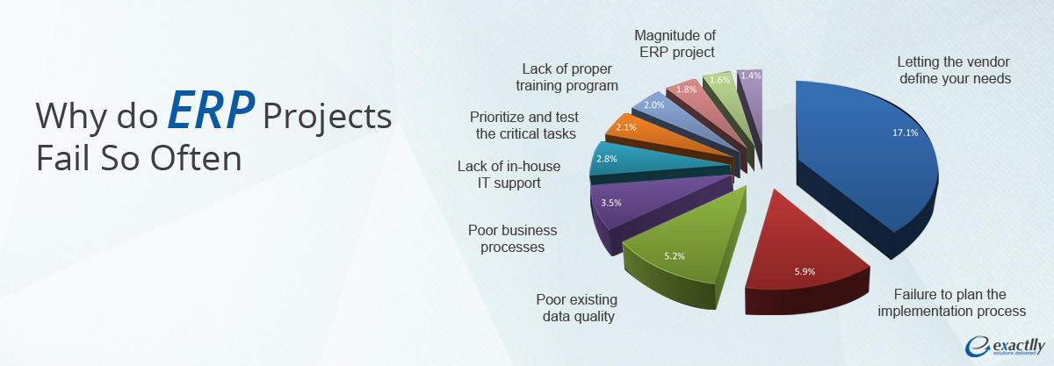

-Letting the vendor define your needs

-Failure to plan the implementation part

-Poor quality of data

-Uncertainty of business processes

-Inadequate ERP training:

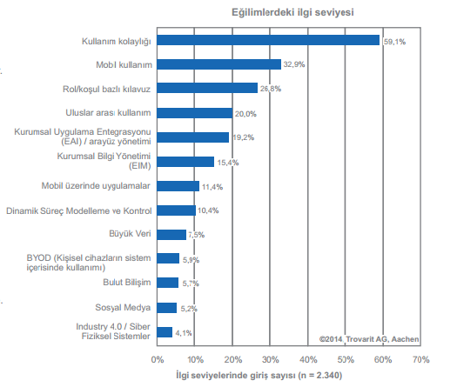

-Lack of in-house IT support

-Failure to develop an ERP program

-Customer issues:

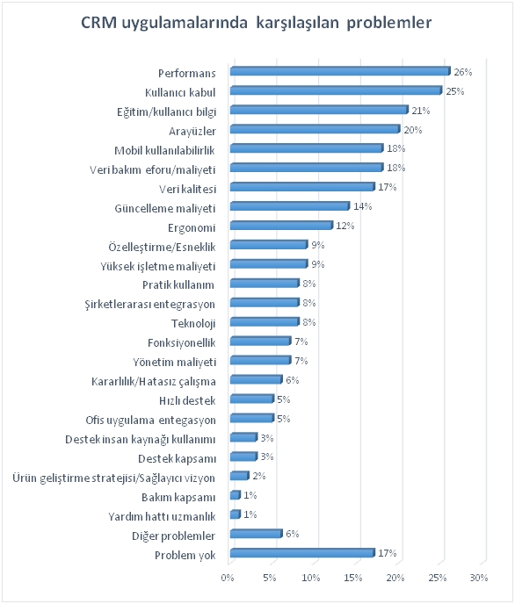

General ERP issues:

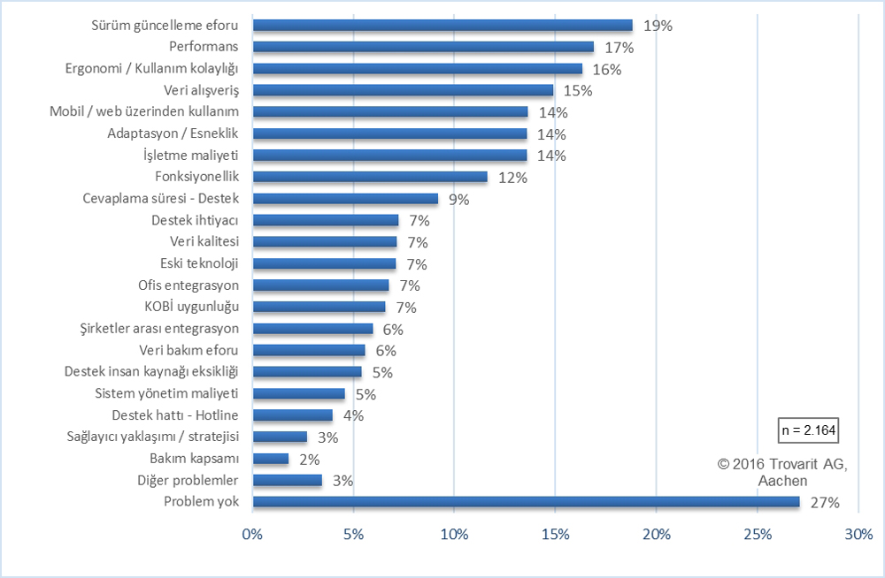

**ERP APPLICATION REVIEW with BILNEX**

Finally, let's examine a medium-sized software called ERP Bilnex being produced that's how they work and functioning in Turkey.

Bilnex is an ERP software that most medium and small sized companies want to use primarily for stock and warehouse management. In addition, with this approach, all sales, purchasing, customer relations, human resources departments such as companies can manage from a center or branch.

So what to do first if the company wants to use Bilnex or any other ERP software. First, the company must create a database so that it can keep its data here and access it at any time.

For Bilnex, we first download Microsoft SQL i and the latest version of Bilnex from its ftp page. Then we install SQL. Then we install Bilnex and make the necessary adjustments to connect with SQL.

Bilnex ERP is now connected to SQL and the login page comes to our wife.

ekran görüntüsü içeren bir resim

Açıklama otomatik olarak oluşturuldu

Bilnex gives us a password-free Supervisor user at first. We log in with this and come to our home screen, and then we put the icons of all the pages we need on the screen so we can work on them faster and easier.

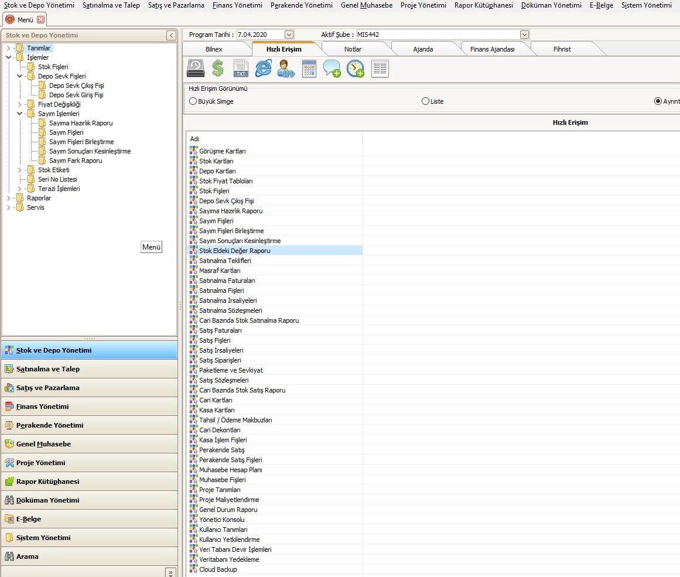

As we have seen in an ERP application; Inventory and Warehouse Management, Purchasing and Demand Management, Sales and Marketing Management, Finance Management, Retail Management, General Accounting, Project Management, Production Management and Report Library. In addition, there are sections that contain the necessary reports for the top executives.

We can also customize these parts within the ERP application. For example, we first open a user for the production department, and then from these user settings, we can make sure that this user can only see the parts related to the production department and have authorization for the parts required in the production department.

Let's examine what we can do on ERP application respectively.

ekran görüntüsü içeren bir resim

Açıklama otomatik olarak oluşturuldu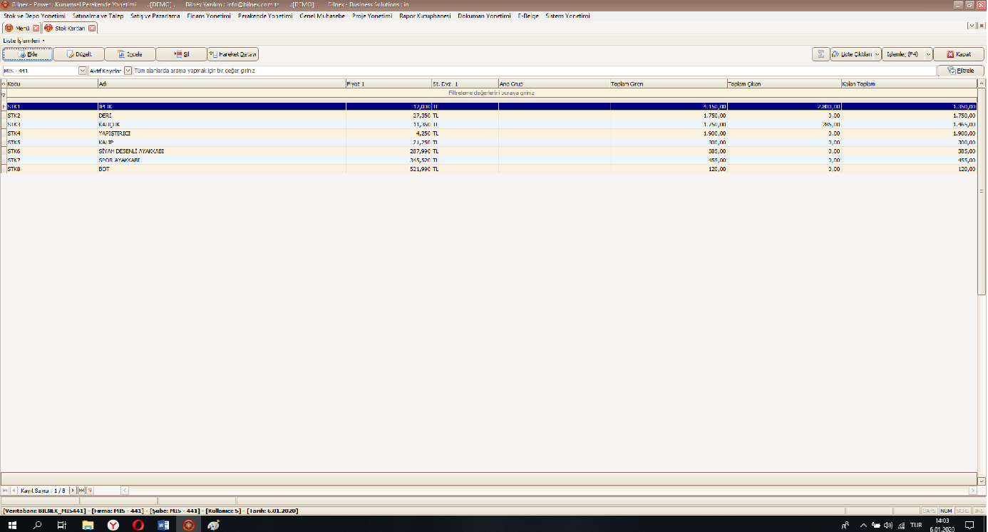We can record the products and raw materials that we have from our stock add page. Here, we can record the necessary information such as price, purchase price and VAT. We can also record which companies were purchased and where they were sold. In this way, what product is demanded, how much of which raw material should we buy and which customers are shopping more than us, we can see them in detail and make the necessary arrangements accordingly.

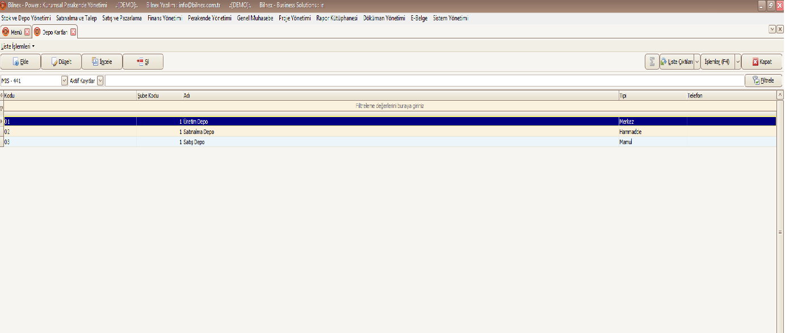

As we can see in the image, we can define different warehouses for each department and in more detail we can control how much of which product is used in which department within the company. In addition, employees belonging to department stores and keep a graph of the performance of these employees.

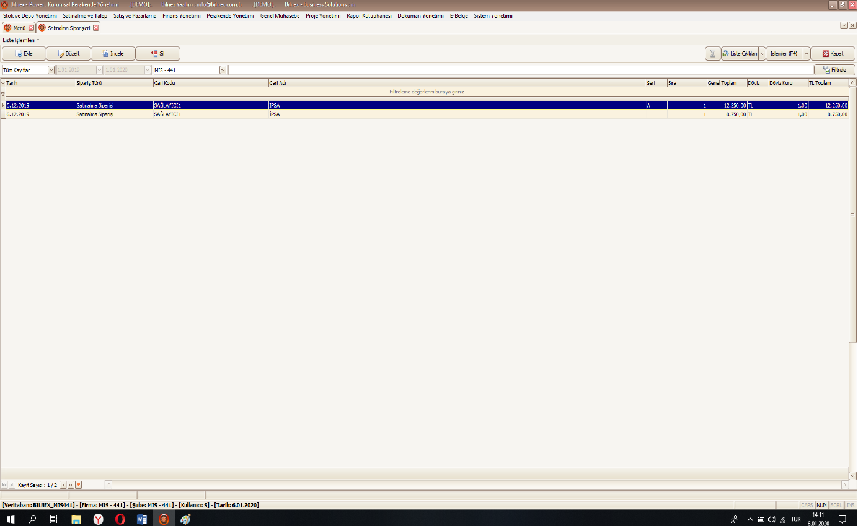

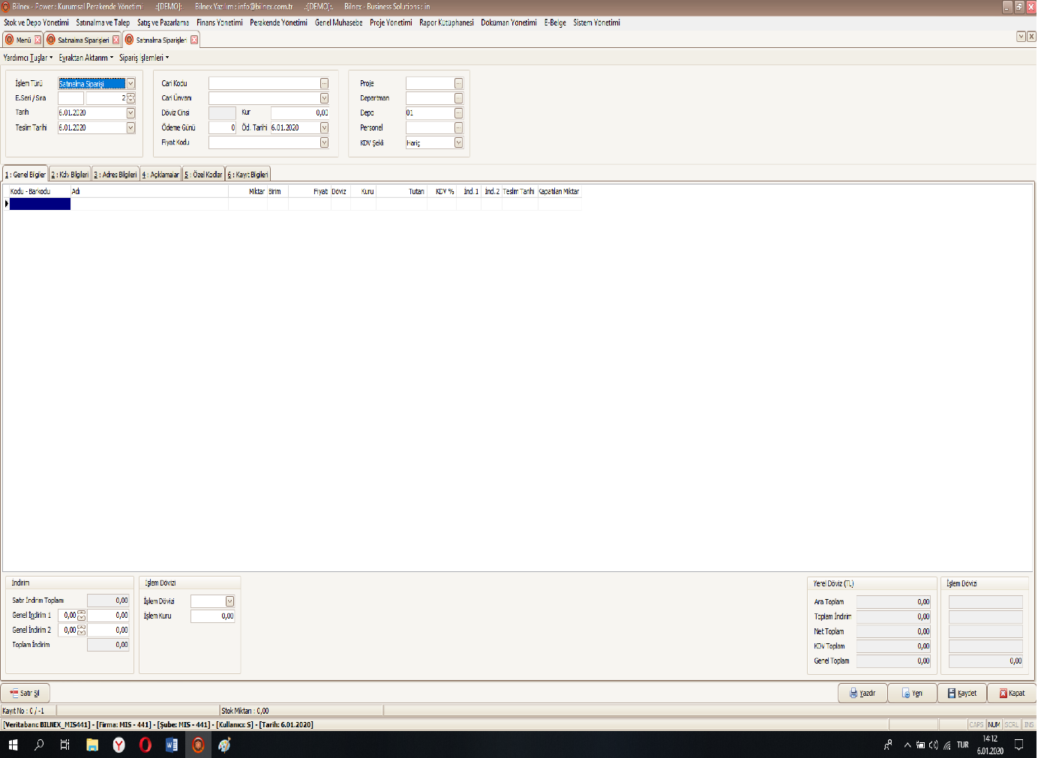

As we have seen in the images above, we can create purchase orders and see if the purchasing department can see and approve them quickly. In this section we will buy the company, the date of purchase but the type of payment, from which product how much and with which unit we can select and send for approval. We can display all our purchase orders on the same screen. You can also change the selection with these same screens to turn it into a sales order. And then by converting the approved order into invoice or waybill, we can automatically ensure that it decreases from our warehouse or if the goods entering our warehouse increase the level of our warehouse.

On the customer and supplier page, we can instantly see the debts and the companies we are credited with. And all of this can fall instantly to our administrators' page. In addition, thanks to these records, when a customer calls us, we can quickly access customers' records and see what has never been done before and provide them with clearer information and services.

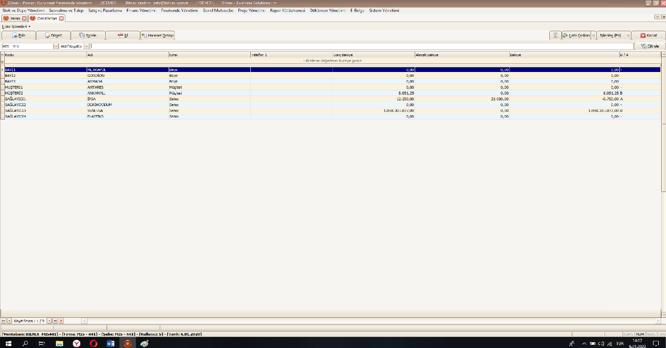

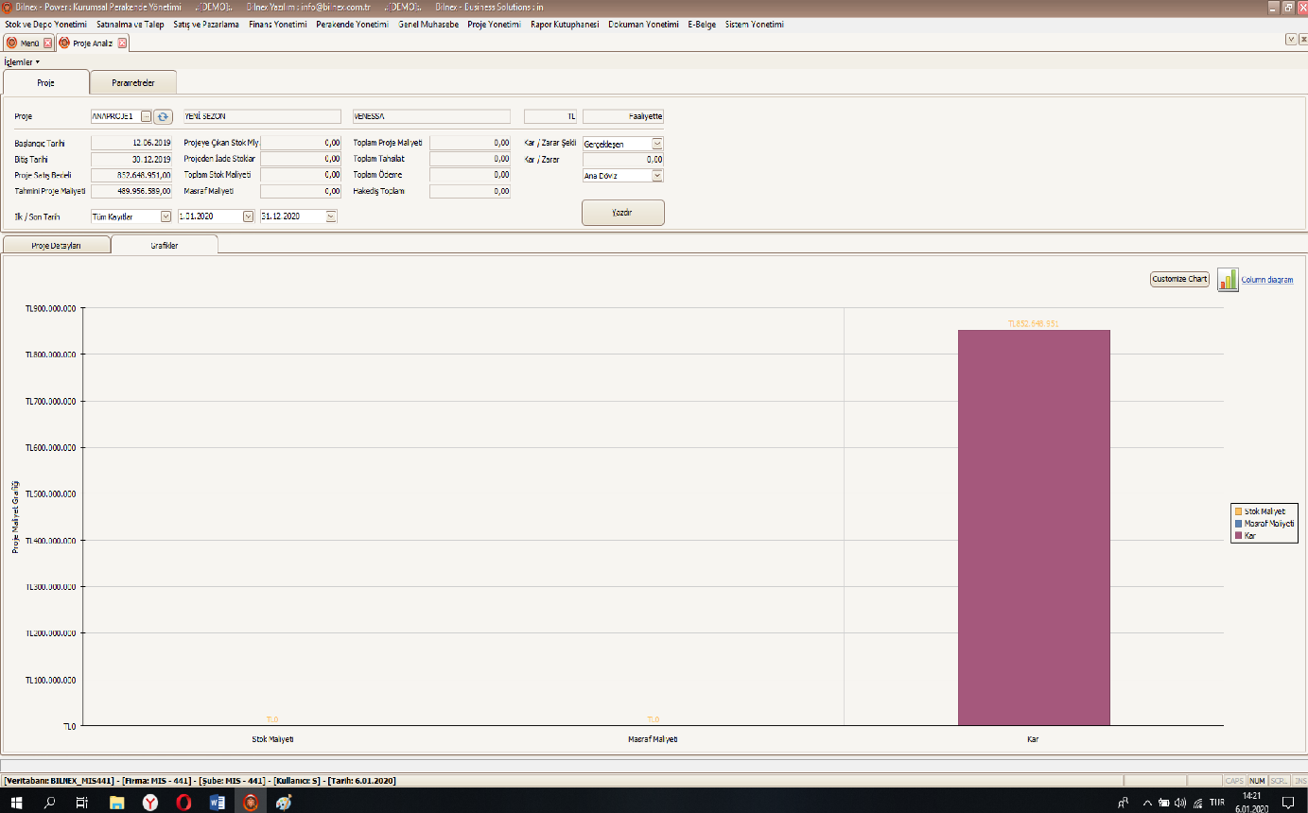

We can create main and sub-projects and we can determine all of the parts such as how much product will be used in these projects, how much will be the costs of the stages, and which staff will deal with which job. In this way, our project may be more regular and completed within the expected time.

iç mekan, ekran görüntüsü, bilgisayar, masa içeren bir resim

Açıklama otomatik olarak oluşturuldu

ekran görüntüsü, bilgisayar, masa, ekran içeren bir resim

Açıklama otomatik olarak oluşturuldu

As you can see in the above two images, we can upload our database at any time or make it accessible at any time. In addition, by creating an automatic backup, we can determine when and how often it should be backed up. Because the most important thing of a company is its data. The company, which has no data in its possession, cannot do any work that is necessary and usual to do on time and as required.

Let me explain how important the data is with the negativities that I have encountered when I work in Bilnex program.

-The biggest problem we experienced in the Police Academy Canteen Presidency. Here, without any credit card and cash money, the company was able to collect the salaries of employees quickly by exchanging information with the bank they received. However, our application could not directly reflect the paper containing the list of the customers who were paid or not paid directly to the customer payments. Because of this, they would stop using Bilnex ERP, but we developed a new interface program and made it possible for Bilnex to draw this incoming bank document directly and provide the collection.

-Another problem we experienced was the change of CRM system used in the previous version after the new Bilnex update, and a company became unable to use the previous customer data and all the calls made in the database. The storage of the data in this section worked very well, and the data in the old database was pulled through SQL and assigned to the new database. The problem was solved in this way.

ERP is a system that is necessary for companies and provides high efficiency when used. It is important to receive the necessary training to maintain ERP in a good way. In addition, the support and customer assistance options provided by the ERP application you use can improve even the slightest problem without any harm.