

Faculty of Computers and Artificial Intelligence

Department: Computer Science

2022/2023

**CS 396 Selected Topics in CS-2**

**Research Project**

Team ID No. 52

|  |  |  |  |
| --- | --- | --- | --- |
|  | ID | Name | Grade |
|  | 201900597 | مارك فايز وديع قسطنطين |  |
|  | 201900938 | هدير محمد حنفي محمود |  |
|  | 201900915 | نورهان محمد المهدي مختار مرجان |  |
|  | 201900960 | ياسمين عزت إبراهيم غريب |  |
|  | 201900973 | يوسف إبراهيم أحمد الجريدلي |  |
|  | 201900980 | يوسف رمضان عبد العزيز عبد الحافظ |  |

Paper Details:

* **Paper Name:**

**“Deep Network Ensemble Learning applied to Image Classification using CNN Trees”**

* **Authors Name:**
* Abdul Mueed Hafiz
* Ghulam Mohiuddin Bhat
* **Dataset USED:**
* ImageNet
* Natural Images
* **Implemented Algorithms:**
* CNN
* Ensemble learning Algorithms
* **Results:**

The classification accuracies of the proposed approach are higher than that of the baseline in all experiments using ImageNet subsets. The accuracy is also almost equal for the Natural Image subset.

* *[Submitted on 23 Jul 2020], Cornell University*

Project Description:

Image classification is a complex procedure which may be affected by many factors

Dataset used:

1. **Natural Images** [**https://www.kaggle.com/datasets/prasunroy/natural-images**](https://www.kaggle.com/datasets/prasunroy/natural-images)

* **Samples:**

It includes 4338 files for (Training, Validation & Testing)

* **Number of Classes and their labels:**
* 6 classes
* Labels:

(Airplane, Car, Dog, Flower, Motorbike, Person)

* **Implementation Details:**

* Resizing to 224 images
* In All the CNNs we use Adam Optimizer for training, with mini-batch size of 32 for larger image categories and of 16 for smaller ones,
* The CNNs are trained using early stopping. We use loss function in binary cross-entropy for binary-class CNNs and categorical cross-entropy for multiclass CNNs.
* We divide the experiments into two sets based on the number of classes used for classification : ( four and six, respectively )

1. **Four-class** :

uses a single binary-class CNN (2 categories per class) i.e. [ (c1, c2) v/s (c3, c4) ] in first stage, and two binary-class CNNs in second stage i.e. [ c1 v/s c2 ] and [ c3 v/s c4 ]

1. **Six-class :**

using two different ensemble structures. When final layer neuron count is 2, we use sigmoid activation. For more that 2 final layer neuron count, we use softmax activation

**Classification using Ensemble Structure #1**

Here , we use a three-class CNN (3 categories per class) i.e. [ (c1, c2) v/s (c3, c4) v/s (c5, c6) ], in first stage, and three binary-class CNNs in second stage i.e. [ c1 v/s c2 ], [ c3 v/s c4 ], and [ c5 v/s c6 ]

**Classification using Ensemble Structure #2**

Here we use a single binary-class CNN (2 categories per class) i.e. [ (c1, c2, c3) v/s (c5, c6, c4) ], in first stage, and two three[1]class CNNs in second stage i.e. [ c1 v/s c2 v/s c3 ] and [ c5 v/s c6 v/s c4 ]. Figure 5 shows the architecture of the six-class classification ensemble#2 for the proposed technique.

* **(for the first dataset):**

**Ratio& number of images:**

-Training: 2298 (53%)

-Validation: 1063 (24%)

-Test: 977 (23%)

1. **10 Monkey Species**

[**https://www.kaggle.com/datasets/slothkong/10-monkey-species?resource=download**](https://www.kaggle.com/datasets/slothkong/10-monkey-species?resource=download)

* **Samples:**

It includes 2488 files for (Training, Validation & Testing)

* **Number of Classes and their labels:**
* 6 classes
* Labels :

(“patas_monkey”, “bald_uakari”, “japanese_macaque”, “white_headed_capuchin”, “silvery_marmoset”, “black_headed_night_monkey”)

* **(for the second dataset):**

**Ratio& number of images:**

**-**Training:1847 (75%)

**-** validation: 498 (20%)

- Test: 143(5%)

**Block Diagram:**

* Four-Class Classification:

* **Six-class classification**

1. three-class CNN:

1. Single binary-class CNN (2 categories per class):

**Hyperparameters:**

Batch size.



Number of neurons, Activation Function.



Optimizer, Loss



Number of epochs, validation steps.

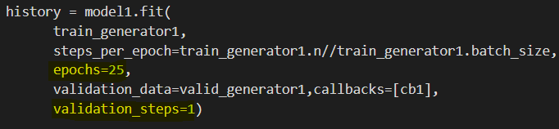

**Testing results**

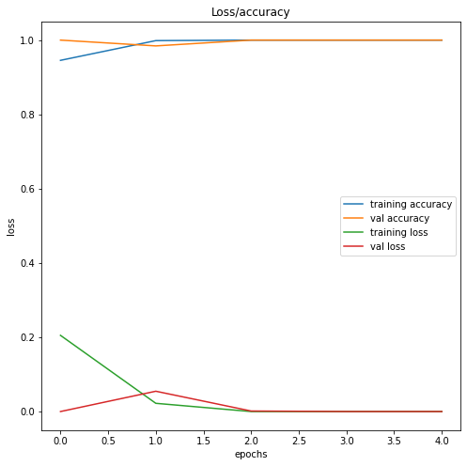

**Outputs :**

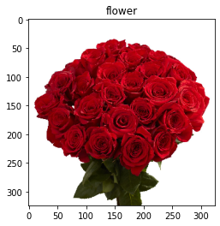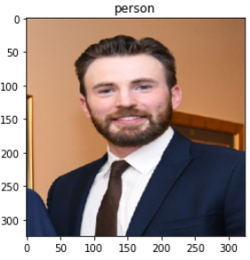

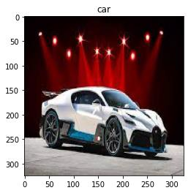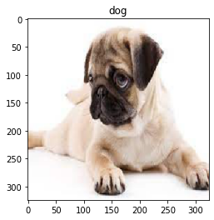

**Accuracy: 99%**

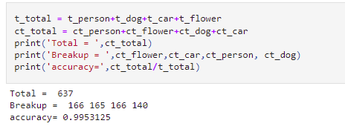

**Results noted:**

The classification accuracies of the proposed approach are higher than that of the baseline in all experiments using ImageNet subsets. The accuracy is also almost equal for the Natural Image subset.