Table6_11

Table of contents

── Attaching core tidyverse packages ──────────────────────── tidyverse 2.0.0 ──  
✔ dplyr 1.1.4 ✔ readr 2.1.5  
✔ forcats 1.0.0 ✔ stringr 1.5.1  
✔ ggplot2 4.0.0 ✔ tibble 3.2.1  
✔ lubridate 1.9.4 ✔ tidyr 1.3.1  
✔ purrr 1.0.2   
── Conflicts ────────────────────────────────────────── tidyverse_conflicts() ──  
✖ dplyr::filter() masks stats::filter()  
✖ dplyr::lag() masks stats::lag()  
ℹ Use the conflicted package (<http://conflicted.r-lib.org/>) to force all conflicts to become errors  
  
Attaching package: 'janitor'  
  
  
The following objects are masked from 'package:stats':  
  
 chisq.test, fisher.test  
  
  
here() starts at C:/Users/Lenovo/OneDrive/Desktop/Malawi_PPT_Project/PPT_Content_development  
  
New names:

## 0.1 Table 1: Demographic characteristics of study participants (N=200)

| **Characteristic** | **N = 1,174***1* |
| --- | --- |
| Gender |  |
| female | 768 (65%) |
| male | 406 (35%) |
| Age (years) | 36.89 (14.26) |
| Education level |  |
| no formal education | 75 (6.4%) |
| primary | 554 (47%) |
| secondary | 452 (39%) |
| tertiary | 93 (7.9%) |
| Location |  |
| rural | 661 (56%) |
| urban | 513 (44%) |
| District |  |
| balaka | 119 (10%) |
| blantyre | 132 (11%) |
| chikwawa | 94 (8.0%) |
| chitipa | 132 (11%) |
| kasungu | 108 (9.2%) |
| lilongwe | 96 (8.2%) |
| mzimba south | 120 (10%) |
| phalombe | 108 (9.2%) |
| salima | 133 (11%) |
| thyolo | 132 (11%) |
| Owenship of phone |  |
| no | 252 (21%) |
| yes | 922 (79%) |
| Owenship of smart phone |  |
| no | 571 (49%) |
| yes | 603 (51%) |
| Aware of Digital Health Surveillance |  |
| no | 477 (41%) |
| yes | 697 (59%) |
| Reported illness before using electronic gauges |  |
| no | 889 (76%) |
| yes | 285 (24%) |
| Familiar with Digital health Tools |  |
| not familiar | 590 (50%) |
| somewhat familiar | 363 (31%) |
| very familiar | 221 (19%) |
| Received health information via Phone |  |
| no | 284 (24%) |
| yes | 877 (76%) |
| Unknown | 13 |
| Seen or Heard Campaigns promoting Digital Reporting |  |
| no | 491 (42%) |
| yes | 683 (58%) |
| Use a Mobile phone or App to receive or report health information |  |
| no | 687 (59%) |
| yes | 487 (41%) |
| Prefered methods for reporting symptoms or receiving alerts |  |
| community health worker | 131 (11%) |
| in-person | 130 (11%) |
| mobile app | 74 (6.3%) |
| phone call | 375 (32%) |
| sms | 464 (40%) |
| Community thinks digital health surveillance works well |  |
| no | 97 (8.3%) |
| yes | 1,077 (92%) |
| In last 12 Month, reported health related information using phone or digital tool |  |
| no | 966 (82%) |
| yes | 208 (18%) |
| Frequncy of using phone to access health service or information |  |
| monthly | 80 (6.8%) |
| never | 691 (59%) |
| rarely | 337 (29%) |
| weekly | 66 (5.6%) |
| *1*n (%); Mean (SD) | |

# 1. Descriptive Analysis on Awareness of Digital Health Surveillance

## 1.1 Table 2:

| **Characteristic** | **N = 1,174***1* |
| --- | --- |
| Aware of Digital Health Surveillance |  |
| no | 477 (41%) |
| yes | 697 (59%) |
| Reported illness before using electronic gauges |  |
| no | 889 (76%) |
| yes | 285 (24%) |
| Familiar with Digital health Tools |  |
| not familiar | 590 (50%) |
| somewhat familiar | 363 (31%) |
| very familiar | 221 (19%) |
| Received health information via Phone |  |
| no | 284 (24%) |
| yes | 877 (76%) |
| Unknown | 13 |
| Seen or Heard Campaigns promoting Digital Reporting |  |
| no | 491 (42%) |
| yes | 683 (58%) |
| *1*n (%) | |

### 1.1.1 Source and channels used for awareness and receive of digital health information

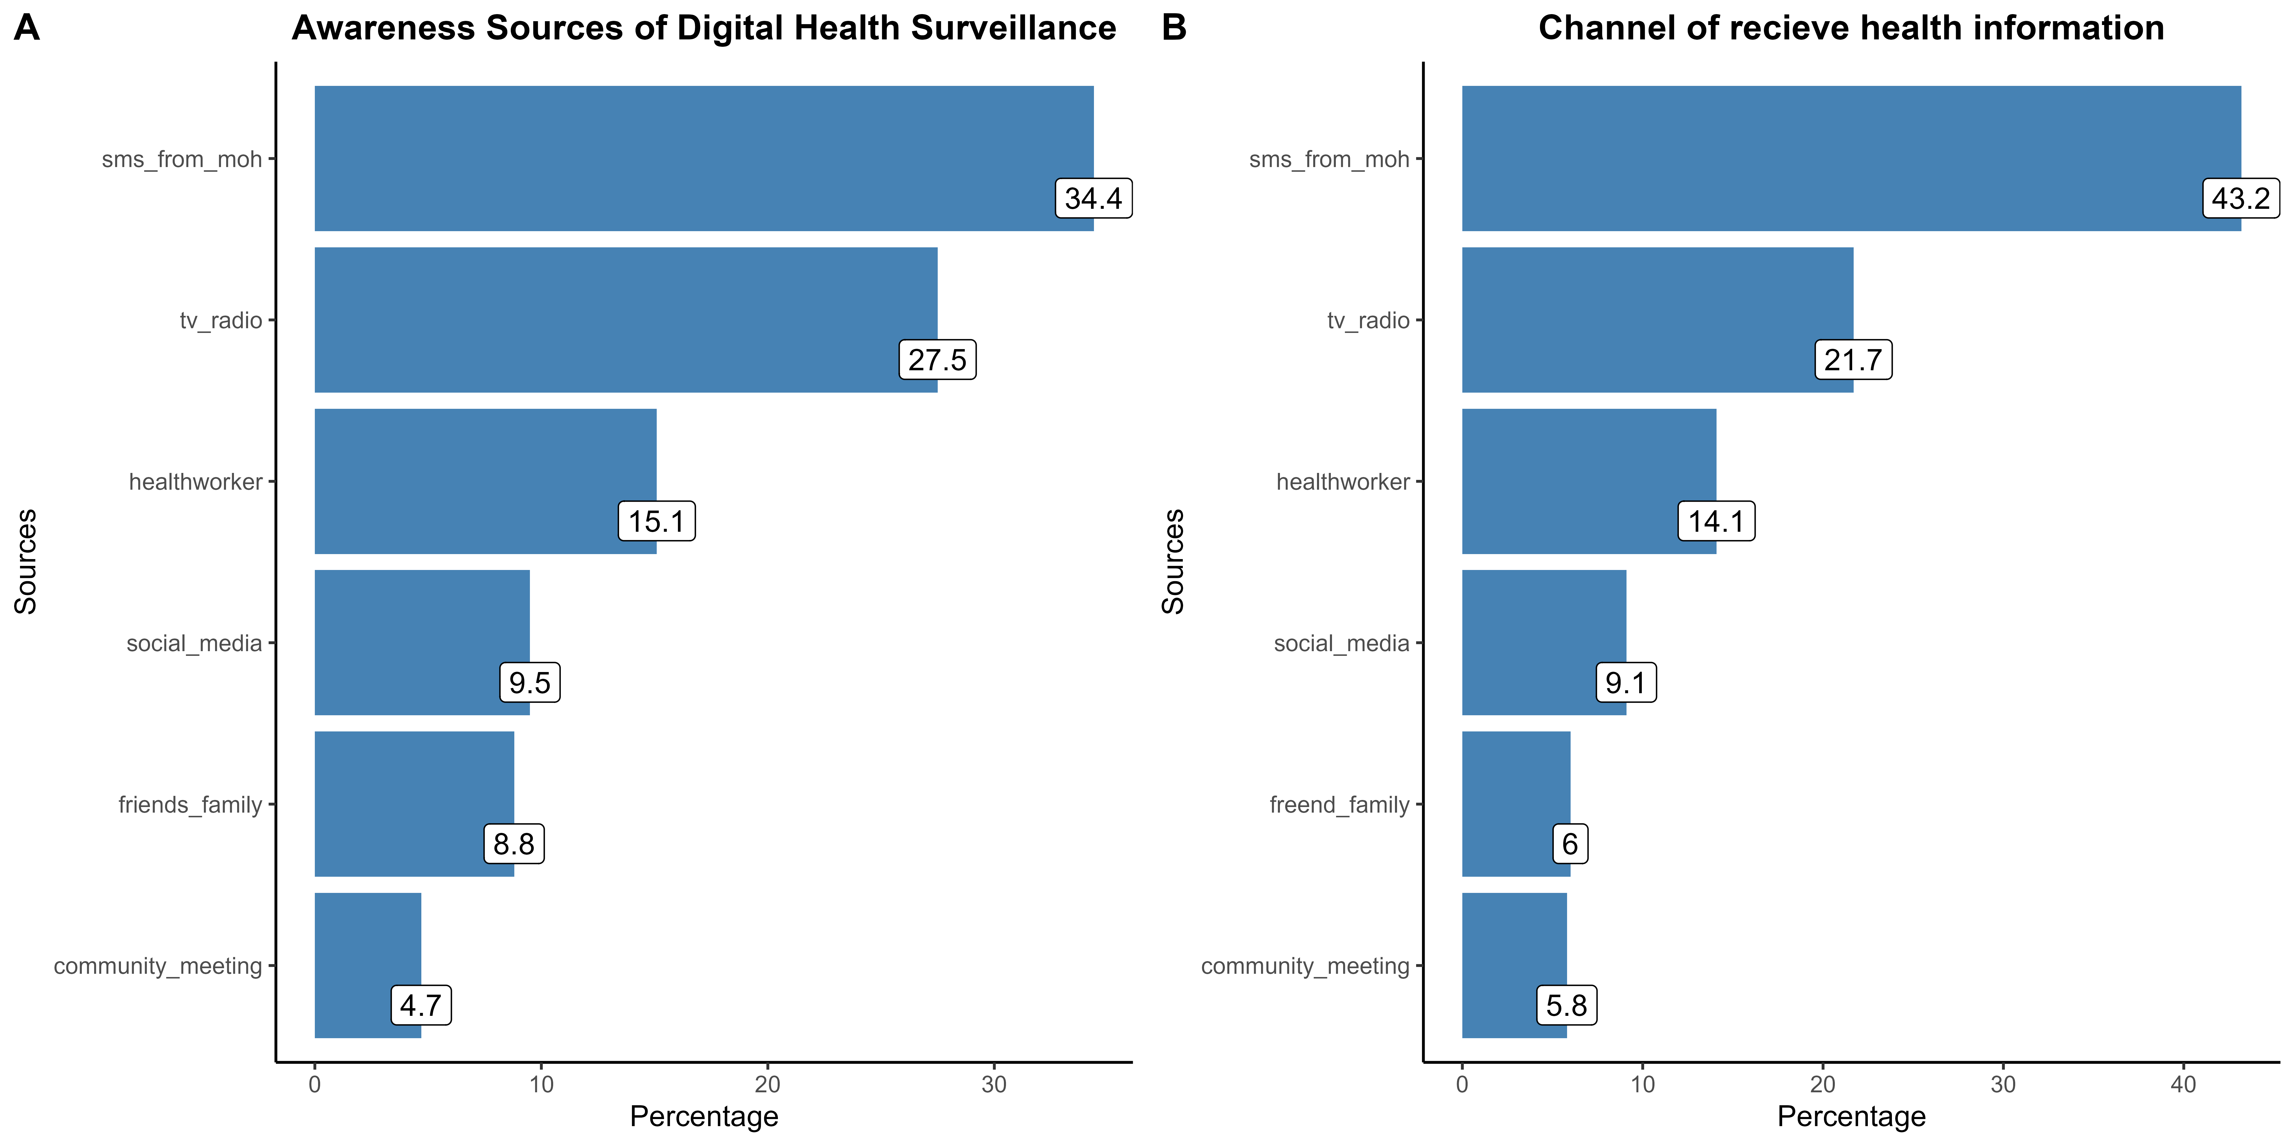

# 2. Descriptve analysis of attitudes towards digital health surveillance

## 2.1 Table 3:

| **Characteristic** | **agree** N = 4,571*1* | **disagree** N = 355*1* | **neutral** N = 653*1* | **strongly agree** N = 2,370*1* | **strongly disagree** N = 269*1* |
| --- | --- | --- | --- | --- | --- |
| Statement |  |  |  |  |  |
| Accept using digital system if it was approval by MoH | 699 (60%) | 34 (2.9%) | 62 (5.3%) | 340 (29%) | 39 (3.3%) |
| Believe using phone to report illness can improve health in community | 552 (47%) | 49 (4.2%) | 77 (6.6%) | 429 (37%) | 67 (5.7%) |
| Believe person health data will be safe when submitted through digital tools | 640 (55%) | 87 (7.4%) | 118 (10%) | 294 (25%) | 35 (3.0%) |
| Feel comfortable reporting health sysmptoms through SMS or Mobile apps like Chatbots | 638 (54%) | 69 (5.9%) | 82 (7.0%) | 340 (29%) | 45 (3.8%) |
| People can accept digital surveillance tools once properly explained | 636 (54%) | 31 (2.6%) | 189 (16%) | 290 (25%) | 28 (2.4%) |
| Trust digital systems can detect disease outbreaks early | 651 (55%) | 44 (3.7%) | 64 (5.5%) | 385 (33%) | 30 (2.6%) |
| Willing to participant in digital disease surveillance programs | 755 (64%) | 41 (3.5%) | 61 (5.2%) | 292 (25%) | 25 (2.1%) |
| *1*n (%) | | | | | |

# 3. Descriptive analysis on public practice in use of digital health surveillance tool.

## 3.1 Table 4:

| **Characteristic** | **N = 1,174***1* |
| --- | --- |
| Use a Mobile phone or App to receive or report health information |  |
| no | 687 (59%) |
| yes | 487 (41%) |
| Prefered methods for reporting symptoms or receiving alerts |  |
| community health worker | 131 (11%) |
| in-person | 130 (11%) |
| mobile app | 74 (6.3%) |
| phone call | 375 (32%) |
| sms | 464 (40%) |
| Community thinks digital health surveillance works well |  |
| no | 97 (8.3%) |
| yes | 1,077 (92%) |
| In last 12 Month, reported health related information using phone or digital tool |  |
| no | 966 (82%) |
| yes | 208 (18%) |
| Frequncy of using phone to access health service or information |  |
| monthly | 80 (6.8%) |
| never | 691 (59%) |
| rarely | 337 (29%) |
| weekly | 66 (5.6%) |
| *1*n (%) | |

# 4. Motivation factors to participation in digital health surveillance

# 5. hindrance factors to participation in digital health surveillance

## 5.1 Table 5:

Warning: Using an external vector in selections was deprecated in tidyselect 1.1.0.  
ℹ Please use `all_of()` or `any_of()` instead.  
 # Was:  
 data %>% select(demo_v)  
  
 # Now:  
 data %>% select(all_of(demo_v))  
  
See <https://tidyselect.r-lib.org/reference/faq-external-vector.html>.

| **Characteristic** | **no** N = 252*1* | **95% CI***2* | **yes** N = 922*1* | **95% CI***2* | **p-value***3* |
| --- | --- | --- | --- | --- | --- |
| **gender** |  |  |  |  | <0.001 |
| female | 195 (77%) | 72%, 82% | 573 (62%) | 59%, 65% |  |
| male | 57 (23%) | 18%, 28% | 349 (38%) | 35%, 41% |  |
| **age_group2** |  |  |  |  | 0.001 |
| 18-39 | 149 (59%) | 53%, 65% | 599 (65%) | 62%, 68% |  |
| 40-59 | 64 (25%) | 20%, 31% | 251 (27%) | 24%, 30% |  |
| 60+ | 39 (15%) | 11%, 21% | 72 (7.8%) | 6.2%, 9.8% |  |
| **edu** |  |  |  |  | <0.001 |
| no formal education | 35 (14%) | 10%, 19% | 40 (4.3%) | 3.2%, 5.9% |  |
| primary | 152 (60%) | 54%, 66% | 402 (44%) | 40%, 47% |  |
| secondary | 61 (24%) | 19%, 30% | 391 (42%) | 39%, 46% |  |
| tertiary | 4 (1.6%) | 0.51%, 4.3% | 89 (9.7%) | 7.9%, 12% |  |
| **locat** |  |  |  |  | 0.2 |
| rural | 151 (60%) | 54%, 66% | 510 (55%) | 52%, 59% |  |
| urban | 101 (40%) | 34%, 46% | 412 (45%) | 41%, 48% |  |
| **district** |  |  |  |  | <0.001 |
| balaka | 24 (9.5%) | 6.3%, 14% | 95 (10%) | 8.5%, 12% |  |
| blantyre | 29 (12%) | 8.0%, 16% | 103 (11%) | 9.2%, 13% |  |
| chikwawa | 21 (8.3%) | 5.4%, 13% | 73 (7.9%) | 6.3%, 9.9% |  |
| chitipa | 13 (5.2%) | 2.9%, 8.9% | 119 (13%) | 11%, 15% |  |
| kasungu | 25 (9.9%) | 6.6%, 14% | 83 (9.0%) | 7.3%, 11% |  |
| lilongwe | 13 (5.2%) | 2.9%, 8.9% | 83 (9.0%) | 7.3%, 11% |  |
| mzimba south | 24 (9.5%) | 6.3%, 14% | 96 (10%) | 8.6%, 13% |  |
| phalombe | 36 (14%) | 10%, 19% | 72 (7.8%) | 6.2%, 9.8% |  |
| salima | 22 (8.7%) | 5.7%, 13% | 111 (12%) | 10%, 14% |  |
| thyolo | 45 (18%) | 13%, 23% | 87 (9.4%) | 7.7%, 12% |  |
| *1*n (%) | | | | | |
| *2*CI = Confidence Interval | | | | | |
| *3*Pearson's Chi-squared test | | | | | |