San Services and Infra

### Availability of Sainitary Infrastrauture

| **Characteristic** | **available** N = 2,921*1* | **95% CI***2* | **not_available** N = 1,825*1* | **95% CI***2* |
| --- | --- | --- | --- | --- |
| sanitary_infractures |  |  |  |  |
| bath_shelter_bathroom | 744 (25%) | 24%, 27% | 47 (2.6%) | 1.9%, 3.4% |
| designated_kitchen_area | 551 (19%) | 17%, 20% | 240 (13%) | 12%, 15% |
| household_handwashing_facility | 240 (8.2%) | 7.3%, 9.3% | 551 (30%) | 28%, 32% |
| soap_or_detergent_available | 171 (5.9%) | 5.0%, 6.8% | 620 (34%) | 32%, 36% |
| soild_waste_disposal | 473 (16%) | 15%, 18% | 318 (17%) | 16%, 19% |
| toilet_facility_avaiable | 742 (25%) | 24%, 27% | 49 (2.7%) | 2.0%, 3.6% |
| *1*n (%) | | | | |
| *2*CI = Confidence Interval | | | | |

### Pie chart on the condition of the sanitary infractures at the study visit

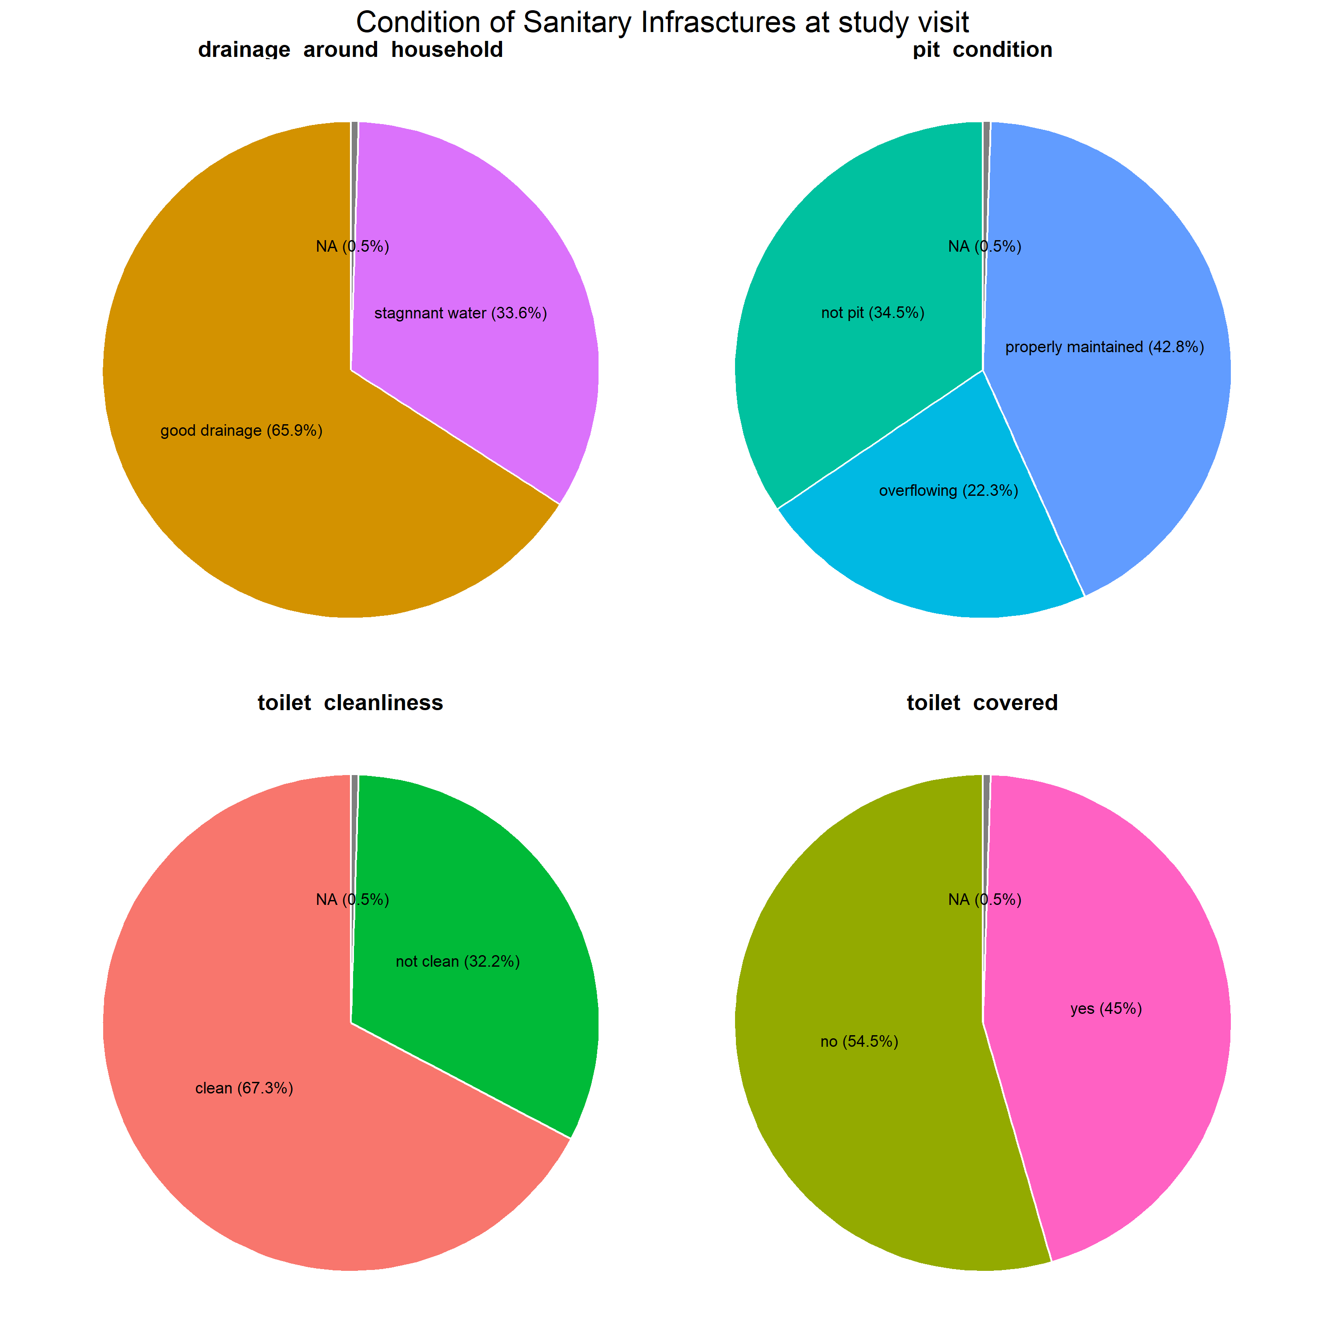

### other methods of fecal disposal if the toilet is not available

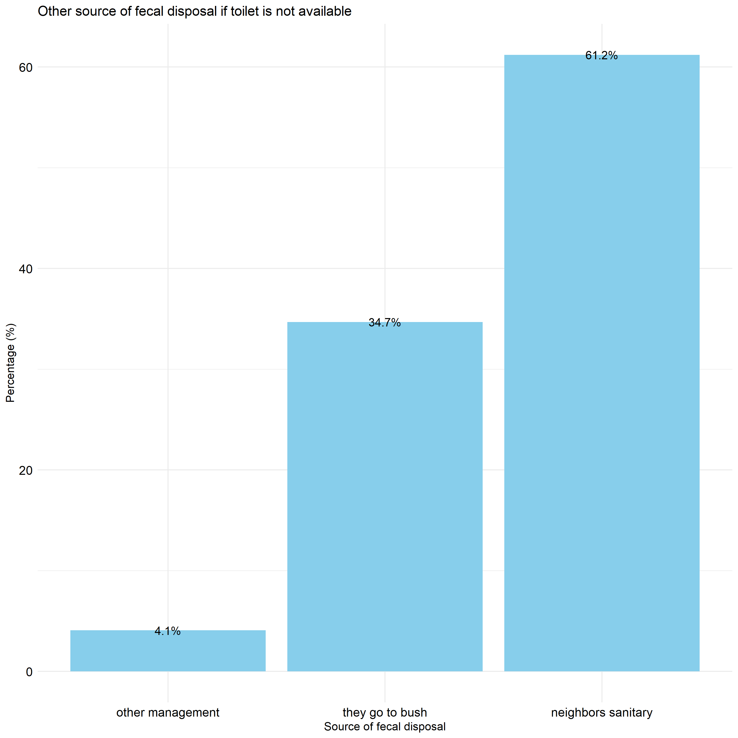

## overall sanitary infrastructures in the community and household level and frequency of handwashing at the household level.

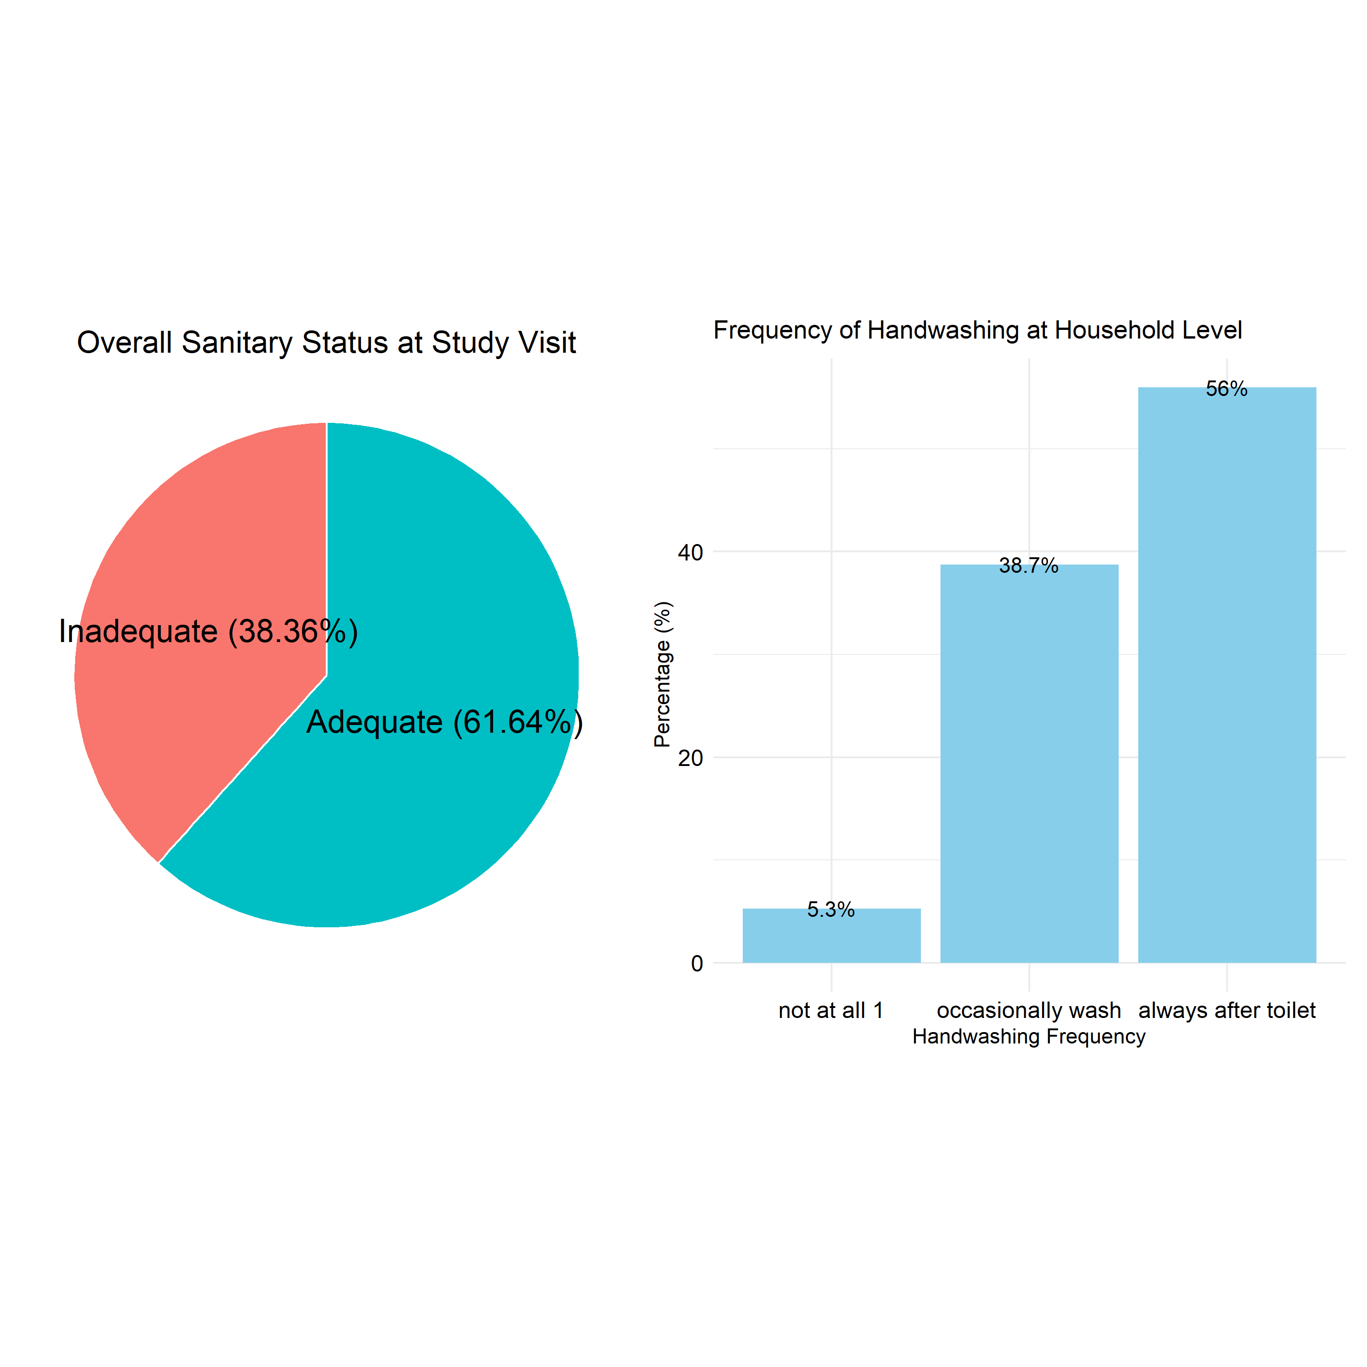

## Crosstabulation sanitary and demographic variables

| **Characteristic** | **Adequate**  N = 4901 | **95% CI**2 | **Inadequate**  N = 3051 | **95% CI**2 | **p-value**3 |
| --- | --- | --- | --- | --- | --- |
| Sex |  |  |  |  | 0.6 |
| Female | 377 (77%) | 73%, 81% | 230 (75%) | 70%, 80% |  |
| Male | 113 (23%) | 19%, 27% | 75 (25%) | 20%, 30% |  |
| age_group |  |  |  |  | 0.5 |
| >50 | 113 (23%) | 19%, 27% | 61 (20%) | 16%, 25% |  |
| 18-30 | 178 (36%) | 32%, 41% | 111 (36%) | 31%, 42% |  |
| 31-50 | 199 (41%) | 36%, 45% | 133 (44%) | 38%, 49% |  |
| level_education |  |  |  |  | >0.9 |
| None | 65 (13%) | 10%, 17% | 43 (14%) | 10%, 19% |  |
| Primary | 306 (62%) | 58%, 67% | 193 (63%) | 58%, 69% |  |
| Secondary | 108 (22%) | 19%, 26% | 62 (20%) | 16%, 25% |  |
| Tertiary | 11 (2.2%) | 1.2%, 4.1% | 7 (2.3%) | 1.0%, 4.9% |  |
| Religion |  |  |  |  | 0.073 |
| Christianity | 377 (77%) | 73%, 81% | 215 (70%) | 65%, 75% |  |
| muslim | 102 (21%) | 17%, 25% | 77 (25%) | 21%, 31% |  |
| others_regligion | 11 (2.2%) | 1.2%, 4.1% | 13 (4.3%) | 2.4%, 7.4% |  |
| marital_status |  |  |  |  | 0.2 |
| divorced | 31 (6.3%) | 4.4%, 9.0% | 30 (9.8%) | 6.8%, 14% |  |
| married | 365 (74%) | 70%, 78% | 201 (66%) | 60%, 71% |  |
| separated | 17 (3.5%) | 2.1%, 5.6% | 12 (3.9%) | 2.1%, 7.0% |  |
| Single | 38 (7.8%) | 5.6%, 11% | 30 (9.8%) | 6.8%, 14% |  |
| widow | 30 (6.1%) | 4.2%, 8.7% | 24 (7.9%) | 5.2%, 12% |  |
| widower | 9 (1.8%) | 0.90%, 3.6% | 8 (2.6%) | 1.2%, 5.3% |  |
| occupation |  |  |  |  |  |
| farmer | 235 (48%) | 43%, 52% | 138 (45%) | 40%, 51% |  |
| fisherman | 2 (0.4%) | 0.07%, 1.6% | 2 (0.7%) | 0.11%, 2.6% |  |
| fishsellar | 2 (0.4%) | 0.07%, 1.6% | 1 (0.3%) | 0.02%, 2.1% |  |
| housewife | 74 (15%) | 12%, 19% | 42 (14%) | 10%, 18% |  |
| other_business | 109 (22%) | 19%, 26% | 80 (26%) | 21%, 32% |  |
| other_occupation | 41 (8.4%) | 6.1%, 11% | 33 (11%) | 7.7%, 15% |  |
| professionalworker | 14 (2.9%) | 1.6%, 4.9% | 5 (1.6%) | 0.61%, 4.0% |  |
| retired | 6 (1.2%) | 0.50%, 2.8% | 3 (1.0%) | 0.25%, 3.1% |  |
| student | 7 (1.4%) | 0.63%, 3.1% | 1 (0.3%) | 0.02%, 2.1% |  |
| ethnicity |  |  |  |  |  |
| chewa | 249 (51%) | 46%, 55% | 143 (47%) | 41%, 53% |  |
| lomwe | 39 (8.0%) | 5.8%, 11% | 26 (8.5%) | 5.7%, 12% |  |
| ngonde | 2 (0.4%) | 0.07%, 1.6% | 2 (0.7%) | 0.11%, 2.6% |  |
| ngoni | 61 (12%) | 9.7%, 16% | 40 (13%) | 9.6%, 18% |  |
| nyanja | 8 (1.6%) | 0.76%, 3.3% | 6 (2.0%) | 0.80%, 4.4% |  |
| other_enthni | 8 (1.6%) | 0.76%, 3.3% | 1 (0.3%) | 0.02%, 2.1% |  |
| Sena | 2 (0.4%) | 0.07%, 1.6% | 1 (0.3%) | 0.02%, 2.1% |  |
| Tonga | 19 (3.9%) | 2.4%, 6.1% | 5 (1.6%) | 0.61%, 4.0% |  |
| tumbuka | 9 (1.8%) | 0.90%, 3.6% | 2 (0.7%) | 0.11%, 2.6% |  |
| Yao | 93 (19%) | 16%, 23% | 79 (26%) | 21%, 31% |  |
| District |  |  |  |  | 0.015 |
| Balaka | 15 (3.1%) | 1.8%, 5.1% | 19 (6.2%) | 3.9%, 9.7% |  |
| Blantyre | 69 (14%) | 11%, 18% | 61 (20%) | 16%, 25% |  |
| Dedza | 62 (13%) | 9.9%, 16% | 43 (14%) | 10%, 19% |  |
| Lilongwe | 202 (41%) | 37%, 46% | 98 (32%) | 27%, 38% |  |
| Mangochi | 77 (16%) | 13%, 19% | 52 (17%) | 13%, 22% |  |
| Nkhatabay | 27 (5.5%) | 3.7%, 8.0% | 9 (3.0%) | 1.4%, 5.7% |  |
| Salima | 38 (7.8%) | 5.6%, 11% | 23 (7.5%) | 4.9%, 11% |  |
| residence |  |  |  |  | 0.6 |
| in_land | 333 (68%) | 64%, 72% | 202 (66%) | 61%, 71% |  |
| lake_share | 157 (32%) | 28%, 36% | 103 (34%) | 29%, 39% |  |
| 1n (%) | | | | | |
| 2CI = Confidence Interval | | | | | |
| 3Pearson's Chi-squared test | | | | | |

# Map of Study Sites

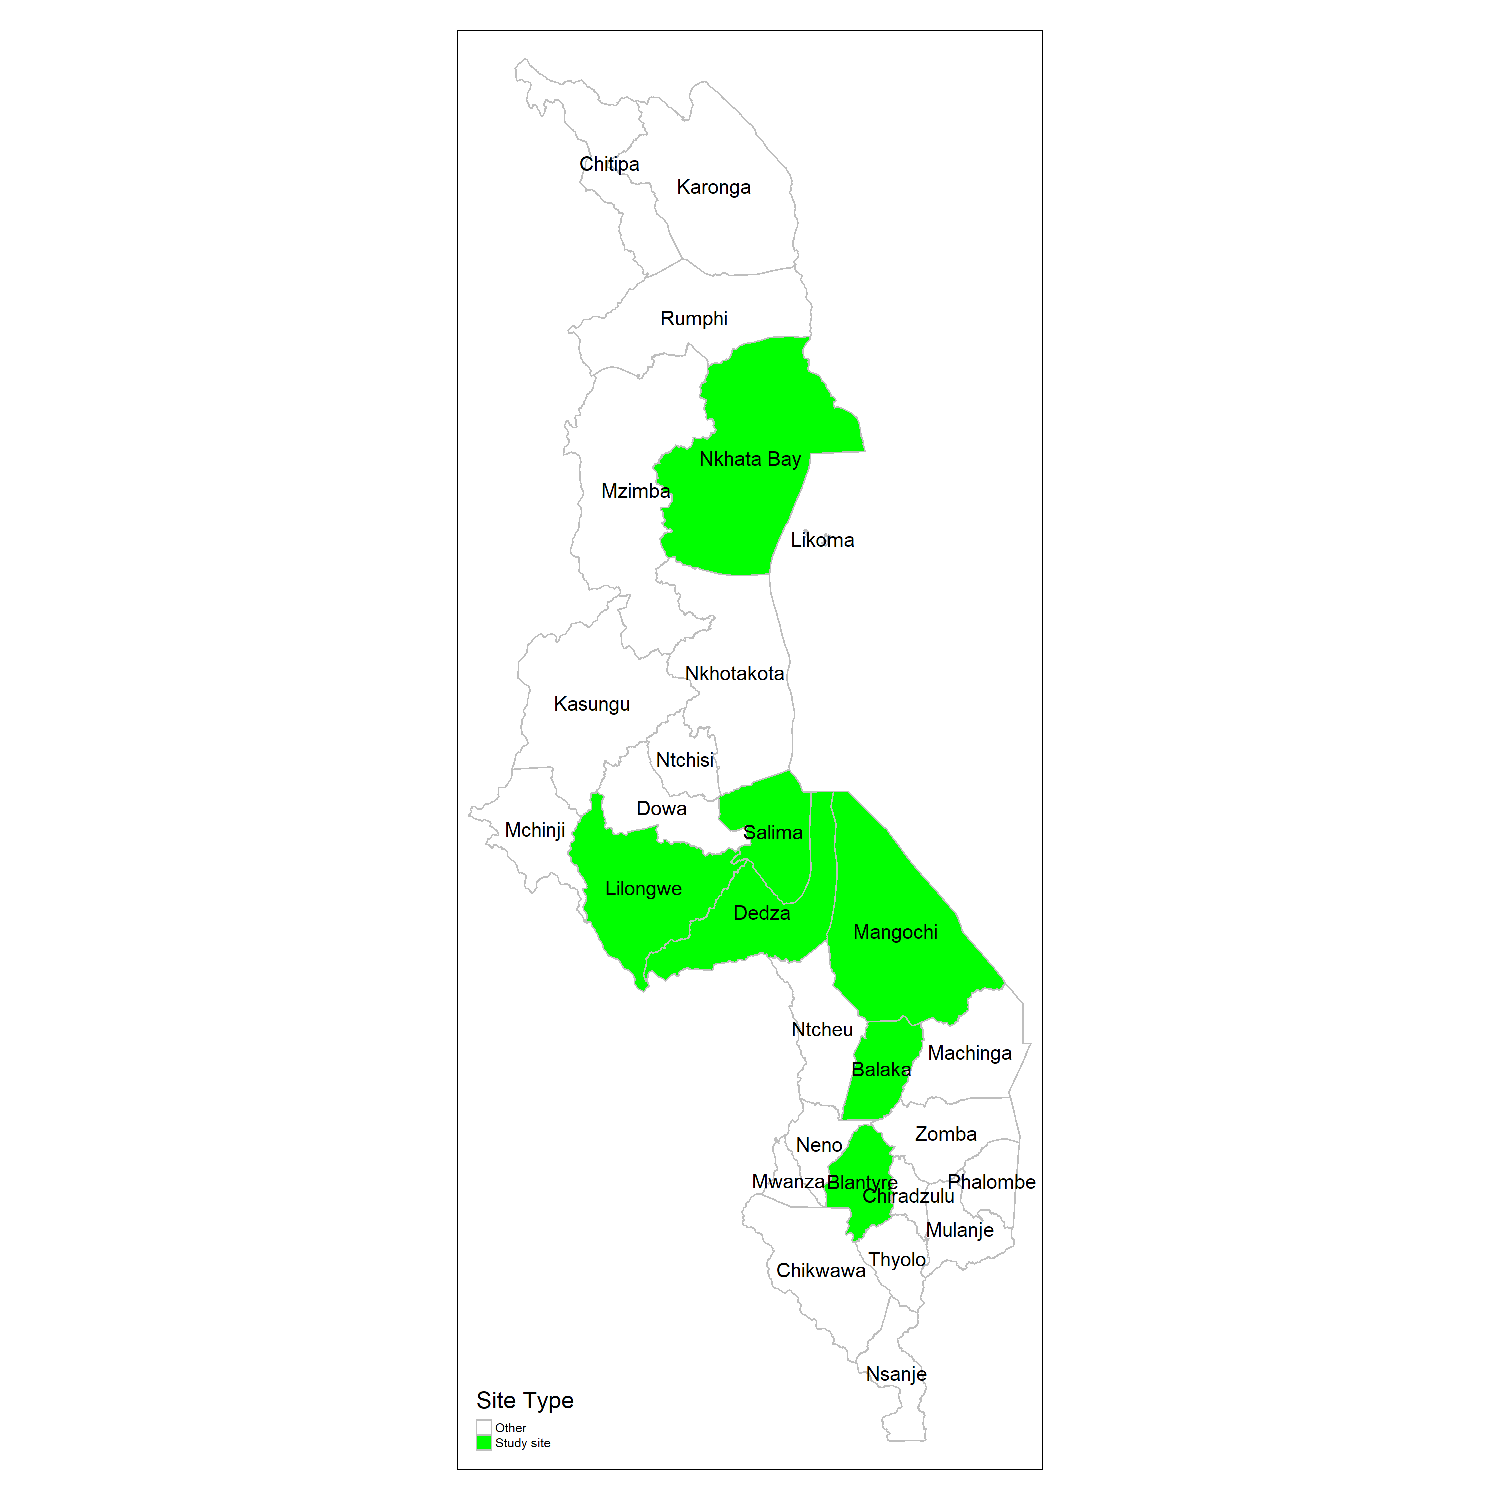

# spatial analysis of the availabiliyt of the sanitaty infrastructure by TA(PAMI).



## common resson of not using the sanitary infractures

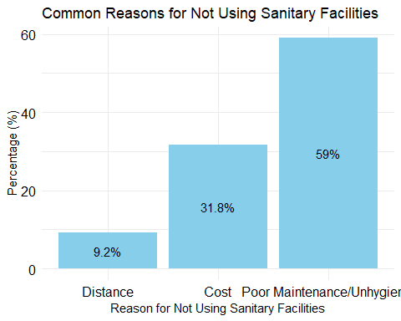

# Regession Analysis on the sanitary infractures and cholera vaccination.(cruded)

| **Characteristic** | **OR**1 | **95% CI**1 | **p-value** |
| --- | --- | --- | --- |
| sex |  |  |  |
| female | — | — |  |
| male | 0.92 | 0.66, 1.29 | 0.6 |
| age_group |  |  |  |
| >50 | — | — |  |
| 18-30 | 0.87 | 0.58, 1.28 | 0.5 |
| 31-50 | 0.81 | 0.55, 1.18 | 0.3 |
| level_education |  |  |  |
| none | — | — |  |
| primary | 1.05 | 0.68, 1.60 | 0.8 |
| secondary | 1.15 | 0.70, 1.89 | 0.6 |
| tertiary | 1.04 | 0.38, 3.02 | >0.9 |
| religion |  |  |  |
| Christianity | — | — |  |
| muslim | 0.76 | 0.54, 1.06 | 0.11 |
| others_regligion | 0.48 | 0.21, 1.10 | 0.082 |
| marital_status |  |  |  |
| divorced | — | — |  |
| married | 1.76 | 1.03, 2.99 | 0.037 |
| separated | 1.37 | 0.56, 3.40 | 0.5 |
| single | 1.23 | 0.61, 2.46 | 0.6 |
| widow | 1.21 | 0.58, 2.53 | 0.6 |
| widower | 1.09 | 0.37, 3.26 | 0.9 |
| occupation |  |  |  |
| farmer | — | — |  |
| fisherman | 0.59 | 0.07, 4.94 | 0.6 |
| fishsellar | 1.17 | 0.11, 25.4 | 0.9 |
| housewife | 1.03 | 0.67, 1.60 | 0.9 |
| other_business | 0.80 | 0.56, 1.14 | 0.2 |
| other_occupation | 0.73 | 0.44, 1.21 | 0.2 |
| professionalworker | 1.64 | 0.61, 5.18 | 0.3 |
| retired | 1.17 | 0.30, 5.63 | 0.8 |
| student | 4.11 | 0.72, 77.3 | 0.2 |
| ethnicity |  |  |  |
| chewa | — | — |  |
| lomwe | 0.86 | 0.51, 1.49 | 0.6 |
| ngonde | 0.57 | 0.07, 4.83 | 0.6 |
| ngoni | 0.88 | 0.56, 1.38 | 0.6 |
| nyanja | 0.77 | 0.26, 2.37 | 0.6 |
| other_enthni | 4.59 | 0.83, 85.7 | 0.2 |
| sena | 1.15 | 0.11, 24.8 | >0.9 |
| tonga | 2.18 | 0.86, 6.69 | 0.13 |
| tumbuka | 2.58 | 0.65, 17.1 | 0.2 |
| yao | 0.68 | 0.47, 0.97 | 0.035 |
| district |  |  |  |
| Balaka | — | — |  |
| Blantyre | 1.43 | 0.67, 3.10 | 0.4 |
| Dedza | 1.83 | 0.84, 4.04 | 0.13 |
| Lilongwe | 2.61 | 1.28, 5.43 | 0.009 |
| Mangochi | 1.88 | 0.88, 4.07 | 0.11 |
| Nkhatabay | 3.80 | 1.41, 10.9 | 0.010 |
| Salima | 2.09 | 0.90, 4.98 | 0.089 |
| residence |  |  |  |
| in_land | — | — |  |
| lake_share | 0.92 | 0.68, 1.25 | 0.6 |
| 1OR = Odds Ratio, CI = Confidence Interval | | | |

## Regession Analysis on the sanitary infractures and cholera vaccination.(Adjusted OR)

| **Characteristic** | **OR**1 | **95% CI**1 | **p-value** |
| --- | --- | --- | --- |
| sex |  |  |  |
| female | — | — |  |
| male | 0.84 | 0.57, 1.22 | 0.4 |
| age_group |  |  |  |
| >50 | — | — |  |
| 18-30 | 0.70 | 0.42, 1.15 | 0.2 |
| 31-50 | 0.68 | 0.42, 1.07 | 0.10 |
| level_education |  |  |  |
| none | — | — |  |
| primary | 1.05 | 0.65, 1.66 | 0.8 |
| secondary | 1.16 | 0.65, 2.04 | 0.6 |
| tertiary | 0.90 | 0.25, 3.25 | 0.9 |
| religion |  |  |  |
| Christianity | — | — |  |
| muslim | 1.40 | 0.71, 2.84 | 0.3 |
| others_regligion | 0.44 | 0.18, 1.05 | 0.063 |
| marital_status |  |  |  |
| divorced | — | — |  |
| married | 1.57 | 0.88, 2.78 | 0.13 |
| separated | 1.28 | 0.51, 3.30 | 0.6 |
| single | 1.17 | 0.54, 2.54 | 0.7 |
| widow | 0.69 | 0.30, 1.58 | 0.4 |
| widower | 0.86 | 0.28, 2.74 | 0.8 |
| occupation |  |  |  |
| farmer | — | — |  |
| fisherman | 0.40 | 0.04, 3.72 | 0.4 |
| fishsellar | 0.99 | 0.09, 22.2 | >0.9 |
| housewife | 0.95 | 0.59, 1.52 | 0.8 |
| other_business | 0.87 | 0.58, 1.29 | 0.5 |
| other_occupation | 0.74 | 0.43, 1.28 | 0.3 |
| professionalworker | 1.70 | 0.53, 6.48 | 0.4 |
| retired | 1.16 | 0.28, 5.89 | 0.8 |
| student | 4.68 | 0.71, 93.4 | 0.2 |
| ethnicity |  |  |  |
| chewa | — | — |  |
| lomwe | 1.40 | 0.73, 2.75 | 0.3 |
| ngonde | 1.03 | 0.09, 11.9 | >0.9 |
| ngoni | 1.37 | 0.79, 2.42 | 0.3 |
| nyanja | 1.23 | 0.37, 4.32 | 0.7 |
| other_enthni | 9.50 | 1.54, 185 | 0.042 |
| sena | 1.36 | 0.11, 31.3 | 0.8 |
| tonga | 3.98 | 0.69, 27.8 | 0.14 |
| tumbuka | 4.99 | 0.76, 51.0 | 0.12 |
| yao | 0.77 | 0.35, 1.64 | 0.5 |
| district |  |  |  |
| Balaka | — | — |  |
| Blantyre | 1.29 | 0.58, 2.91 | 0.5 |
| Dedza | 1.69 | 0.72, 4.02 | 0.2 |
| Lilongwe | 3.17 | 1.36, 7.52 | 0.008 |
| Mangochi | 2.01 | 0.90, 4.56 | 0.091 |
| Nkhatabay | 1.24 | 0.20, 7.08 | 0.8 |
| Salima | 2.27 | 0.91, 5.80 | 0.081 |
| residence |  |  |  |
| in_land | — | — |  |
| lake_share |  |  |  |
| 1OR = Odds Ratio, CI = Confidence Interval | | | |