IST3134 GROUP ASSIGNMENT
Large-Scale Analysis of US Traffic Accidents Using PySpark
Spatiotemporal, Severity, Weather, and Road-Feature Patterns with a Pandas Performance Comparison
Course: IST3134
Student 1: [Name and student ID]
Student 2: [Name and student ID]
Lecturer: [Lecturer's name]
Submission date: [Date]
GitHub repository: [Insert repository URL]
May Semester 2026

Abstract
This study developed and evaluated a scalable workflow for analysing the US Accidents dataset using PySpark on Amazon EMR, with chunked Pandas as a single-machine comparison. The downloaded CSV contained 7,728,394 records, 46 variables, and approximately 3.06 GB of data covering 14 January 2016 to 31 March 2023. An explicit schema and a mixed-format timestamp parser were applied before the validated records were stored as Year-partitioned Parquet in Amazon S3. PySpark DataFrame aggregations examined geographic, temporal, severity, weather, and road-feature patterns, and all principal grouped totals reconciled to the complete dataset. California contained the largest state count with 1,741,433 records (22.53%), while Miami, Florida had the largest city–state count with 186,768. Recorded incidents were concentrated on weekdays and around 07:00, 08:00, 16:00, and 17:00. Severity level 2 represented 79.67% of records, whereas levels 3–4 together represented 19.46%. Weather and road-feature comparisons showed descriptive associations but could not establish risk or causality. In the three-run benchmark, Pandas recorded a median end-to-end runtime of 15.6320 seconds and PySpark recorded 15.4447 seconds. PySpark was approximately 1.2% faster, but the 0.1873-second difference was not substantial. The findings demonstrate a reproducible cloud-based big-data workflow while also showing that chunked Pandas remained competitive for this dataset and relatively simple aggregation workload.

1. Introduction

1.1 Background
Traffic accidents are a significant public-safety and transportation-management concern. Effective analysis requires more than counting incidents: decision-makers also need to understand where reported events are concentrated, when they occur, how their recorded severity varies, and which environmental or road-context characteristics accompany them. These questions are inherently multidimensional because an accident record may combine location, time, weather, road features, and event-impact information. A large dataset therefore provides an opportunity to identify broad patterns that may be difficult to observe in smaller local samples.
The US Accidents dataset was created to address limitations in the availability and contextual richness of large-scale traffic-accident data. Its original release combined traffic-event reports with location, weather, points-of-interest, and period-of-day information, enabling analyses of spatial and temporal patterns as well as contextual associations (Moosavi et al., 2019a). The current Kaggle release extends the coverage from February 2016 to March 2023 and contains approximately 7.7 million records from 49 US states (Moosavi, n.d.). This scale makes the dataset appropriate for an assignment concerned with big-data processing, particularly because several analytical tasks require repeated grouping and aggregation across millions of rows.
Large scale alone does not make an analysis valid. Counts can be shaped by data-collection coverage, missing reporting days, population size, road mileage, traffic volume, and the frequency with which different weather conditions occur. Consequently, the present project is framed as an analysis of recorded incidents within the dataset rather than an estimate of true accident risk. This distinction is important because a state with more records is not necessarily more dangerous, and a weather category with many accidents is not necessarily a causal risk factor without an appropriate exposure denominator.

1.2 Problem Statement
The analytical problem is to transform a large collection of heterogeneous accident records into interpretable geographic, temporal, severity, weather, and road-feature summaries. A conventional Pandas workflow offers a familiar tabular interface, but its practical behaviour depends on the memory and processing resources of a single machine. PySpark, by contrast, provides a distributed DataFrame and SQL framework in which structured transformations can be planned and executed across partitions. The project therefore combines substantive accident analysis with a controlled comparison of two processing approaches.
The central challenge is not merely to produce charts. The implementation must establish a reproducible cleaning and aggregation pipeline, validate equivalent outputs across PySpark and Pandas, and interpret the summaries without overstating what the observational dataset can demonstrate. The report must also explain how the chosen big-data platform supports the task and where the overhead or complexity of distributed processing may limit its advantage on smaller workloads.

1.3 Aim and Objectives
The aim of this project is to develop and evaluate a scalable analytical workflow for identifying patterns in the US Accidents dataset using PySpark, with Pandas serving as a comparable single-machine implementation.
- Calculate and compare recorded accident counts by state.
- Identify city–state combinations with the largest recorded accident counts.
- Examine yearly and monthly patterns in recorded accidents.
- Examine the distribution of records by weekday and hour.
- Describe the distribution of the dataset's severity measure.
- Compare average recorded severity across states and qualifying city–state groups.
- Examine associations between weather conditions, recorded accident counts, and severity.
- Examine associations between road-context features, recorded accident counts, and severity.
- Implement equivalent PySpark and Pandas workloads and compare their measured runtime and scalability.

1.4 Research Questions
- How are recorded accidents distributed across US states and city–state combinations?
- How do recorded accident counts vary by year, month, weekday, and hour?
- How is the dataset's severity measure distributed, and how does average severity vary geographically?
- What associations are observable between weather conditions and recorded accident count or severity?
- What associations are observable between road-context features and recorded accident count or severity?
- How do equivalent PySpark and Pandas pipelines compare as the processed data volume increases?

1.5 Scope and Report Structure
The project is descriptive and comparative. It focuses on aggregations and exploratory summaries rather than causal inference or predictive modelling. The geographic analysis uses state and city–state labels; the temporal analysis uses fields derived from the recorded start time; and the contextual analysis uses weather and road-feature attributes supplied by the dataset. The technology comparison is limited to equivalent PySpark and Pandas operations performed under a documented environment. Population-normalised accident rates, traffic-exposure rates, and claims about accident causation are outside the scope unless additional denominator data are introduced and validated.
Following this introduction, Section 2 reviews the dataset and technical background. Section 3 describes the data source, structure, analytical relevance, big-data characteristics, and limitations. Section 4 presents the completed methodology, Section 5 reports the validated results, and Section 6 discusses their meaning and the technology comparison. Section 7 is reserved for the two individual reflections, and Section 8 concludes the report.

2. Background and Related Work

2.1 Large-Scale Traffic-Accident Data
Traffic-accident research has often been constrained by datasets that are geographically limited, difficult to share, outdated, or missing contextual attributes. Moosavi et al. (2019a) introduced the US Accidents dataset as a large-scale, publicly available resource intended to support reproducible analysis across the contiguous United States. The original dataset included event attributes together with address, weather, point-of-interest, and period-of-day information. This combination is relevant to the present project because it allows the same analytical pipeline to examine spatial concentration, temporal variation, environmental context, and nearby road features.
The dataset was also used by Moosavi et al. (2019b) in research on accident-risk prediction using heterogeneous sparse data. That work demonstrates the wider analytical value of combining traffic, time, weather, and contextual variables, although the present assignment has a narrower purpose. Instead of building a predictive model, this project uses transparent grouped summaries to demonstrate distributed data processing and to produce interpretable descriptive evidence.

2.2 Spatiotemporal and Contextual Analysis
Geographic counts can reveal where records are concentrated, while temporal groupings can show recurring patterns and changes in data coverage. State and city summaries are useful starting points because they reduce millions of records to interpretable comparisons. However, the meaning of these counts is constrained by the absence of denominators. A valid rate comparison would require measures such as population, vehicle miles travelled, traffic volume, road length, or another defensible exposure quantity. For this reason, geographic outputs in the present report should be labelled as recorded accident counts rather than rankings of safety or danger.
The same caution applies to weather and road-feature summaries. Weather-condition counts combine the frequency of a condition with the number of reported accidents observed during it. Without information on the total time or traffic exposure under each condition, the analysis can describe associations but cannot determine whether a condition raises accident risk. Likewise, Boolean road-context fields describe features associated with accident locations; they do not provide a comparison sample of road locations without accidents. The report should therefore use terms such as associated with, observed among, or accompanied by instead of caused by.

2.3 PySpark for Structured Big-Data Processing
Spark SQL is Apache Spark's module for structured data processing. Its DataFrame interface represents data in named columns and gives the engine structural information that can be used for query optimisation (Apache Software Foundation, n.d.-a). PySpark exposes this functionality to Python and supports common analytical operations such as column selection, filtering, transformation, joining, grouping, and aggregation (Apache Software Foundation, n.d.-b). These features align closely with the planned accident analyses, which repeatedly derive temporal fields and aggregate records by geographic or contextual dimensions.
A PySpark implementation can divide records into partitions and execute transformations through Spark's distributed engine. This architecture is relevant when a dataset approaches or exceeds the comfortable memory capacity of a single process or when the workload is deployed to a multi-node environment. Nevertheless, distributed processing introduces startup, scheduling, serialisation, and coordination costs. Its value should therefore be demonstrated through the actual workload and environment rather than assumed from the size of the dataset alone.
For this project, Spark is deployed through Amazon EMR on EC2. Amazon S3 provides persistent storage for the source file, scripts, logs, and outputs, while Hadoop YARN manages Spark resources within the cluster. HDFS is treated only as temporary cluster storage because it is not retained after cluster termination. This architecture separates persistent storage from the short-lived compute environment and allows the processing configuration to be documented independently of the dataset location (Amazon Web Services, n.d.).

2.4 Rationale for the Pandas Comparison
Pandas provides a two-dimensional, size-mutable DataFrame for heterogeneous tabular data and supports a wide range of filtering, transformation, grouping, and summarisation operations (The pandas development team, n.d.). It is therefore suitable for implementing the same logical analyses as the PySpark pipeline. Using Pandas as the comparison approach satisfies two purposes: it supplies a familiar non-distributed baseline, and it makes the trade-off between implementation simplicity and scalable execution visible.
The comparison must be designed carefully. PySpark uses lazy evaluation, so timing only the transformation definitions would omit the actual computation. Conversely, Pandas generally executes operations eagerly. The final benchmark should force a Spark action, separate loading from analytical processing, repeat each workload, and verify that both implementations produce equivalent results before comparing speed. Smaller workloads may favour Pandas because Spark's fixed overhead can dominate, whereas larger workloads may better expose the benefits of partitioned execution. These expectations are propositions to test, not results.

3. Dataset Description

3.1 Provenance and Coverage
The selected dataset is US Accidents (2016–2023), published by Sobhan Moosavi on Kaggle. According to the data card, the current release contains approximately 7.7 million accident records collected from February 2016 to March 2023 and covers 49 US states. The records were assembled from multiple application programming interfaces that supplied streaming traffic-incident information derived from sources such as transportation departments, law-enforcement agencies, traffic cameras, and road sensors (Moosavi, n.d.).
The dataset is distributed for non-commercial research and academic use under the Creative Commons Attribution–NonCommercial–ShareAlike 4.0 licence. The data card requires users to cite the two papers associated with the dataset (Moosavi, n.d.). These conditions are compatible with the present academic assignment, provided that attribution is retained in the report and repository.

3.2 Dataset Snapshot
Characteristic | Description
Dataset | US Accidents (2016–2023)
Source | Kaggle data card maintained by Sobhan Moosavi
Scale | 7,728,394 records and 46 columns in the downloaded file
Geographic coverage | 49 US states
Temporal coverage | 14 January 2016 to 31 March 2023; seven records precede February 2016
Collection approach | Multiple streaming traffic-event APIs and contextual data sources
Format | CSV (US_Accidents_March23.csv), approximately 2.8 GB
Licence | CC BY-NC-SA 4.0 for non-commercial research and academic use
Note. The downloaded file used for this project was US_Accidents_March23.csv. Profiling confirmed a file size of 3,058,183,727 bytes (approximately 3.06 GB or 2.85 GiB), 7,728,394 rows, and 46 columns. The earliest recorded Start_Time was 14 January 2016 and the latest was 31 March 2023. Seven records occurred before February 2016; the analysis retained the exact observed range while recognising that the main coverage began in February 2016.

3.3 Variables Relevant to the Project
The project requires four broad groups of variables. Geographic variables include State and the combination of City and State. Temporal analysis requires Start_Time, from which year, month, weekday, and hour can be derived. The severity analysis uses the dataset's Severity field, while the contextual analysis uses Weather_Condition and available numeric weather measurements such as visibility, temperature, precipitation, humidity, and wind speed. Road context can be examined using Boolean indicators including Crossing, Junction, Railway, Roundabout, Stop, Traffic_Signal, and other available features.
The downloaded data dictionary must be treated as the authority for field meanings. In particular, the report should reproduce the definition of Severity accurately and should not equate it with injury or fatality severity unless the data dictionary explicitly supports that interpretation. City-level analysis should use the City–State combination because city names may recur in different states. Every analytical variable should also be checked for missingness and type consistency before use.

3.4 Relevance to the Analyses
The dataset directly supports the nine analytical modules selected for the project. State and city fields enable geographic aggregation; the recorded start time supports annual, monthly, weekday, and hourly patterns; Severity supports distributional and group-level summaries; weather attributes support contextual comparisons; and road-feature indicators support conditional aggregation. Because the same modules can be expressed using both PySpark and Pandas, the data also provide a consistent basis for evaluating the two processing approaches.
The analysis should prioritise clarity and reproducibility. Each output should be generated from a named transformation, saved in a stable tabular form, and accompanied by a figure only when the visual encoding makes comparison easier. Aggregated outputs may be converted to Pandas for plotting after the large-scale computation has been completed in Spark; this avoids collecting the full accident-level dataset into the driver process merely for visualisation.

3.5 Big-Data Characteristics
Volume. Approximately 7.7 million records create a substantial tabular workload for repeated scans, transformations, and group-level aggregations.
Variety. The data combine timestamps, geographic labels and coordinates, text or categorical weather information, numerical measurements, severity values, and Boolean road-context fields.
Velocity. Although the downloaded release is static, the underlying records originated from APIs that supplied streaming traffic incidents. The project analyses the archived data rather than implementing a live streaming pipeline.
Veracity. The data card warns that some days may be missing because of network-connectivity issues. Missing fields, heterogeneous providers, and changing coverage also require explicit checks.
Value. The data can support interpretable summaries relevant to traffic operations, urban planning, infrastructure review, and the design of subsequent predictive or exposure-adjusted studies.

3.6 Limitations and Interpretation Boundaries
The most important limitation is that the dataset represents reported traffic incidents captured by particular providers and collection systems. It is not a complete census of every crash. Differences between places or periods may therefore reflect changes in provider coverage or collection success as well as genuine differences in incidents. The data card specifically notes that records may be missing for certain days because of connectivity problems (Moosavi, n.d.). Analyses by month or year should check for gaps and identify the partial coverage of 2016 and 2023.
A second limitation is the absence of exposure denominators in the planned dataset. State and city counts are affected by population, road-network size, traffic volume, and observation coverage. Weather counts are affected by how often each condition occurs, while road-feature counts are affected by the prevalence of each feature in the road network. Accordingly, the project can describe distributions and associations within the recorded data but cannot establish comparative accident risk or causality.
A third limitation concerns aggregation. Average severity can conceal skewed or multimodal distributions, and rankings based on small city groups can be unstable. Geographic severity comparisons should therefore report both record count and mean severity, apply a justified minimum group size, and preferably include the full severity distribution. Weather categories may also be fragmented by spelling or intensity labels; any grouping of categories must be documented and retained in a mapping table.
The records should be handled as public research data while still avoiding unnecessary disclosure of exact event descriptions or coordinates in outputs. The report should focus on aggregated patterns, cite the dataset creators, comply with the non-commercial licence, and avoid language that stigmatizes particular communities on the basis of unadjusted record counts.

4. Methodology
This section describes the completed quantitative, descriptive, and comparative workflow. PySpark was used on Amazon EMR to prepare and analyse the full US Accidents dataset, while an equivalent three-run Pandas workload supplied a single-machine benchmark. Results were reported only after row totals and grouped outputs had been reconciled.

4.1 Analytical Design
The study used a quantitative, descriptive, and computational design. Geographic summaries grouped records by State and City–State; temporal summaries used year, month, weekday, and hour derived from Start_Time; and severity summaries reported counts, percentages, mean Severity, and the percentage of observations at levels 3–4. Weather and Boolean road-feature summaries were treated as contextual associations. The comparative component applied the same raw input, validation rules, fields, and state, year, and severity aggregations in Pandas and PySpark. The study described patterns within the recorded dataset and did not estimate exposure-adjusted risk or causal effects.

4.2 Computing Environment
The PySpark environment was provisioned on Amazon EMR on EC2 in US East (N. Virginia). It used emr-spark-8.0.0 and Spark 4.0.2 with Hadoop YARN as the Spark master. The Spark Interactive bundle included Jupyter Enterprise Gateway 2.6.0 and Livy 0.8.0. The cluster contained one m5.xlarge primary node and one m5.xlarge core node, with no task nodes. Uniform instance groups, manual provisioning, Amazon Linux, gp3 EBS storage, S3 and CloudWatch logging, and a one-hour idle-termination policy were used. Spark Connect and the AWS Glue Data Catalogue were disabled. Amazon S3 stored the raw CSV, scripts, processed Parquet data, results, and logs. The deployment was a small cluster-based environment with one core worker rather than a multi-worker scale-out test.

4.3 Data Ingestion and Cleaning
The input file was US_Accidents_March23.csv, containing 7,728,394 rows and 46 columns and occupying 3,058,183,727 bytes (approximately 3.06 GB). Start_Time ranged from 14 January 2016 to 31 March 2023. An explicit 46-column schema was applied. Profiling confirmed 7,728,394 distinct, non-null IDs and no invalid Severity values. The raw file contained timestamps both with whole seconds and with nine-digit fractional seconds; both formats were explicitly parsed after an initial validation identified that a single-format parser would incorrectly exclude 743,166 records. The corrected pipeline retained all 7,728,394 records. City–State, Year, Month, Weekday, Weekday_Number, Hour, and Severity_3_4 fields were derived, and the prepared data were written to Amazon S3 as Year-partitioned Parquet. Missing weather values were retained and labelled in weather summaries, and missing precipitation was not interpreted as zero.

4.4 PySpark Transformations
The PySpark pipeline read the validated Parquet dataset, cached it for the analytical workload, and used DataFrame groupBy and aggregation operations. State and city summaries calculated record count, mean Severity, and the percentage at Severity 3–4. Temporal modules grouped by Year, Year–Month, Weekday, Hour, and Weekday–Hour. The weather module retained missing Weather_Condition as an explicit category, while road-feature processing produced present-versus-absent summaries for 13 Boolean indicators. City severity rankings required at least 1,000 records. Compact aggregate outputs were written as CSV files to Amazon S3. Turning_Loop was retained during validation but excluded from substantive interpretation because it was false for every record.

4.5 Pandas Implementation
The Pandas benchmark ran on an Apple M1 computer with 8 GB RAM, macOS 15.6.1, Python 3.12.13, and Pandas 2.2.3. To remain within single-machine memory limits, the 3.06 GB raw CSV was processed in chunks of 200,000 rows; this was a memory-management strategy rather than sampling. Each run read State, Severity, and Start_Time, applied the same validity rules, produced state, year, and severity counts, and wrote the resulting tables. Every run processed and reconciled all 7,728,394 records.

4.6 Runtime Benchmark
The benchmark compared three full-data runs per platform. Each timed workload read the same raw CSV, validated State, Severity, and Start_Time, calculated state, year, and severity counts, and wrote results. Spark execution was forced through an S3 write, and cluster-provisioning time was excluded. PySpark used Spark 4.0.2-amzn-0 on YARN, default parallelism of 4, and 16 shuffle partitions. Median end-to-end runtime was the primary summary. The comparison was interpreted as a platform-level evaluation because Pandas ran locally with chunking while PySpark ran on a two-node EMR environment and read from S3.

4.7 Validity and Reproducibility
Validity checks covered schema consistency, ID uniqueness, valid Severity values, mixed timestamp formats, row counts before and after preparation, and minimum and maximum dates. The final prepared row count equalled the original 7,728,394 records. State, year, severity, weekday, hour, weekday–hour, and weather aggregations each reconciled to the same total. Both benchmark implementations also reconciled state, year, and severity totals during every run. Raw data were preserved in S3, while scripts, quality reports, Parquet data, analytical outputs, and benchmark logs were stored separately to support reproducibility.

5. Results
All results in this section were generated by the completed PySpark pipeline. The principal aggregation totals reconciled to 7,728,394 records. Findings are described as patterns among recorded incidents and are not interpreted as exposure-adjusted risk or causal effects.

5.1 Accident Count by State
California contained 1,741,433 records (22.53%), followed by Florida with 880,192 (11.39%) and Texas with 582,837 (7.54%). Together, these three states accounted for approximately 41.46% of the dataset. The results indicate concentration in the recorded data, not comparative danger, because population, traffic volume, road length, and reporting coverage were not controlled.
Figure 1. Top 10 states by recorded accident count.
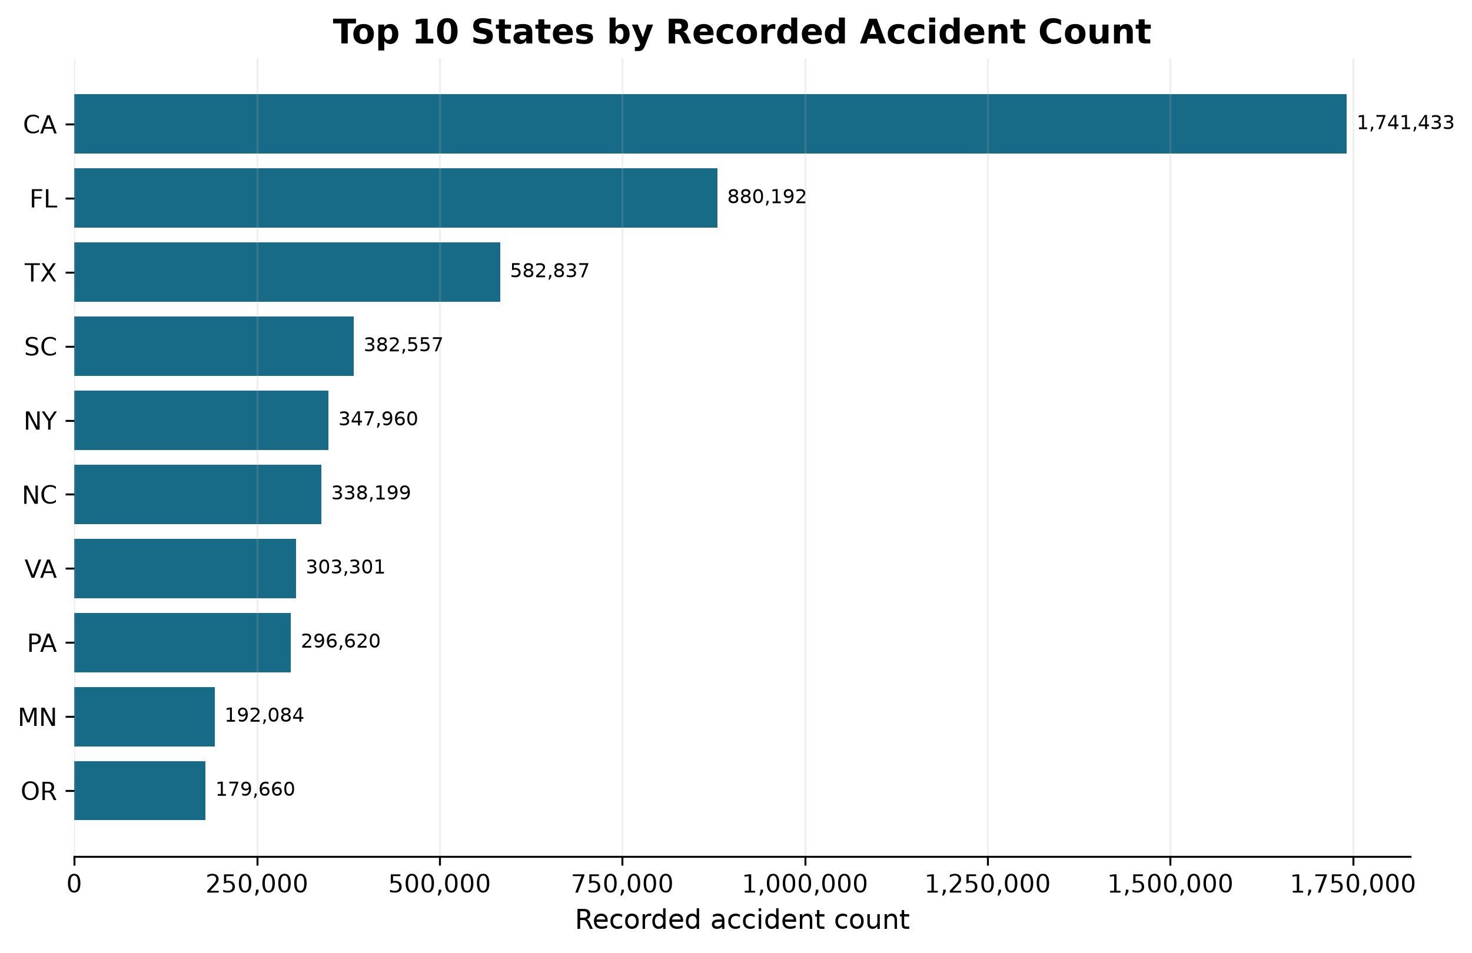

5.2 Accident Count by City
Miami, Florida had the largest city–state count at 186,768, followed by Houston, Texas (169,428), Los Angeles, California (156,491), Charlotte, North Carolina (138,345), and Dallas, Texas (130,303). City names were paired with State to avoid ambiguity. These counts remained unadjusted for city size, road use, or provider coverage.
Figure 2. Top 10 city–state groups by recorded accident count.
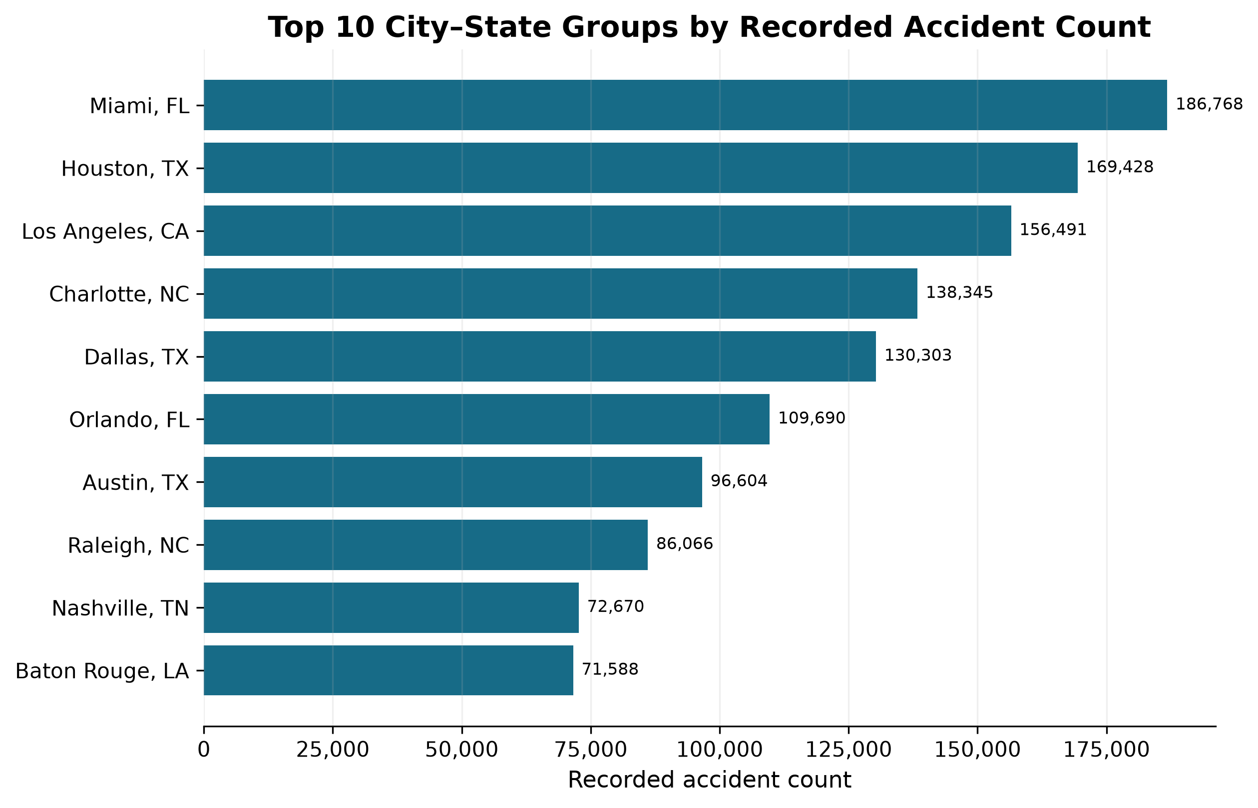

5.3 Yearly and Monthly Trends
Recorded counts increased from 410,821 in 2016 to 1,762,452 in 2022, while 2023 contained 246,633 records. April 2022 was the largest year–month combination, with 196,687 records. The 2016 and 2023 totals were not directly comparable with complete years because those years contained partial coverage. Moreover, changes in sources and reporting coverage could contribute to the apparent annual pattern.
Figure 3. Recorded accident count by year; 2016 and 2023 are partial-coverage years.
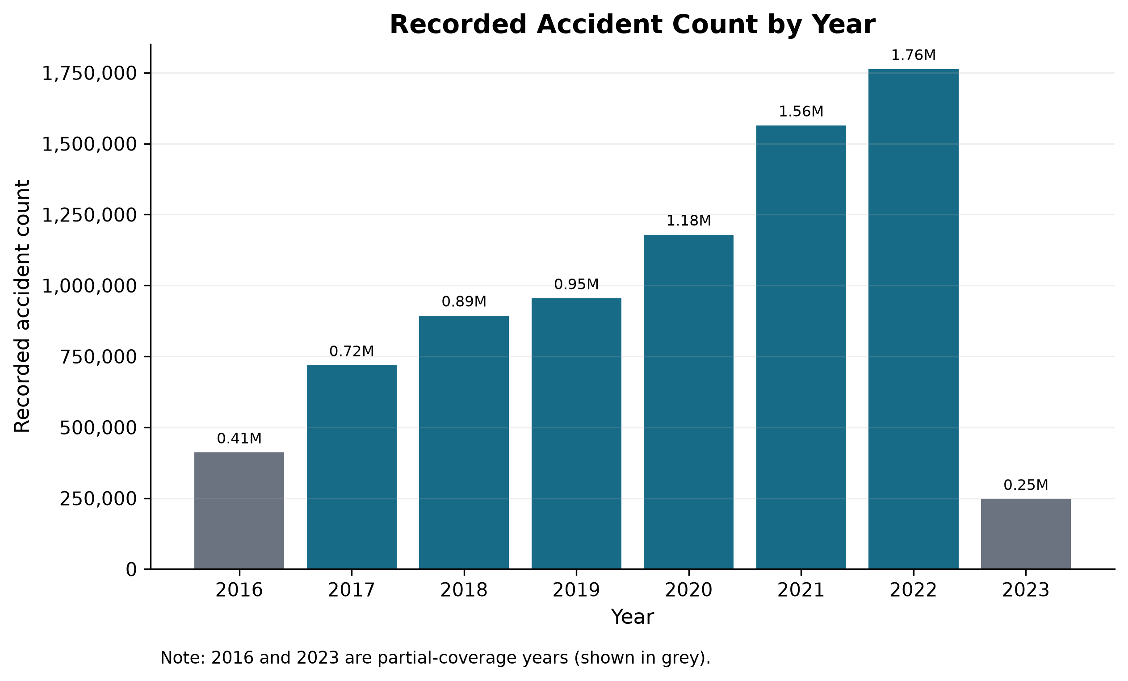

5.4 Weekday and Hourly Patterns
Friday had the largest weekday count at 1,366,499 (17.68%), whereas Sunday had the smallest at 562,744 (7.28%). Hourly counts showed two main concentrations: 07:00 contained 587,472 records (7.60%) and 16:00 contained 581,969 (7.53%), followed closely by 08:00 and 17:00. Tuesday at 07:00 was the largest weekday–hour combination, with 118,920 records. The pattern resembled commuting periods, although traffic-volume exposure was unavailable.
Figure 4. Distribution of recorded accidents by weekday.
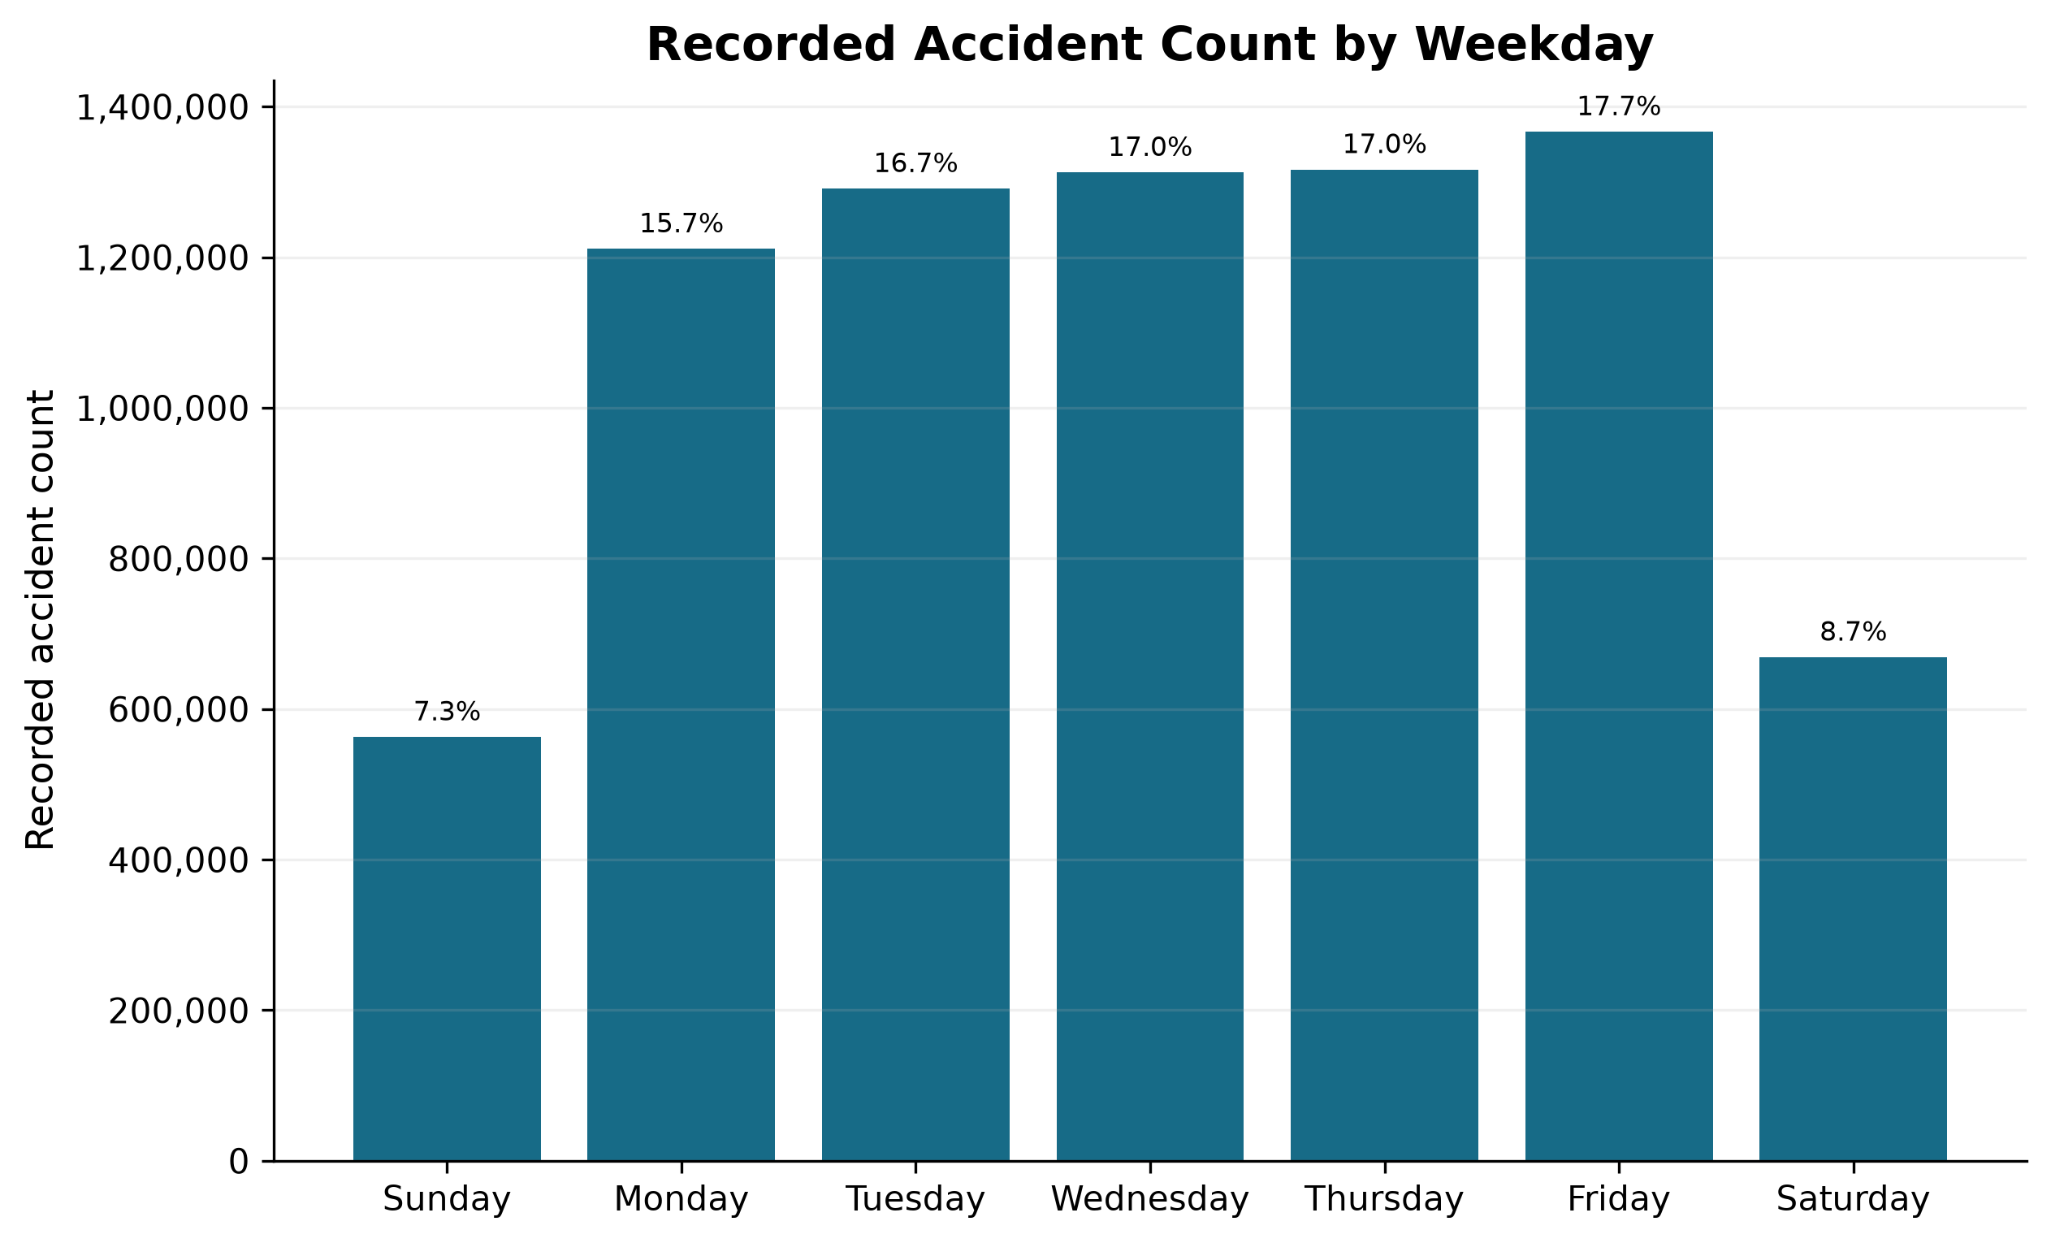
Figure 5. Distribution of recorded accidents by hour of day.
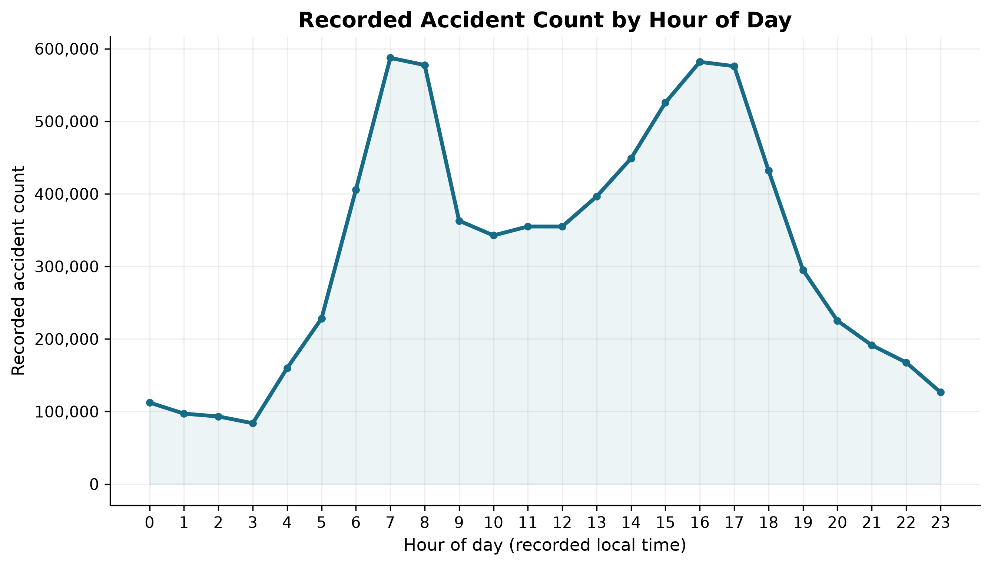

5.5 Severity Distribution
Severity level 2 dominated the dataset with 6,156,981 records (79.67%). Severity levels 3 and 4 contained 1,299,337 (16.81%) and 204,710 records (2.65%), respectively, while level 1 contained 67,366 (0.87%). Levels 3–4 combined represented 1,504,047 records (19.46%). Severity described traffic impact or delay rather than injury or fatality severity.
Figure 6. Distribution of recorded Severity levels.
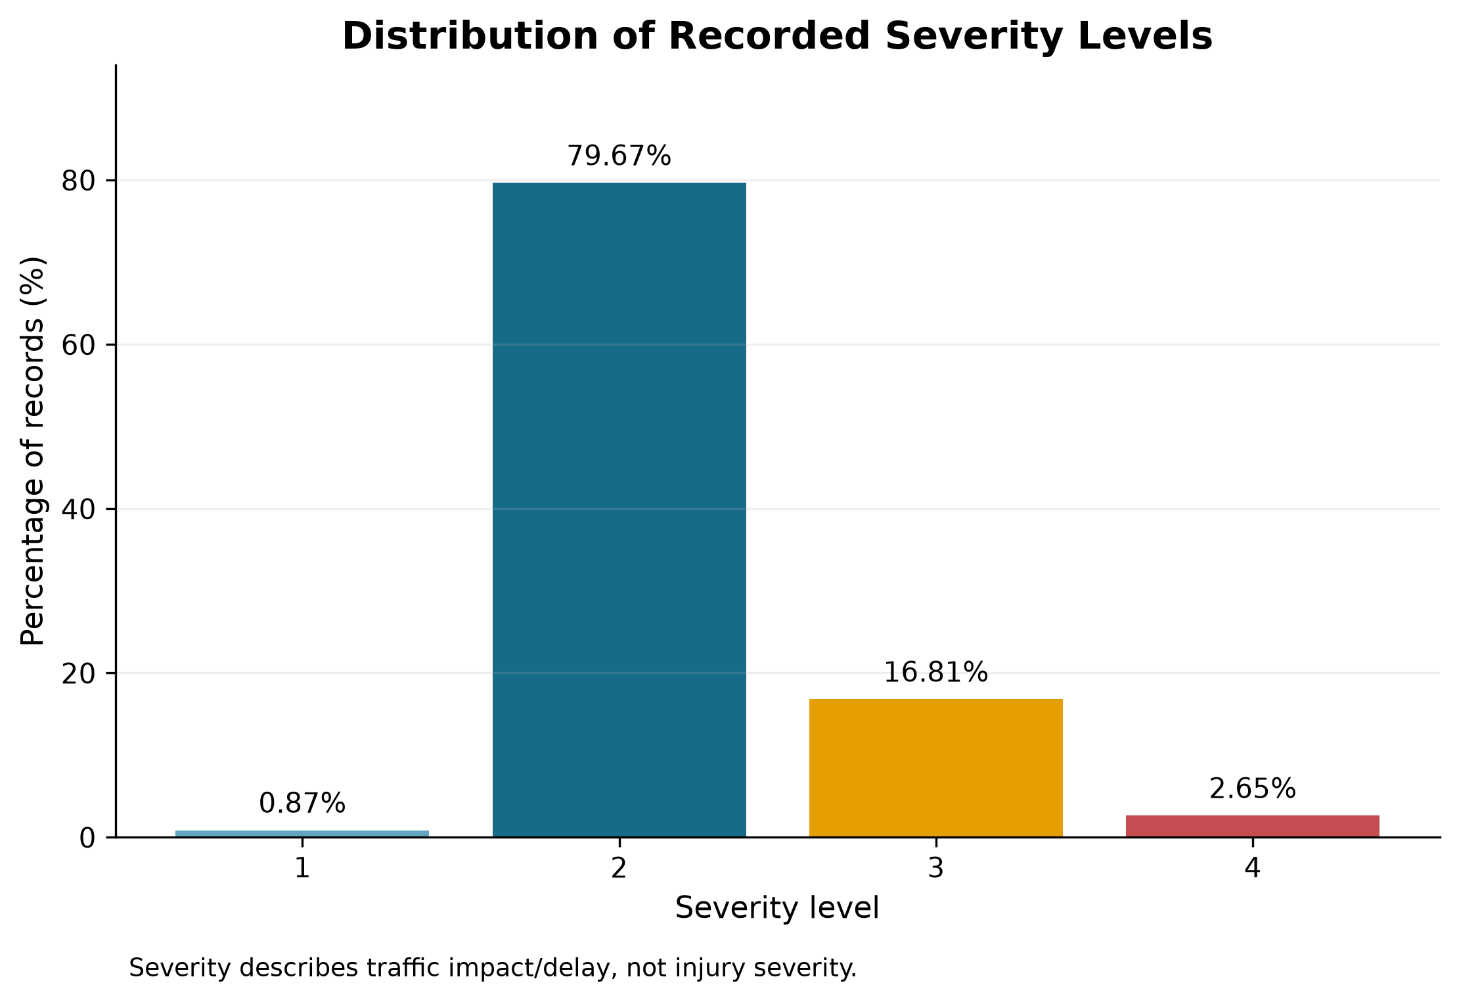

5.6 Average Severity by State and City
Across states, Georgia had a mean Severity of 2.5069 and 43.74% of records at levels 3–4; Rhode Island had 2.4583 and 46.24%; and Wisconsin had 2.4739 and 37.67%. These comparisons were accompanied by sample sizes because state record counts differed substantially. Among city–state groups with at least 1,000 records, Larkspur, Colorado ranked highest by mean Severity at 2.8285 based on 1,114 records, followed by Joliet, Illinois at 2.7072 based on 1,028 records. These rankings may reflect provider and coverage differences and should not be treated as stable safety rankings.

5.7 Weather Condition, Count, and Severity
Fair was the most frequent Weather_Condition, occurring in 2,560,802 records (33.14%), followed by Mostly Cloudy (1,016,195; 13.15%), Cloudy (817,082; 10.57%), Clear (808,743; 10.46%), and Partly Cloudy (698,972; 9.04%). Weather_Condition was missing for 173,459 records (2.24%). Among categories with at least 10,000 observations, Overcast, Scattered Clouds, and Clear showed comparatively high mean Severity. These were descriptive associations; condition exposure and provider-specific terminology were not controlled.
Figure 7. Top 10 weather conditions by recorded accident count.
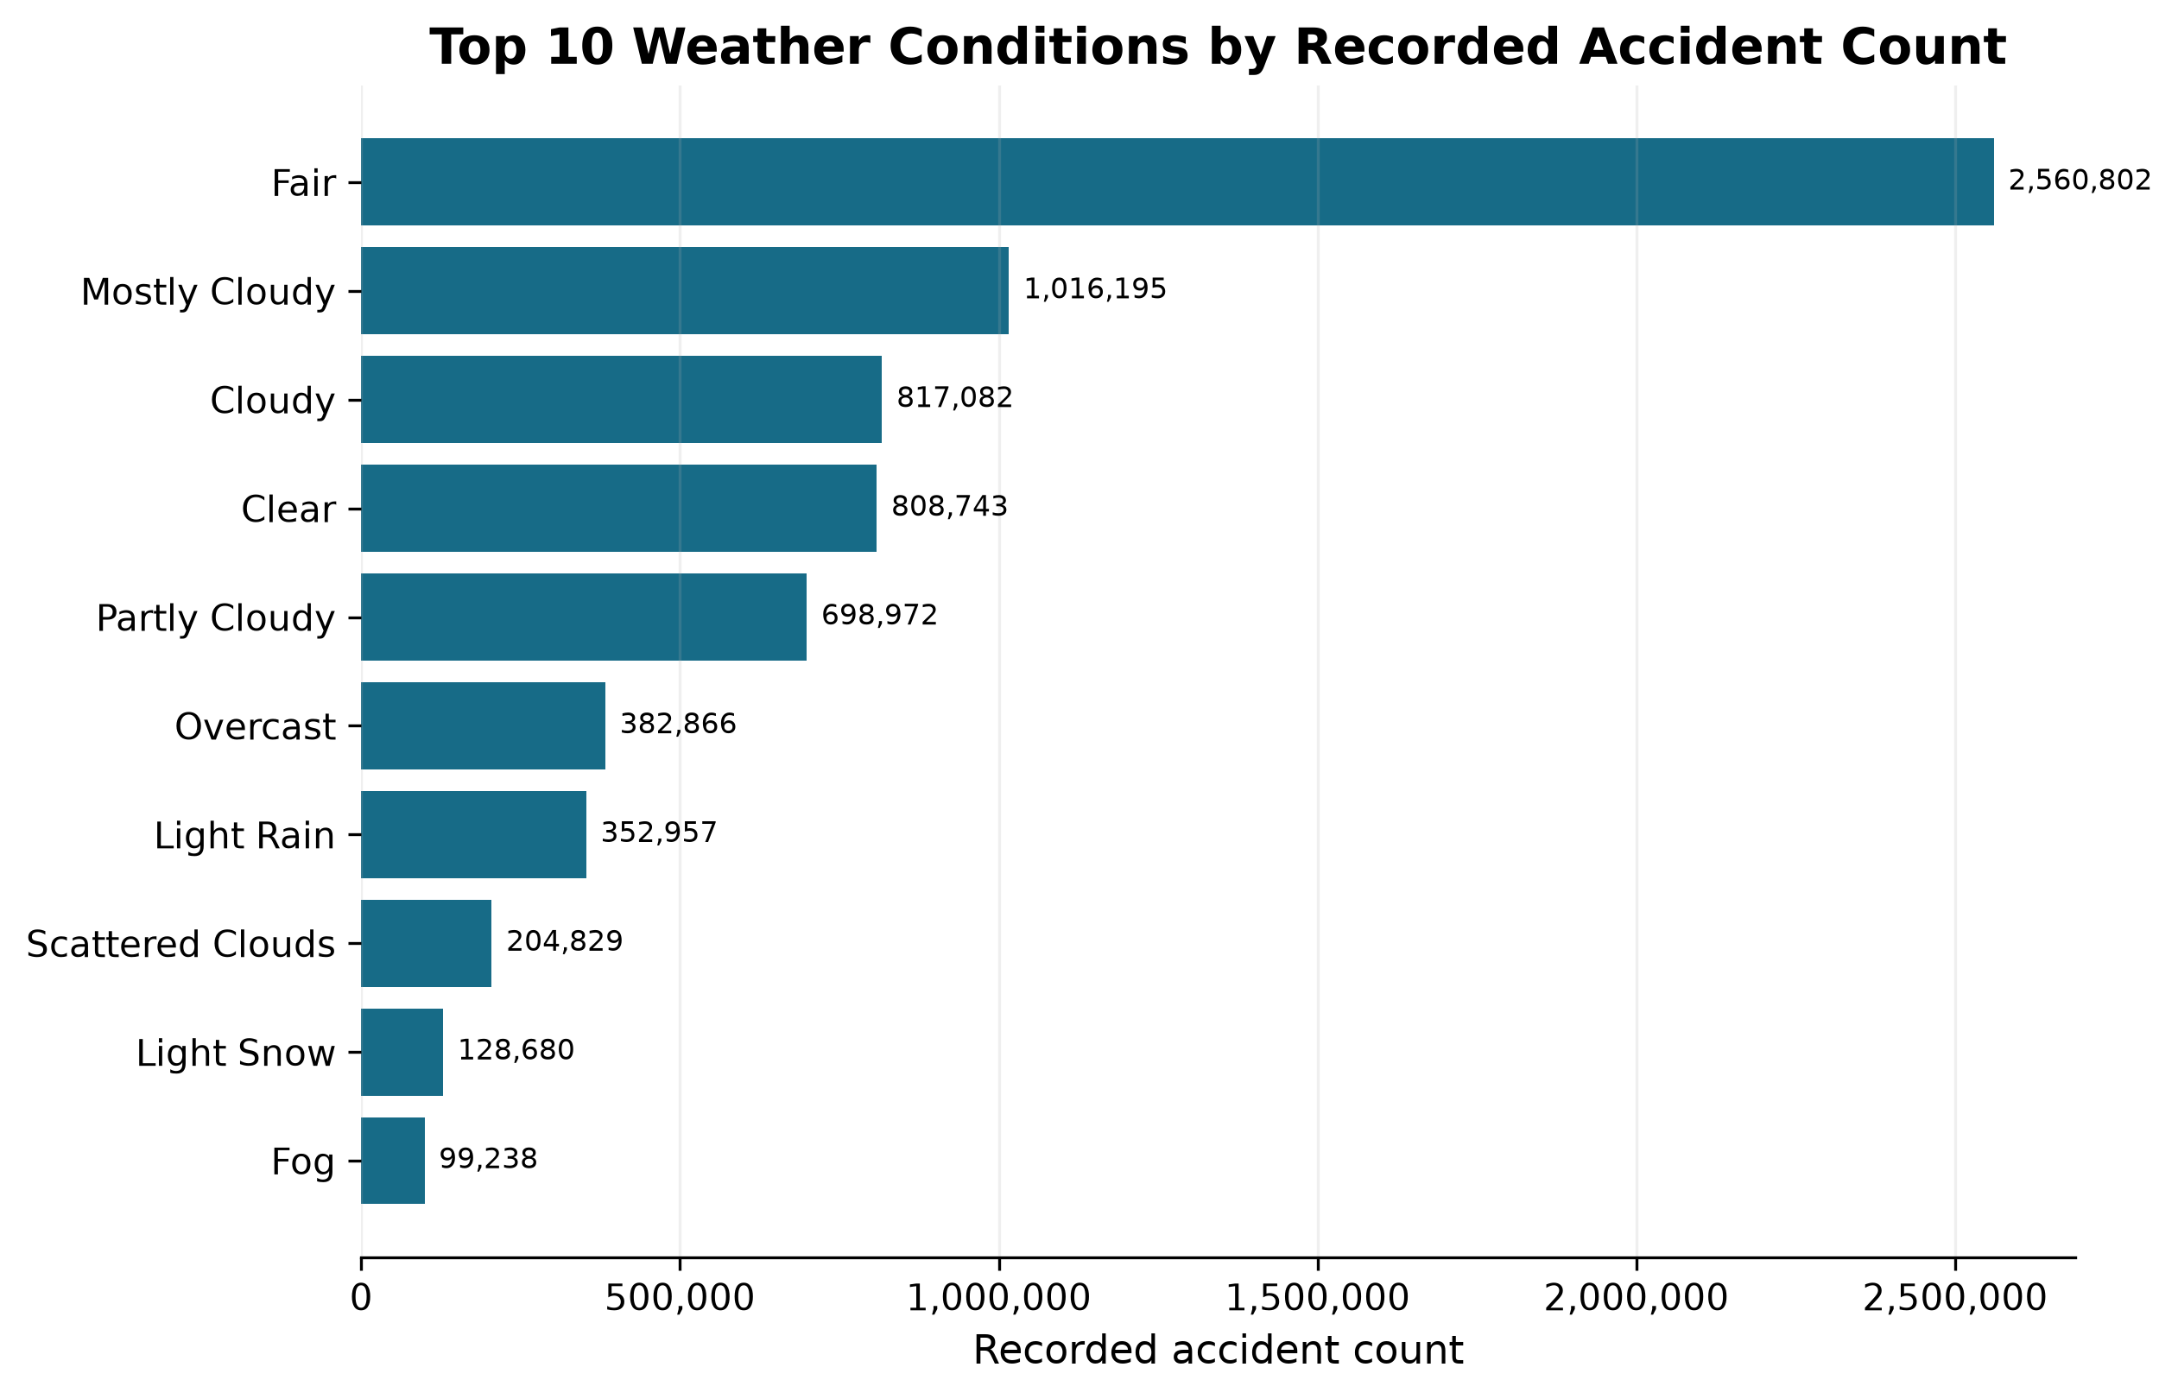

5.8 Road-Feature Analysis
Traffic_Signal was present in 1,143,772 records, Crossing in 873,763, and Junction in 571,342. Junction-associated records had a mean Severity of 2.2985 and 26.79% at levels 3–4, compared with 2.2055 and 18.88% when Junction was absent. Crossing, Traffic_Signal, Stop, Station, and Amenity indicators were associated with lower Severity 3–4 percentages than records without those indicators. Because features overlapped and no non-accident control locations were available, these results did not establish risk or causality. Turning_Loop was false in every record and therefore provided no analytical variation.
Figure 8. Recorded accidents with selected road-feature indicators.
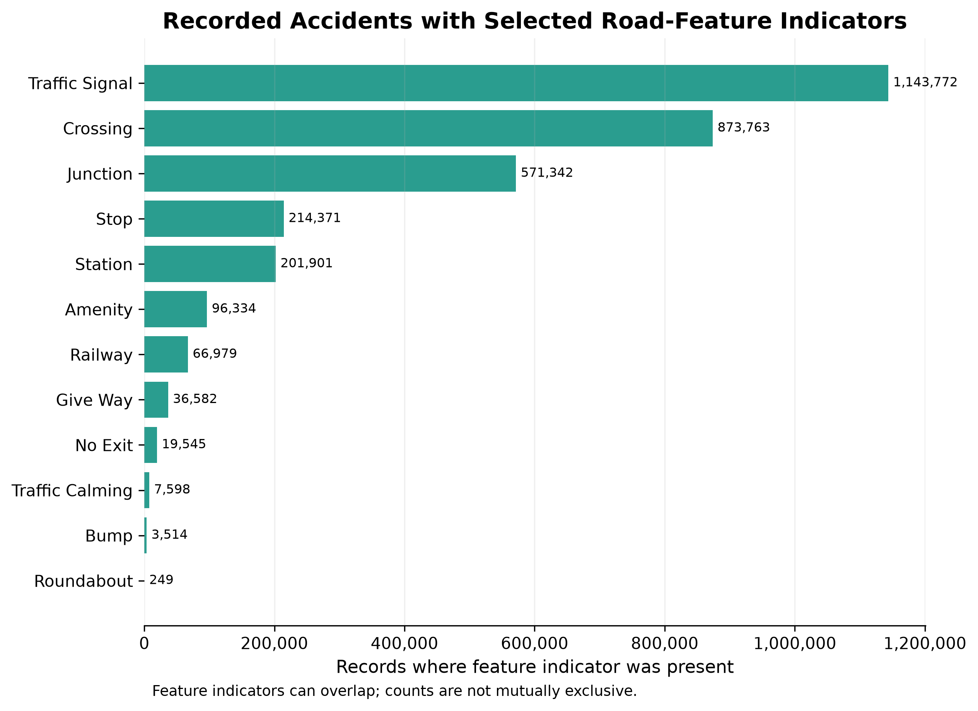

5.9 PySpark and Pandas Runtime Comparison
Pandas recorded total runtimes of 15.9206, 15.6320, and 15.4213 seconds, producing a median of 15.6320 seconds. PySpark recorded 22.4094, 15.4447, and 14.9614 seconds, producing a median of 15.4447 seconds. The resulting speed-up factor was 1.012 (15.6320/15.4447), so PySpark was approximately 1.2% faster by 0.1873 seconds. This difference was not substantial. The slower first PySpark run was consistent with warm-up overhead, although the experiment did not isolate its individual sources. Pandas used approximately 170.41 MB of peak process memory because it processed the CSV in chunks.
Figure 9. End-to-end runtime for the equivalent Pandas and PySpark workloads.
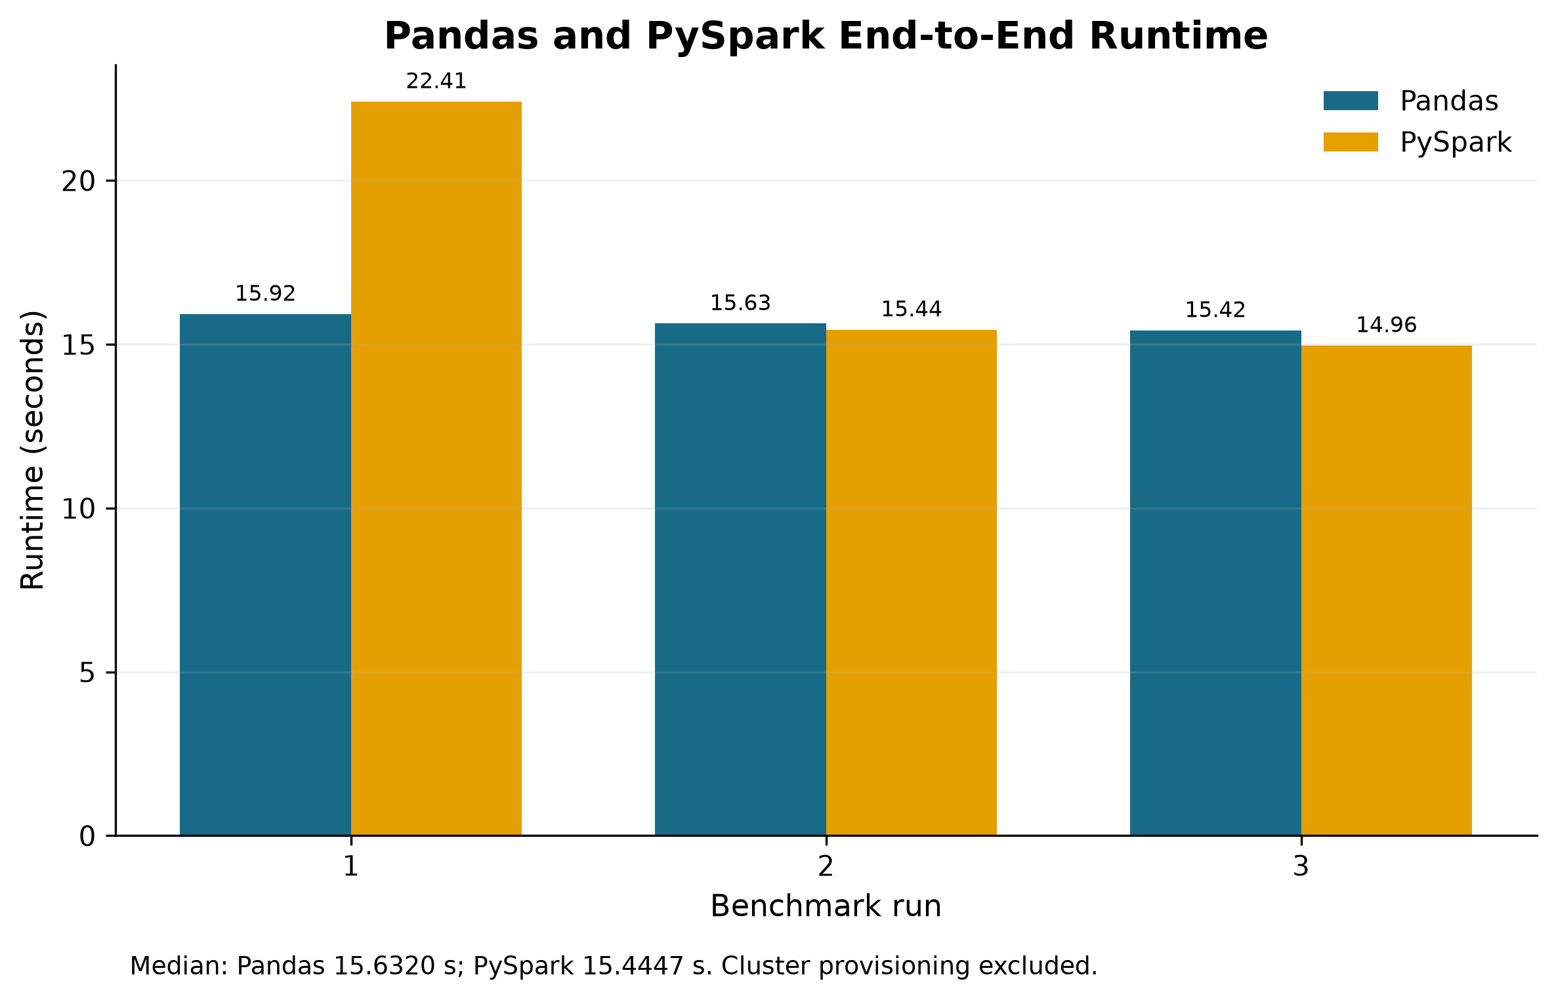
Table 2. Three-run Pandas and PySpark benchmark results.
Run | Pandas (s) | PySpark (s)
1 | 15.9206 | 22.4094
2 | 15.6320 | 15.4447
3 | 15.4213 | 14.9614
Median | 15.6320 | 15.4447

6. Discussion
The results answered the geographic research question by showing a strong concentration of recorded incidents in a limited number of states and cities. California alone contributed 22.53% of all records, and California, Florida, and Texas together contributed 41.46%. At city level, Miami, Houston, and Los Angeles led the counts. These concentrations are useful for describing the dataset and prioritising where recorded-event volumes were greatest, but they cannot identify the most dangerous locations. State population, traffic volume, road mileage, urban form, and the coverage of contributing providers were not controlled. The findings therefore support a conclusion about record concentration rather than comparative accident risk.
The temporal results showed both recurring daily patterns and substantial changes in annual record volume. Weekdays accounted for much larger shares than weekends, and the largest hourly counts occurred around the morning and afternoon commuting periods. This interpretation is plausible because the peaks occurred at 07:00–08:00 and 16:00–17:00, but it remains descriptive without hourly traffic-volume denominators. Annual counts rose from 410,821 in partial-year 2016 to 1,762,452 in 2022, while the proportion at Severity 3–4 fell from approximately 34–36% during 2016–2018 to 6.88% in 2022. This simultaneous change suggests that source composition, reporting practices, or coverage expansion may have altered the dataset over time. The partial coverage of 2016 and 2023 further prevents simple trend claims about national accident frequency.
Severity level 2 dominated the distribution, accounting for 79.67% of observations, while levels 3–4 together represented 19.46%. This imbalance explains why mean Severity values were generally close to level 2 and why averages alone would provide an incomplete picture. Reporting mean Severity together with the full distribution, group counts, and the Severity 3–4 percentage reduced this problem. The city threshold of 1,000 records also avoided ranking extremely small groups, although the resulting order may still reflect local provider characteristics. Most importantly, Severity measures traffic impact or delay and should not be interpreted as medical injury severity.
The contextual results identified associations rather than causal effects. Fair was the most common weather label, but weather-condition counts combine accident occurrence with how often each condition occurred and how providers classified it. Comparatively high mean Severity under Overcast, Scattered Clouds, and Clear therefore does not establish that these conditions increased accident risk or impact. Similarly, Junction was associated with a larger Severity 3–4 percentage than its absence, whereas several other road-feature indicators showed lower percentages. The Boolean indicators overlap, their prevalence in the wider road network is unknown, and the dataset contains no non-accident control locations. These limitations prevent causal or risk-based interpretations.
The implementation demonstrated the practical value of a cloud-based Spark workflow. Amazon S3 separated persistent storage from the temporary EMR compute environment, while Hadoop YARN managed Spark resources and the DataFrame API supported reproducible transformations across millions of records. The discovery of mixed timestamp formats also illustrated the importance of validation: an initial single-format parser would have excluded 743,166 valid records, whereas the corrected parser preserved and reconciled the full dataset. Writing Year-partitioned Parquet reduced the need to repeatedly scan the wider CSV schema during the substantive analyses, and S3 outputs remained available after cluster termination.
The performance comparison did not show a meaningful winner for the tested workload. PySpark's median runtime of 15.4447 seconds was 0.1873 seconds below Pandas at 15.6320 seconds, equivalent to a 1.012 speed-up factor. The first PySpark run was slower, consistent with warm-up and distributed scheduling overhead, whereas the chunked Pandas runs were more stable. Pandas was therefore efficient for a 3.06 GB file when only three columns and simple grouped counts were required. Spark nevertheless provides advantages that this small, one-core-worker experiment could not fully test, including expansion to additional workers, distributed scheduling, fault management, and integration with persistent cloud storage. The comparison should consequently be understood as evidence about the two deployed platforms, not an isolated judgement about the libraries.

7. Individual Reflections

7.1 Reflection: Member 1
[To be written personally by Member 1. Identify specific responsibilities, technical decisions, problems encountered, evidence of learning from the actual results, contribution to the PySpark/Pandas comparison, and what would be improved. Avoid generic statements.]

7.2 Reflection: Member 2
[To be written personally by Member 2. Identify specific responsibilities, technical decisions, problems encountered, evidence of learning from the actual results, contribution to the PySpark/Pandas comparison, and what would be improved. Avoid generic statements.]

8. Conclusion
This project achieved its aim by developing a validated PySpark workflow on Amazon EMR and applying it to 7,728,394 US accident records. The analysis showed that recorded incidents were geographically concentrated, with California contributing 22.53% of the dataset and Miami leading the city–state counts. Records were more frequent on weekdays and clustered around morning and afternoon commuting hours. Severity level 2 dominated the data, while levels 3–4 represented 19.46% of records. Weather and road-feature comparisons revealed contextual associations, but the absence of exposure denominators and non-accident controls prevented causal or risk interpretations. The benchmark produced nearly identical median runtimes: 15.6320 seconds for chunked Pandas and 15.4447 seconds for PySpark. PySpark was only 1.2% faster, so the experiment did not demonstrate a substantial speed advantage on the small EMR configuration and simple aggregation workload. Its principal benefit was instead the reproducible, YARN-managed, S3-integrated architecture and its potential to scale beyond one worker. Future work should incorporate population or traffic-exposure denominators, harmonise provider and weather categories, test complete annual periods, and benchmark larger or more complex workloads across multiple Spark workers.

References
Amazon Web Services. (n.d.). Overview of Amazon EMR architecture. Retrieved August 13, 2026, from https://docs.aws.amazon.com/emr/latest/ManagementGuide/emr-overview-arch.html
Apache Software Foundation. (n.d.-a). Spark SQL, DataFrames and Datasets guide. Retrieved August 11, 2026, from https://spark.apache.org/docs/latest/sql-programming-guide
Apache Software Foundation. (n.d.-b). DataFrames: A view into your structured data. Retrieved August 11, 2026, from https://spark.apache.org/docs/latest/api/python/user_guide/dataframes.html
Moosavi, S. (n.d.). US Accidents (2016–2023) [Data set]. Kaggle. Retrieved August 11, 2026, from https://www.kaggle.com/datasets/sobhanmoosavi/us-accidents
Moosavi, S., Samavatian, M. H., Parthasarathy, S., & Ramnath, R. (2019a). A countrywide traffic accident dataset. In Proceedings of the 1st ACM SIGSPATIAL International Workshop on Advances in Resilient and Intelligent Cities. https://arxiv.org/abs/1906.05409
Moosavi, S., Samavatian, M. H., Parthasarathy, S., Teodorescu, R., & Ramnath, R. (2019b). Accident risk prediction based on heterogeneous sparse data: New dataset and insights. In Proceedings of the 27th ACM SIGSPATIAL International Conference on Advances in Geographic Information Systems (pp. 33–42). Association for Computing Machinery. https://doi.org/10.1145/3347146.3359078
The pandas development team. (n.d.). pandas.DataFrame. Retrieved August 11, 2026, from https://pandas.pydata.org/docs/reference/api/pandas.DataFrame.html

Appendix A. Completion Checklist
- Complete the remaining identity, lecturer, date, repository, and reflection placeholders before submission.
- Completed: dataset filename, size, row count, column count, schema, date range, and Severity interpretation were verified.
- Completed: each analytical objective and research question has a corresponding method and validated result.
- Completed: the benchmark used equivalent fields, validation rules, groupings, outputs, and full-data reconciliation.
- Completed: computing environments, three-run results, medians, and reconciliation checks are reported.
- Completed: the analytical tables and figures are numbered and introduced in the Results section.
- Add the GitHub repository and dataset URLs and test them in a signed-out browser.
- Add both individual reflections and a clear contribution statement.
- Completed: the abstract, discussion, and conclusion use only verified findings.
- Proofread the final report and check that all in-text citations appear in the reference list.

Appendix B. Repository and Supporting Materials
GitHub repository: [Insert public or instructor-accessible URL]
Dataset URL: https://www.kaggle.com/datasets/sobhanmoosavi/us-accidents
Recommended repository contents: README, environment/dependency file, PySpark code, Pandas code, output-validation script, aggregated results, figures, and benchmark logs. Do not redistribute the full dataset unless its licence and Kaggle terms permit that mode of sharing; link to the source instead.

