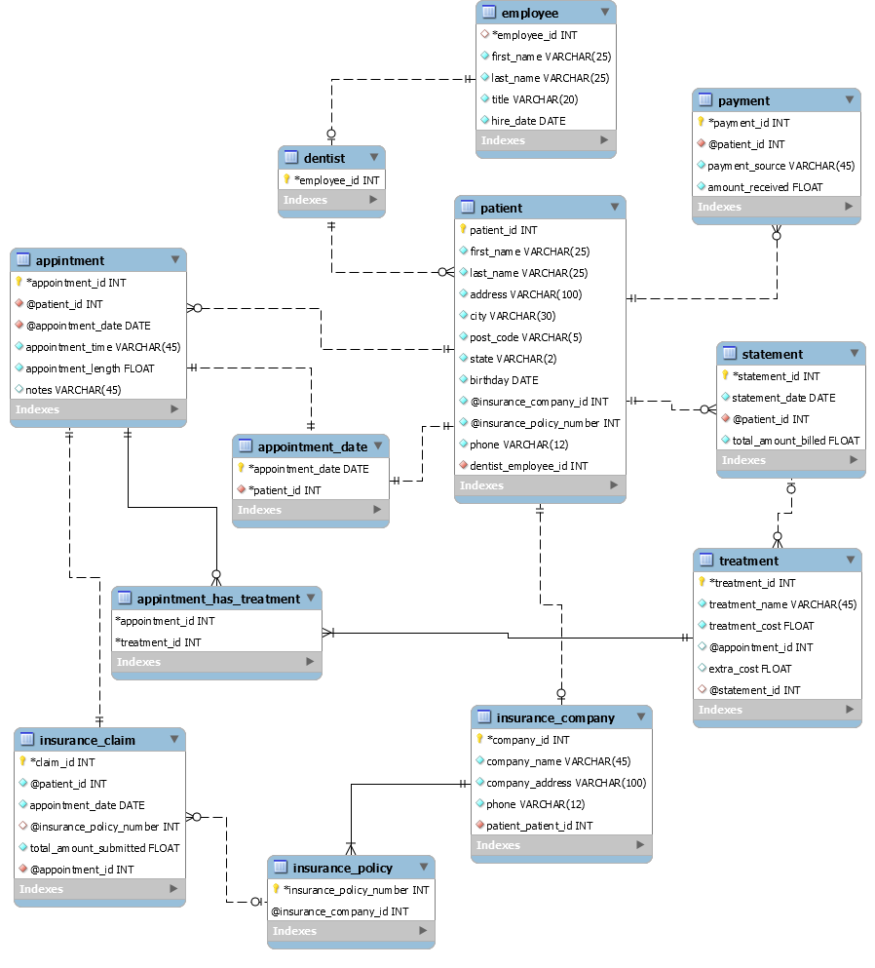

**Assumptions:**

- A Dentist has zero or more Patients since at the starting time a dentist may have no patients.

–A patient has zero or more appointments since new patients may have no appointments.

–A patient has zero or more statements since new patients may have no appointments.

–A patient has zero or more payments since new patients may have no appointments.

–A patient has zero or one insurance companies since patients may have no insurance.

–A patient has only one appointment date.

–An appointment is for one and only one patient.

–An appointment has zero or more treatments performed since may have no charge visit.

–An appointment has zero or more insurance claims since may have no charge visit.

–A treatment can be performed at zero or more appointments since a new treatment may have not yet been performed.

–A treatment can be on zero or one statement since a recent treatment may not have been billed yet.

–A statement is for one and only one patient.

–A statement is for zero or more treatments performed on a patient.

–A payment is for one and only one patient.

–An insurance company has zero or more insurance claims.

–An insurance company has one or more insurance policies.

–An insurance company is used by zero or more patients.

–An insurance claim is for one and only one appointment.

–An insurance claim is for one and only one insurance company since patients have only one insurance company

–An insurance policy is used for one or many insurance claims.