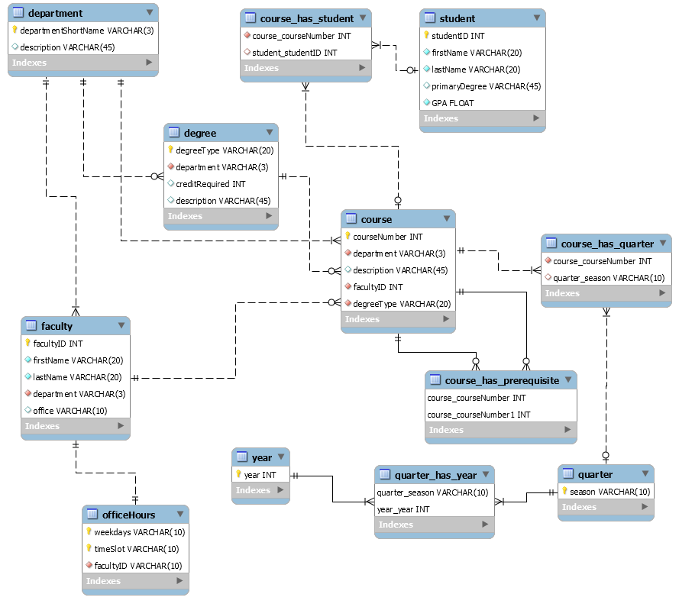

department (departmentShortName ->> description)

degree (degreeType ->> department, creditRequired, description)

course (courseNumber ->> department, description, facultyID, degreeType)

faculty (faultyID ->> firstName, lastName, department, office)

officeHours (weekdays, timeslot ->> facultyID)

stdent (studentID ->> firstName, lastName, primaryDegree, GPA)

course_has_student ( courseNumber, studentID)

course_has_quarter (courseNumber, season)

course_has_prerequisite (courseNumber, prerequisite_courseNumber)

quarter (season)

year (year)

quarter_has_year (season, year)