|  |  |
| --- | --- |
| **Status Report W8** | **Student: Xin Dong** |

**Accomplishment**

- Consolidate part 1 and part 2 audio files both into python code and ensure it runs consistently.

|  |
| --- |
| obtain the audio file (*.wav) as the audio source  from os import path  AUDIO_FILE1 = path.join(path.dirname(path.realpath(__file__)), "C:\LWTECH\CSD480-CapStone\Deliverables\AudioFile-part1.wav")  AUDIO_FILE2 = path.join(path.dirname(path.realpath(__file__)), "C:\LWTECH\CSD480-CapStone\Deliverables\AudioFile-part2.wav")  r = sr.Recognizer()  with sr.AudioFile(AUDIO_FILE1) as source1:      audio1 = r.record(source1)  # read part1 audio file  with sr.AudioFile(AUDIO_FILE2) as source2:      audio2 = r.record(source2)  # read part2 audio file  audio_command1 = r.recognize_google(audio1).lower()  audio_command2 = r.recognize_google(audio2).lower()  audio_command = audio_command1 + " " + audio_command2 |

- Capture both natural speech and audio file videos for project presentation.

- Use open source video clip tool “OpenShot Video Editor” to edit video and clip off those portions which natural speech have been recognized as wrong words.

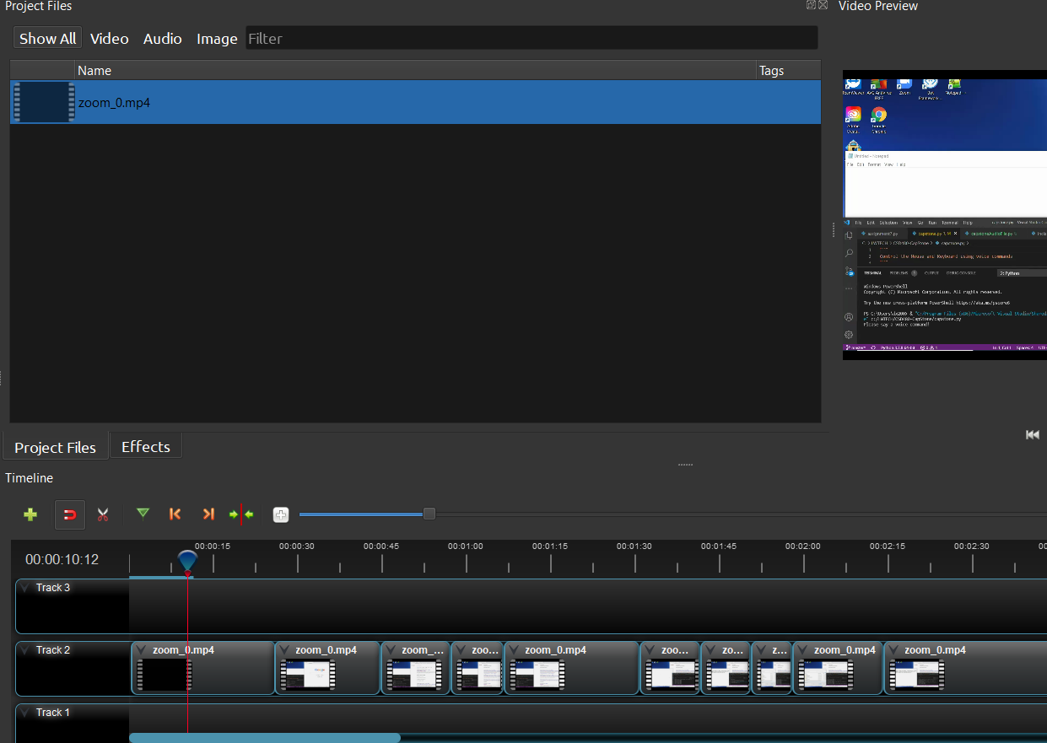

- Test on some other keyboard command.

**Plan for next week**- prepare for deliverables and presentation powerpoint.

- upload project to GitHub.