“Fluid Reaction Wheel”
Isaac Shure

The principle of a “fluid reaction wheel” is simple. It functions in the same manner as traditional reaction wheels: by causing a mass to revolve, creating torque and adjusting the attitude of the craft. The only difference is that the mass is a fluid held in tubing rather than a solid wheel.
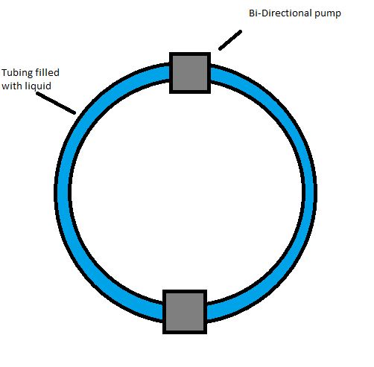

This system could pump the fluid within the tubing in either direction, generating torque in either direction, functioning almost identically to traditional reaction wheels. However, it is advantageous compared to its traditional counterpart, especially when used in small craft, such as “cube-sats” in that it is much less obtrusive than traditional reaction wheels. The tubing can be threaded through and around components, or it can be conformed to the shape of the craft. This frees up volume in the interior of the craft.

Traditional reaction wheels must be placed in a central location. This is not the case for fluid reaction wheels because their center of mass exists within the ring of tubing. Solid reaction wheels have a set shape that the builders of the craft must keep in mind, often wasting space. With fluid reaction wheels, the tubing can be laced around or within the casing of the craft, taking up virtually no volume, making their potential applications in microsatellites apparent.

However, they do present two major challenges. First, the tubing must be filled with a fluid, and that fluid must stay in a fluid state throughout the mission. This provides a level of complication that solid reaction wheels do not. Second, because a more intricate mechanism is required to manipulate fluids than would be required for solids, fluid reaction wheels would be more likely to malfunction with continued use.

