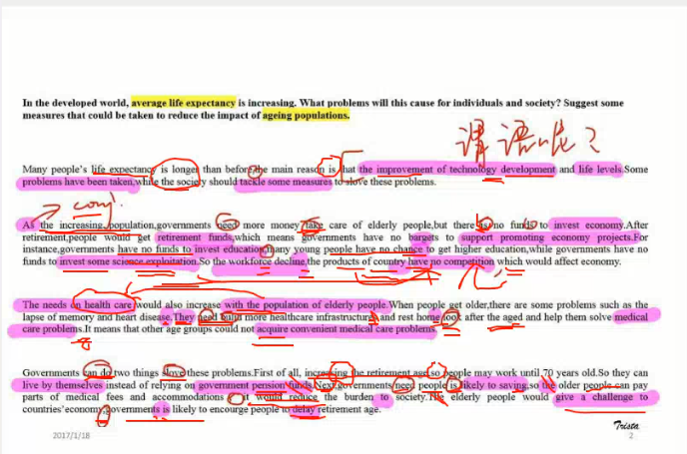
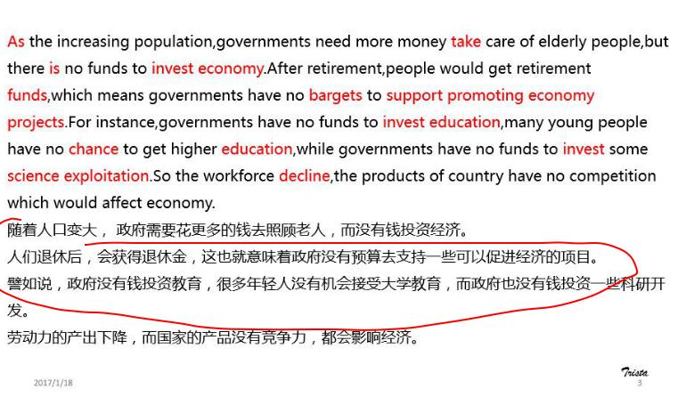
- 随着人口变大，政府需要花更多的钱去照顾老人。

61 Parker(472060112) 15:33:31
Population is increasing rapidly and governments need to spend more money taking care of the aged.

23 悦悦 yue 🍭(1005237549) 15:33:43
With the increasing population, governments should spend much money taking care of elder people.

21长安0211(535590174) 15:33:45
population is increasing and governments need to spend more money in taking care of old people.

09我想去青青草原上抓羊阿(503326861) 15:33:50
governments need to pure more money to take care of senior citizens because of the rapidly increase population, but have no investment in economy.

50火锅大魔王0218(402570793) 15:33:52
with population expension, the government need to spent money taking care of 老人

24孔祥祥 待定(605723384) 15:33:54
population has increased and governments have to spend more money on taking care of old people

38【小班长】Frances0218(446586445) 15:34:05
population is increasing and the government should spend more money taking care of old people.

26小水儿 0225(2413248146) 15:34:16
population has increased and governments need to spend more money taking care of the elderly.

35helloʕ •ᴥ•ʔ(2723024300) 15:34:35
populations have increased, governments need to spend more money in taking care of elderly people and governments do not have adequate money to support subjects which can boost economy.

51夕颜2月份(974768913) 15:34:39
the population is increasing and the government need to spend more money in taking care of old people

- 而没有钱投资经济
30If(466925607) 15:41:04
there is lack of money for economy
23 悦悦 yue 🍭(1005237549) 15:41:07
Governments lack money to invest economy
21长安0211(535590174) 15:41:12
there is a lack of money for investing economy
39 0211loris<ran3127@qq.com> 15:41:13
there is a lack of funds for economy
63sx(365005921) 15:41:14
there is lack of money to invested in fianancial
38【小班长】Frances0218(446586445) 15:41:19
there are a lack of funds for economy
61 Parker(472060112) 15:41:22
There is a lack of funds for economy.
26小水儿 0225(2413248146) 15:41:26
There is a lack of money for economy
34格林0121(717506552) 15:41:28
There is a lack of funds for economy
53lynn0211(408191305) 15:41:30
There is a lack of money for economy
09我想去青青草原上抓羊阿(503326861) 15:41:33
there is a lack of funds for eoconomy.
40 0218天眼通(275324543) 15:41:33
there is a lack of money for economy
- 人们退休后，会获得退休金，
35helloʕ •ᴥ•ʔ(2723024300) 15:45:42
after retirment, people can gain pension
29木鱼0421(873678728) 15:45:58
People can get pensions after retirement
61 Parker(472060112) 15:46:00
After retirement,old people can receive pensions
30If(466925607) 15:46:03
after retirement,, they will receive pensions.
63sx(365005921) 15:46:10
they will acquire pension after retirement.
09我想去青青草原上抓羊阿(503326861) 15:46:11
people will receive pensions after they retired.
43👑杨婉冰(2313560501) 15:46:11
After retirement,peole will get pension .
34格林0121(717506552) 15:46:12
After retiring,people can gain pension
45biu(419369356) 15:46:13
people will get pensions after retirement
59Joy0216(316684936) 15:46:14
They will receive pensions after retirement.
26小水儿 0225(2413248146) 15:46:16
after retirement.they can gain pension
40 0218天眼通(275324543) 15:46:19
after retirement,people will get pension
- 这也就意味着政府没有预算去支持一些可以促进经济的项目
61 Parker(472060112) 15:53:55
Because of this,governments have difficult in financing programs boosting economy.
38【小班长】Frances0218(446586445) 15:54:01
because of this, the government has difficulty in fianancing a program to improve economy.
63sx(365005921) 15:54:10
because of this , governmrnts have difficulty in fianancial to boosting lacal economic projiects.
23 悦悦 yue 🍭(1005237549) 15:54:12
Because of this, governments have difficulty in financing to support some projects which can promote economy
39 0211loris<ran3127@qq.com> 15:54:15
because of this,goverments have diffculty in financing projects to imporve economy
09我想去青青草原上抓羊阿(503326861) 15:54:25
this means governments have difficulty in financing some projects to improve economy. 别抓我了哭。。。
51夕颜2月份(974768913) 15:54:26
because of this，governments have difficulty in financing to improve economic objects
- 譬如说，政府没有钱投资教育
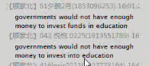
- 很多年轻人没有机会接受大学教育，而政府也没有钱投资一些科研开发
- 劳动力的产出下降，而国家的产品没有竞争力，都会影响经济
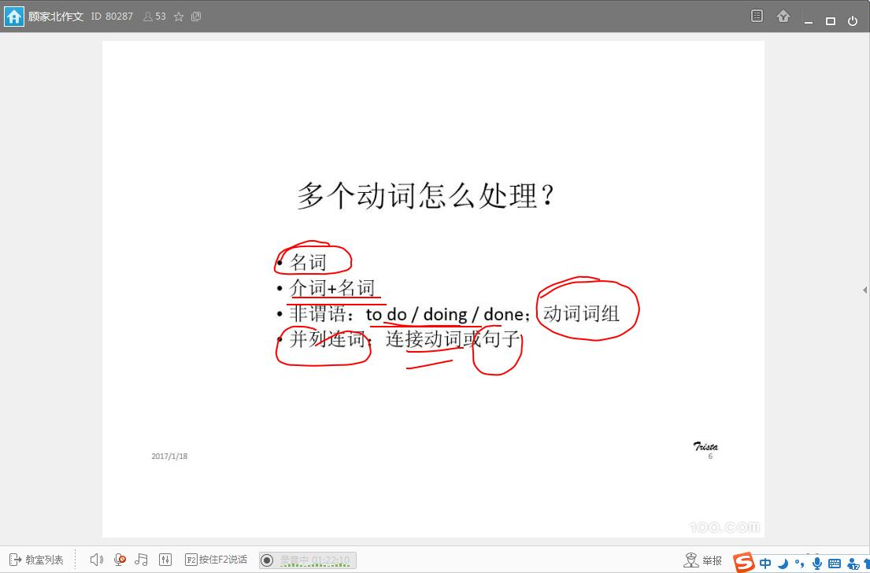
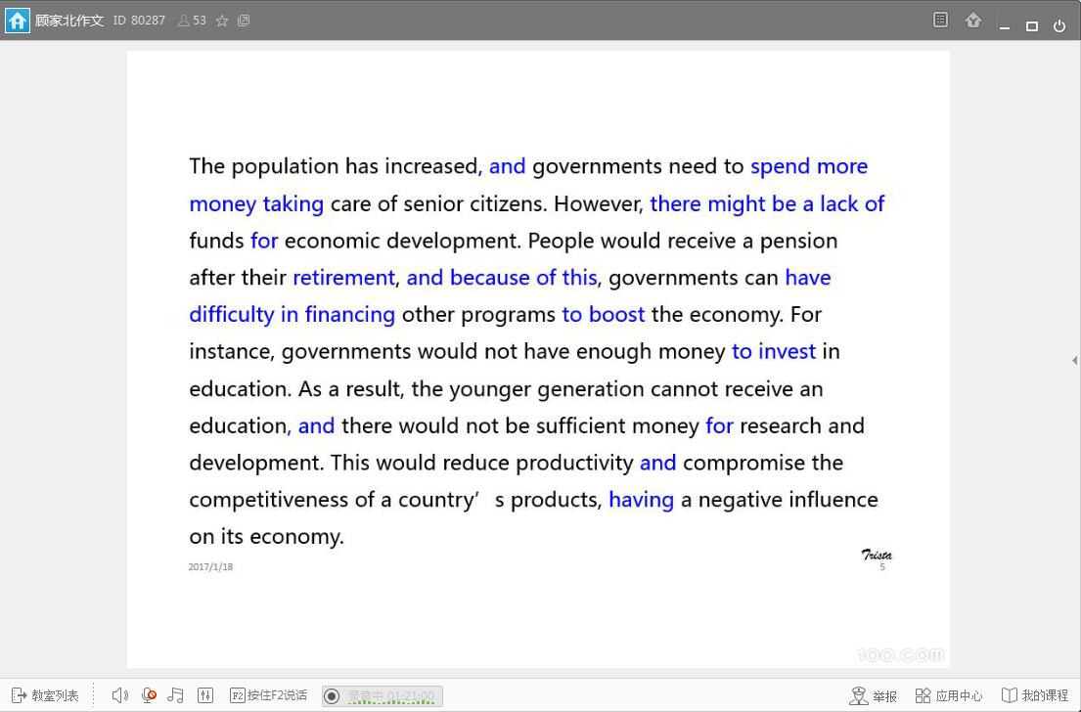

句子分析：
