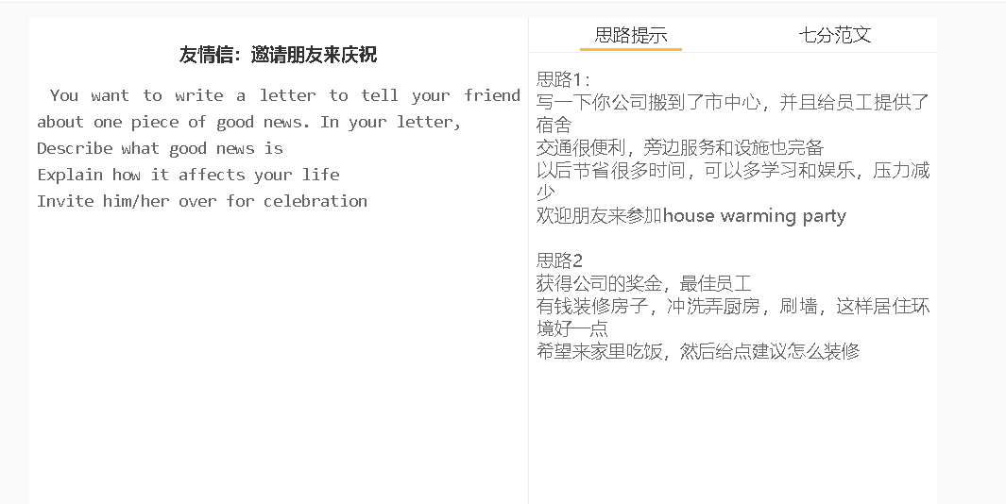

7分范文1
Dear Mick How’s everything going? I cannot wait to tell you that I won a gold medal in a software competition last week. Do you remember last month, the competition I mentioned when we went jogging? You know how much effort I had put into preparing for this national competition. I'm very happy that six months’ arduous work finally paid off. I’m sorry I rejected your dinner plans multiple times since I had to devote all my time to designing, developing and debugging software. My company is thrilled for my achievement and my boss has decided to make me a partner of the company and planned to market my software as soon as possible. In the next few months, I will change my role from a programmer to a project manager who has the lion’s share of the profit of the programme I designed! I'm planning to hold a party to celebrate it. The venue will be Hall 1 in ABC Hotel on 1st, Fec, 2020, and only a few close friends are invited. Please tell me you’ll be available, as I know you are busy at the time of the year. I’ll have all your favourite dishes and beers ready. Best Wishes Nick

