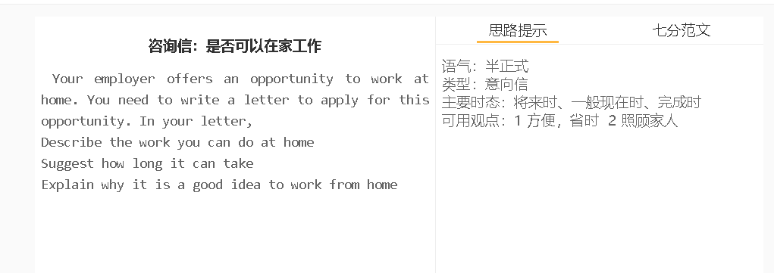

7分范文1
Dear Mr. Johnson, I’m writing this letter to enquire whether I can work from home, as I have heard that the company has recently introduced this policy to boost productivity. As an engineer working for the IT department, I believe that I can complete work at home as well as I do in the office. My current job is basically monitoring the company’s system, fixing any bug and upgrading it if necessary. As long as I have access to the network, I can carry out all these tasks. I can work remotely four days a week, and go to the office on any weekday, in case that our supervisor needs me to attend group meetings or see him personally about some special tasks. Whenever my team needs my presence, I will be there. We are expecting the second child, and my wife will struggle to look after two children. I feel guilty if I am not available to share her workload. I believe I can balance my domestic duties and my professional life effectively. I will work harder to show my gratitude for the trust you will place on me. Please keep me noted if you make any decision. Sincerely yours, David 我写这封信是想询问我是否可以在家工作，因为我听说公司最近推出了这项政策来提高生产率。 作为一名IT部门的工程师，我相信我在家也能像在办公室一样完成工作。我目前的工作基本上是监控公司的系统，修复任何错误，并在必要时升级。只要我能接入网络，我就能执行所有这些任务。 我可以每周远程工作四天，并在任何工作日去办公室，以备我们的主管需要我参加小组会议或亲自见他一些特殊的任务。我的团队需要我的时候，我都会出现。 我们要生第二个孩子了，我妻子要努力照顾两个孩子。如果我不能分担她的工作量，我会感到内疚。我相信我能有效地平衡我的家庭责任和我的职业生活。我会更加努力工作，感谢您对我的信任。 如果你做了决定，请随时通知我。

