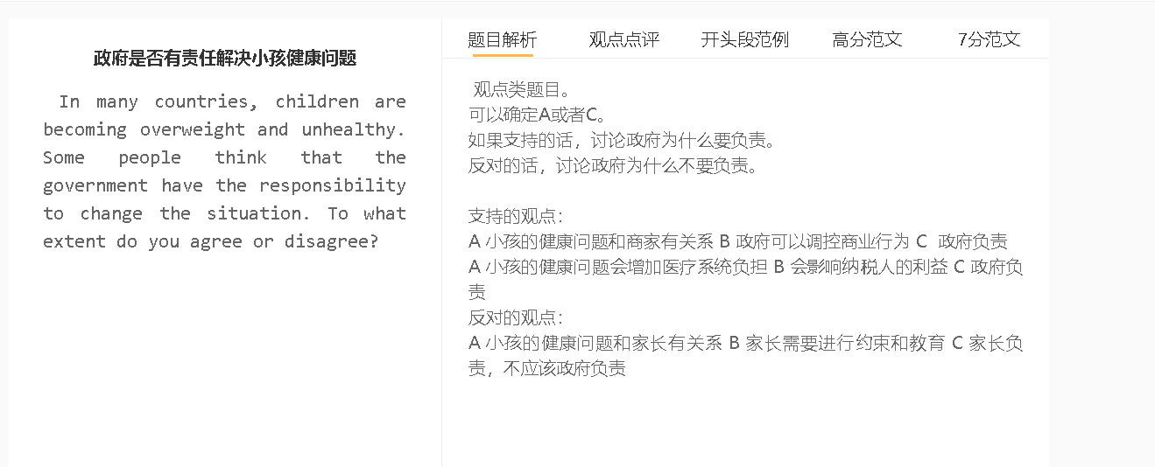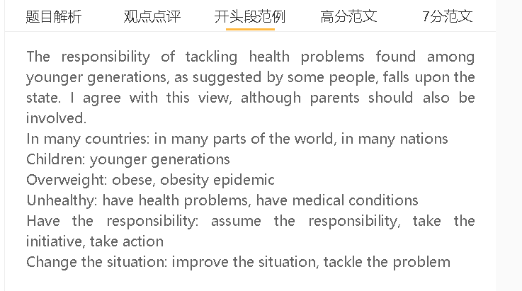

范文

7.5+
Childhood obesity and poor health are increasingly becoming a serious concern across the globe. I would argue that the government should be responsible for changing the situation, although parents’ involvement is also important.
One compelling reason why the government should take responsibility is the profound impact that children’s health problems can have on society. Conditions such as obesity can negatively affect their physical development, making them unfit for physical exercise and worsening their health issues, ultimately leading to increased demand for medical services and a burden on taxpayers. Moreover, unhealthy children lack the energy and stamina to handle academic activities or workplace tasks, leading to adverse economic consequences. As no individual or organisation can address these devastating effects, government intervention becomes imperative.

Reducing the health problems of younger generations should be the government’s responsibility because it is beyond the capacity of individuals to improve the situation. Children are bombarded with advertisements promoting unhealthy habits such as snacks, games, and electronic devices. These young consumers are not yet emotionally or socially mature enough to understand the power of marketing tools, such as free gifts that encourage trial use and campaigns that associate games with happiness. The government can intervene by banning advertisements directed at children to protect the next generation until they reach adulthood when they are capable of making well-informed buying decisions.

On the other hand, parents should also be partly responsible for children’s healthy habits as they can monitor their children on a daily basis. They decide the diet children eat every day and limit their intake of junk food, sweets and sugary drinks. They can engage in regular physical activities, such as sports and outdoor play, to model children’s behaviour, as well as reduce children’s screen time by minimising their access to electronic devices and video games. Their intervention is also important, as the government often lacks the manpower and finances to adequately supervise each child.

In conclusion, the government has a significant responsibility to address the issue of childhood obesity, although parents also have a crucial role to play.

