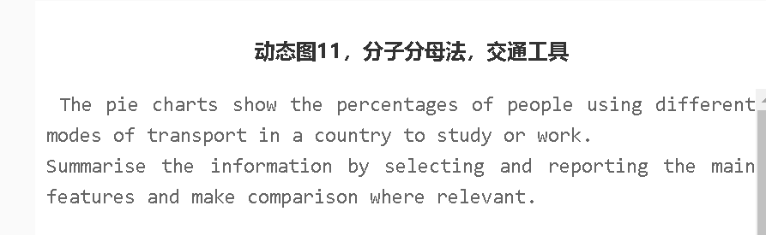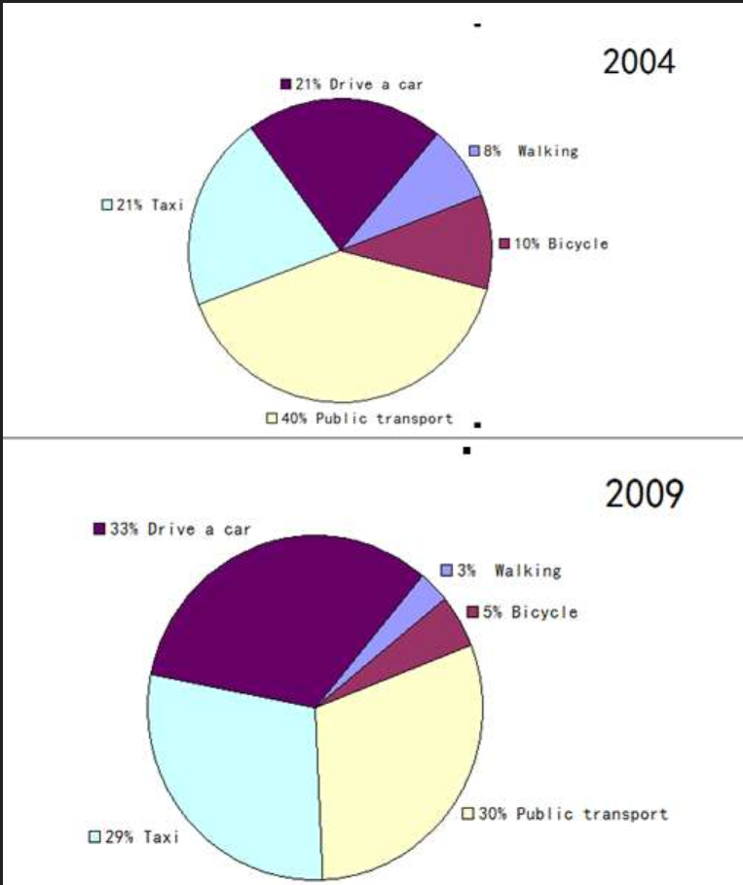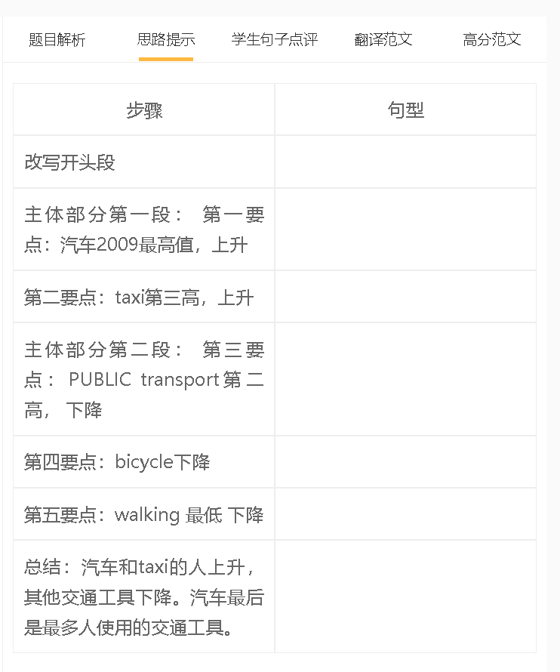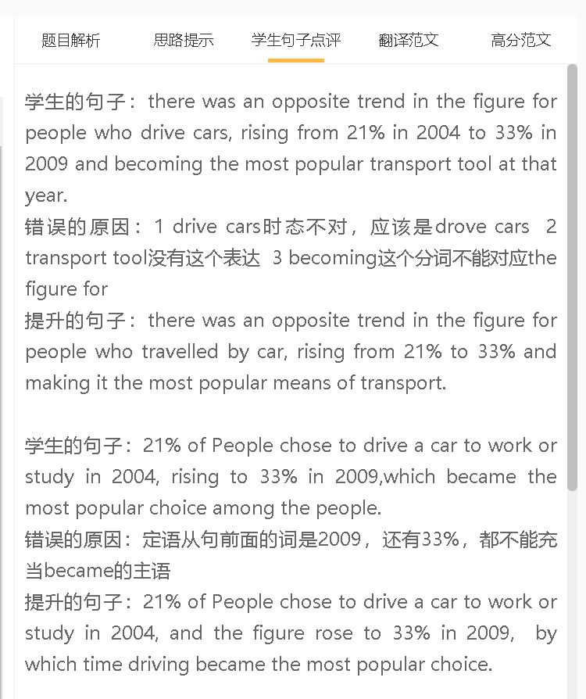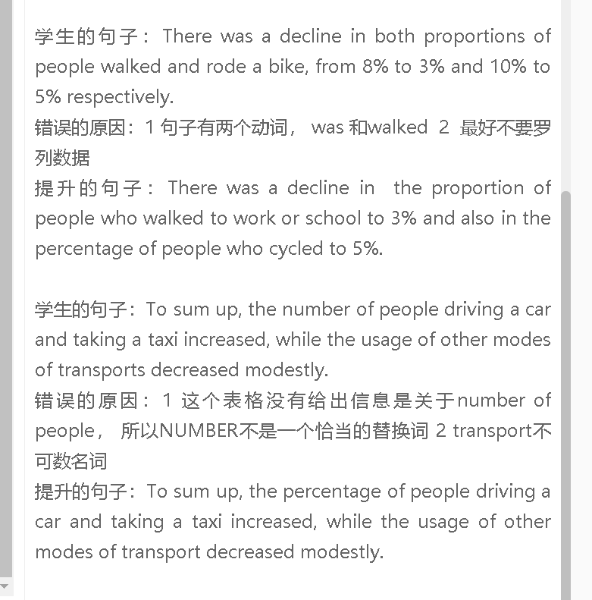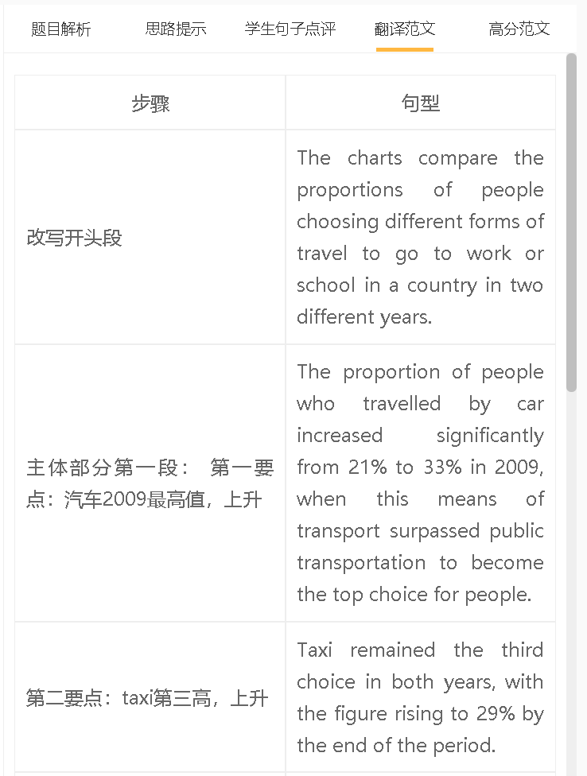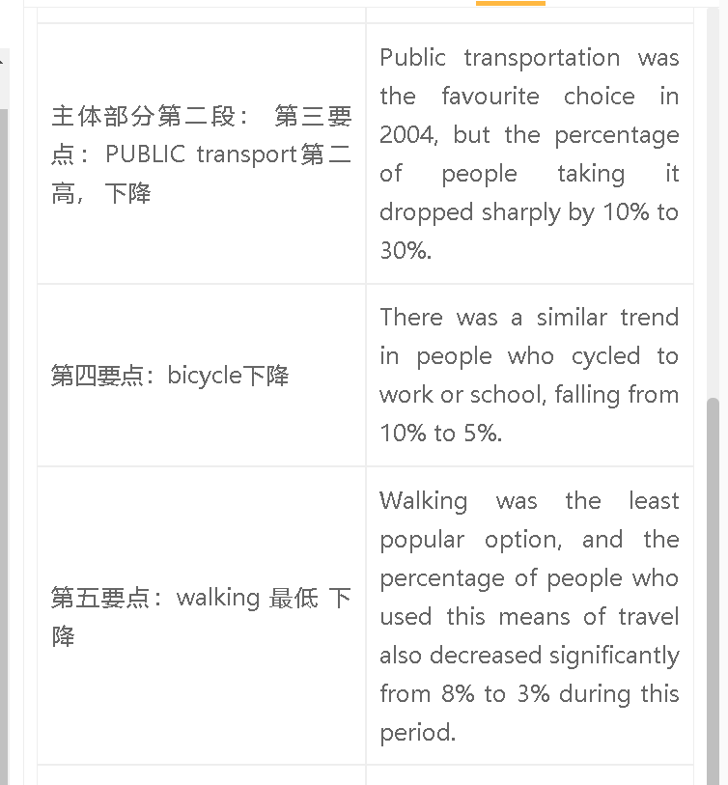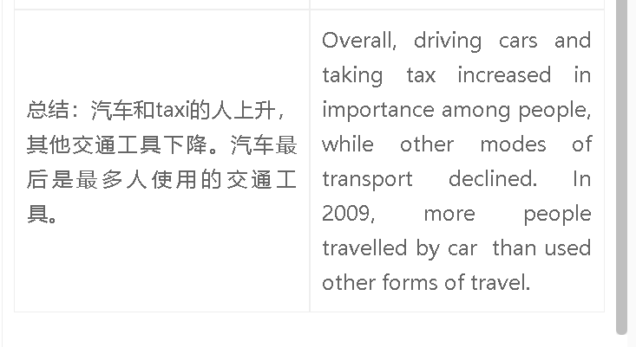

高分范文1
The charts give the information about the proportions of people who travelled to school or place of work every day by using different means of transport in a country. The proportion of people who drove to school or work was the highest in 2009, at 33%, although the figure in 2004 was much lower at 21 %. The trend in travelling by taxi was similar, with the percentage of people who relied on this form of transport increasing to 29% in 2009. By comparison, there was a decline in the use of public transport between 2004 and 2009, during which time the percentage of people using it dropped to 30%. Walking and cycling to work or study was unpopular with people: the percentage of commuters and students who travelled by bicycle dropped by half to 5%, and the figure for walking declined even more dramatically to 3%. Overall, the proportion of people who used the eco-friendly means of transport such as cycling, walking and public transport declined, in contrast to the increase in the use of taxi. Driving became the most popular choice in 2009.

