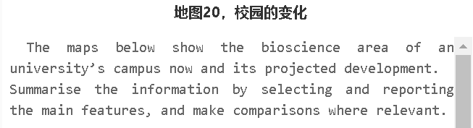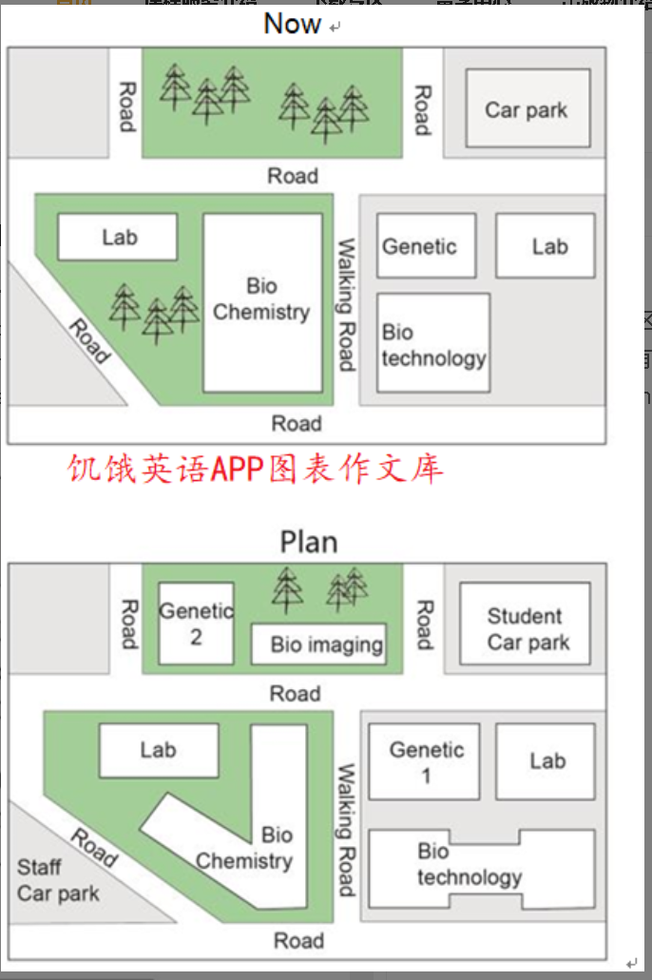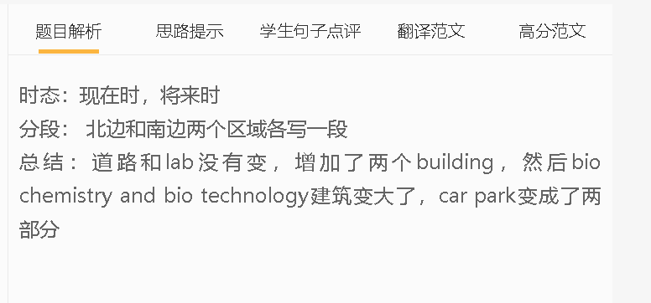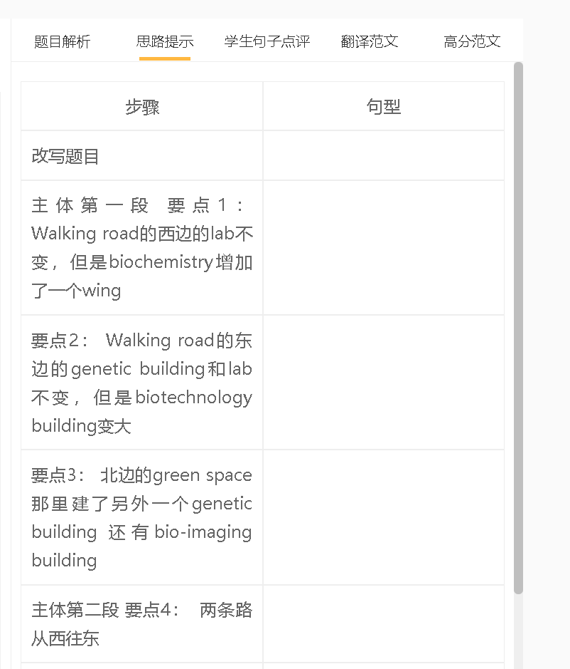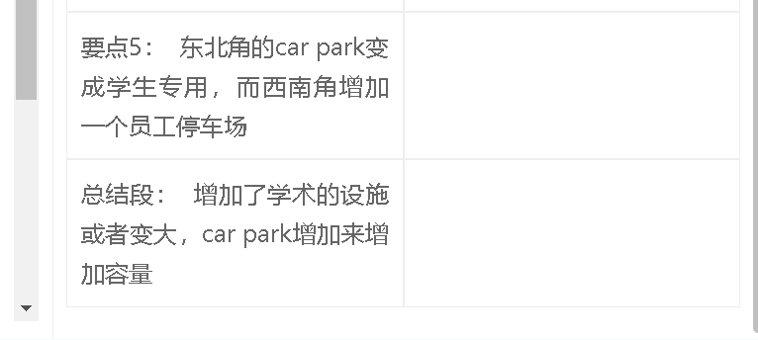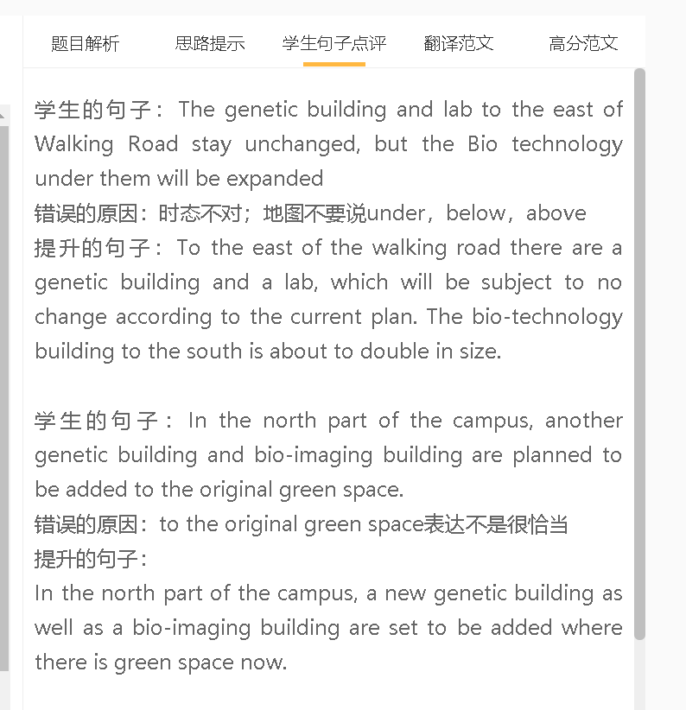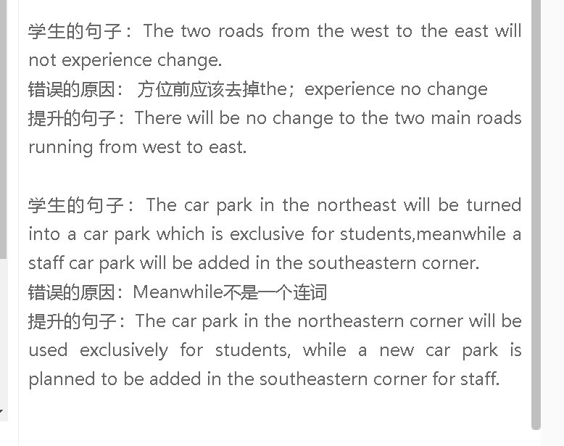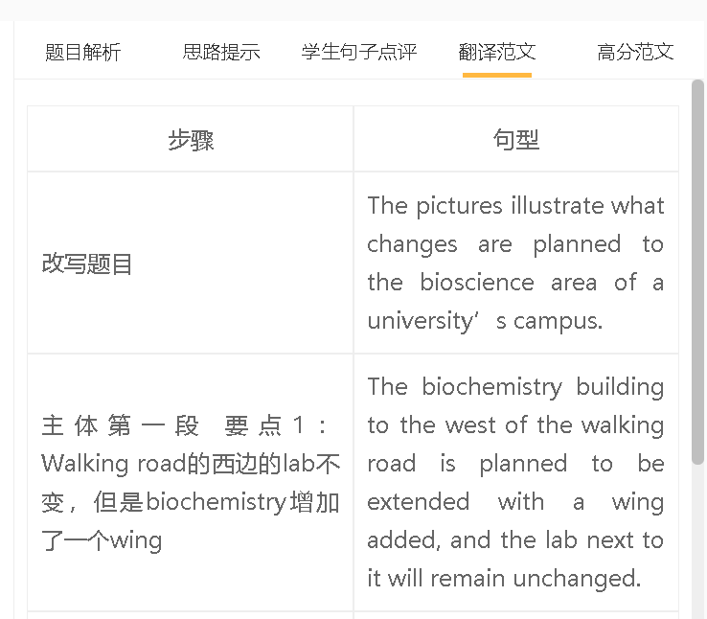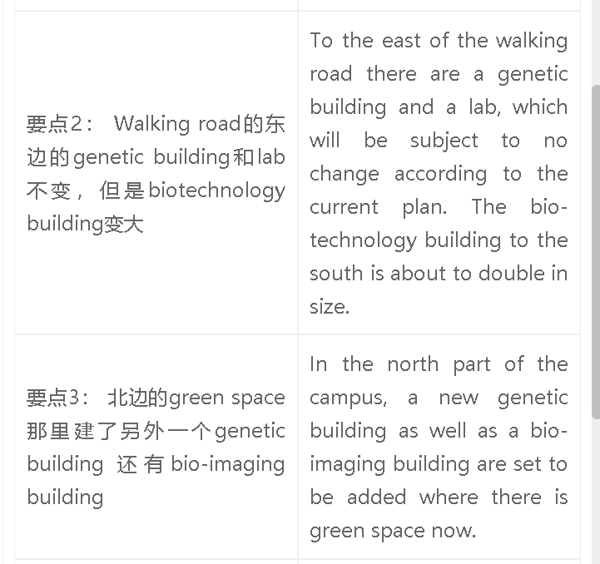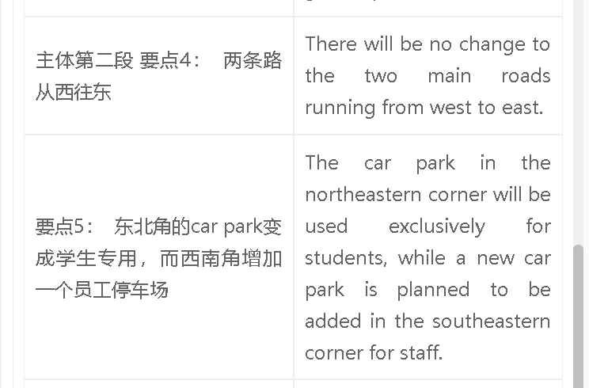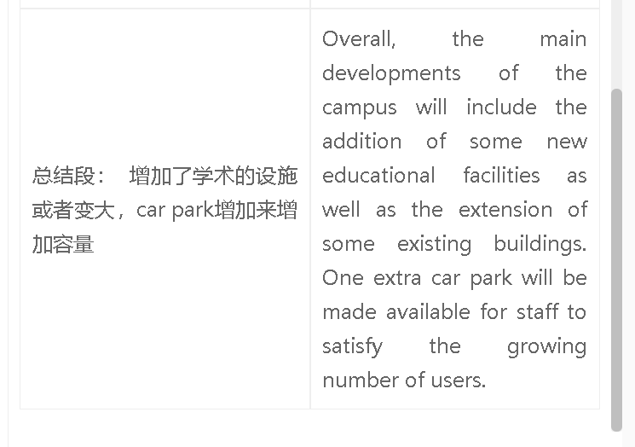

高分范文1
6.5-7 范文 The images illustrate the changes that will possibly happen to the bioscience area of a university. The first map shows that there are two roads crossing this area from west to east. Between these two roads, there is a road in the middle for walking. People can find a genetic building, a bio-technology building and a lab to the east of this walking path, as well as a biochemistry building and a lab to the west. Finally, people can have access to a green space and a car park in the north. In the future, one major change is that another building for genetic science and a bio-imaging building will be added in the north, where there was a green space. Next, the biotechnology building is projected to be expanded, and the bio-chemistry building is planned to add a wing. It is also clear that a triangular car park for staff will be built in the southwestern corner while the original car park will be dedicated for students. In contrast, roads, the existing genetic building and two labs are expected to remain unchanged. Overall， the bio-science area of this university is set to undergo remarkable changes, including the addition of some new educational facilities and a new staff car park, and the extension of some exisiting structures. By comparison, the rest is basically the same. 7+范文 The maps illustrate the planned changes to the bioscience section of a university. There are two roads crossing this area from west to east. Lying between them are a number of key facilities. The lab in the central area will remain unchanged, while the biochemistry building to the east is planned to be extended. Students can find a genetic engineering building across the walking path, and then a lab next to it. Both will not be changed in the development plan, whereas the biotechnology building to the south is set to be enlarged. Trees in the north part of the campus are expected to be removed, making way for the construction of a new genetic building and one brand-new facility for bio-imaging. There is a car park in the north-eastern corner, which will be used exclusively for students. A new car park for staff is about to be constructed in the south-eastern corner. Overall, the major changes include the extension of some existing structures, and the addition of two new facilities for various educational purposes, to make better use of space. These will be accompanied by an increase in parking lots.

