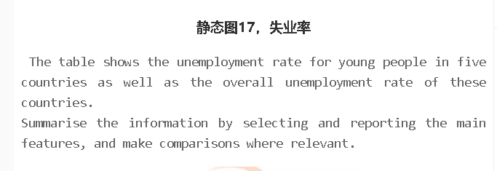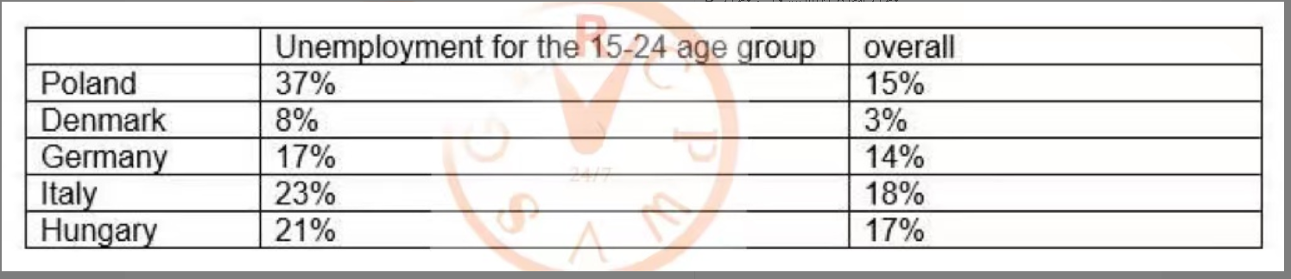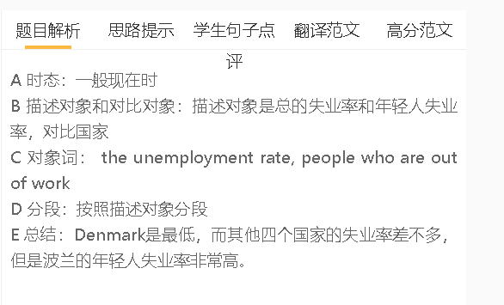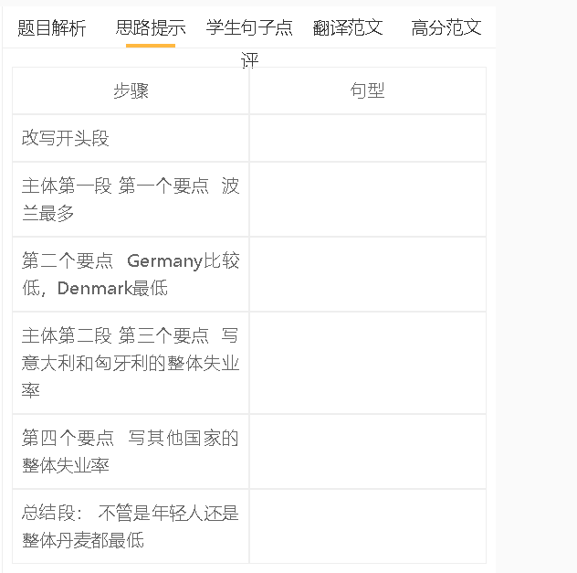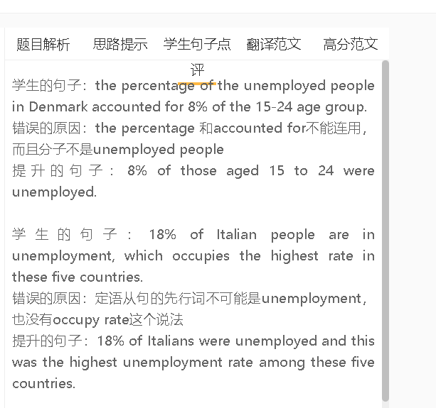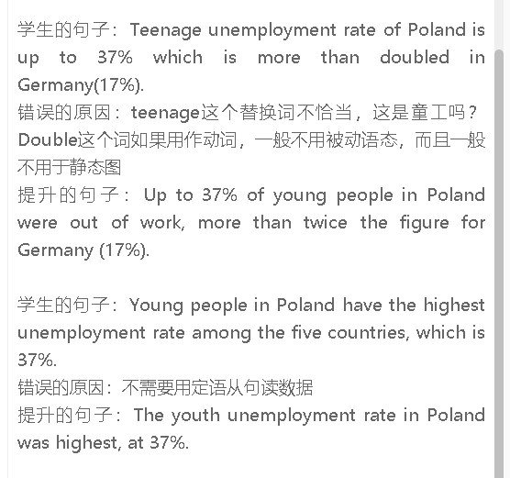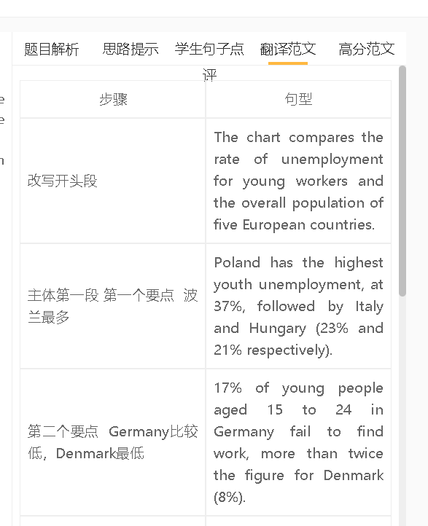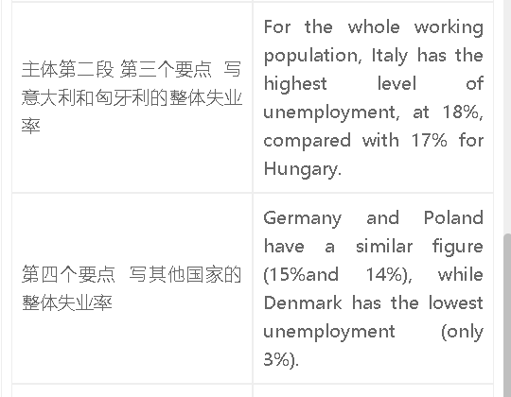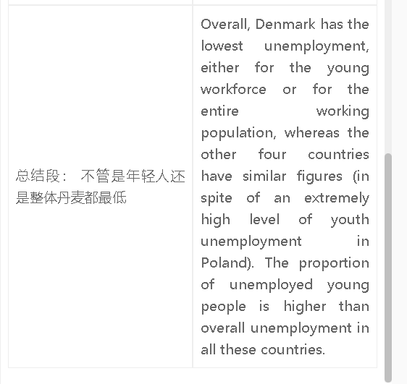

高分范文1
The table compares five European countries in terms of the proportions of unemployed people as well as the figures for those young people out of work. Poland had the highest youth unemployment rate at 37%, nearly five times the level in Denmark. The levels of unemployment for young people were similar in other countries, with the highest seen in Italy at 23% and the lowest in Germany at 17%. It is clear from the table that in all these countries, the unemployment rate for the younger generation was higher than the overall unemployment figures. Interestingly, Poland, Germany, Italy and Hungary had similar unemployment rates, ranging between 15% and 18%, while the figure for Denmark was significantly lower at 3%. Overall, youth unemployment was more serious in Poland than in other countries. Denmark had the lowest figures for both youth unemployment and overall unemployment, while other countries countries had similar figures for these problems.

