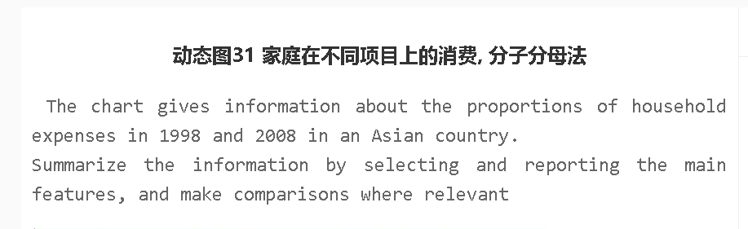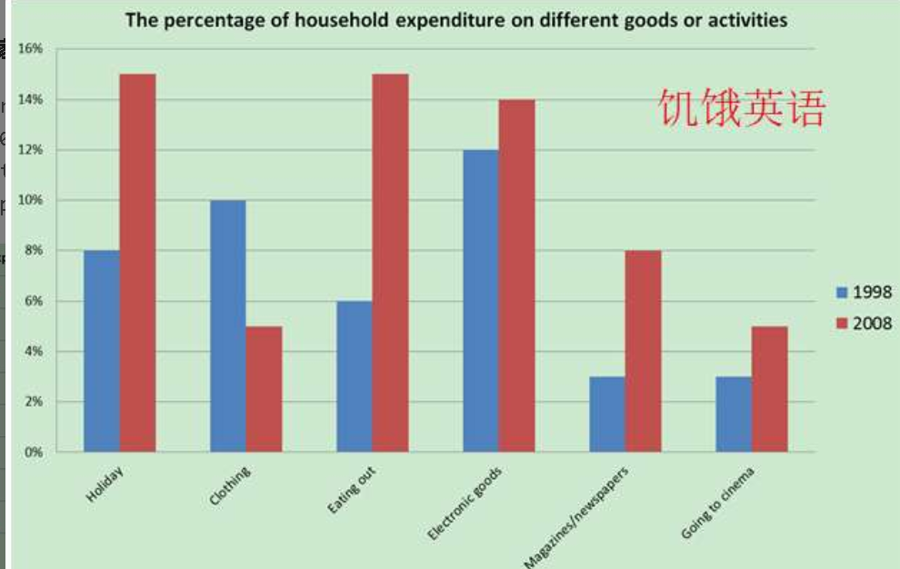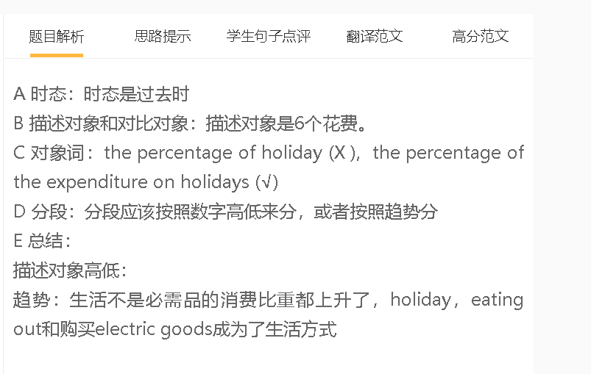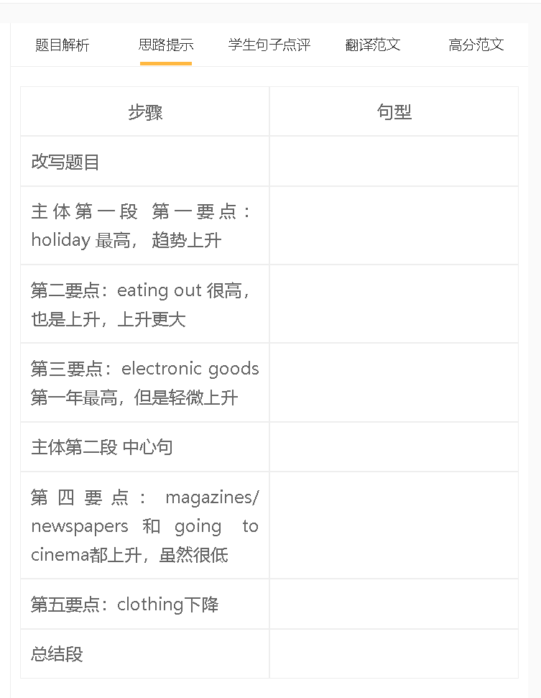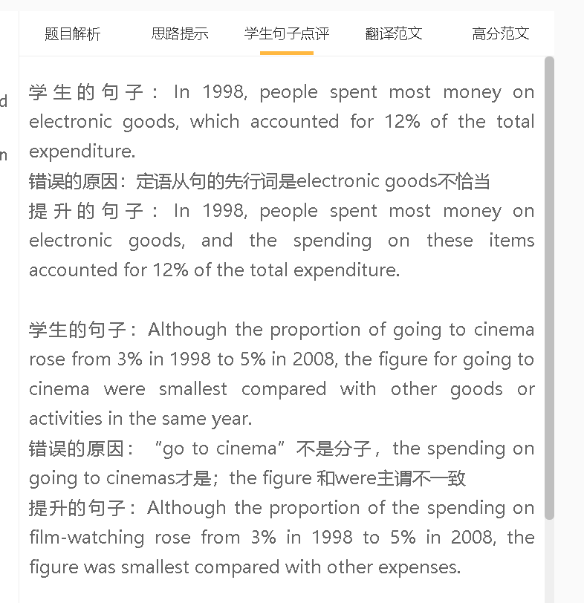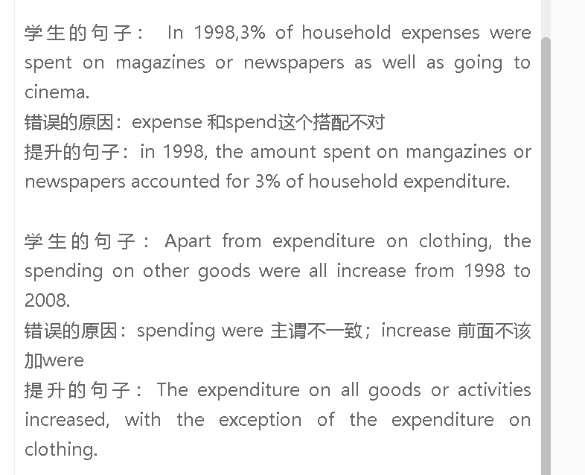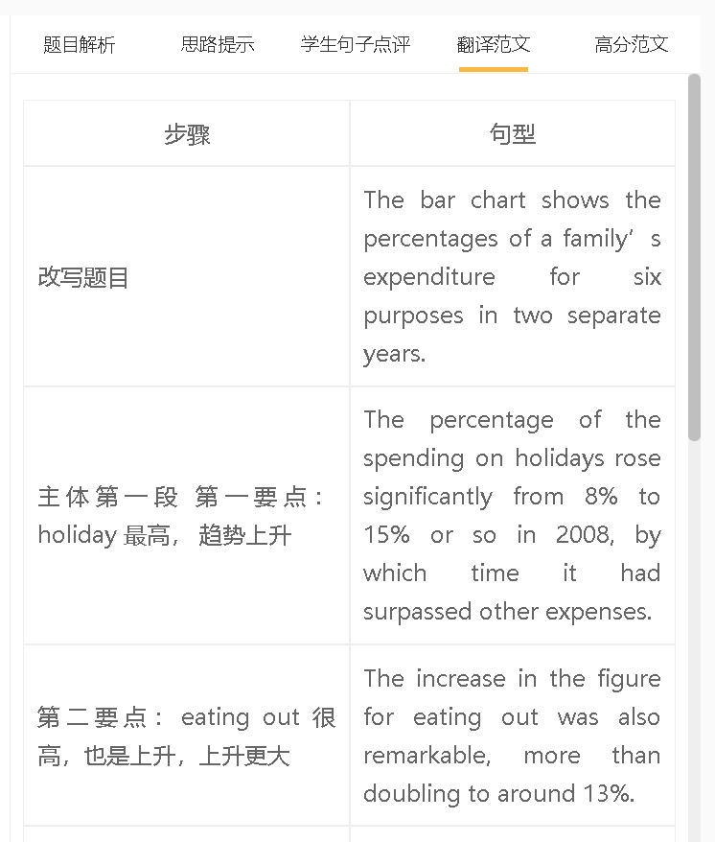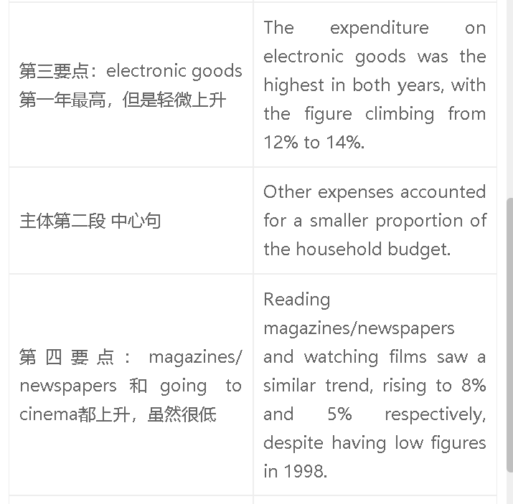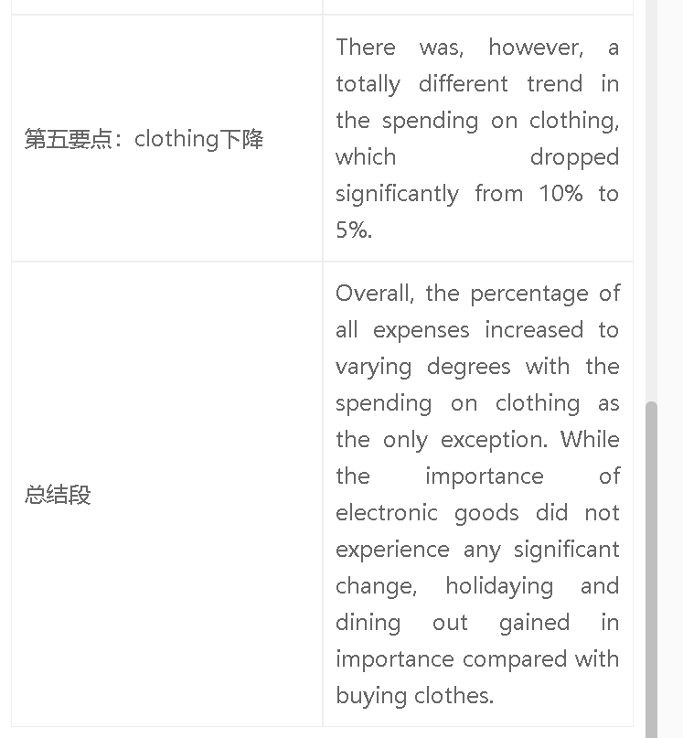

高分范文1
7+ The bar chart shows different categories of household expenditure of an Asian country in the years 1998 and 2008. The percentage of spending on holiday nearly doubled from 8% to around 15% in 2008, by which time this category of expenditure had become the highest. In the meantime, the biggest increase was seen in the spending on eating out, rising from 6% to 15%. By comparison, the proportion of the expenditure on electronic goods grew much less significantly to 14%, although it was higher than other expenses in 1998. A similar trend was seen in magazines/ newspapers, increasing nearly three-fold to 8%. The expenditure on watching films was the lowest, despite an increase to 5%. In contrast to the increases in these expenses, the figure for clothing saw a significant drop from 10% to 4.5%. Overall, people in this Asian country spent the largest proportion of their money on holidays and eating out in 2008. The percentages of all expenses, with the exception of clothing, increased. 6.5 The bar chart compares the percentages of household expenses over a ten-year period in an Asian country. The percentage of the spending on holidays was the highest in 2008, with the figure rising from 8% in 1998 to around 15% in 2008. There was a similar trend in the proportion of the spending on eating out, increasing from 6% to about 15%. The spending on electronic goods also saw the same pattern: the figure rose slightly from 12% to 14%. The figures for other expenses were lower. The percentage of the spending on clothing dropped from 10% to around 5% during the same period. There was a different trend in the spending on newspapers, growing from 3% to more than 8%. Going to the cinema saw a similar change, reaching 5%, although it was the lowest figure. Overall, the percentages of the spending on holidays, eating out, magazines, electronic goods and going to the cinema rose, while the figure for clothing decreased. The spending on holidays, eating out and electronic goods was higher than the figures for other expenses.

