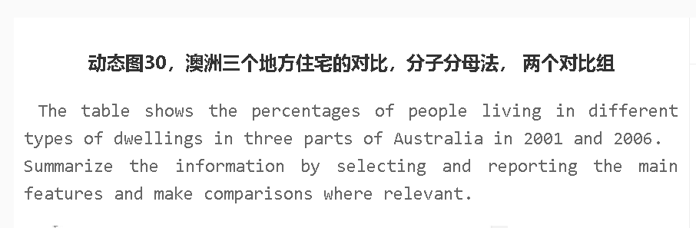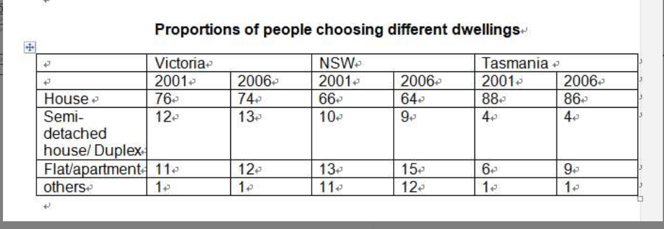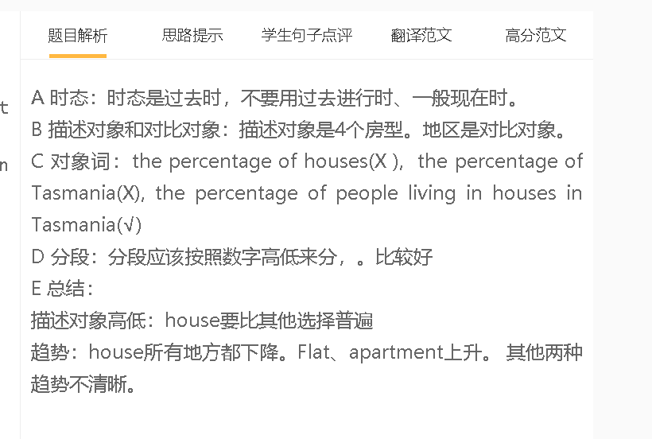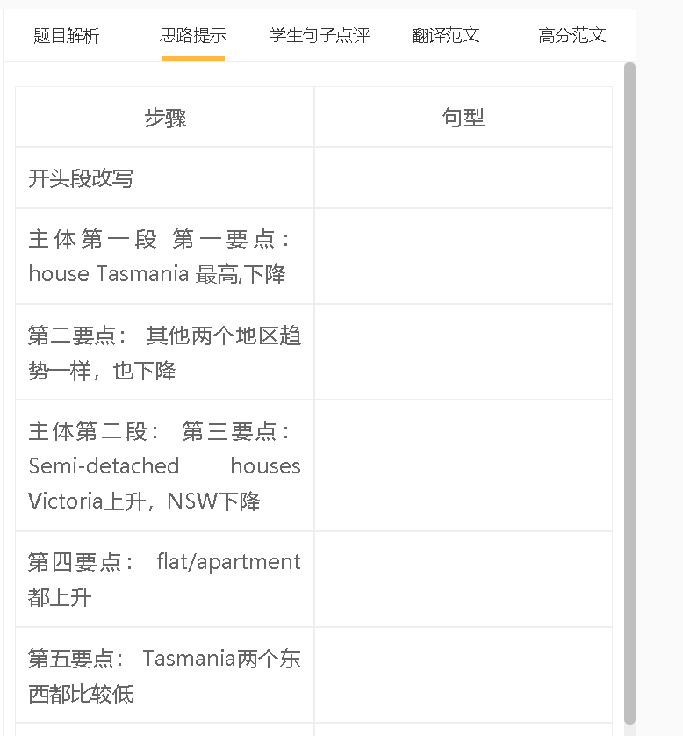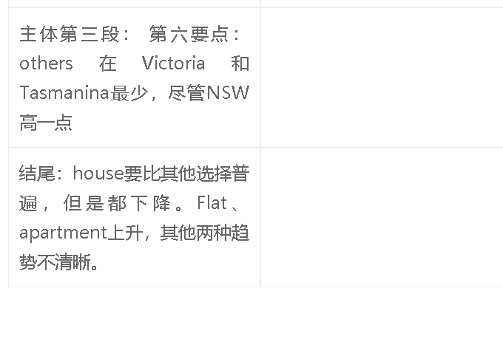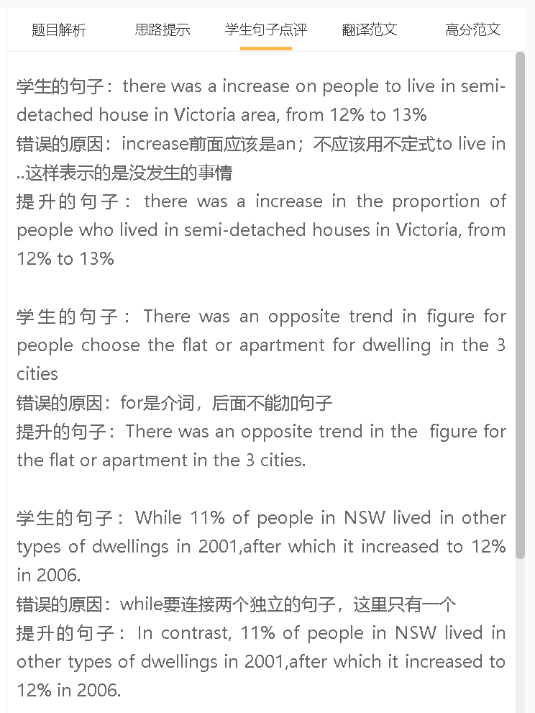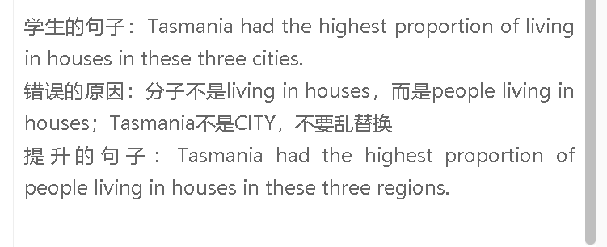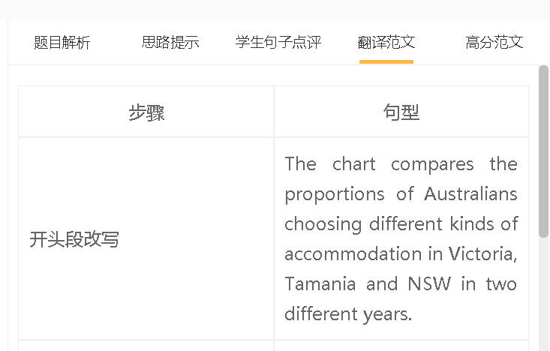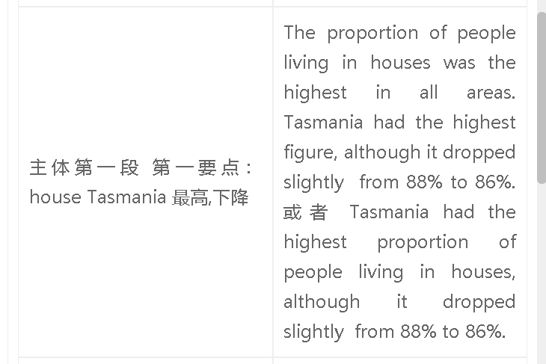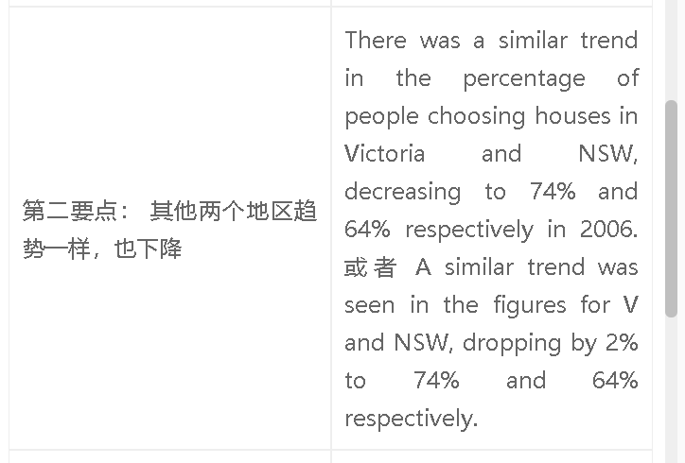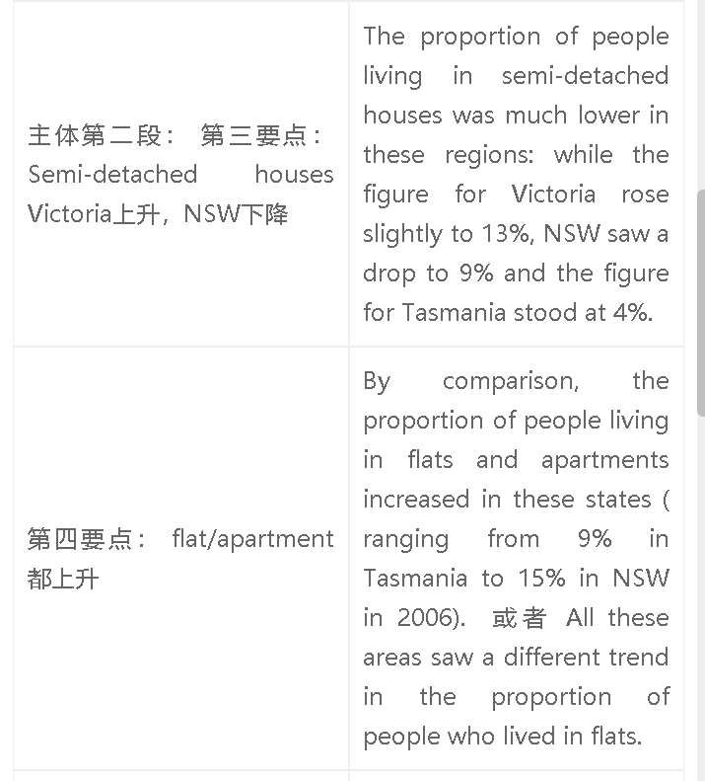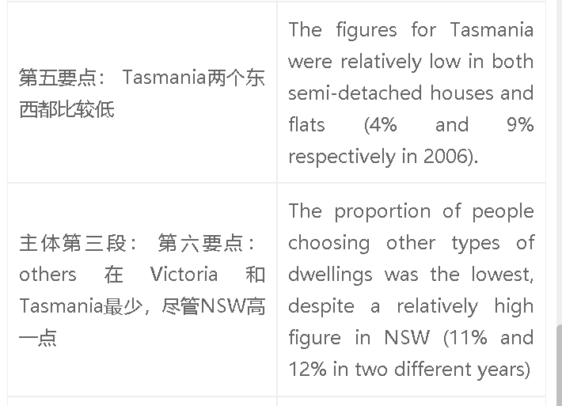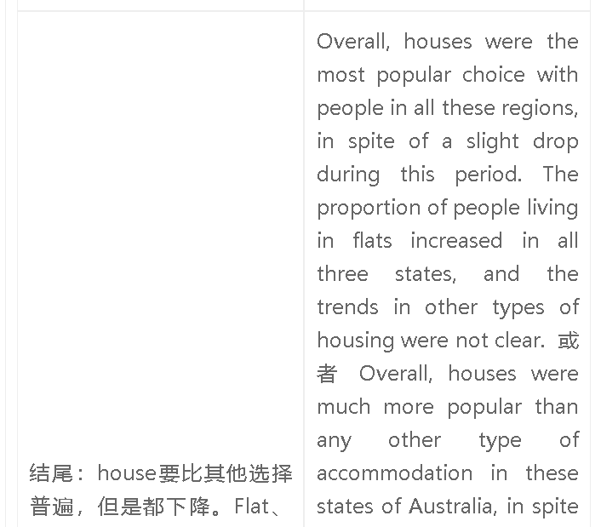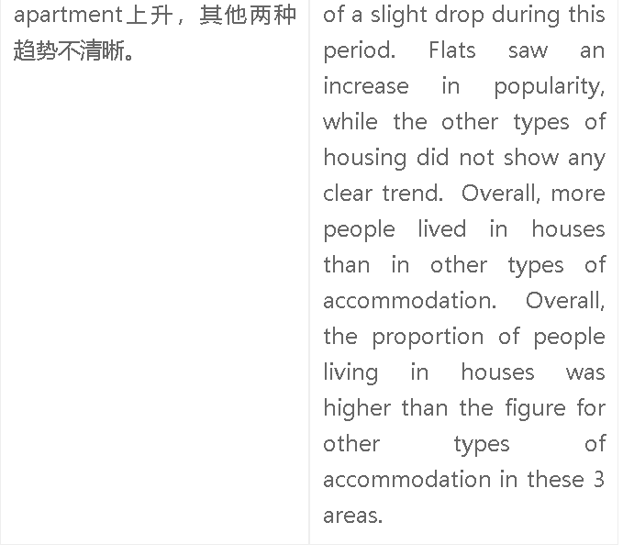

高分范文1
The table provides information about the popularity of different housing options in three areas of Australia. Houses represented the most popular option for all regions in both years, especially in Tasmania, where up to 88% of residents lived in houses, despite a slight drop to 86% in 2006. A similar trend was seen in Victoria and NSW, with figures dropping to 74% and 64% respectively. Victoria had the highest proportion of residents living in semi-detached houses, increasing slightly to13% in 2006. The figure for NSW in this type of dwelling fell to 9%, while Tasmania had the lowest figure at 4%. The preference for flats and apartments increased in all regions, and NSW had the highest proportion of residents choosing these dwellings, rising from 13% to 15%. The figures for the other two areas increased to 12% and 9% respectively. NSW also had a significant proportion of people living in other types of dwellings (12%), but these options were unpopular in Victoria and Tasmania. Overall, houses were the most popular choice with people in all these regions, in spite of a slight drop during this period. The proportion of people living in flats increased in all three states, and the trends in other types of housing were not clear.

