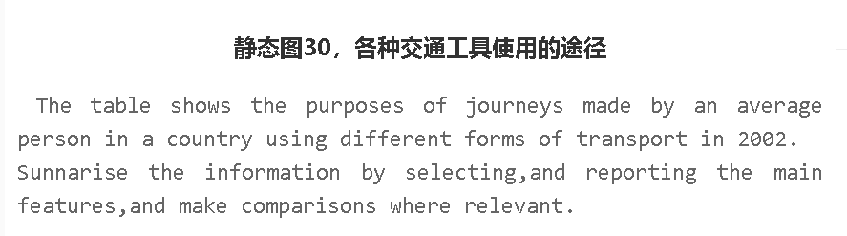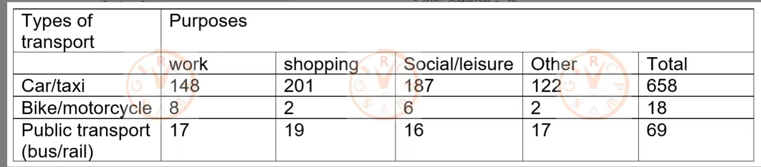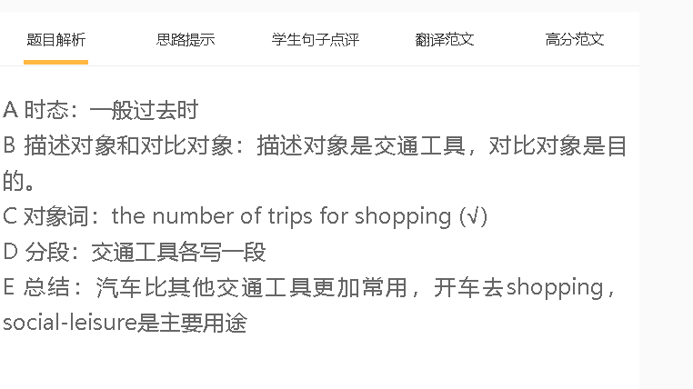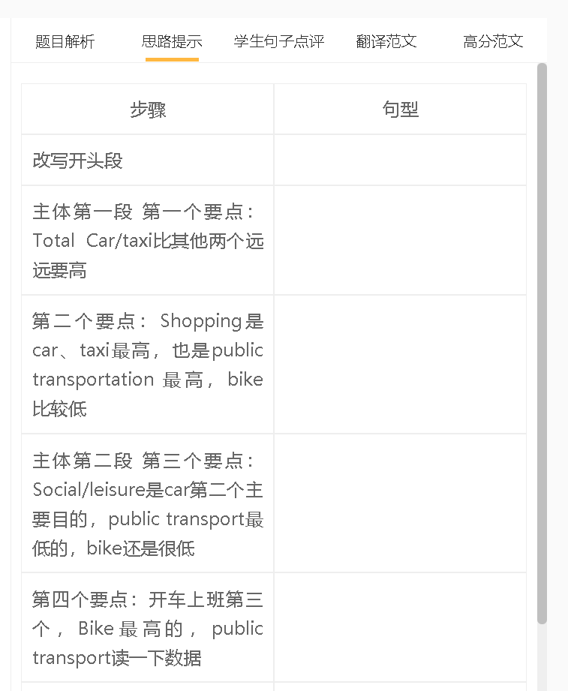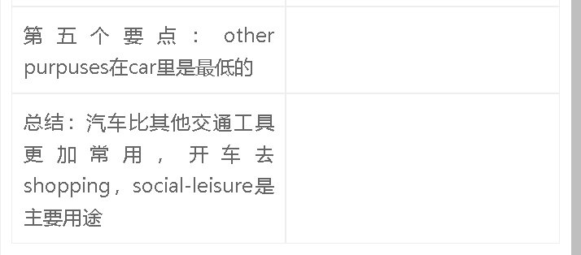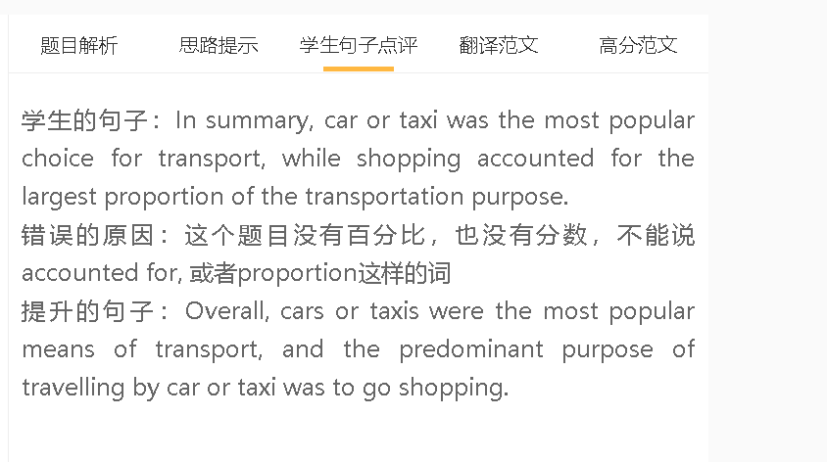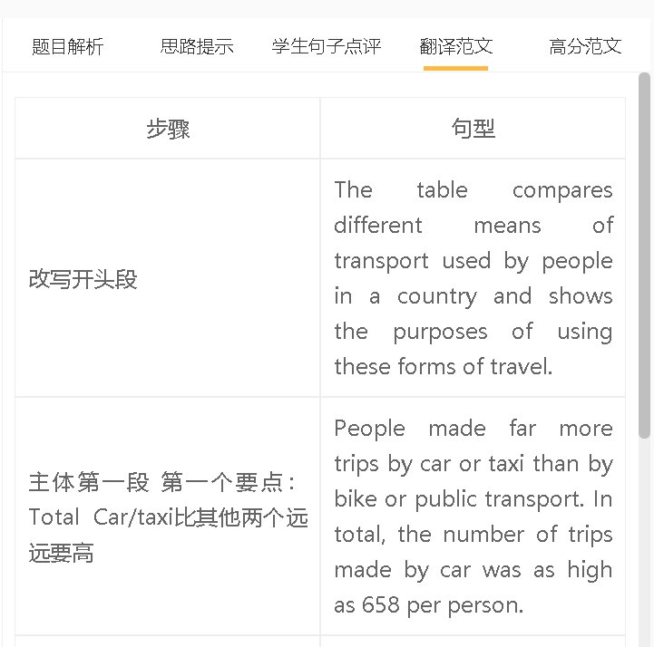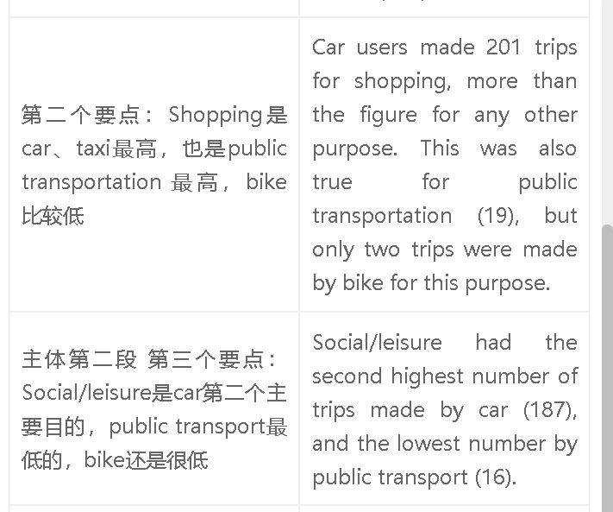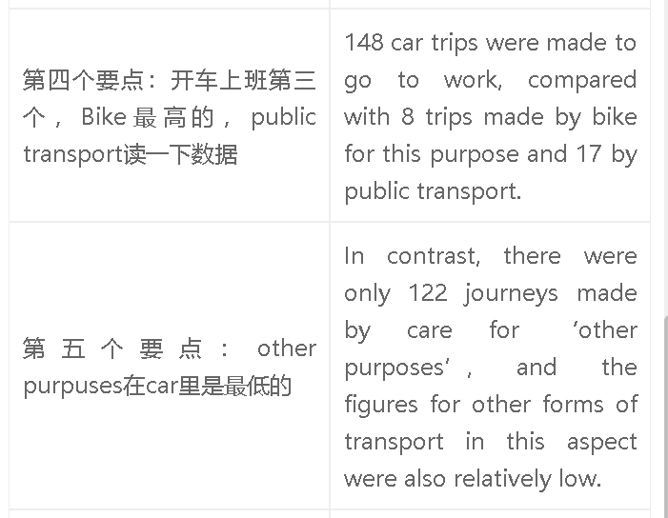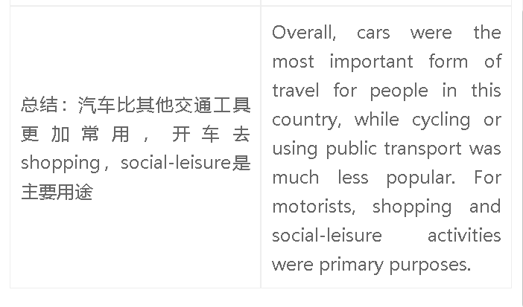

高分范文1
6.5分 The chart compares the types of journeys made by an average person in a country by using three means of transport in the year 2002. The number of journeys made by or taxi was the highest, at 658, in contrast to only 69 of journeys by public transport and 18 of journeys by bike. 201 car journeys were for shopping purposes, compared with 187 for social/leisure purposes. 148 car journeys were made for working, higher than the figure for other purposes (122). The figures for public transport were significantly lower. 19 journeys were made to go shopping, followed by 17 journeys for working and 17 for other destinations. The number of journeys by public transport for social or leisure life was the lowest, only 16. Riding the bike or motorbike was the least popular choice. People in this country made 8 trips by using this type of transport to go to work, compared with 6 journeys for social/leisure purposes. Overall, driving cars or travelling by taxi was the most popular means of travel, while biking or motorcycling was the least popular. The number of trips for shopping was much higher than the figure for any other purpose. 7 分 The given chart compares the various modes of transportation used by an average person in a country in the year 2002. It is evident that the majority of people preferred to travel by car or taxi, while bike or motorbike was the least popular option. The number of journeys made by car or taxi was the highest, with 658 trips. In contrast, only 69 journeys were made using public transport, and a mere 18 journeys were made by bike. Out of the mentioned car journeys made, 201 were for shopping-the leading purpose-followed by 187 for social or leisure purposes and 148 journeys made for work. Public transport, on the other hand, was significantly less popular for all purposes. Only 19 journeys were made for shopping, 17 for working and other destinations, and a mere 16 for social or leisure purposes. This indicates that people primarily relied on private transportation for their everyday travel needs. Lastly, the chart shows that bike or motorbike was the least used mode of transportation. Only 8 journeys were made for work, while 6 journeys were for social or leisure purposes. Overall, driving cars or travelling by taxi was the preferred means of transportation, while biking or motorcycling was the least popular. The highest number of trips were made for shopping purposes, followed by social or leisure activities. 7分 The table compares different means of transport used by people in a country and shows the purposes of using these forms of travel. The car or taxi was far more important than other forms of transport, regardless of purpose, and the highest number of car or taxi journeys was made for shopping (201). Shopping was also the main purpose of using public transport, with 19 out of 69 trips made for this aim. 187 car or taxi journeys were made for social and leisure activities, while 16 trips for those activities used public transport and 6 trips were by bike or motorcycling. The gap between different means of transport narrowed for commuting to work, but travelling by car or taxi remained the predominant choice (148 trips). In contrast, public transport was used in 17 trips, more than twice the number of trips using cycling or motorcycling. Overall, it is clear that people in this country relied heavily on cars or taxis to get around, while cycling was the least popular choice. Shopping and social activities were two leading purposes of travelling by car or taxi.

