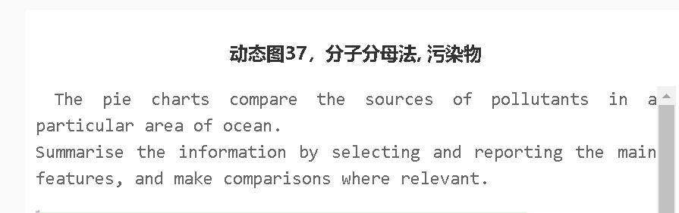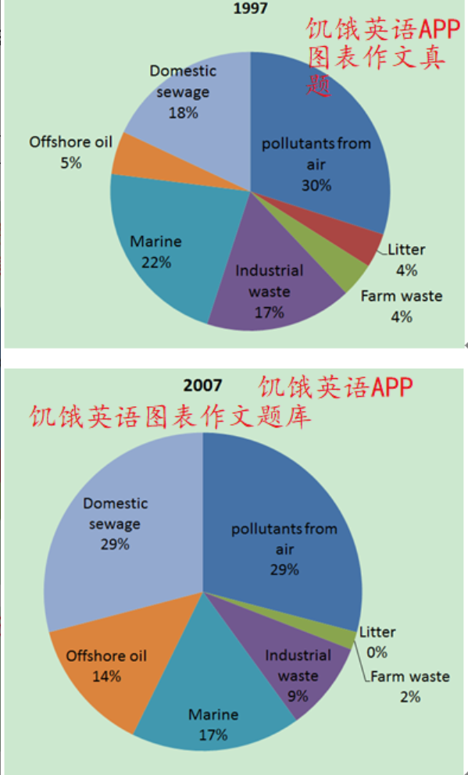
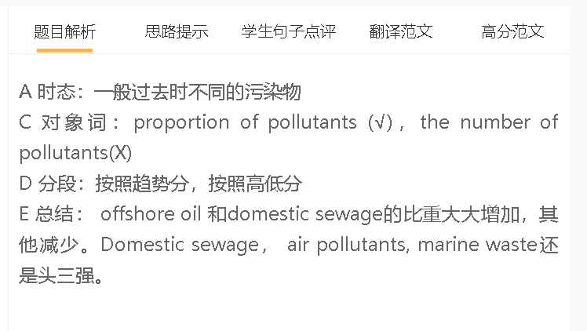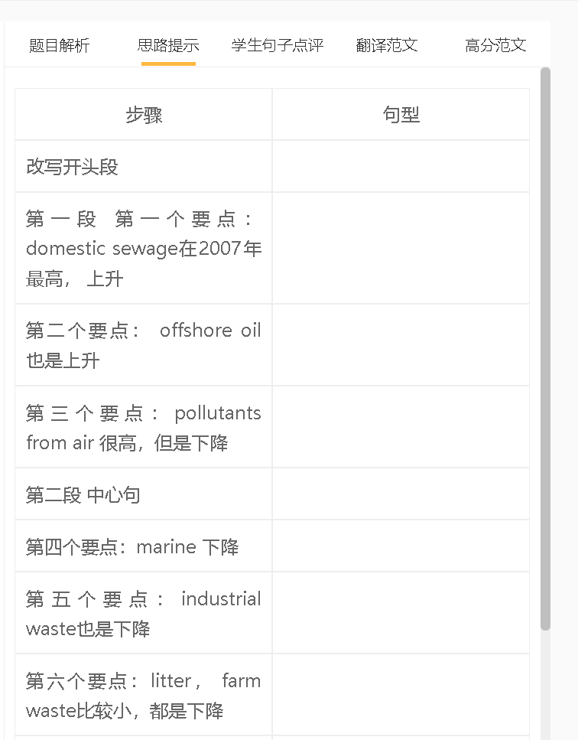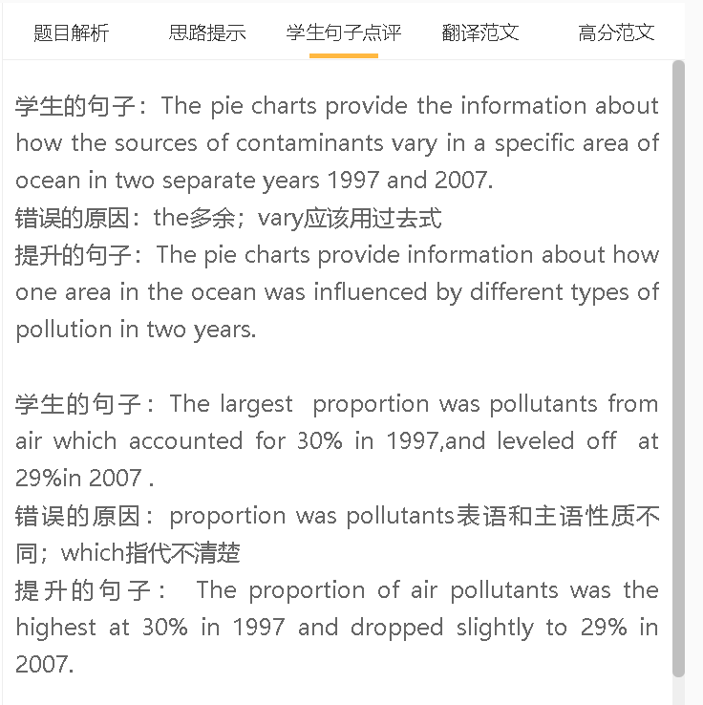
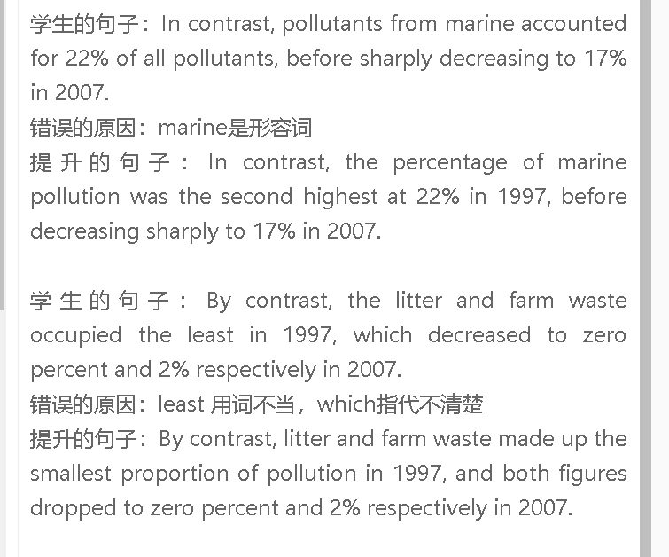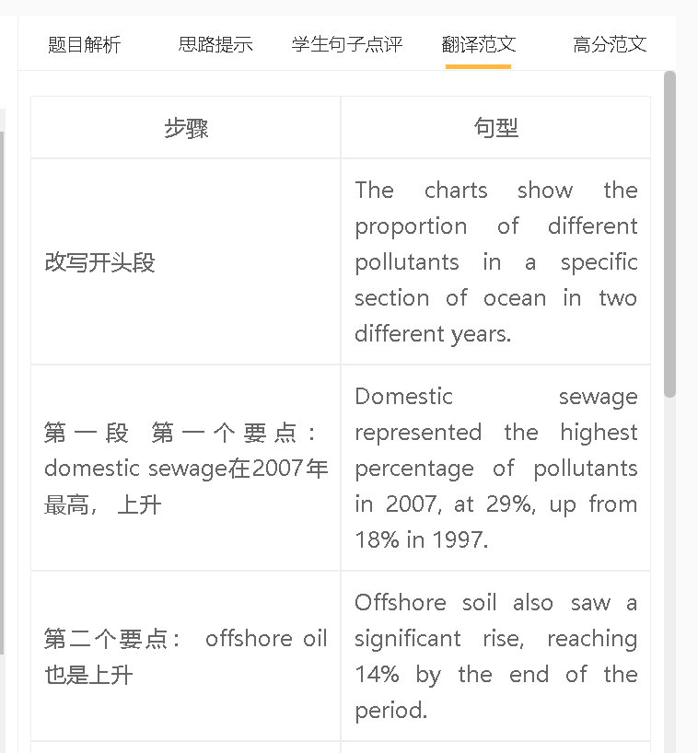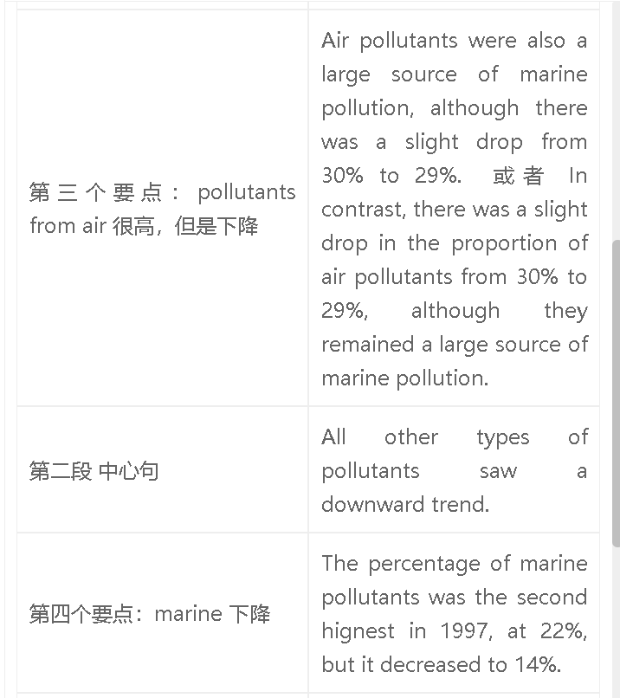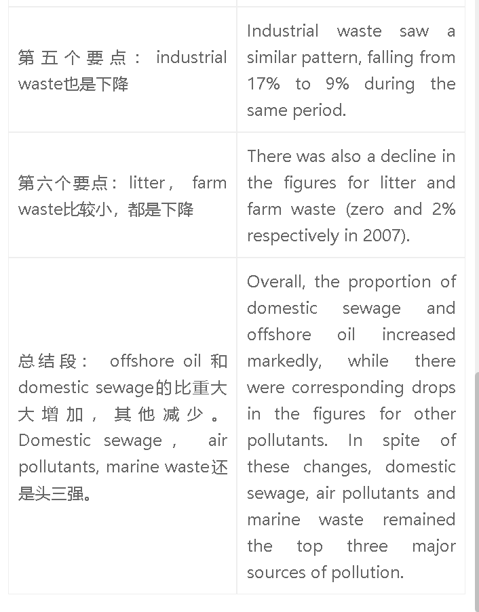

高分范文1
The charts show the changes in the proportions of different pollutants in an area between 1997 and 2007. There was a marked increase in the proportion of domestic sewage, reaching 29% in 2007, when it became a major source of pollution. Air pollution was also a major threat to the environment, although the figure for this type of pollution dropped slightly to 29%. A similar pattern was seen in marine waste, declining by 5% to 17%. A smaller proportion of this area’s pollution is attributed to other sources. The percentage of pollution caused by offshore oil rose nearly three-fold to 14%, while industrial waste made up a smaller proportion of total pollution at 9%. The figures for farm waste and litter were minimal. Overall, most pollutants of this area were from domestic sewage and air pollution in 2007. The proportion of offshore oil increased over this period, in contrast to a drop in the proportion of other sources of pollution.

