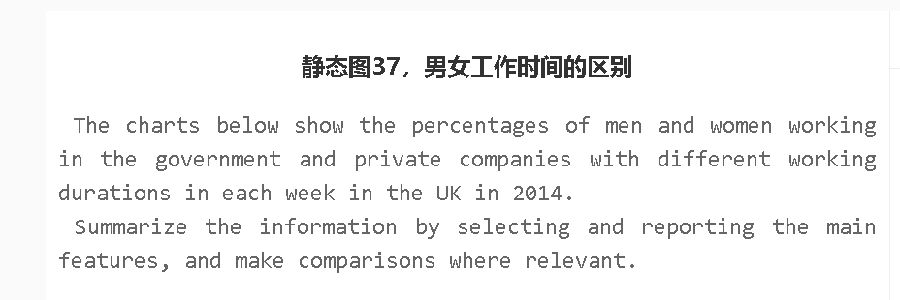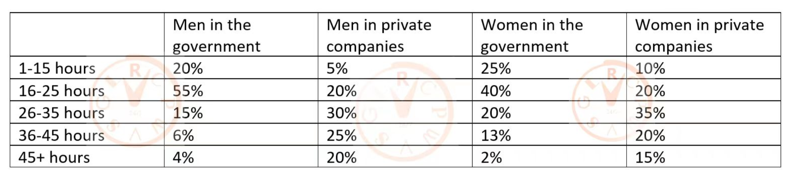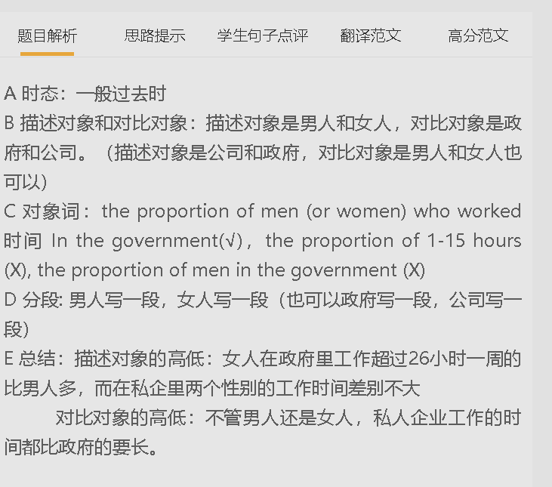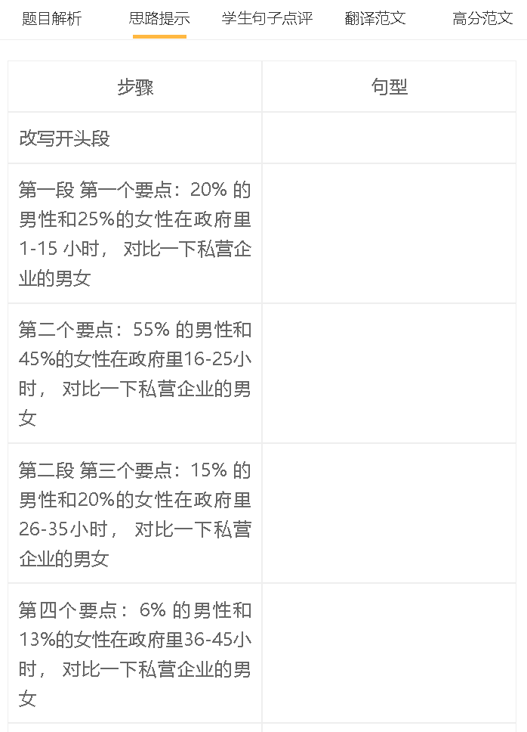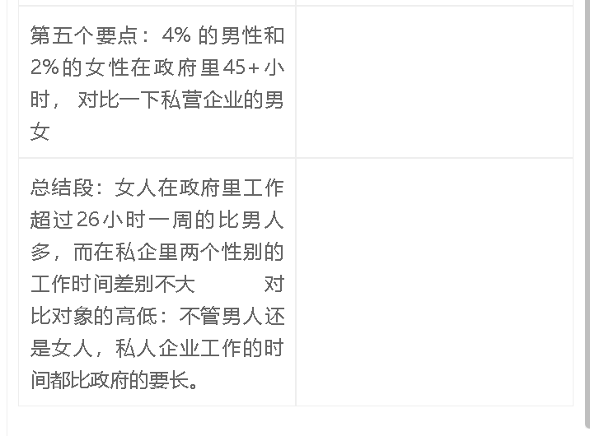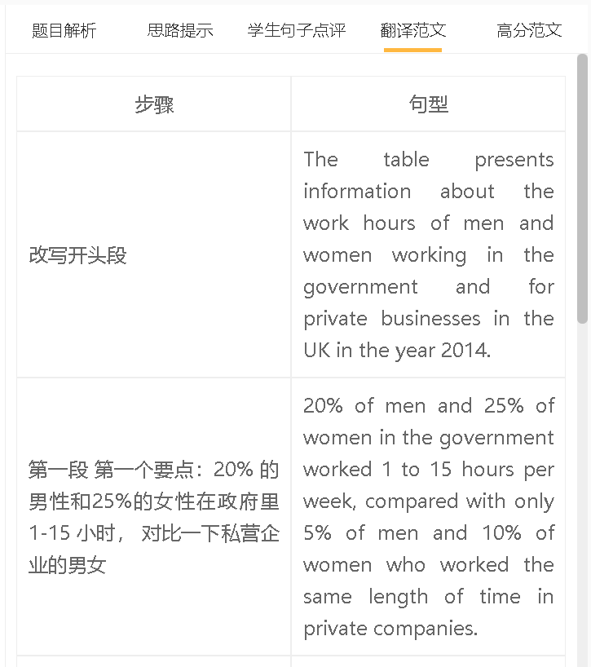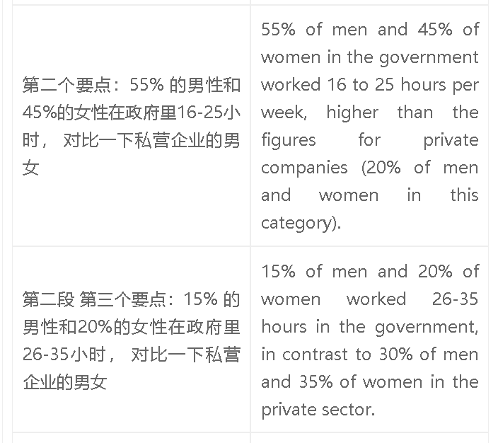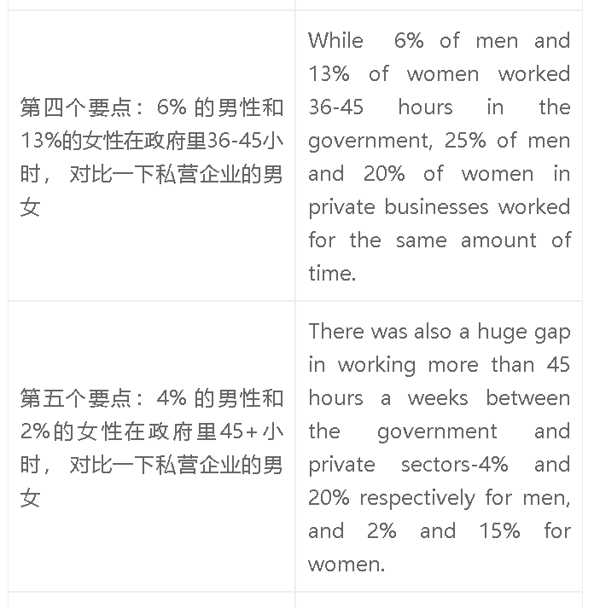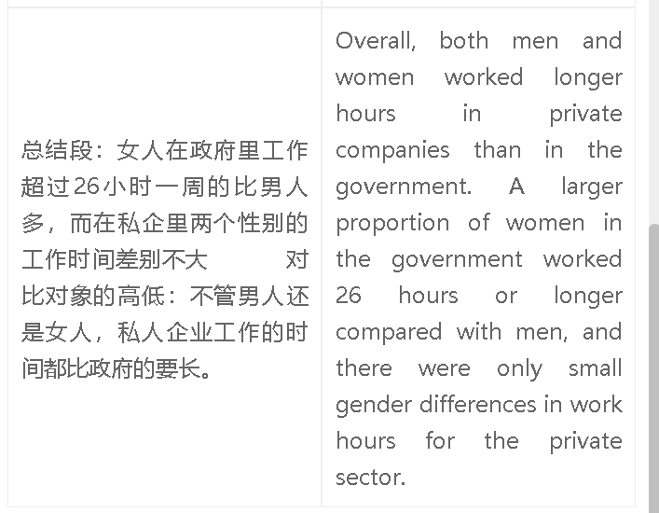

高分范文1
7+范文 The table presents information about the work hours of men and women working in the government and for private businesses in the UK in the year 2014. 20% of men and 25% of women in the government worked less than 15 hours a week, far higher than the figures for their counterparts in the private sector (5% and 10% respectively). Similarly, as high as 55% of men and 40% of women worked 16 to 25 hours as public servants, in contrast to only 20% of men and women in private companies. There was a totally different situation to people working 26 hours or longer. The figures for the government were low for both men and women, less than 20%, while 20% to 35% of men and women worked 26 to 45 hours in privately-owned companies. The gap was even wider for a 45+ hour work week: 20% of men and 15% of women in private companies fell into this category, significantly higher than the figures for their counterparts in the government. overall, private companies had longer working hours than government departments for both genders. In the private sector, men were more likely to work 36 hours or longer, while the opposite was true in the government.

