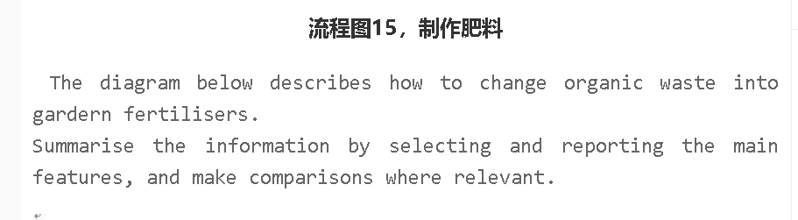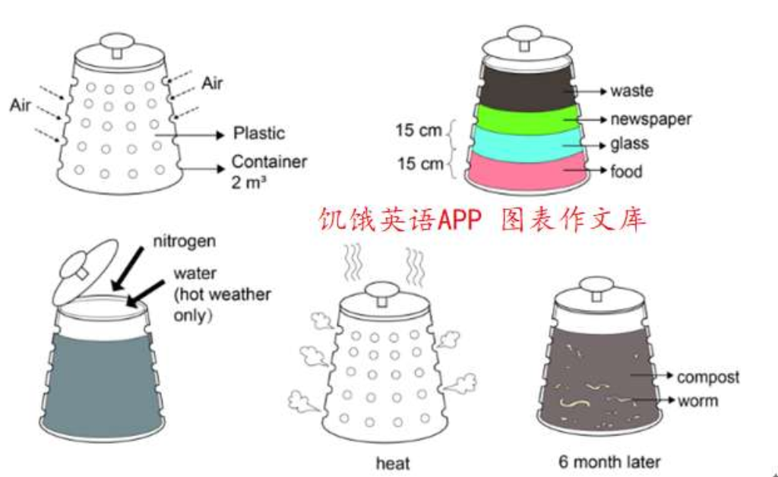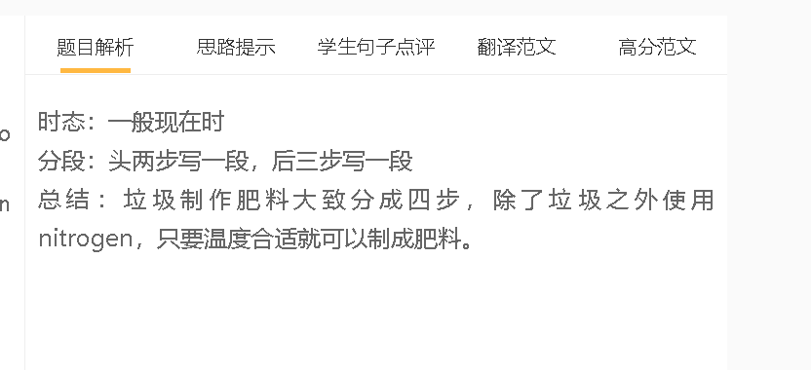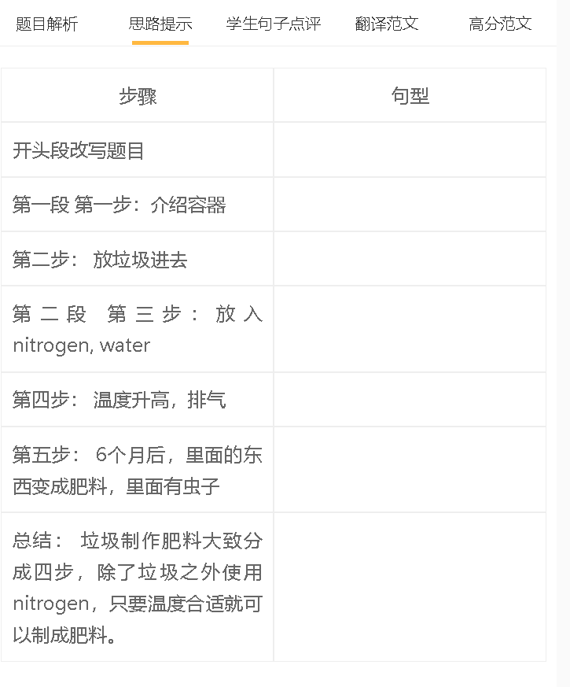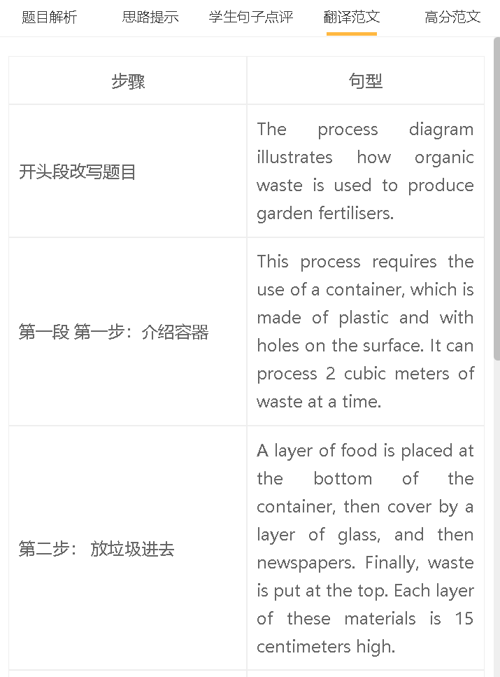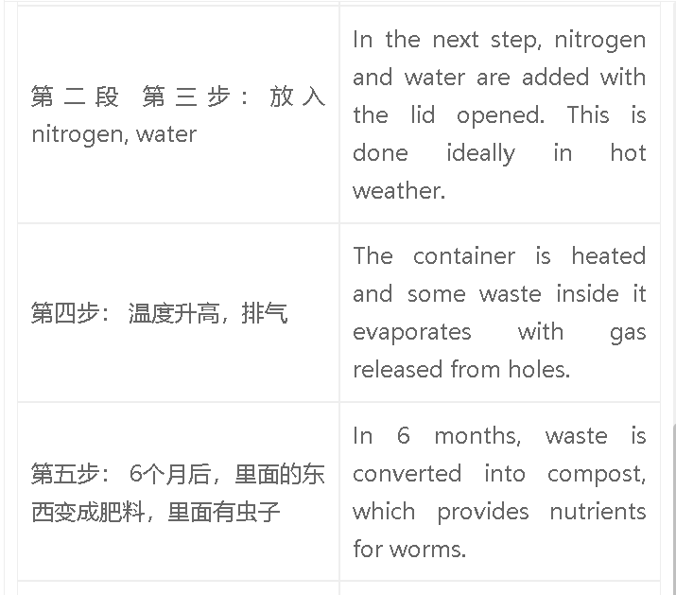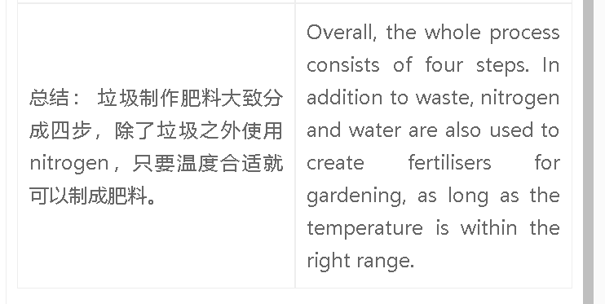

范文

高分范文1
The process diagram illustrates the conversion of organic waste into garden fertilisers. The process involves using a plastic container with holes on its surface to process up to 2 cubic meters of waste at a time. To begin the process, a layer of food waste is placed at the bottom of the container, followed by a layer of grass and newspapers, each 15 centimeters high. The organic waste is then added on top. Next, nitrogen and water are added to the container with the lid open, preferably in warm weather conditions. The container is then heated, and gas is released from the holes as some of the waste evaporates. Over a period of six months, the organic waste is converted into compost, which in turn provides nutrients for worms. Overall, this process involves four steps, and it requires the use of nitrogen and water in addition to organic waste to produce garden fertilisers, as long as the temperature is maintained within the appropriate range.

