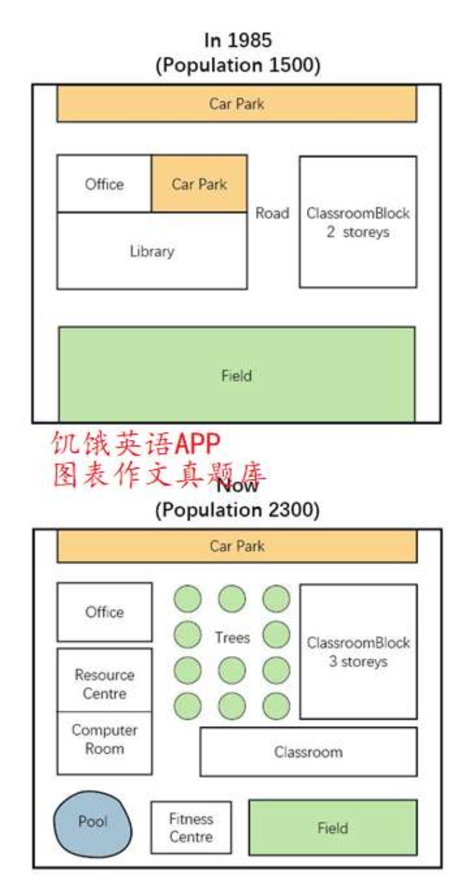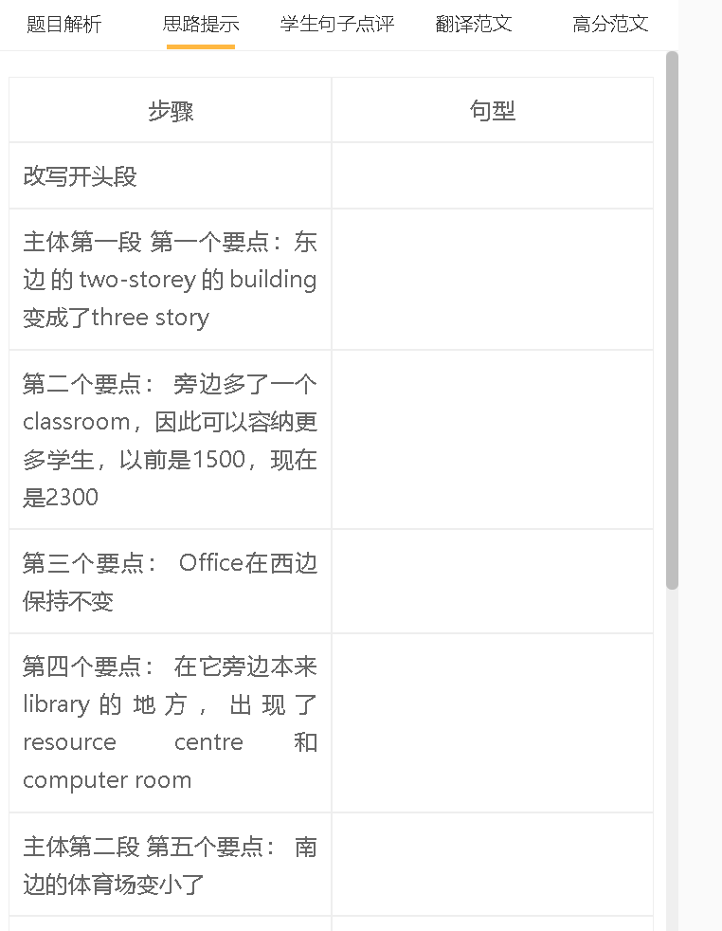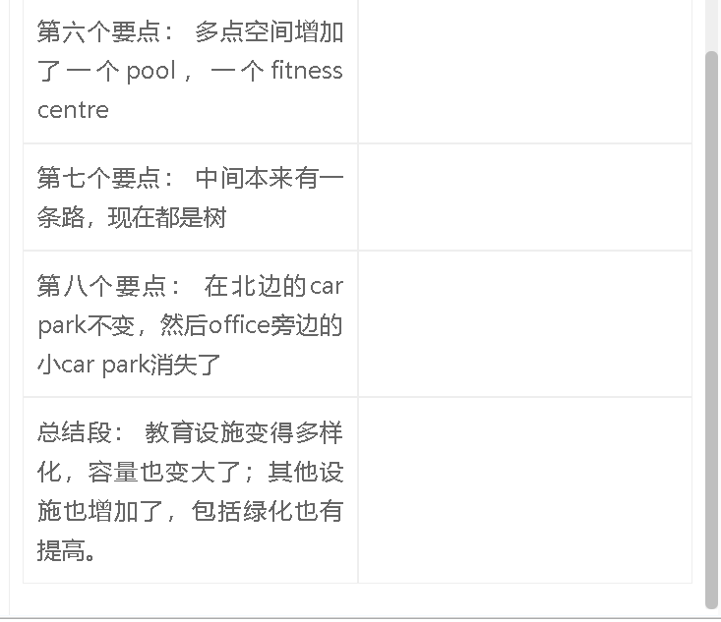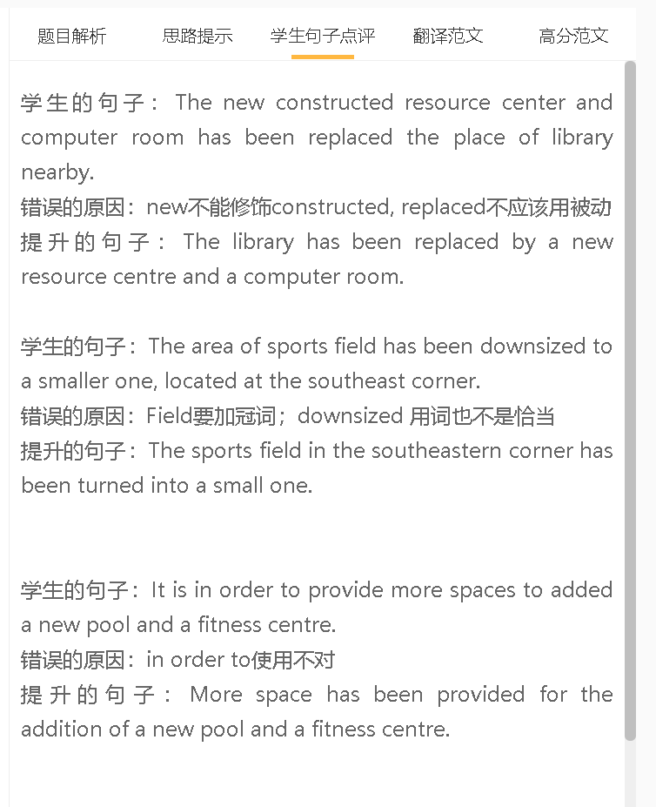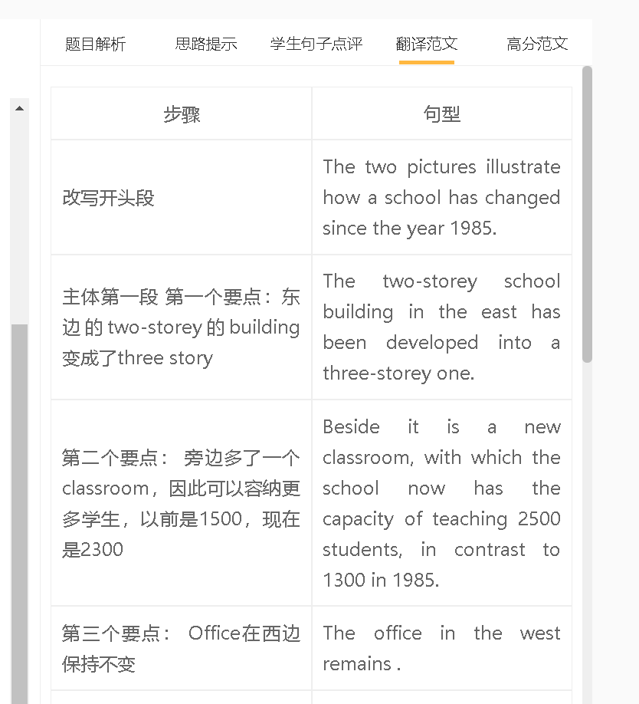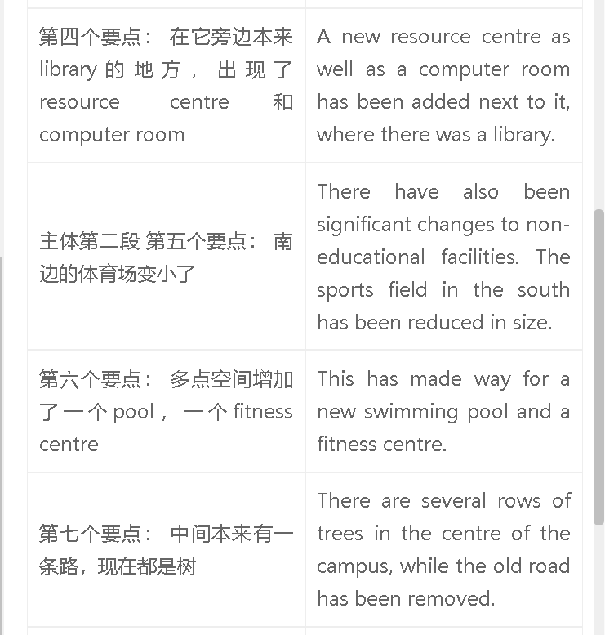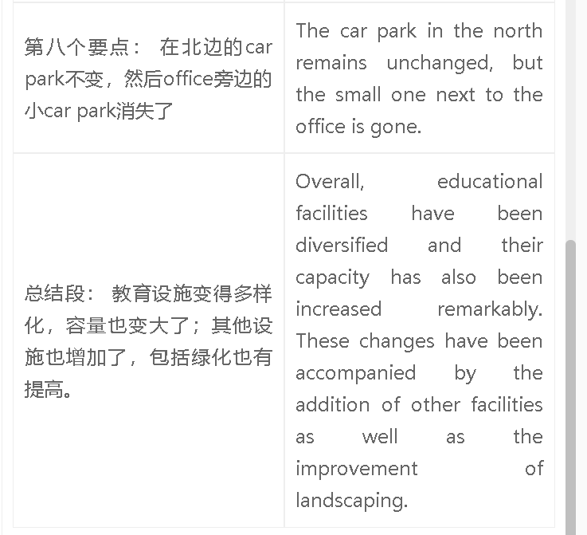

范文

高分范文1
The images reveal the changes that have happened to a school from the year 1985. It is clear that the school’s capacity has increasingly significantly from 1500 to 2300 students. This is due to the availability of a three-storey classroom block, in the replacement of the original two-storey one, and of a new classroom next to it. The old library has been removed and replaced by a resource centre and computer room, while the office beside it remains in the same place. Other facilities have also been changed substantially, with the car park in the north as the exception. The sports field in the south has been reduced in size, making space for a swimming pool and a fitness centre . Several rows of trees have been planted in the centre of the school campus, occupying the area previously for a small car park. Overall, the school has seen an increase in the variety of facilities that serve different purposes, including a resource centre, computer room, swimming pool and fitness centre. This has been accompanied by making the sports field smaller, improving landscape and removing the library.

