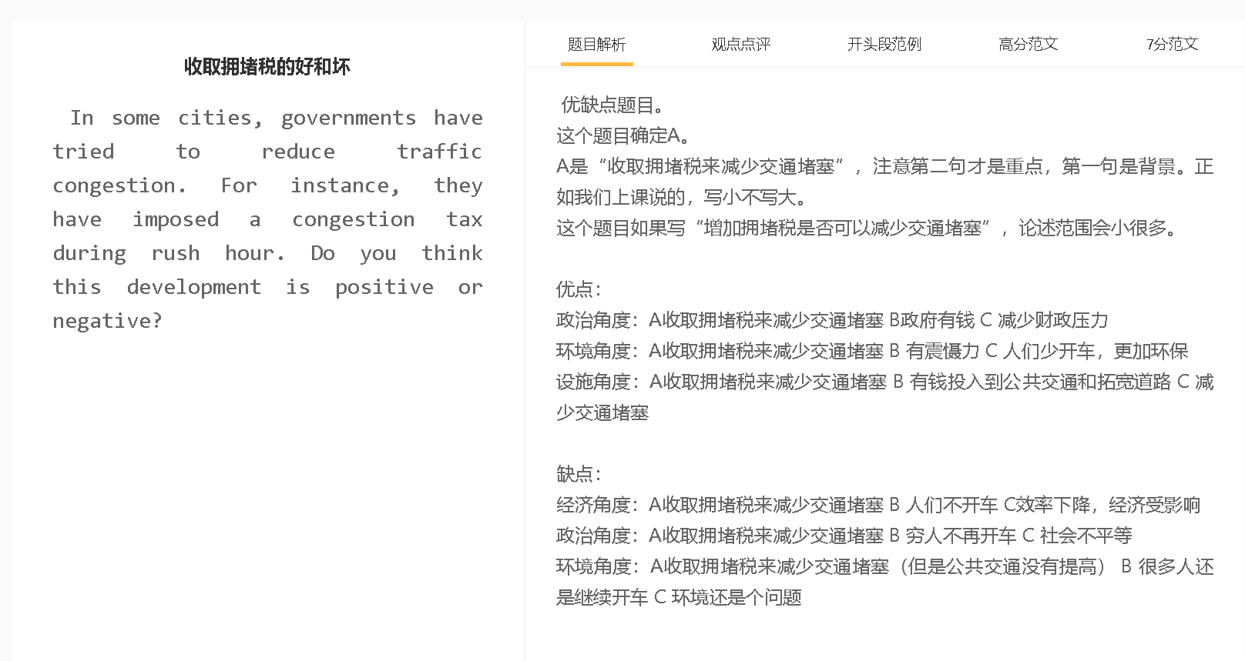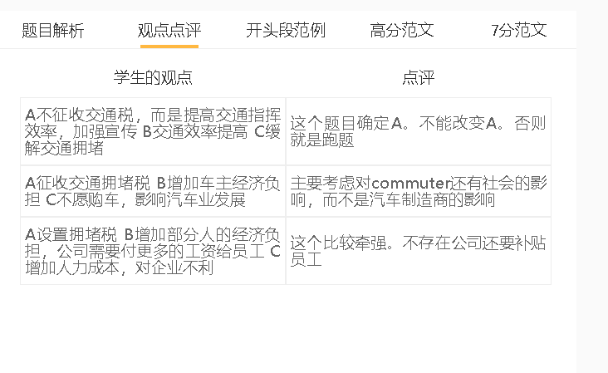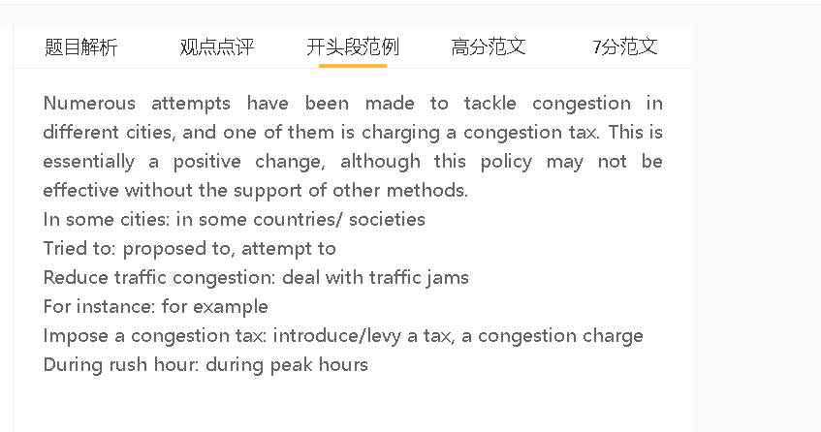

范文

6.5分
Traffic congestion has become a growing problem. Personally I would argue that the overall effect of imposing a congestion tax is positive.
A 拥堵税 B 增加人们出行的成本 C 减少车流量
中心句： A C because/as/since B
背景（想不到，可以不写）：This is understandable in cases where 句子
解释（解释A到B或者B到C的跳跃）： 原因，meaning that 结果
举例 （名词具体化进行替代）：for example, 句子
拓展一下结果（只限于确定A的题目）： It follows that 句子
对比（只限于有对比对象的题目或者出现比较级最高级的题目）：
The congestion tax can lead to a drop in traffic because the cost of driving increases. This is understandable in cases where people live on a tight budget. Car users have to pay more for driving their cars, meaning that they will avoid this form of transport and turn to other means of travel, including buses, trains or even cycling. It follows that commuters spend less time travelling to and from work and car emissions also drop.
The congestion tax may offer a solution to traffic problems because it pushes the cost of driving higher. This approach is particularly effective in cases where people live on a tight budget. They have to pay more for using cars, when they enter the city centre during rush hour, thereby shifting to other means of travel, including buses, trains or even cycling. A drop in the volume of traffic can reduce the time commuters spend travelling to and from work and also improve air quality of urban areas by reducing car emissions.
A 拥堵税 B 增加政府税收 C 利于城市建设
中心句： Another advantage/disadvantage/reason is that ABC
背景（想不到，可以不写）：This is particularly true for ….where 句子
解释（解释A到B或者B到C的跳跃）： 原因，so 结果
举例 （名词具体化进行替代）：for example, 句子
拓展一下结果（只限于确定A的题目）： In the long run, 句子
对比（只限于有对比对象的题目或者出现比较级最高级的题目）：
Another advantage is that the congestion tax can generate more revenue for the government and benefit urban development. This is particularly true for cities where the government has budget deficits. Tax revenue can bring cash to these cities, so the government can increase its investment in infrastructure, such as roads, bus stops and metro stations. In the long run, these facilities can address congestion issues and improve life satisfaction of people living in these cities.
A收拥堵税 B 穷人减少开车 C 对穷人不方便
中心句： On the other hand, AC because/since/as B
背景（想不到，可以不写）：This happens when 句子
解释（解释A到B或者B到C的跳跃）： 原因; therefore, 结果
举例 （名词具体化进行替代）：for example, 句子
拓展一下结果（只限于确定A的题目）：This is important considering that 句子
对比（只限于有对比对象的题目或者出现比较级最高级的题目）：
On the other hand, imposing a tax is inconvenient to disadvantaged people since this can discourage them from driving. This happens when they live far away from the workplace. They cannot drive to work; therefore, they may have to accept longer commutes or give up their current employment. This is an issue worth mentioning considering that people from disadvantaged backgrounds earn less and the income gap will widen.
In conclusion, imposing a congestion tax is basically a positive change, although it may cause some problems to people of low socio-economic status.

7分
Traffic congestion has become an issue of concern to the public. From my personal perspective, I think that imposing a congestion tax has a positive/negative overall impact.

The congestion tax may offer a solution to traffic problems because it pushes the cost of driving higher. This approach is particularly effective in cases where people live on a tight budget. They have to pay more for using cars, when they enter the city centre during rush hour, thereby shifting to other means of travel, including buses, trains or even cycling. A drop in the volume of traffic can reduce the time commuters spend travelling to and from work and also improve air quality of urban areas by reducing car emissions.

Another advantage is that the congestion tax can generate more revenue for the government and benefit urban development. This policy is particularly important for cities which struggle with budget deficits. Congestion charges can provide cash that can be allocated to infrastructure construction, such as broader roads, bus stops and metro stations that allow people to get around easily without using private vehicles. In the long run, these facilities can address congestion issues and improve life satisfaction of people living in these cities.

On the other hand, this taxation policy may present a challenge to disadvantaged people since this can discourage them from driving. They mostly live in outer suburbs, where housing is more affordable but public transport may not be available. If driving to work is no longer an option, they have to use different means of transport to reach the office, which usually takes longer time, or give up their current employment. The economic disparity will worsen if they finally accept a low-pay job near where they live.

In conclusion, imposing a congestion tax is basically a positive change, although it may cause some problems to people of low socio-economic status.

7分范文
Numerous attempts have been made to tackle congestion in different cities, and one of them is charging a congestion tax. This is essentially a positive change, although this policy may not be effective without the support of other methods.
A征税 B 更多人可能会选择公共交通，减少小汽车的使用 C 道路上车辆少了，交通更顺畅
背景：他们对运输成本很敏感
举例：选择乘地铁或者乘公共汽车去市中心
拓展结果：效率更高，对经济有好处
Public transport, reduce car use, traffic flow smoothly
The congestion charge can reduce the amount of traffic on roads since many people may choose to take public transport, rather than use private vehicles. This initiative is particularly effective if the majority of commuters are sensitive to transportation costs, which can constitute a large proportion of the family budget. In order to avoid the extra payment, they would choose to take metros or travel by bus to the centre of the city, and this means that traffic can flow smoothly as roads are less crowded. Productivity will be given a boost if people spend less time travelling to and from the office and more time on their work. This can yield economic benefits as productivity has relevance to competitiveness and profitability of businesses.

A 征税 B 政府有更多的钱来更新交通网络和公共交通服务 C减少交通堵塞
背景：由于医疗保健等无数公共服务都在争夺有限的财政资源，政府的预算有限。
解释：来自富裕家庭的司机继续驾车出行，而不是乘坐不方便、不可靠的公共交通工具。
解释：拥堵费可以用来拓宽或修建道路，以增加交通系统的容量，并开发一个综合的、高效的公共交通系统。
扣题：这些变化可以进一步缓解拥塞和相关问题。

Another benefit is that the government has more money at its disposal to update traffic networks as well as public transport services. Some cities struggle with budget constraints as countless public services such as medical care are competing for limited financial resources. Levying a congestion tax can bring in cash for transport authorities since motorists from well-off backgrounds continue to travel by car, rather than less convenient and reliable public transportation. Congestion charges can be used to broaden or build roads to increase the capacity of the transport system, and to develop an integrated, efficient mass transit system. These changes can further alleviate congestion and related problems.

A 征税 B 人们不会改变自己的驾驶行为 C 交通堵塞没有得到解决
背景：没有便捷、准时的火车或公共汽车服务，只能开车
拓展结果：大家很恼火
Upgrade public transport services, drive cars, alleviate traffic congestion
On the other hand, imposing the congestion charge may not reduce traffic in some cities. Without the availability of convenient, punctual train or bus services, commuters have no choice but to drive cars, despite the high congestion payment. They will feel resentful as the tax does not mitigate traffic problems but simply add a financial burden on them. There will be questions about whether their money has been misused and opposition to other policies the government plans to implement.

In conclusion, charging motorists extra fees to reduce congestion is a sensible decision, but the outcome is limited if this policy is not enacted together with other initiatives, such as the improvement of public transportation.

