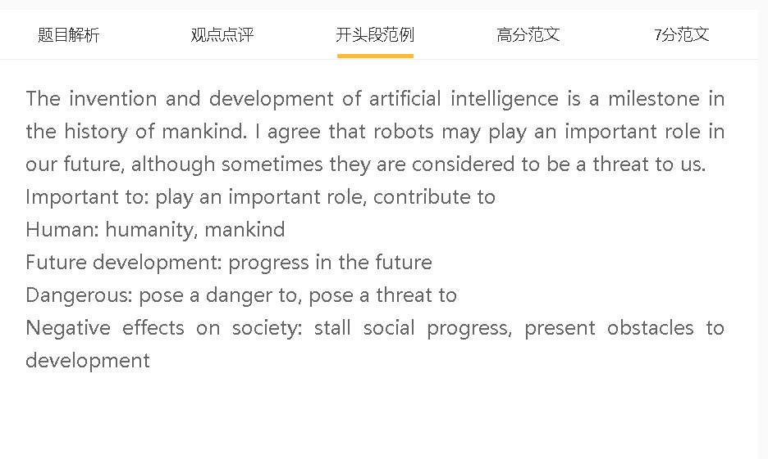3

范文

The value of robots for social progress has been recognised by many people. I basically agree upon this view, although this technological innovation sometimes poses dangers to human beings.
A robots B 替代人类做一些工作 C 推动未来的发展
解释（A-B）：误差小，不会疲惫，按照程序去工作
解释（B-C）： 人们去做一些智力型，创造型的工作，推进了劳动力市场的变化
结果：robots推动未来的发展 原因： 替代人类做一些工作
结果：替代人类原因：误差小，不会疲惫，按照程序去工作
原因：推进了劳动力市场的变化, 人们去做一些智力型，创造型的工作 结果：社会发展
Some people are confident in robots’ contribution to development of human society because these machines substitute for human workers in numerous jobs. They can act as replacements for the simple reason that they are programmed to perform tasks with precision and to work tirelessly. This can promote changes in the labour market and lead to a transition to intellectual or creative work, which opens the door for more ground-breaking innovations and discoveries in society.
A robots B 用在不好的用途 C 伤害人类，对社会有影响
解释（A-B）：批量生产，成本比较低
解释（B-C）：放在战争中，无差别杀人， 机器人高度聪明，可能会成为人类的主人
结果：robots伤害人类，对社会有影响 原因：用在不好的用途
结果： 用在不好的用途 原因：批量生产，成本比较低
原因：放在战争中， 机器人高度聪明 结果：无差别杀人，可能会成为人类的主人
另一方面，机器人有时被视为对人类的威胁，因为它们可能被用于恶意目的。这种情况发生在一个低成本大规模生产的世界里。它们被部署在战场上，在那里它们可以不分青红皂白地杀死人类，并被发展为超过人类，但结果是，如果它们有自我意识，总有一天它们会接管。这可能会使整个世界处于危险之中。
On the other hand, robots are sometimes seen as a threat to mankind since they can be used for malicious purposes. This happens in a world where they have been mass produced at low costs. They are deployed in battlefields, where they could kill humans indiscriminately, and developed to outmatch humans, but the consequence is that they could take over one day if they are self-aware. This can put the entire world at risk.
A robots B 在危险环境下作业 C 推动未来的发展
解释（A-B）：高质量的材料做的，可以反辐射，反腐蚀，等等
解释（B-C）：从事科学相关的工作

结果：robots推动未来的发展 原因：在危险环境下作业
结果：在危险环境下作业 原因：高质量的材料做的，可以反辐射，反腐蚀，等等
结果：推动科技发展，社会发展 原因：从事科学相关的工作
In my view, robots have a significant role to play in helping our society advance as they can work in hazardous environments for various purposes, especially scientific research. This is primarily due to the fact that they are made of high-quality materials which have some unique properties, including resistance to radiation and erosion. They can carry out tasks in harsh conditions, such as outer space, polar regions and deep ocean, to gather data, collect samples and conduct experiments, which contribute to scientific breakthroughs and social progress.

In conclusion, I agree that technological advances in robots open up new opportunities for future development, although they can be risky, if not managed well.

