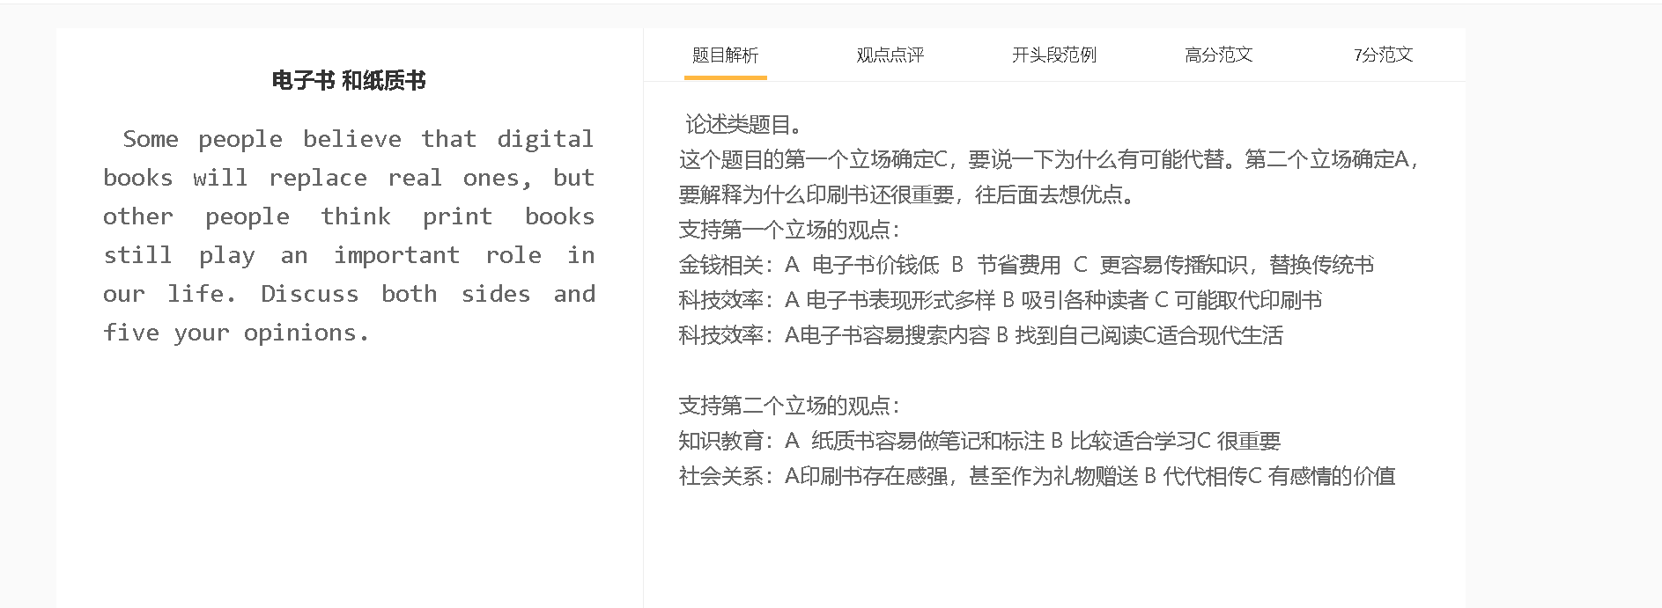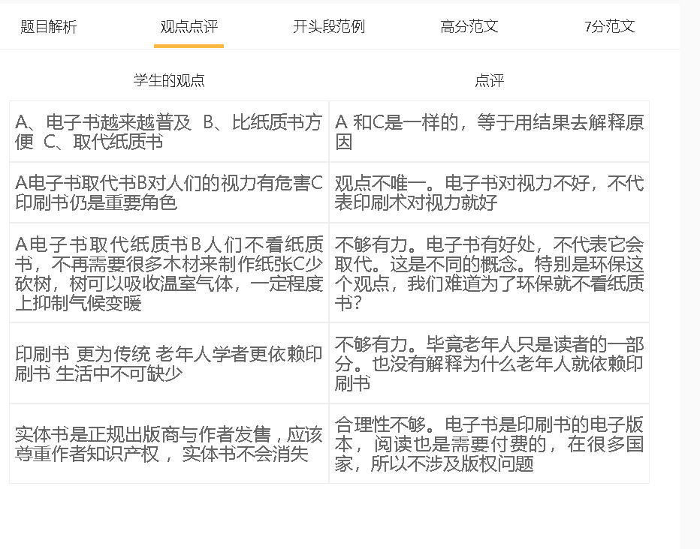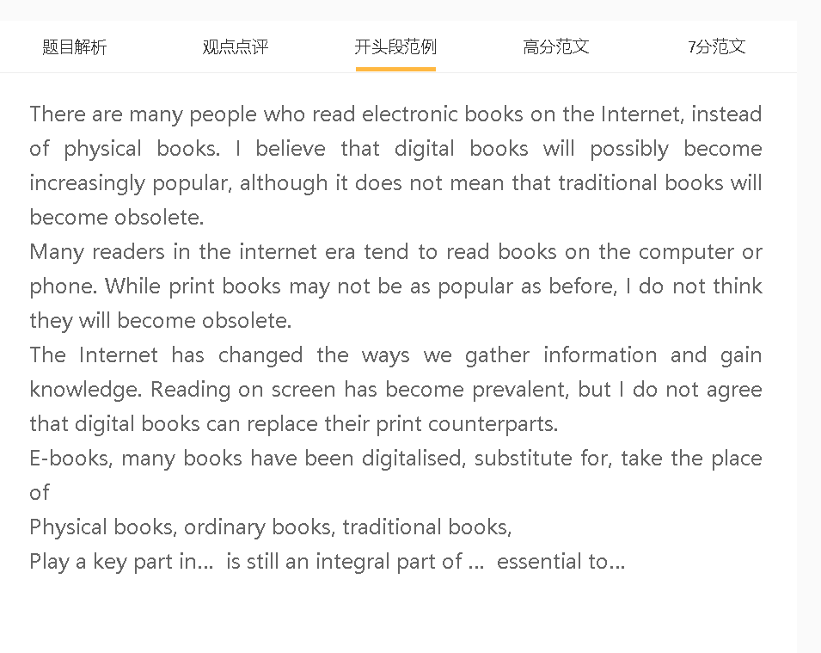

范文

People in the digital age have numerous ways to read books, especially with the advent of electronic readers. Digitalisation of publication is a positive development, but I believe that print books still have their fans.

A 电子书价钱低 B 节省费用 C 更容易传播知识，替换传统书
背景：人们很在意成本
解释(why B has happened)：不用印刷，不用运输
举例：教科书，小说，字典
At a low price, cost-efficient,
Impart knowledge/disseminate knowledge
Conventional books, hard copy books
Transportation costs/ shipment costs
Textbooks,
People from disadvantaged backgrounds,
一些人认为电子图书可能会取代印刷图书，因为电子图书将在传播思想和知识方面发挥更大的作用。这些书是对生活在生活成本飙升、经常入不敷出的世界中有成本意识的人们的幸事。数字图书对大众来说更实惠，原因很简单，因为这些图书不再需要印刷和运输。低价促成了电子书的普及，因为读者可以很容易地从电子图书馆提供的课本、小说和词典中获得知识。

Some people believe that electronic books are likely to replace print ones because e-books will play a bigger role in spreading ideas and knowledge. These books are a blessing to cost-conscious people living in a world where the cost of living soars and it is increasingly difficult to make ends meet. Digital books are more affordable for the masses for the simple reason that these books eliminate the need for printing and transportation. Low prices have contributed to popularity of e-books, as readers can gain knowledge easily from textbooks, novels and dictionaries which are available in e-libraries.

A纸质书容易做笔记和标注 B 比较适合深度阅读 C 对于学习和工作仍然很重要
解释：有一定的标记习惯，书写习惯，使用键盘不够快
举例：很难理解一个信息
好的points反复阅读
对比：哪怕是电子书有类似的功能，担心软件问题导致信息消失
另一方面，纸质书很受读者的欢迎，他们在阅读自己喜欢的书时有兴趣记笔记和标记重要概念。这些习惯已经形成了很长一段时间，以至于人们不愿意切换到使用键盘或触摸板来突出电子书中的重要句子。他们发现，如果阅读他们在页边空白处写的笔记或重读之前划线的单词，更容易掌握一些想法或理论。一些电子阅读器也开发了类似的功能，但读者担心任何故障都可能导致笔记丢失。
On the other hand, Print books are popular with readers who are interested in taking notes and marking important concepts when reading their favourite books. These habits have developed for such a long time that people are reluctant to switch to the use of the keyboard or the touchpad to highlight important sentences of e-books. They find it easier to grasp some ideas or theories, if they read the notes they wrote on margins or re-read the words they underlined before. Some e-readers have developed similar functions, but readers fear that any glitch could lead to a loss of notes.
电子书表现形式多样，吸引各种读者，可能取代印刷书
背景：阅读是一个相对无聊的过程，也非常烧脑
解释（A-B）：有声读物，适合阅读能力不好，视觉有问题的人，老人
解释（A-B）：视频，照片，小孩，生动
Present information in diverse forms/ different ways,
Attract a broad audience , have a broader readership
Audible books, reading skills, poor literacy, poor vision
Engage the interest of … grab attention, In engaging ways
Tedious, arduous
数字图书可能会取代传统图书，因为电子书以多种形式呈现信息，并吸引了广泛的受众。考虑到阅读是一项相对乏味的活动，需要巨大的脑力劳动，阅读很难成为一种流行的消遣，但数字技术已将其转变为对许多人有益的体验。例如，有声读物适合阅读能力差的人，如很早就不读书的人和视力差的人。此外，带有视频或生动图片的数字形式的阅读材料更有可能通过降低理解难度吸引年轻读者。
In my view, digital books may take the place of conventional counterparts because e-books present information in diverse forms and attract a broad audience. Reading is hardly a popular pastime, considering that it is a relatively tedious activity and requires tremendous mental effort, but digital technology has transformed it into a rewarding experience for many. For example, audible books are suitable for people who have poor reading skills, such as those who leave school early, and those who have poor vision. In addition, reading materials in digital forms with videos or vivid pictures are more likely to engage young readers by reducing the difficulty of comprehension.

In conclusion, it is probable that e-books go mainstream while print books would exist only among people who find enjoyment in deep reading.

