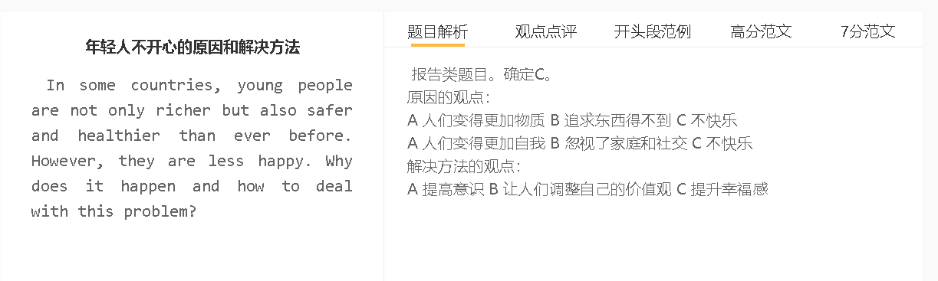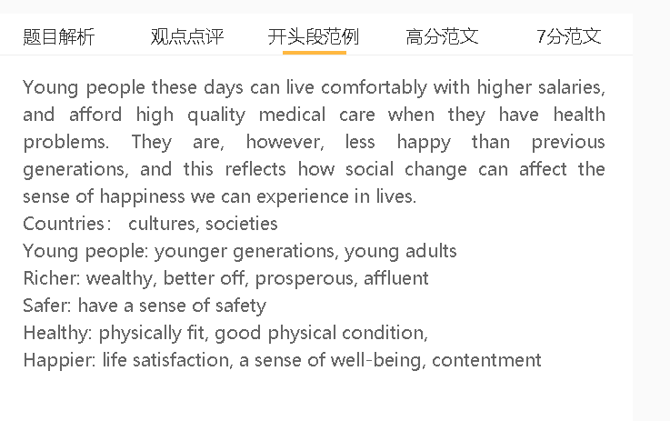

范文

Lower levels of happiness have become a growing problem among younger generations. It is important to identify the underlying cause of this issue and find solutions.

A 年轻人攀比和有野心 B 自己达不到目标 C 不开心
6.5分段落：The main reason why young people are unhappy is that they engage in social comparison and have become too ambitious. This is due to the fact that they have been exposed to information about what makes a successful life and what successful people do. They have chosen to pursue career success and luxury items, meaning that they cannot attain these targets. For example, they want to buy luxury cars and stylish clothing, although they cannot afford these items. This is particularly true for those societies where luxuries are promoted as status symbols.
年轻人生活满意度较低的主要原因是他们参与社会比较，变得过于雄心勃勃。这是因为他们接触到了关于什么是充实的生活以及成功人士所做的事情的信息，包括亿万富翁、著名演员和体育名人。他们努力实现自己的抱负，过着奢侈的生活，但他们中的大多数人没有实现这些目标的天赋和能力。例如，他们渴望获得名声和财富，但他们没有实现，他们也渴望购买豪华汽车和时尚服装，但他们负担不起。这可能会导致他们在生活中所能体验到的满足感下降。对于那些为追求职业目标而做出个人牺牲的人来说尤其如此。
7.5分段落：The main reason why young people have lower life satisfaction is that they engage in social comparison and have become too ambitious. This is due to the fact that they have been exposed to information about what makes a fulfilling life and what successful people do, including billionaires, famous actors and sports personalities. They have striven to realise their ambitions and live an extravagant life, but most of them do not have talents and abilities to attain these targets. For example, they aspire to achieve fame and earn a fortune, which they fail to achieve, and they are also eager to buy luxury cars and stylish clothing, which they cannot afford. This can lead to a drop in the contentment they can experience in their lives. This is particularly true for those who have made personal sacrifices in the pursuit of their career targets.

A 年轻人要改变思维 B 多点关注生活不同的快乐点 C 开心
6.5分段落：To address this issue, it is necessary to educate young people to change their mindset and shift their attention to different sources of happiness in their lives. This is primarily because their values and thoughts are negatively influenced by the outside world. If they pay attention to different aspects of their lives, they will experience happiness more easily. For instance, they can try to do unpaid work and spend more quality time with their family.
为了解决这个问题，有必要教育年轻人改变他们的心态，将他们的注意力转移到生活中不同的幸福来源上。这主要是因为他们的价值观和幸福感受到外界的负面影响，比如过分强调个人成就。如果他们优先考虑生活的其他方面，他们会更容易体验到幸福。例如，他们可以从无偿工作中获得乐趣，这可以赢得社会其他成员的赞扬和认可，并与家人共度更多优质时光，这可以避免孤独和孤立的感觉。
7.5分段落： To address this issue, it is necessary to educate young people to change their mindset and shift their attention to different sources of happiness in their lives. This is primarily because their values and perceptions of happiness are negatively influenced by the outside world, such as overemphasis on personal achievements. If they prioritise other aspects of their lives, they will experience happiness more easily. For instance, they can derive pleasure from unpaid work, which can earn praise and recognition from other members of society, and spend more quality time with their family, which can avoid feelings of loneliness and isolation.

In conclusion, young people experience a drop in happiness levels in large part because they have goals they cannot attain easily. This situation can be improved if they can lower their expectations.

7+
Younger generations in some societies tend to experience a drop in life satisfaction, despite having an improvement in wealth, fitness and safety. Changing social values may contribute to this problem, and adjusting their mindset can deal with this problem.
A 年轻人追求消费 B 欲望满足不了 C 不开心
背景：国家经济不断发展，商业使用各种手段去刺激消费，维持收入的增长
解释：大家收入再高，也很难满足所有的物质欲望
具体化：奢侈品、别墅、昂贵的度假、古董
年轻人可能会变得不高兴，因为他们对物质产品日益增长的需求无法得到充分满足。他们生活在那些日益繁荣的国家，在那里，他们被来自不同企业的大量商业信息轰炸，以说服他们花钱。尽管他们有高薪的工作，但他们几乎买不起所有想要买的东西，比如奢侈的商品、豪宅/别墅、昂贵的假期和古董。如果物质需求得不到满足，他们会感到不快，尤其是当他们认为拥有这些奢侈品已经成为常态时。
Young adults might become unhappy as their growing demand for material goods could not be fully satisfied. They live in those increasingly prosperous countries, where they are bombarded with numerous commercial messages from different businesses to persuade them to spend money. Even though they have well-paid jobs, they can hardly afford everything they intend to buy, such as lavish goods, grand houses/villas, expensive holidays and antiques. They feel unhappy if their material needs are unmet, especially when they believe the ownership of these luxuries has become the norm.
A 年轻人比较自我 B 忽视了家庭和社交 C 不开心
背景： 经济不断发展，年轻人已经不像以前一样那么依赖家庭关系来生活，所以更加愿意追求个人生活和选择。
解释：追求事业，工作和生活方式
解释（B-C）：生活遇到不顺，不懂得寻求身边人的支持和帮助，抑郁
具体化：工作不顺利，感情问题，创业失败
另一个原因是人们以自我为中心，对家庭和社会生活的意识较低。他们更喜欢自由地追求自己喜欢的生活方式，因为经济增长使他们能够在不依赖社会关系的情况下实现经济独立。这些年轻人更关注自己在职业生涯中的个人成就和做出选择的自由，而不是与家人的沟通和朋友的陪伴。他们可能会遭受挫折甚至抑郁等负面情绪，因为当他们面临一些困难时，他们不知道如何寻求他人的帮助，例如对工作不满、人际关系问题以及无法维持业务生存。
Another reason is that people are self-centred and less conscious of family and social life. They prefer to pursue their favourite lifestyles freely as economic growth enables them to achieve financial independence without relying on their social connections. These young people pay more attention to their personal achievements in their career and freedom to make choices, than to communication with family and the companionship provided by friends. They may suffer negative emotions such as frustration and even depression since they do not know how to turn to others for help when they face some difficulties, such as dissatisfaction with their jobs, relationship problems and failure to keep their business viable.
A 调整自己的心态 B 关注更加容易获得的幸福感 C 获得快乐
背景：不管社会多么有钱，人要知道总会有挑战，或者是自己做不到的事情
解释（B-C）： 从家庭生活获得快乐，从自己的进步中获得快乐，从帮助别人获得快乐
为了获得幸福，年轻一代应该调整自己的期望，并专注于更容易实现的目标。他们应该认识到，由于可用资源的限制，即使是富裕国家也无法满足每个公民的所有需求。他们经济独立，但生活中还存在其他挑战和挫折。他们可以通过记录自己的进步和个人发展来获得成就感，而不是不停地追求物质财富。他们还可以学会从培养与他人的社会关系中获得乐趣，而不是独自解决每一个问题。
To attain happiness, younger generations should adjust their expectations and focus on more attainable targets. They should realise that even rich countries cannot satisfy all needs of each citizen, due to the limits to resources available. They are financially independent, but there exist other challenges and setbacks in lives. Instead of pursing material goods incessantly, they can gain a sense of achievement by noting their progress and personal development. They can also learn to derive pleasure from nurturing social relationships with others, rather than tackle every problem alone.

In conclusion, young people are less happy because they are obsessed with material wealth and personal freedom, and one solution to this problem is to reshape their perception of pathways to happiness.

