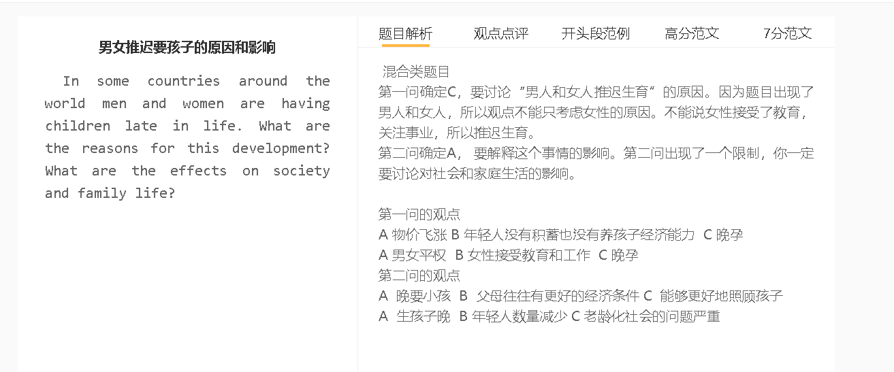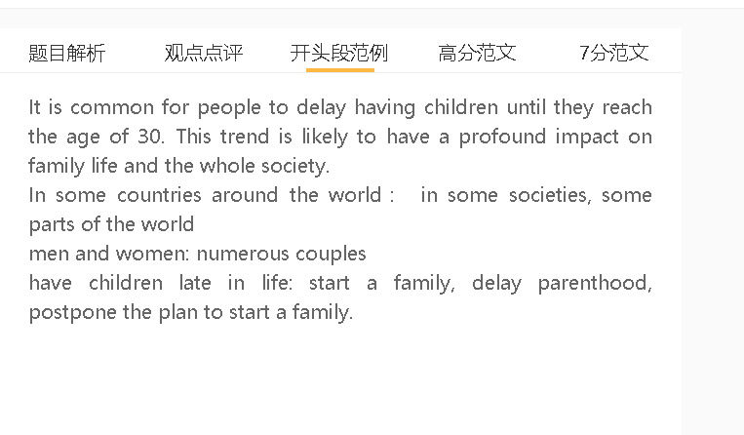

6.5-7范文
The fact that many people today have children at a later age has become an issue of concern to the public. There are some factors driving this change, which can have significant effects.
The main reason why people in some countries choose to delay parenthood is that they prioritise their career achievements over family life. This is due to the fact that economic development has provided more job opportunities and people have more career choices. These countries also have a strong desire for material wealth, so people also pay more attention to their careers. They invest time in their work, meaning that they have no energy or time for their family life. For example, they have to work overtime, travel for business and attend networking events, thus having no time in dating, having children and bringing up children. This is particularly true for countries where the cost of living is high.
One advantage is that couples are mature emotionally and financially to provide a good family environment. This is particularly true in situations where they have disagreements. They have been working for a long period of time, so they have experience in handling different problems. For example, they are mature in managing their emotions and settling arguments; therefore, they can maintain a loving family easily. In the long run, this can have a beneficial effect on mental well-being and life satisfaction.
On the other hand, having children in later life has an adverse impact on society because the birth rate is lower. This happens when they gain a sense of achievement from their working lives. A lower birth rate will lead to labour shortages; as a result, a drop in productivity can damage the economy. For instance, technology industries need energetic, productive young people to work. This is important considering that many companies can go bankrupt in a highly competitive world.

In conclusion, people delay the plan to start a family in large part because they focus on their careers. This is basically a positive change for family life, although it may cause problems for society.

7．5+ 范文
The fact that many people today have children at a later age has become an issue of concern to the public. There are some factors driving this change, which can have significant effects.
一些国家的人们选择推迟为人父母的主要原因是，他们把职业成就置于家庭生活之上。这是因为经济发展提供了更多的就业机会，使她们能够从事自己喜欢的职业，尤其是以前对劳动力参与有限的女性来说。这些国家对物质财富也有着强烈的欲望，迫使他们努力工作以赚取更高的薪水。他们在工作中投入时间，包括加班、出差和参加社交活动，因此没有精力约会和组建家庭。对于起薪相对较低的行业来说尤其如此。
The main reason why people in some countries choose to delay parenthood is that they prioritise their career achievements over family life. This is due to the fact that economic development has provided more job opportunities and allow them to pursue their favourite careers, especially for women whose presence in the workforce was limited. These countries also have a strong desire for material wealth, pushing them to work hard to earn higher salaries. They invest time in their work, including working overtime, travelling for business and attending networking events, thus having no energy for dating and starting a family. This is particularly true for industries where the starting salary is relatively low.
此举的一个好处是，夫妻在情感和经济上都很成熟，可以提供一个舒适舒适的家庭环境。在他们有分歧并就重大问题做出决定的情况下尤其如此。多年的工作经验意味着他们的收入已经上升到可以轻松负担抵押贷款和其他生活费用的水平，并且他们已经从处理关系问题中培养了情绪管理技能。他们可以有效地解决与配偶或子女的争吵，这对心理健康和生活满意度有着有益的影响。
One advantage of this move is that couples are mature emotionally and financially to provide a comfortable and cozy family environment. This is particularly true in situations where they have disagreements and make decisions on consequential issues. Years of work experience means that their income has risen to a level to afford mortgage and other living expenses easily and that they have developed emotion-management skills from handling relationship problems. They can settle arguments with spouses or children effectively, which has a beneficial effect on mental well-being and life satisfaction.
另一方面，由于出生率较低，在晚年生孩子会对社会产生不利影响。当他们有一个成功的职业生涯，不需要在经济上依赖家庭，或者有高收入者作为婚姻伴侣或孩子来支持他们的退休生活时，就会发生这种情况。年轻人口的减少将导致劳动力短缺，降低劳动力的生产力，这可能会削减企业收入，损害经济。随着商品和服务的公共消费大幅减少，年轻消费者的减少也是对经济增长的挑战。
On the other hand, having children in later life has an adverse impact on society because the birth rate is lower. This happens when they have a successful career and do not need to rely on family financially, either having high-income earners as marriage partners or children to support their retirement. A dwindling younger population will lead to labour shortages and reduce the productivity of the workforce, which can cut business revenue and damage the economy. A drop in young consumers is also a challenge to economic growth as public consumption of goods and services decreases dramatically.
总结段：
In conclusion, people delay the plan to start a family in large part because they focus on their careers. This is basically a positive change for family life, although it may cause problems for society.

7+范文
Many people today have delayed their parenthood in some countries, especially in developed countries. It is important for us to understand why this trend has happened and how it impacts on society and family life.

A 物价飞涨 B年轻人没有积蓄去养孩子 C 晚孕
背景：在大都市地区尤其如此，对商品和服务的强劲需求推高了通胀，导致食品、租金和家庭用品价格上涨
解释（A-B）：工资比较低，年轻人剩下不多少钱
解释（B-C）：受过高等教育，觉得孩子成长环境很重要
解释（举例）：学费越来越贵，奶粉，小孩的衣服都很贵
The cost of living, savings，delay parenthood, Start a family, raise a family， bring up children, rear children
Low income, save money
Well-educated, receive a college education, home environment, provide a secure environment, a nourishing environment
Property prices, rent affordable, disposable income
Tuition fee, formula,
The ever-rising cost of rearing a child is possibly the main reason why people delay starting a family. This is particularly the case in metropolitan areas, where the robust demand for goods and services has fueled inflation, making food, rent and household goods expensive. People in their twenties struggle to save money, as they do not have experience and expertise that is required for a high-paying job. They choose not to start parenthood until they are able to increase earnings to cover relevant expenses, such as formula, baby outfits and school tuition.

A 晚要小孩 B 父母往往有更好的经济条件 C 家庭更加美满
背景：很大一部分家庭争吵是由于对如何使用金钱的分歧引起的，而这在预算紧张的时候更常见。
解释(A –B )：专注工作，事业发展，收入增加
解释（B-C）：家庭因为比较宽裕，不会因为金钱而吵架
举例：买房子，送孩子去好的学校，请保姆，旅游长见识

For this reason, the decision of delaying parenthood has a positive effect on family life as couples are in a better financial situation to perform their child-care duties. A large proportion of family quarrels arise from disagreements about how to use money, which are more common when the budget is tight. Having children at an older age means that they can concentrate on their career without devoting time to family commitments, thereby gaining more opportunities to get promoted and receive a pay rise. With a higher level of income, they can live comfortably and spend freely on whatever is beneficial for raising children, such as buying a bigger house, hiring caregivers, sending children to a prestigious school and taking a holiday overseas.

A 生孩子晚 B 年轻人数量减少 C 老龄化社会
背景：预期寿命的提高给一些国家在赡养老年人口方面带来了压力，而较低的出生率加剧了这一问题
解释：年轻工人数量的下降可能会损害劳动力的生产力，损害经济
解释2：如果政府不得不征收更高的税来资助老年护理机构和养老金计划，他们的消费能力也会下降
On the other hand, a society with a growing number of couples delaying parenthood will face some challenges of an ageing population, as the proportion of young people drops significantly. Improved life expectancy has put strains on some countries in terms of supporting the elderly population, and a lower birth rate has exacerbated this problem. A drop in the number of young workers may compromise the productivity of the workforce and damage the economy. They spending power also dwindles, if the government has to levy higher tax to finance elderly care facilities and the pension scheme.

In conclusion, young adults today are unwilling to have children in their twenties because of financial considerations, and this has a deep impact on families and society at large.

