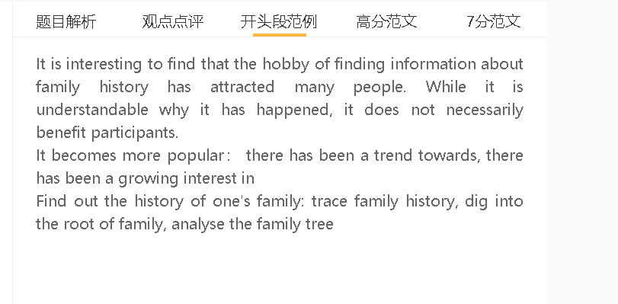

范文

It is interesting to find that the hobby of finding information about family history has attracted many people. While it is understandable why it has happened, it does not necessarily benefit participants.

A 科技发展 B 通过网络和社交媒体可以找到有血缘关系的人C 研究家庭历史变得流行
People are enthusiastic about their family history since doing research on their family has become technologically feasible in the digital age. Text messaging apps and social media have allowed users to connect with their distant relatives living in other cities or even on the other part of the world, so they can exchange information and develop a comprehensive picture of how a family originated and what some prominent members of family did in the past. Digitalisation of some documents, such as birth certificates, and the astounding progress in the DNA database make it possible for people to locate their long-lost relations.

A调查家庭历史 B 知道祖先的生活和事迹C过好自己的人生
People can draw upon the experience of their ancestors when gathering information about family history. It is part of human beings’ survival instinct to emulate successful individuals, either in their family or in broader community, in large part because they may believe that there are formula for personal achievements. Anecdotes about some renowned relatives in the past may inspire present and future generations about how to overcome difficulties, seize opportunities and achieve prominence. Young people in modern times may show resilience in the face of adversity and work diligently to prove that they share the same traits as their respectable ancestors.

A调查家庭历史 B 过分关注过去 C 浪费时间
On the negative side, the obsession of the past could be a problem if people expend their precious time conducting painstaking research which ends up nothing. Information about the past of one’s family can be fragmentary and it is a daunting task to uncover proof about one’s connection with a family. Even though evidence points to one’s biological relationship with a respectable family, such as a loyal family or a historic figure, this finding may not be as valuable as expected. One may not inherit any fortune or character from remote ancestors. The glories of the family may inflate one’s self-esteem but fail to yield any tangible benefit in terms of rising to current challenges.

In conclusion, technological progress has fired the enthusiasm for investigating family history but this trend has mixed effects.

