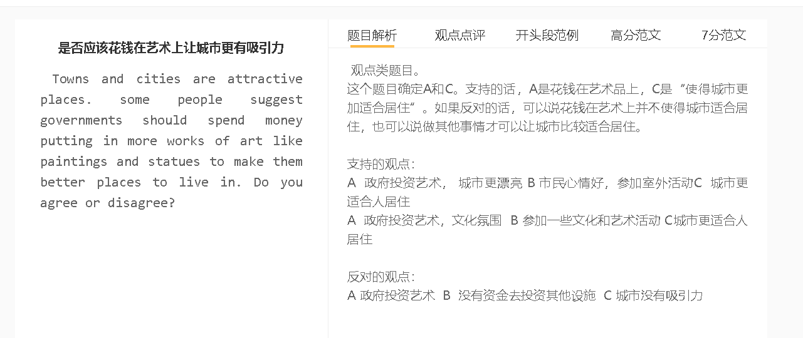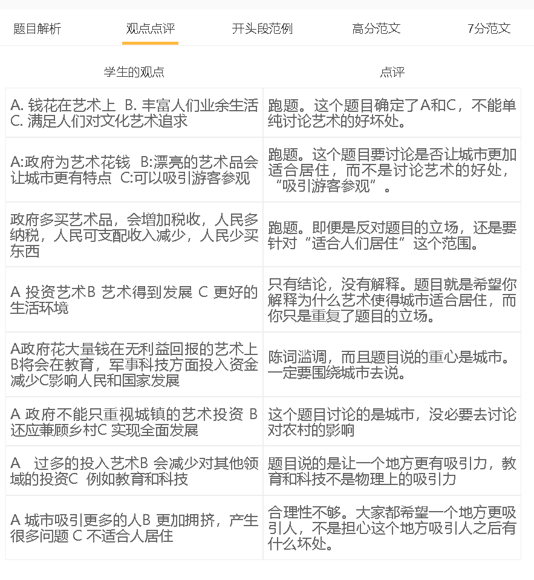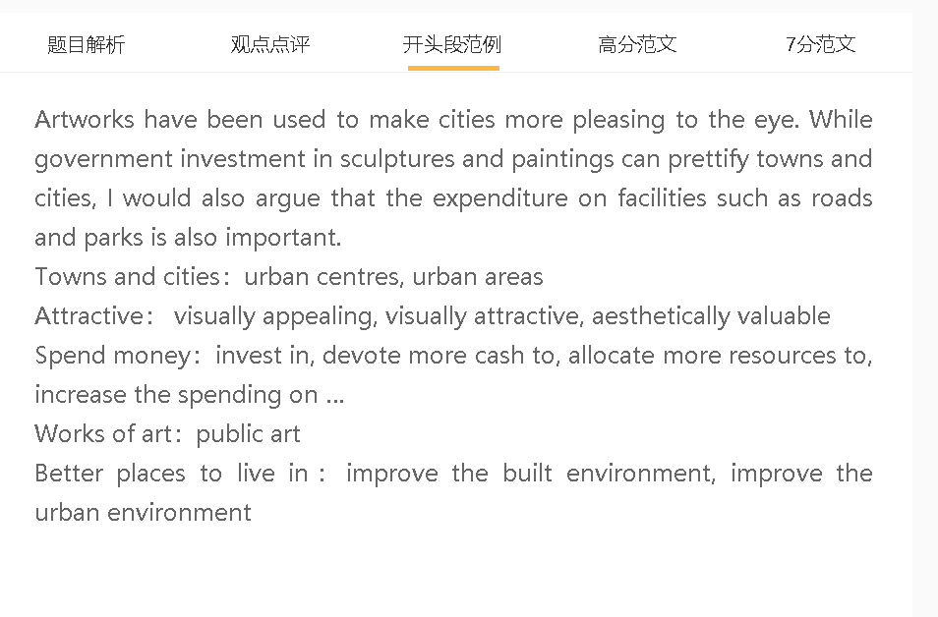

范文

People today are able to earn higher income to cover basic needs, and many of them have paid attention to cultural life. I agree with the idea of increasing government funding for art, even though there are other projects/initiatives to increase the appeal of cities.

A 政府投资艺术品B 让城市有变化C 城市更有吸引力
背景：高层建筑，千篇一律，世界很乏味
解释：线条、颜色和样式都增加了变化
解释：蓝天白云绿地这些绘画的素材都让人们在城市里感受那些自然的要素
Visually attractive/ appealing
Lighten mood,
Go sightseeing, appreciate works of art, take photos
Talking points
High-rise buildings, mundane world
Public art could make cities attractive as works of art can add variety to city scenes. This is important for modern cities which have resembled each other because of the increase in skyscaperes. Paintings and murals can make the concrete jungle less tedious by increasing the variance in lines, colours and patterns. Some subjects of paintings, such as blue skies, white clouds and grassland of the countryside, put city dwellers in good moods for they serve as reminders of the natural elements missing in urban settings.

A 政府投资艺术品B 改变城市的生活节奏 C 城市更有吸引力
背景：城市生活很单调，高的生活成本强迫大家不断工作
解释：艺术品使得很多地方很漂亮，人们愿意停下来欣赏。
解释：有很多艺术品的地方是人们观光、喝咖啡、阅读和拍照的好场所
总结：这样使得城市生活更加变化
One additional benefit of having more pieces of art in cities is that art can change the pace of life for many and enrich city life. People living in cities are desperate to adjust to the fast rhythm, given the high cost of living has necessitated overworking. Places decorated by art are so visually attractive that residents cannot help pause and appreciate these items. Places with sculptures and paintings such as city squares can be ideal locations for people to go sightseeing, have a coffee, do some reading and take photos. These activities can make urban life more dynamic and varied, adding the appeal of living in cities.

A 政府投资艺术 B 没有资金去投资公共设施 C 城市居住不好
背景：有些城市比较落后，人们收入不高，更加关注城市的基本设施
解释：政府的钱有限，而艺术又比较花钱

On the other hand, it may not be appropriate to pour money in public art in those cities which are ill-equipped to match basic needs of local residents. Inhabitants of these less affluent cities are more conscious of amenities that support their daily lives, such as libraries, bus stations, sports centres and hospitals, as they may not have sufficient money to afford relevant costs, if these facilities are privately owned. The spending on art may use up public money that could otherwise be spent in the upgrading of these facilities. A majority of inhabitants of these urban areas, especially those who have limited visual literacy, tend to perceive artworks as luxuries, rather than necessities.

In conclusion, public expenditure on artworks can improve the urban environment and alter the dynamics of cities, although it may not be advocated by people who place value on basic infrastructure.

