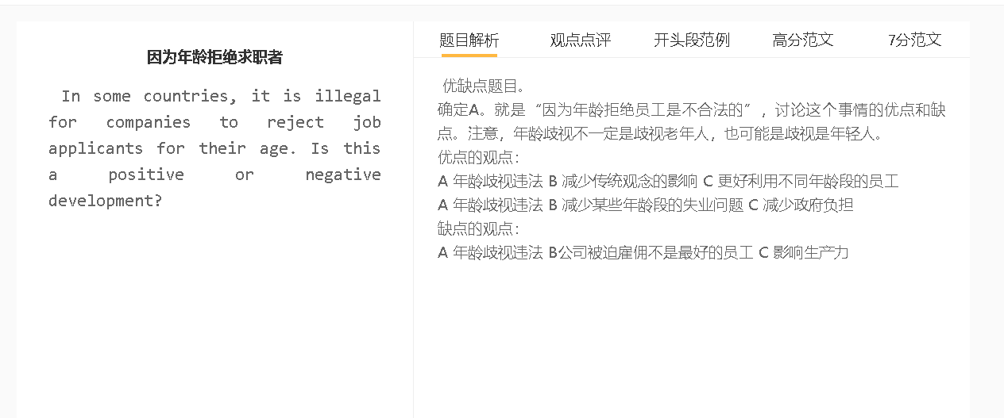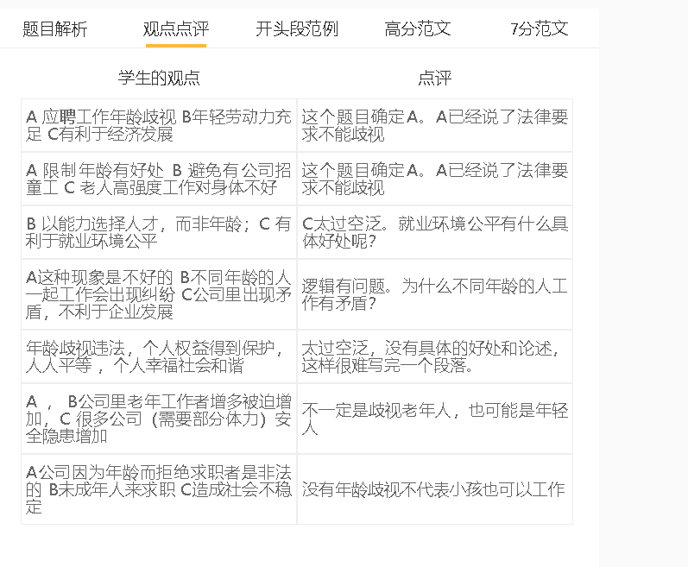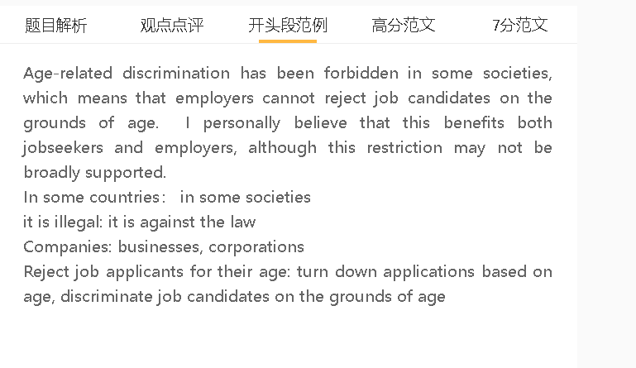

范文

Age-related discrimination has been forbidden in some societies, which means that employers cannot reject job candidates on the grounds of age. I personally believe that this benefits both jobseekers and employers, although this restriction may not be broadly supported.

A 年龄歧视违法 B 减少传统观念的影响 C 更好利用不同年龄段的员工
解释：重视员工的能力，明白员工对公司的影响
举例：年纪大的员工给公司带来经验，知道如何防范风险
举例2：年纪小的员工给公司带来新的想法和做法，方便创新
Making age-discrimination practices illegal is a positive development since it will help companies tap into the talent of employees of different ages. Hiring managers will pay attention to the merit of applicants, rather than age, and place value on the contribution of staff in different age groups, who have their respective strengths and perspectives. For example, employees in their fifties can contribute to a company’s management with experience and sound advice, such as avoiding some financially reckless decisions that can endanger the business. Meanwhile, young employees may arrive with some bold ideas and innovative practices because they are ambitious and well-informed about advanced technology. These examples all suggest that if companies set aside their age-related bias, they can benefit from workforce diversity.

A 年龄歧视违法 B 减少某些年龄段的失业问题 C 减少政府负担
背景：年轻人失业率和人口老龄化仍然存在，失业率带来极大的不稳定。
背景：制定年龄歧视相关的法律意味着雇主为了避免遇到雇佣方面的纠纷而选择雇佣哪怕短时间不是特别合适的年纪大或者小的员工。
解释1：年轻人有工作，政府不需要付那么多失业补助，还要投资帮助他们再就业
解释2：老年人工作，政府要减少pension
Another reason why anti-discrimination laws are important is that this legal change can tackle unemployment problems facing some age groups and lighten the burden on the government. This is important in societies where youth unemployment and population ageing have presented economic challenges. Outlawing any unfair age-related employment practice would push employers to hire young or elderly employees who may not be the best candidates at the moment but have the potential to perform well if trained well. The government can cut the spending on unemployment benefits for the jobless and job-creation schemes that help young people seek employment. Likewise, less money should be spent in the pension, when people can remain in the workforce beyond the retirement age.

A 年龄歧视违法 B公司被迫雇佣不是最好的员工 C 影响生产力
背景：不敢拒绝那些年龄不符合要求的人
解释1：年轻人劳动力不够
解释2：年纪大的人劳动力也不够
拓展结果：提高企业的成本
On the other hand, as anti-age-discrimination laws are enforced, some companies may be forced to recruit less qualified jobseekers. Businessowners may not turn down the applications of people whose age has an impact on their ability to perform their duties well, fearing that companies may face lawsuits for unfair hiring decisions. For example, a company may have to hire an elderly employee, even though he or she is not physically capable of handling demanding jobs, or provide a position for a young schoolleaver, who does not have the experience and decision-making abilities required for this job. Keeping these employees in the workforce can raise the cost of running of the company, while compromising profit-making capacity.

In conclusion, I would argue that outlawing discriminatory hiring practices is a positive change although it may have its downside.

