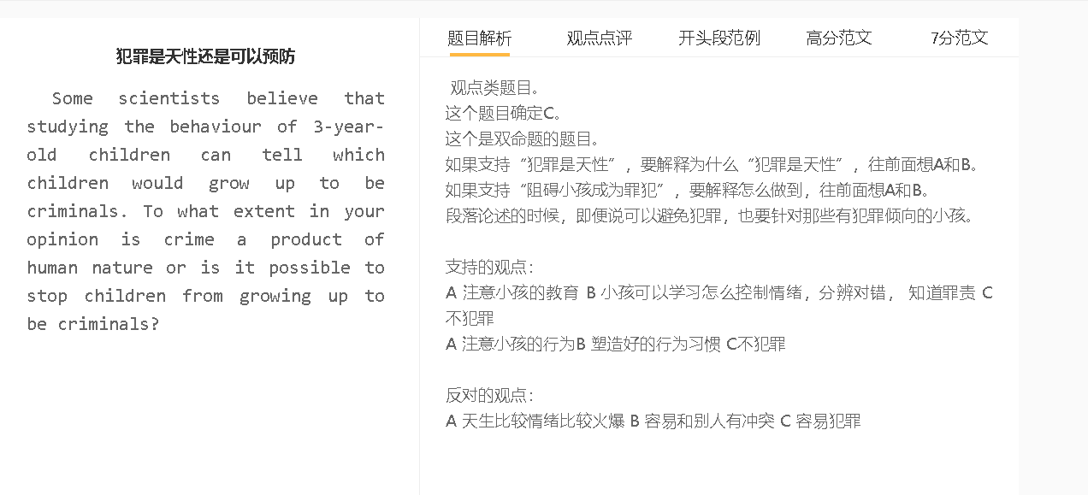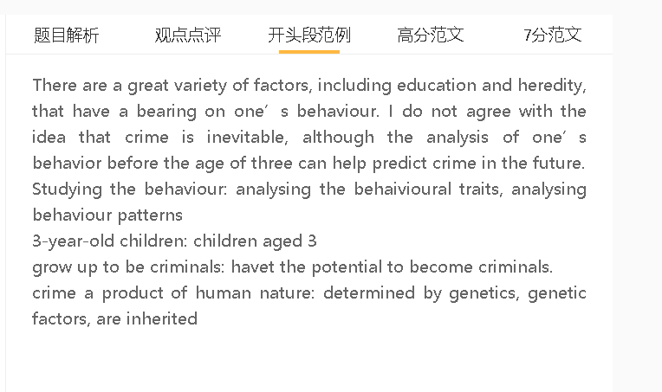

范文

6.5分范文
It is sometimes argued that there are ways of preventing children from growing into criminals. I agree with this view, although the opposite may be true in some cases.

A通过教育等方式 B 提高情绪管理的能力和就业能力 C 避免坏小孩变成罪犯
The main reason why I support this argument is that education can improve skills and prevent crime. This is particularly true for children who struggle to manage their emotions and lack the knowledge of the consequences of law-breaking behaviour. Teachers can impart the skills of managing anger and negative emotions, so students understand how to release these emotions effectively, rather than hurt others. Teachers can also share knowledge of laws; therefore, students will not violate laws.

A 通过政府政策改革 B 提高人们生活满意度，创造一个安稳的社会 C 避免坏小孩变成罪犯
背景（想不到，可以不写）：很多社会问题的社会
解释（B-C）：人们生活满意度，小孩在一个好的家庭生活，就会减少一些家庭矛盾、家庭暴力对他们的影响
解释（B-C）：社会安保系统，法律严格，小孩就压制一些犯罪的冲动，因为害怕受到惩罚。
Another reason is that policy reforms can improve life satisfaction and create a peaceful society to reduce crime. This is important in cases where many social issues exist, such as poor economy, a widening wealth gap and high unemployment. The government can take steps to provide social benefits and promote economic growth, meaning that many people have financial security. The government can also impose tougher laws and improve security measures, which can also lead to a low crime rate.

A天生基因 B暴力倾向和缺乏同情心 C容易犯罪
On the other hand, it is possible that 相反的立场 if 原因。
背景（想不到，可以不写）： 遗传基因，和暴力有关系
解释（解释A到B或者B到C的跳跃）：大脑掌控情绪的部分不正常，导致很难控制情绪，对别人的疼痛冷漠，甚至从伤害别人那里获得乐趣
On the other hand, it is possible that some children are likely to commit crime if they have violent tendencies and lack compassion. In some cases, some children have inherited some genes. They tend to hurt others as they have difficulty in controlling their temper.
In conclusion, I would argue that we can adopt some measures to minimise the risk of illegal behaviour among children even though there are some exceptions.

7.5+范文
It is sometimes argued that there are ways of preventing children from growing into criminals. I agree with this view, although the opposite may be true in some cases.

The main reason why I support this argument is that education can prevent crime by imparting skills and knowledge to younger generations. Some courses can be provided about the techniques of managing anger and negative emotions, so students understand how to regulate and release these emotions effectively, such as taking a deep breath and walking away when having arguments with peers, rather than carry out acts of violence. Teachers can also inform students about the legal consequences of some behaviours; therefore, students will not violate laws, even though they are genetically predisposed to do so.

Another reason is that policy reforms can improve life satisfaction and create a peaceful society to reduce juvenile delinquencies. This is important in cases where numerous social issues exist, such as stagnant economy, a widening wealth gap and soaring unemployment. The government can take steps to provide social benefits and promote economic growth, thereby improving financial security for countless families. Growing up in a comfortable, secure home environment can minimise children’s exposure to family quarrels and domestic violence, which are common triggers of criminal behaviour. Other approaches can also be taken, including imposing tough laws and improving security measures, thus suppressing some children’s urge to commit crime.

On the other hand, it is possible that some children are more prone to commit crime if they have violent tendencies and lack compassion. In some cases, some children have inherited some genes that are usually linked to aggressive behaviour. The region of brain responsible for controlling emotions does not function properly, so they have difficulty in keeping temper in check, show an indifferent response to the sufferings of victims, and even derive pleasure from assaulting or abusing others physically. These biological factors may sometimes have a stronger impact on behaviour than external influences for some children.

In conclusion, I would argue that we can adopt some measures to minimise the risk of illegal behaviour among children even though there are some exceptions.

7分范文
There are a great variety of factors, including education and heredity, that have a bearing on one’s behaviour. I do not agree with the idea that crime is inevitable, although the analysis of one’s behavior before the age of three can help predict crime in the future.

A 注意小孩的教育 B 小孩可以学习怎么控制情绪，分辨对错， 知道罪责 C 不犯罪
背景：那些有暴力倾向的人在某些情绪状态下倾向于表现出侵略行为，如愤怒和痛苦，但他们的理性思维可以战胜这些思维，如果提供相关培训
解释：他们知道如何通过非暴力手段，如体育运动来平息或释放不满情绪
解释：如果他们充分了解这种行为的法律影响，他们会三思而后行

Children will be less prone to crime if they learn about emotion management and the consequences of criminal acts. Those who have predisposition to act violently tend to show aggression in some emotion states, such as anger and distress, but their rational thinking can take over, if provided with relevant training. They understand how to calm down or release discontent though non-violent means, such as sport, when schools run some workshops. They will also think twice if well-informed about the legal implications of behaviour, possibly by pamphlets circulated on campus or by some courses.

A 家长要注意 B 塑造好的行为习惯 C不犯罪
背景：犯罪在很大程度上是社会学习的产物，即使对有暴力倾向的孩子也是如此。通过电视、书籍、视频游戏和不良的同龄人，他们逐渐意识到身体攻击和杀人可以达到目的。
解释（A-B）：成年人可以尽量减少孩子对这些信息来源的接触，减少模仿攻击性行为的可能性
解释（A-B）：如果观察到不良行为，纪律是必要的，可以提供一些奖励来加强一些积极的行为，如善良和礼貌的行为
结果：这类干预可以抵消对儿童行为的一些负面影响
Early intervention is also an integral part of preventing crime as adults can correct misbehavior and establish positive behaviour pattens of children. Crime is largely a product of social learning, even for children with violent tendencies, and it is from TV, books, video games and delinquent peers that they gradually realise physical assaults and homicides can achieve their ends. Adults can minimise children’s exposure to these sources of information, reducing the likelihood of copying aggressive behaviour. Discipline is necessary if misbehavior is observed, and some rewards can be provided to reinforce some positive behaviour, such as acts of kindness and courtesy. These kinds of intervention can counterbalance some negative influences on children’s behaivour.
A 天生比较情绪比较火爆 B 容易和别人有冲突 C 容易犯罪
解释（A-B）：人的性格、脾气由基因决定的。
解释（B体现在哪里）：情绪化，占上风, 不能够理性思考
具体化：有矛盾的时候，冲动犯罪

On the other hand, those who have a long history of repeated violent behaviour are prone to crime, whatever measures are taken. There are some inherited traits that have a lifelong impact on their behaviour, such as apathy, aggression and irritability, and the regions of the brain that control and regulate emotions do not function well. The influence of genetics is so strong that it can override any external intervention, such as education. They can lose temper easily and resort to violence in the face of threats, confrontations and arguments, so in these extreme circumstances, criminality is basically attributed to biology.

In conclusion, I would argue that criminal acts can be prevented in most cases, although this is difficult for those who have strong violent tendencies.

