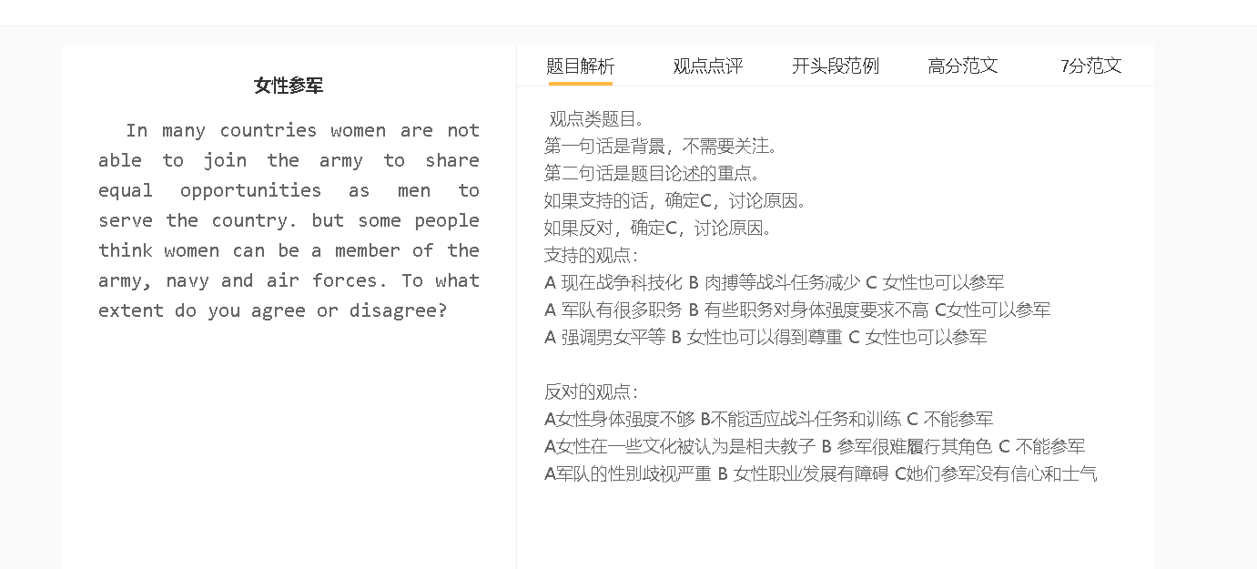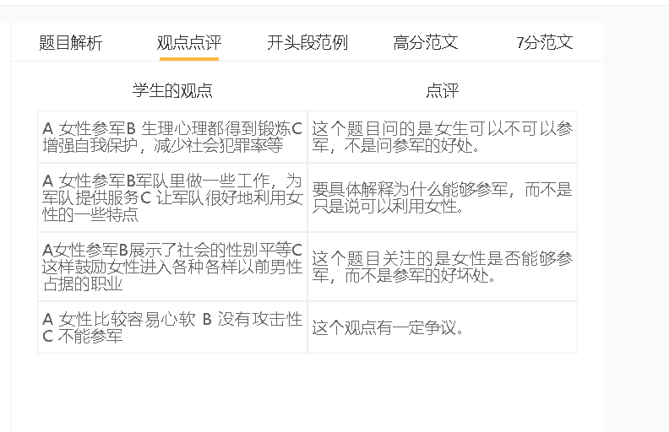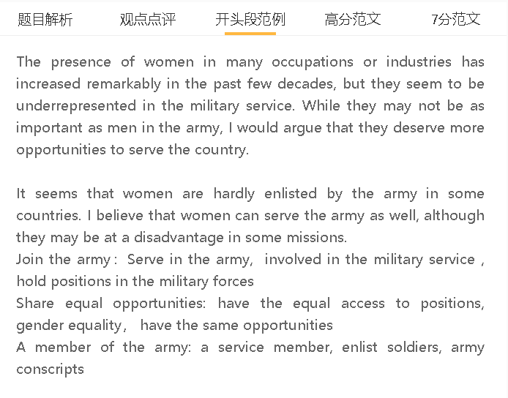

范文

It is believed that women are able to carry out the same duties in the military forces as men do. I agree with this view, although the presence of women in the army can be limited.

A 现在战争科技化 B 肉搏等战斗任务减少 C 女性也可以参军
背景：很多国家仍然觉得武器是保护国家领土和利益的重要手段，投入大量的钱
解释：无人机、导弹应用在战争中
解释：军队人员的身体要求下降了，而女性智力和知识上和男性一样，操作机器和使用科技
One justification for conscripting women in the army is that technological progress has reduced hand-to-hand combats. Billions of dollars have been invested in modernising military forces, which are perceived as an important factor in defending sovereignty and national interests. Modern weaponry, such as drones and missiles, is applied on a large scale in warfare, allowing soldiers to attack and kill enemies from afar. This increases the possibility of having more women serving the army, who are not physically strong to handle combat missions but as intelligent as their male counterparts in operating advanced equipment and harnessing technology.

A 军队有很多职务 B 有些职务对身体强度要求不高 C女性可以参军
背景：军队很庞大需要分工协作
举例：医疗 后勤 文员 情报
解释：主要是在办公室，远离战场的地方工作
解释：不需要个人和家庭有很大的牺牲
Another reason why women can be enlisted is that they can fill numerous non-combat positions in military services. The operation of an army requires the cooperation of different functional units, including logistics, intelligence, administration and medical services, most of which involve clerical work carried out in offices, rather than battlefields. Women can take up these positions without making considerable personal or family compromises. They can gain support from families, as long as they can strike a balance between work and other commitments.

A军队的性别歧视严重 B 女性职业发展有障碍 C她们不应该参军
背景：军队传统来说是男性主体，有一些性别的偏见
具体化：女性不能够适应比较恶劣的环境，不能长时间工作
解释：女性不会考虑参军
解释：女性也不会进入军队
On the other hand, women may have to overcome numerous obstacles, such as gender discrimination, in an attempt to join the army. The military force is traditionally a male-dominated world, in which women encounter some gender stereotypes. One widely-held view is that they cannot endure harsh conditions and long working hours. Women who are pessimistic about their career progression will not consider the option of entering the army. Meanwhile, they may not have the equal opportunities to train for the jobs if recruiters hold a similar attitude towards female applicants.

In conclusion, I believe that more women can go into army thanks to technological advances, although gender bias is a challenge.

