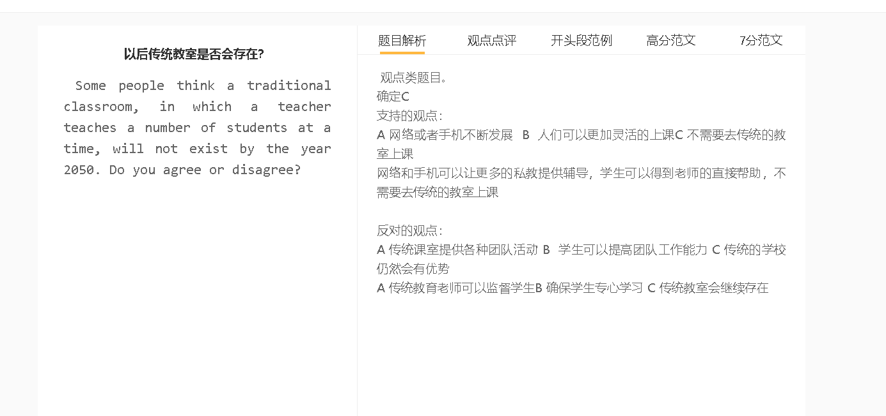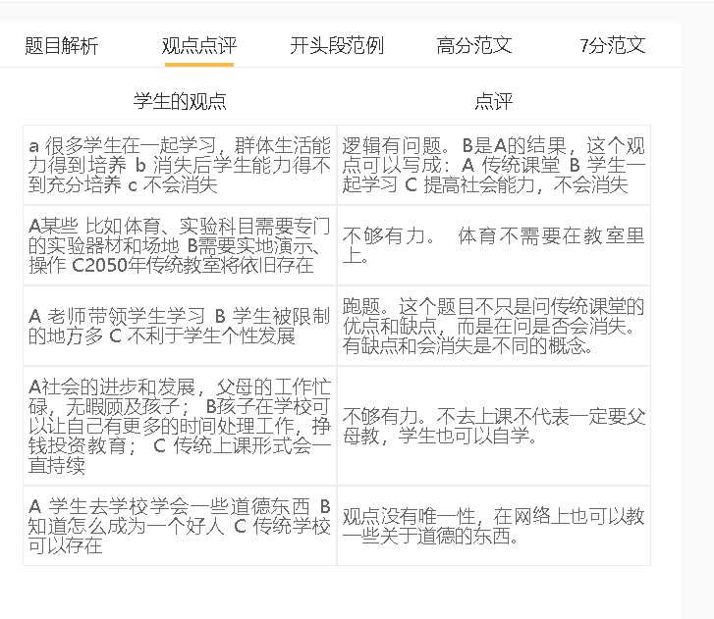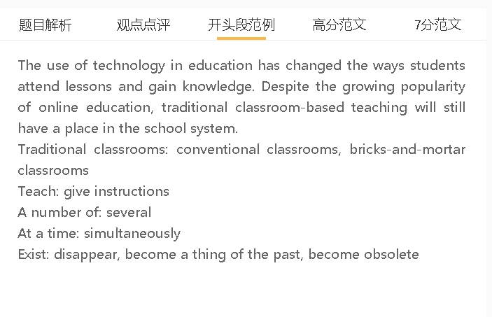

范文

The use of technology in education has changed the ways students attend lessons and gain knowledge. Despite the growing popularity of online education, traditional classroom-based teaching will still have a place in the school system.

A 老师近距离观察学生 B 监督学习 C 传统教室不会消失
传统课堂可以继续存在，具有一些独特的功能，因为教师密切监督学生，以确保最佳的学习结果。这对中小学教育尤为重要，因为这些年龄段的学生对学校教育的含义理解不足，缺乏自律和保持专注的动力。教师可以发现心不在焉或昏昏欲睡的孩子，并采取措施将注意力拉回课堂内容。即使借助网络摄像头，这在互联网上也难以实现，因为网络摄像头太小，无法在屏幕上清晰地显示每一张脸。
Traditional classrooms can continue to exist with some unique functions as teachers supervise students closely to ensure the best learning outcomes. This is particularly important for primary and secondary education, considering that students in these age groups have a poor understanding of what schooling implies and lack self-discipline as well as motivation to stay focused. Teachers can detect absent-minded or sleepy children and take steps to draw attention back to class content. This is less attainable on the Internet, even with the aid of web cameras, which are too small to show each face clearly on the screen.

A 教室允许大量的交流 B 有助于学生的社会技能发展 C 传统教室不会消失
传统教学手段的另一个理由是，它允许为社会发展进行密集的交流。传播知识并不是教育的唯一目的，学校应该为年轻一代做好成年准备，让他们作为社区中有意义的成员有效地发挥作用。学校是社会的缩影，不同背景的孩子在一起接受教育。他们参加学术或课外活动，在这些活动中，他们排练各种情景的沟通策略和技巧，例如进行团队项目或在有不同意见时达成协议。这种情况不太可能发生在虚拟教室中，因为那里与同龄人的互动是有限的。
Another justification for conventional means of teaching is that it allows for intensive communication for social development. Dissemination of knowledge is not the sole purpose of education, and schools are expected to prepare younger generations for adulthood, when they function effectively as meaningful members of community. Schools are the miniature of society in which children of different backgrounds are educated together. They participate in academic or extracurricular activities in which they rehearse communication strategies and skills for diverse scenarios, such as doing a team project or reaching an agreement when having different opinions. This is unlikely to happen in virtual classrooms, where interactions with peers are limited.

A （对于成年人）网络学习方便 B 大家可以很容易学习 C 传统教室会消失
另一方面，由于知识可能以更方便的方式传播，许多砖砌的教室可能会消失。学生可以在方便的时候参加在线课程，无论是在舒适的家里，还是在他们喜欢的任何地方，比如咖啡馆，原因很简单，互联网普及率将大幅提高。这意味着他们可以通过平板电脑、手机或其他电子设备学习，而不用去离线实体教室，从而节省时间，提高学习效果，更容易管理时间表。互联网还拥有丰富的资源，从直播课程到外国著名学者的录播讲座，这些资源可以让学习者接触特定地区传统课堂上无法获得的知识。
On the other hand, numerous bricks-and-mortar classrooms will possibly disappear because knowledge is possibly disseminated in a more convenient way. Students can attend online courses at their convenience, whether in the comfort of their homes or any place they prefer, such as a café, for the simple reason that Internet penetration will increase substantially. This means that they can study through their tablets, phones or other electronic devices instead of going to off-line physical classrooms, thus saving time, improving learning outcomes and managing their timetable more easily. The Internet also has a wealth of resources, ranging from live-streaming courses to recorded lectures of renowned scholars in foreign countries, which can expose learners to knowledge not available in conventional classrooms of a specific area.

In conclusion, technology will certainly threaten traditional forms of education, especially for adult learners, but classroom-based teaching will be sustained for younger children.

